LESSON 1

A. Vocabulary

Exercise 1. Complete using the words in the boxes.

Dạng bài: Embedded answers
climate forecast heatwave shower thunder
insect mammal reptile species wildlife

- Have you heard what the weather _______________ is for tomorrow?
- Britain is experiencing a _______________ at the moment. It's unusually hot and it hasn't rained for several weeks.
- It's not going to rain much, but there might be the occasional ______________.
- During the thunderstorm, the ____________ was so loud I hid under the bed!
- ____________ hit a tree in the garden during the thunderstorm and a branch came off.
- I wish I lived in a country with a warmer ____________

I don't see a lot of ________________ because I live in a big city.

It's very unusual to see this ________________ of bird around here at this time of year.

If it's got six legs, it's probably a/an ____________________________.

Humans and monkeys are different types of _______________.

Snakes and lizards are different kinds of _______________.

1. forecast 2. heatwave 3. shower 4. thunder 5. Lightning
6. climate 7. wildlife 8. species 9. insect 10. mammals 11. reptiles

Exercise 2. Choose the best word to complete the sentences.

Dạng bài: Selecting missing words

litter | mazing | located | rescue
freezing | local | global | named

- The _____________ weather forecast is usually much more accurate than the national one.
- I wish you wouldn't drop your ____________ on the ground. Put it in the bin!
- Scientists have ____________ the new planet 'Sedna'.
- Looking down at the Earth from space must be an ____________ experience.
- It’s ________________ here! Let's put the heating on.
- The wildlife park is ________________ 15 km outside the town.
- If you get lost in the desert, there will be no one around to ______________ you!
- Climate change is a ________________ problem. Every country in the world is affected.
1. local 2. litter 3. named 4. amazing 5. freezing
6. located 7. rescue 8. global

B. Grammar

Exercise 3. Complete using the plural form of the words in the box.

Dạng bài: Selecting missing words
child foot man person
puppy tooth watch woman

- Did you know that Jason's dog has had three beautiful ____________?
- The Spice Girls was an all-girl band, so there weren't any ____________.
- It's a bit strange that Victor wears two ______________ - one on each arm.
- If _____________ do the same jobs as their husbands, they should be paid the same.
- The dentist says I have to have two ____________ taken out!
- How many _______________ were there at the show?
- We've walked miles! My ___________ are hurting!
- Mrs Jenkins has just had a baby, so she's got three __________ now.
1. puppies 2. men 3. watches 4. women 5. teeth
6. people 7. feet 8. children

Exercise 4. Circle the correct word or phrase.

Dạng bài: Selecting missing words
- Your money is/are on the table in the dining room.
- The advice you gave me was / were really useful. Thanks!
- The cakes in that shop looks/look absolutely delicious.
- There has / have been a lot of bad news recently.
- Your homework was / were late. Please do it sooner next time.
- Does / Do the information about the museum include the opening times?
- We need new furniture in the dining room. It's / They're very old and scratched.
- The fish in this tank all seems / seem to be ill.
- I love your hair. It's / They're really soft.
- Oh, no! The rice has / have gone all over the floor!

C. Listening

Exercise 5. Listen for the numbers and answer the questions.

Choose the correct letter, A, B, or C

Dạng bài: Selecting missing words

Credit Card Charge Form
Card Holder: Roger Wilcox
Address: 13 High street
Card Number: _________________________

How many seats are there in the new theater?

A 200

B 250

C 500

Name Phone
Roberts, Sherry _______________________________

- How much will the woman pay for the hotel room?
- $255
- $265
- $315

Lost Luggage Report
Passenger name: Richard Lyons
Flight number: __________________________________

- 8677532148
- C
- 5753174
- B
- XY538

Exercise 6. Choose the correct spelling of the name you hear.

Dạng bài: Selecting missing words
- Tomas Thomas
- Maine Main
- Patty Patti
- Roberts Robertson
- Springfield Springvale
- Nixon Dixson

Exercise 7. Complete the notes below.

Write ONE WORD AND/OR A NUMBER for each answer.

Dạng bài: Embedded answer

TOTAL HEALTH CLINIC

PATIENT DETAILS

Personal information

Example

Name Julie Anne Garcia

Contact phone 1. ___________________

Date of birth 2. ___________________, 1992

Occupation works as a 3. _______________

Insurance company 4. ___________ Life Insurance

Details of the problem

Type of problem pain in her left 5. ____________

When it began 6. _____________ ago

Action already taken has taken painkillers and applied ice

Other information

Sports played belongs to a 7. _______________ club

goes 8. _________________ regularly

Medical history injured her 9. _______________ last year

no allergies

no regular medication apart from 10. ____________

219 442 9785

10 October/10th October

manager

Cawley

knee

3 weeks

tennis

running

shoulder

vitamins

LESSON 2

A. Vocabulary

Exercise 1. Match to make sentences.
Dạng bài: Selecting missing words

1 They're going to blow | A. up a sign to tell people not to drop any litter.
2 Let's clear | B. down and then I'll help you with the tent.
3 I'm going to put | C. up the old bridge with dynamite.
4 There was a sign saying 'Keep | D. up a lot around here over recent years.
5 How long did it take to put | E. Out’ on the gate.
6 I'll just put this box | F. up this rubbish and put it in the bin.
7 The traffic has built | G. out unless we put some more wood on.
8 The fire will go | H. out the forest fire?

- C 2. F 3. A 4. E 5. H 6. B 7. D 8.G

Exercise 2. One of the words in each sentence is in the wrong form. Write the correct word.
Dạng bài: Selecting missing words
- Air pollute is a serious problem, especially in cities.
- What's it like living in centre London?
- We should let animals live in their nature environment rather than keep them in zoos.
- It's so fog that I can't see where I'm going.
- What would you do if there was an invade of the Earth by aliens?
- The island is almost completely circle.
1. pollution 2. central 3. natural 4. foggy 5. invasion 6. circular

B. Grammar

Exercise 3. Complete using the phrases in the box. You have to use some phrases more than once. Where there is more than one answer, write all the answers separated by “/”.
a few a little a piece some
Dạng bài: Embedded answer

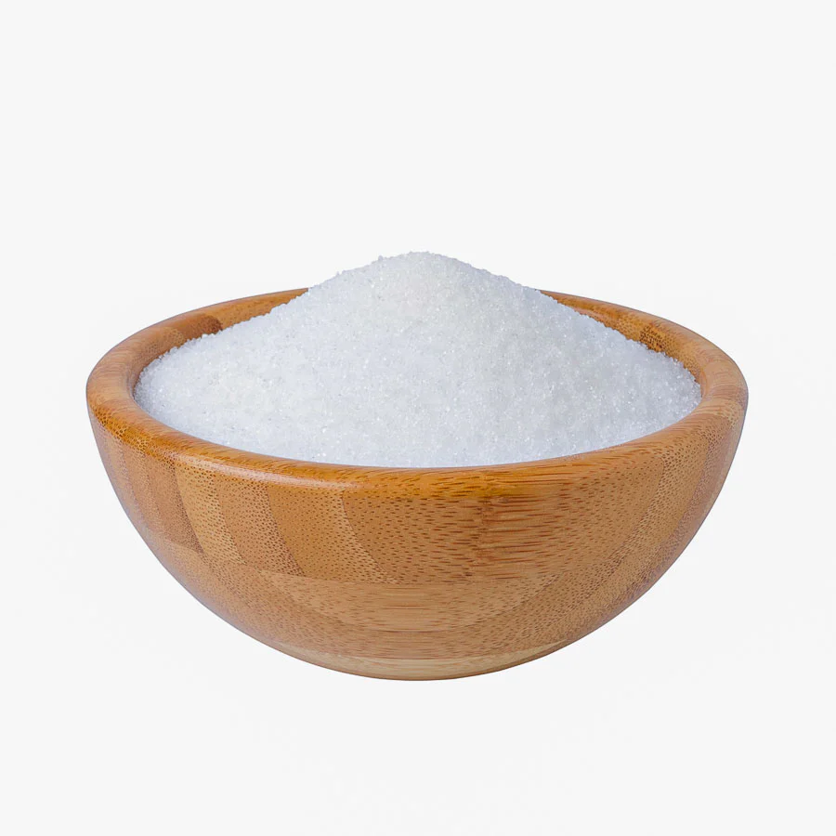 |  |  | 
_____________  sugar | ______________  bread | ______________  bottles | _____________  water
 |  |  | 
_____________  fruit | _____________  toys | _____________  butter | _____________  music

1 some

2 a little/a piece of/some

3 a few/some

4 a little/some

5 a little/a piece of/some

6 a few/some

7 a little/some

8 a little/a piece of/some

Exercise 4. Complete each second sentence using the word given, so that it has a similar meaning to the first sentence. Write no more than three words.

Dạng bài: Embedded answer
- We don't know anything about the problem. information
→ We don't _______________________________________________ about the problem.
- Is it okay if I have some cheese? bit
→ Is it okay if I have ____________________________ cheese?
- There's only a little coffee left in the jar. much
→ There ____________________________ coffee left in the jar.
- I try not to drink too much Coca-Cola in a week. cans
→ I try not to drink too ____________________________ of Coca-Cola in a week.
- Would you like some more chocolate? piece
→ Would you like ____________________________ chocolate?
- I don't want a lot of cream on my strawberries. cream
→ I only want ____________________________ on my strawberries.

1 have any information
2. a bit of
3. isn’t much/ is not much
4. many cans
5. another piece of
6. a little cream

C. Listening

Exercise 5. Read and choose the correct answer for each question

Dạng bài: Essay
- What do the diagrams show? ________________
- How could you describe the appearance? ____________
- What do the labels indicate? Try to predict the answers. ________________
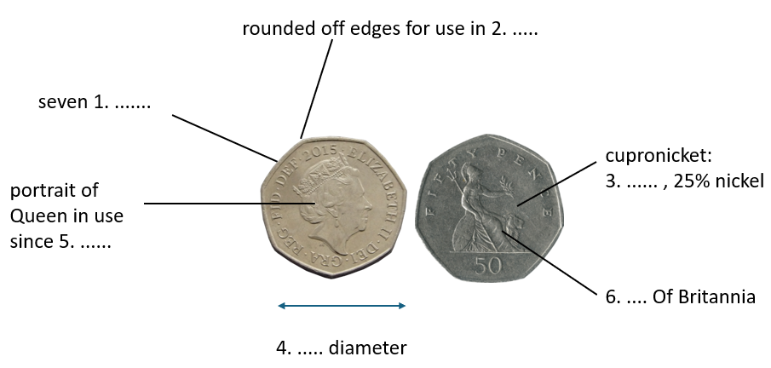
Suggested answer:
- coins (the British 50 pence piece)
- Students' own answers.

1 a feature of the coin
2 something the coin is used in
3 possibly a metal
4 a measurement
5 a date
6 a feature on the face of the coin

Exercise 6. Listen and complete the labels (1-6) using NO MORE THAN TWO WORDS OR A NUMBER in each space.

Dạng bài: Embedded answer

1 curved sides
2 vending machines
3 75% copper
4 27.5 mm
5 1998
6 seated figure

Exercise 7. Label the diagram below based on what you hear.

Dạng bài: Selecting missing words
- cacao fruit
- vat for fermenting/vat
- cacao tree
- seeds/ cocoa beans
- chocolate factory
- drying trays

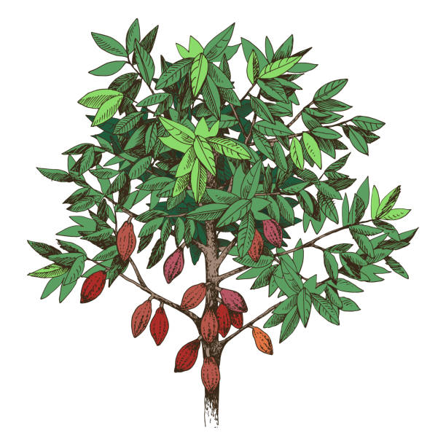  - ____________________ | 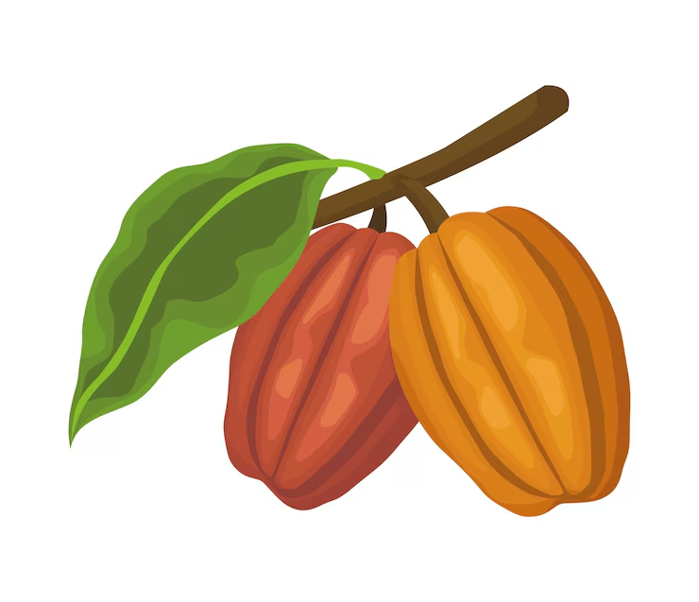  - ____________________ |   - ____________________
  - ____________________ | 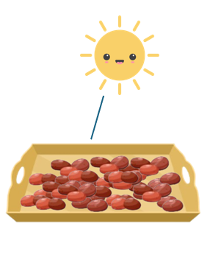  - ____________________ |   - ____________________

c 2. a 3. d 4. b 5. f 6. e

Write NO MORE THAN THREE WORDS for each answer.

7. When the fruit is ripe, it ___________.

8. Then the seeds ___________.

9. The cocoa beans are fermented in vats for ___________.

10. Then the beans ___________ in the sun.

11. The cocoa beans ___________ the factory.

12. At the factory, the cocoa beans are turned into ___________.

7. is harvested 8. are removed 9. about a week
10. dry/ are dried 11. are shipped to/sent to 12. delicious chocolate treats/ chocolate

LESSON 3

A. Vocabulary

Exercise 1. Match the job on the left with something the person uses on the right.
Dạng bài: Selecting missing words
1 lecturer | a gun
2 plumber | b wood
3 accountant | c books
4 builder | d pipes
5 soldier | e bricks
6 carpenter | f numbers

1 c 2 d 3 f 4 e 5 a 6 b

Exercise 2. Think and write a suitable job
Dạng bài: Embedded answer
Jobs | what he/she does
- ______________ | designs buildings
- ______________ | represents people with legal problems
- ______________ | plans the building of roads, bridges, machines, etc.
- ______________ | controls the financial situation of people and companies
- ______________ | teaches in a university, e.g. gives lectures
- ______________ | installs and repairs electrical things, e.g. lights
- ______________ | repairs cars when there is a problem

1. architect 2. lawyer 3. engineer 4. accountant
5. university lecturer/lecturer 6. electrician 7. mechanic

B. Grammar

Exercise 3. Choose the correct answer.
Dạng bài: Selecting missing words
1. Be careful with that vase because it's made of ___________!
- glass B. a glass
2. I started coughing because I had ____________ at the back of my throat.
- hair B. a hair
3. Don't put your hot cup on my new table! It's ____________ and I don't want you to burn it.
- wood B a wood
4. We should all recycle ____________ so that it can be used again.
- paper B. a paper
5. My dad gets ____________ every day on his way to work.
- paper B. a paper
6. Of course you can have some milk. Get _________ out of the cupboard.
- glass B. a glass

Exercise 4. Write one word in each gap.
Dạng bài: Embedded answer

Open-air markets
Even if you only have a (1) __________ money, you can still have a great time at your
local open-air market. The clothes (2) _____________ cheap, and the fruit (3) ____________ cheap, too! Often, the food in your local supermarket (4) _________ travelled a long way, but at the market you know that you're buying food which has been produced locally. The vegetables (5) ____________ fresh, even if you go late in the day when there are only a (6) ________________ left. Support your local market and help local farmers. Contact your Town Hall to find out if there are (7) _____________ open-air markets in your area.

- little 2. are 3. is 4. has 5. are 6. few 7. any

C. Listening

Exercise 5. a. Listen to the conversations. Put a check (🗸) by the frequency of the action.
Dạng bài: Selecting missing words
 | always | often | sometimes | seldom | never

1. sometimes 2. seldom 3. always
4. never 5. often 6. always

b. Listen to the conversations. Put a check (🗸) by the frequency of the action.
Dạng bài: Selecting missing words
 | daily | twice a week | once a month | every other week | from time to time
7. daily 8. once a month 9. twice a week
10. from time to time 11. once a month 12. every other week

Exercise 6. Listen to the audio and choose the correct letter, A, B or C.
Dạng bài: MCQs

Street Play Scheme

When did the Street Play Scheme first take place?

A two years ago

B three years ago

C six years ago

How often is Beechwood Road closed to traffic now?

A once a week

B on Saturdays and Sundays
C once a month

Who is responsible for closing the road?

A a council official

B the police

C local wardens

Residents who want to use their cars

A have to park in another street.

B must drive very slowly.

C need permission from a warden.

Alice says that Street Play Schemes are most needed in

A wealthy areas.

B quiet suburban areas.

C areas with heavy traffic.

What has been the reaction of residents who are not parents?

A Many of them were unhappy at first.

B They like seeing children play in the street.

C They are surprised by the lack of noise.

LESSON 4

A. Vocabulary

Exercise 1. Match the words on the left with the words on the right.
Dạng bài: Selecting missing words
set up | a. clients
in charge | b. a company
deal | c. overtime
earn | d. with complaints
do | e. of a small department
advise | f. money

1b 2 e 3 d 4 f 5 c 6 a

Exercise 2. Rewrite the sentences on the left starting with the words given. Keep a similar meaning.
Dạng bài: Essay
- What do you do? → What’s your job?
- I’m a marketing assistant. → I work __________________________.
- I’m employed by the government. → I work __________________________.
- I earn £34,000 a year from my two jobs. → My __________________________.
- What do you have to do exactly? → What does your job __________________________?
- I’m responsible for the reception area. → I’m in __________________________.
- What’s your job? → What do you do for __________________________?
- I have to read government reports. → My job involves __________________________.
- I advise clients. → I give __________________________.
- I complained about the service. → I made __________________________.

2 I work in marketing/ I work as a marketing assistant.
3 I work for the government.
4 My income is £34,000./My salary is £34,000 a year.
5 What does your job involve?
6 I’m in charge of the reception area.
7 What do you do for a living?
8 My job involves reading government reports.
9 I give advice to clients.
10 I made a complaint about the service.

B. Grammar

Exercise 3. Complete the sentences. Choose from the box.
Dạng bài: Embedded answer
a | them | pair | glasses | don’t
are | doesn’t | it | some

My eyesight is getting worse. I need glasses.

The trousers you bought for me __________ fit me.

The jacket you bought for me __________ fit me.

I need __________ scissors to cut this piece of material.

I can’t find my binoculars. Have you seen __________?

I went shopping and bought a __________ of jeans.

Where __________ my sunglasses?

I went shopping and bought __________ pair of pyjamas.

I don’t know much about politics. I’m not interested in __________.
2 don’t 3 doesn’t 4 some 5 them
6 pair 7 are 8 a 9 it

Exercise 4. Complete the sentences. Use is or isn’t, and choose from the box.
Dạng bài: Embedded answer
a lot to carry enough money too hot long enough a long time

Three years is __________ to be without a job.

Thirty degrees __________ for Tom. He doesn’t like hot weather.

Ten dollars __________ . We need more than that.

Four days __________ for a holiday. You need at least a week.

Twenty kilos __________. Are you sure you can manage?
1. is a long time 2 is too hot
3 isn’t enough money/is not enough money
4 isn’t long enough/ is not long enough 5 is a lot to carry

C. Listening

Exercise 5. Complete the notes below. Write ONE WORD AND/OR A NUMBER for each answer.
Dạng bài: Embedded answer
Flanders Conference Hotel
Example
Customer Services Manager: Angela
Date available
- weekend beginning February 4th

Conference facilities
- the 1. ___________________ room for talks
(projector and 2. ___________________ available)
- area for coffee and an 3. ___________________
- free 4. ___________________ throughout
- a standard buffet lunch costs 5 $. ___________________ per head

Accommodation
- Rooms will cost 6 $. __________________ including breakfast.

Other facilities
- The hotel also has a spa and rooftop 7. ___________________
- There's a free shuttle service to the 8. ___________________

Location
- Wilby Street (quite near the 9. ___________________)
- near to restaurants and many 10. ___________________

1. Tesia 2. microphone 3. exhibition 4. wifi 5. 45 6. 135
7. pool 8. airport 9. sea 10. clubs

Exercise 6. Listen and choose the correct letter, A, B or C.
Dạng bài: MCQs

Science experiment for Year 12 students

1. How does Clare feel about the students in her Year 12 science class?

worried that they are not making progress

challenged by their poor behaviour in class

frustrated at their lack of interest in the subject

2. How does Jake react to Clare's suggestion about an experiment based on children's diet?

He is concerned that the results might not be meaningful.

He feels some of the data might be difficult to obtain.

He suspects that the conclusions might be upsetting.

3. What problem do they agree may be involved in an experiment involving animals?

Any results may not apply to humans.

It may be complicated to get permission.

Students may not be happy about animal experiments.

4. What question do they decide the experiment should address?

Are mice capable of controlling their food intake?

Does an increase in sugar lead to health problems?

How much do supplements of different kinds affect health?

5. Clare might also consider doing another experiment involving

other types of food supplement.

different genetic strains of mice.

varying amounts of exercise.

Exercise 7. Listen and complete the note below. Write ONE WORD ANDIOR A NUMBER for each answer.
Dạng bài: Embedded answer
OCEAN RESEARCH
The Robotic Float Project
- Float is shaped like a 1. __________________
- Scientists from 2. __________________ have worked on the project so far

Listen and complete the diagram below
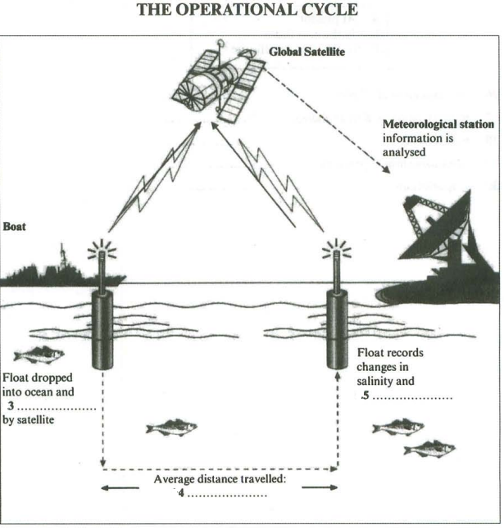
1. cigar 2. 13 countries/13 different countries 3. activated
4. 50 km/50 kms/50 kilometers/50 kilometres 5. temperature

