Lesson 1

Exercise 1:
Đề bài: People are talking about their families. Choose the correct answer. (Audio 1)
1. Stephanie would like to have ……………. .
a. brothers b. sisters c. cousins
2. Donna’s brother is a …………….. .
a. teacher b. student c. professor
3. Bob’s sister …………….. bosses him around
a. never b. sometimes c. always
4. Rosie’s friend would like to come from a …………….. family.
a. small b. big c. medium-size
5. Tina is ……………… child.
a. an only b. a lonely c. one

Exercise 2:
Đề bài: Listen. Are the sentences true (T) or false (F)? (Audio 2)
- The Beckhams’ children are all boys. ____
- David Beckham is a footballer and works for UNICEF. ____
- David’s wife, Victoria, is a fashion model. ____
- Their daughter is a model for Burberry. ____
- Brooklyn sometimes works in a shop. ____
- Louise is David’s sister. ____
- They only have houses in England and America. ____
- They all like family time at home. ____

Lesson 2

Exercise 1:
Đề bài: Listen and choose the correct answer (A, B or C) (Audio 3)
- What’s Tom doing?
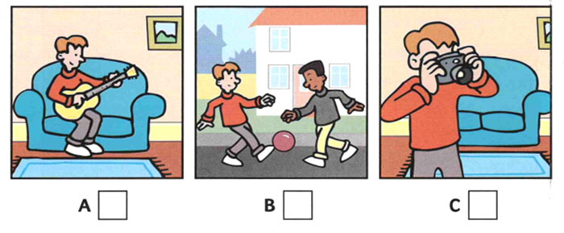
A |  | B | C
- Where’s Mummy?
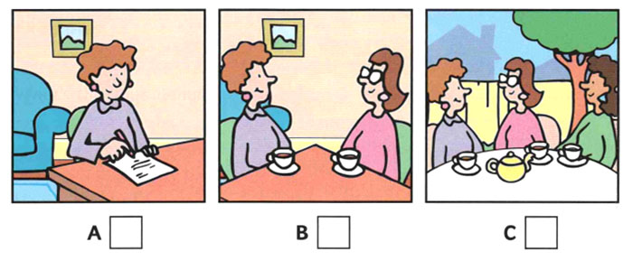
A |  | B | C
- What’s Daddy doing?
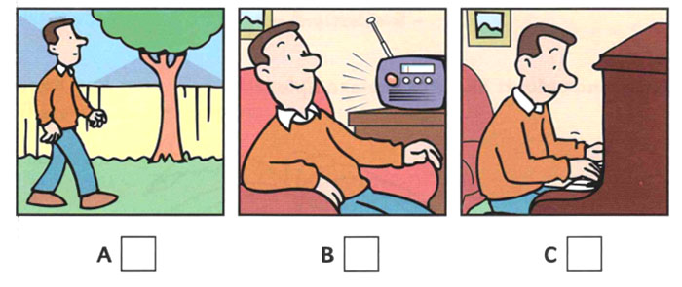
A |  | B | C
- What game are Sam and Pat playing?
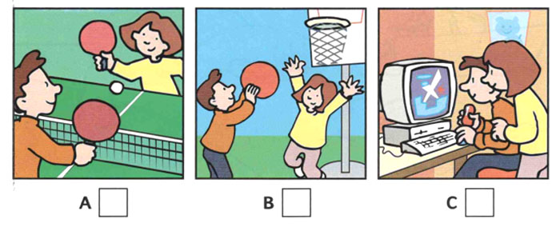
A |  | B | C
- What’s Grandfather doing?
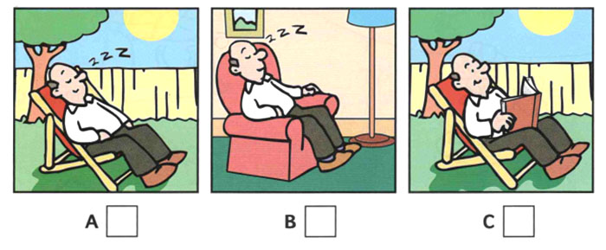
A |  | B | C

Exercise 2:
Đề bài: Read the question. Listen and write a name or a number. (Audio 4)
1. What’s the girl’s name? __________
2. How many bedrooms are in her house? __________
3. What number is on the door? __________
4. What is the name of her baby brother? __________
5. Which book is the girl reading? __________

Lesson 3

Exercise 1:
Đề bài: A man and a woman are ordering dinner at a restaurant. What does each person order? Listen and check the correct answer. (Audio 5):
 | Woman’s order | Man’s order
Appetizers
Broccoli soup | ◻ | ◻
Tomato soup | ◻ | ◻
Salad | ◻ | ◻
Main Dishes
Chicken | ◻ | ◻
Steak | ◻ | ◻
Fish | ◻ | ◻
Vegetables
Peas | ◻ | ◻
Spinach | ◻ | ◻
Carrots | ◻ | ◻
Potatoes | ◻ | ◻

Exercise 2:
Đề bài: People are talking about their dinners. What did they think of the food? Listen and write the correct letter. (Audio 6)
1. Lisa thought the peas were …….

2. John said his steak was …….

3. Carolyn said the soup was …….

4. Brad said the salad was …….

5. JoAnn said the cake was …….

a. creamy.

b. oily.

c. tough.

d. moist.

e. too soft.

Lesson 4

Exercise 1:
Đề bài: What time does each person get up and go to bed? Listen and write the times. (Audio 7)
 | gets up | goes to bed
1 Sandra | ………………… | …………………
2 John | ………………… | …………………
3 Sam | ………………… | …………………
4 Grace | ………………… | …………………
5 Mia | ………………… | …………………
6 James | ………………… | …………………

Exercise 2:
Đề bài: Listen again. Circle the correct statement. (Audio 7)
- a Sandra studies before school.
b Sandra studies at night.
- a John looks happy.
b John looks tired.
- a Sam usually goes running in the morning.
b Sam usually sleeps late in the morning.
- a Grace is a night person.
b Grace is a morning person.
- a Mia gets up early to go to work.
b Mia gets up early to take a walk.
- a James likes his new job.
b James likes working at night.

Lesson 5

Exercise 1:
Đề bài: People are calling about show times for movies. Listen and write the time you hear. (Audio 8)
1. The box office opens at ……………. .
2. The coffee bar is open from …………… to …………… .
3. The sneak preview begins at …………….. .
4. The box office closes at ……………. .

Exercise 2:
Đề bài:Listen and write ONE WORD or ONE NUMBER in each blank. (Audio 9)
THE BIRTHDAY PARTY
Day: Saturday
1 Place: The ……………………. Café
2 Number of children: ……………………………….
3 Where they sat: table ………………………
4 Food: cake, ………………………
and ice cream ……………………
5 Drinks: lemonade and ……………………juice

Lesson 6

Exercise 1:
Đề bài: Listen and write ONE WORD or ONE NUMBER in each blank. (Audio 10)
Dạng bài Embedded answer
- Which class in Sam in? ………………………
- What’s the name of Sam’s teacher? Mr ………………………
- Who sits next to Sam in class? ………………………
- How many books are in Sam’s bag? ………………………
- How old is Sam’s sister? ………………………

Exercise 2:
Đề bài: Listen and write ONE WORD or ONE NUMBER in each blank. (Audio 11)
Dạng bài Embedded answer
- What’s the name of Anna’s school? ……………………… Tree School
- How many children are in Anna’s class? ………………………
- Who sits next to Anna at school? ………………………
- What’s the name of Anna’s English teacher? ………………………
- How many monsters are in the story? ………………………

Lesson 7

Exercise 1:
Đề bài: People are talking about sports. Listen and mark T (true) if the statement is correct and F (false) if the statement is incorrect. (Audio 12)
- ____ George’s favorite sport is swimming.
- ____ Mari loves windsurfing and water-skiing.
- ____ Bill loves to play soccer these days.
- ____ Jody likes jogging, but she can’t jog now.
- ____ Joe loves watching baseball.

Exercise 2:
Đề bài: Listen to a student’s report about how young people spend their free time. Check how often people do these activities. (Audio 13)
 | Every day | Once or twice a week | Once a month
1. taking walks | ◻ | ◻ | ◻
2. playing soccer | ◻ | ◻ | ◻
3. bicycling | ◻ | ◻ | ◻
4. playing video games | ◻ | ◻ | ◻
5. watching sports on television | ◻ | ◻ | ◻

Lesson 8

Exercise 1:
Đề bài: Listen and match the people (1-8) to the pictures (a-h). (Audio 14)
a. ___ | 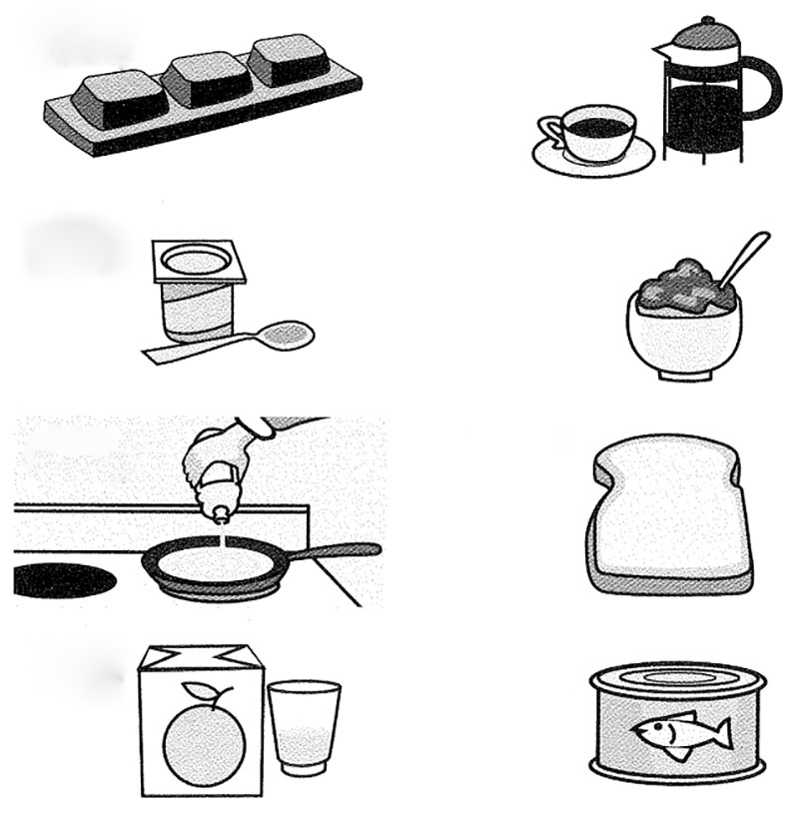 |  | b. ___
c. ___ |  |  | d. ___
e. ___ |  |  | f. ___
g. ___ |  |  | h. ___

Exercise 2:
Đề bài: Listen and choose the correct answer (A, B or C) (Audio 15)
- What’s the baby doing?
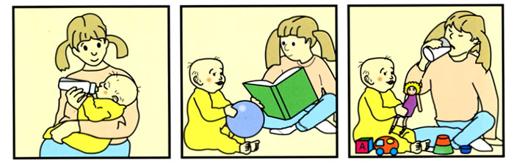
A | B | C
- What’s Nick doing?
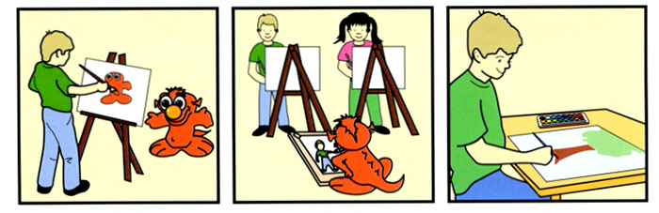
A | B | C
- What’s Mum doing?
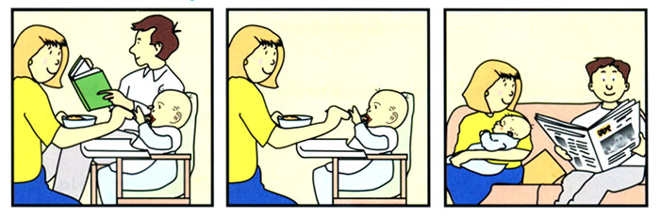
A | B | C
- What’s Tom doing?
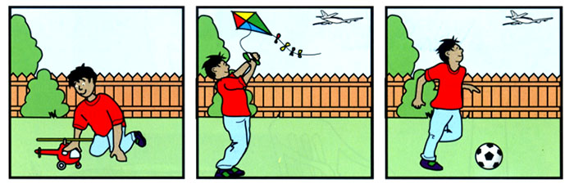
A | B | C
- Who’s playing the piano?
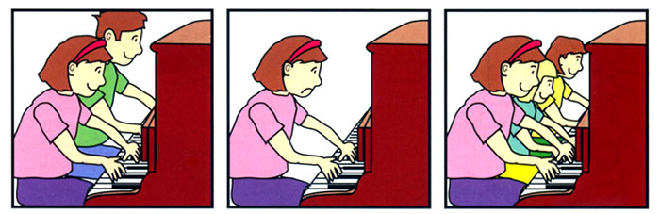
A | B | C

Lesson 9

Exercise 1:
Đề bài: Listen and choose the correct answer (A, B or C) (Audio 16)
- What’s Ann doing?
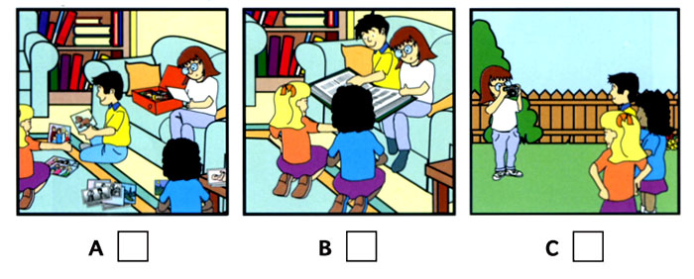
A | B | C
- Which girl is Sue?
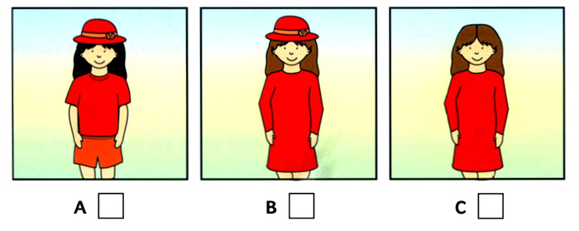
A | B | C
- What’s Nick doing?
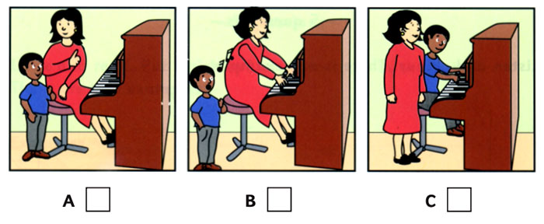
A | B | C
- What’s the cat doing?
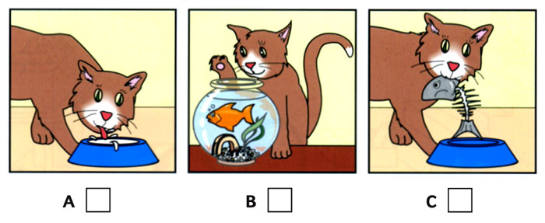
A | B | C
- What’s Mum doing?
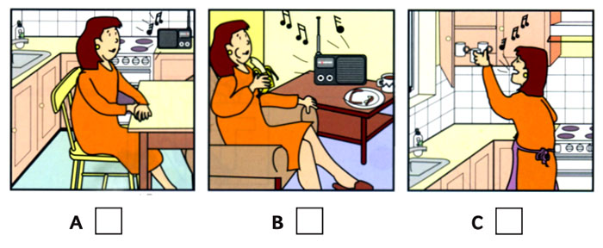
A | B | C

Exercise 2:
Đề bài: Listen and write ONE WORD or ONE NUMBER in each blank. (Audio 17)
- What’s the name of Nick’s dog? ………………………
- How old is the dog? ………………………
- Where is Nick’s flat? in ……………………… Street
- Where is Nick going now? to ……………………… Park
- What number is Nick’s bus? ………………………

