Practice Test 1

Reading Passage 1: Look at the pictures and read the story. Write some words to complete the sentences about the story. You can use 1, 2 or 3 words.
Dạng bài: quiz_type_7
Meera's Saturday
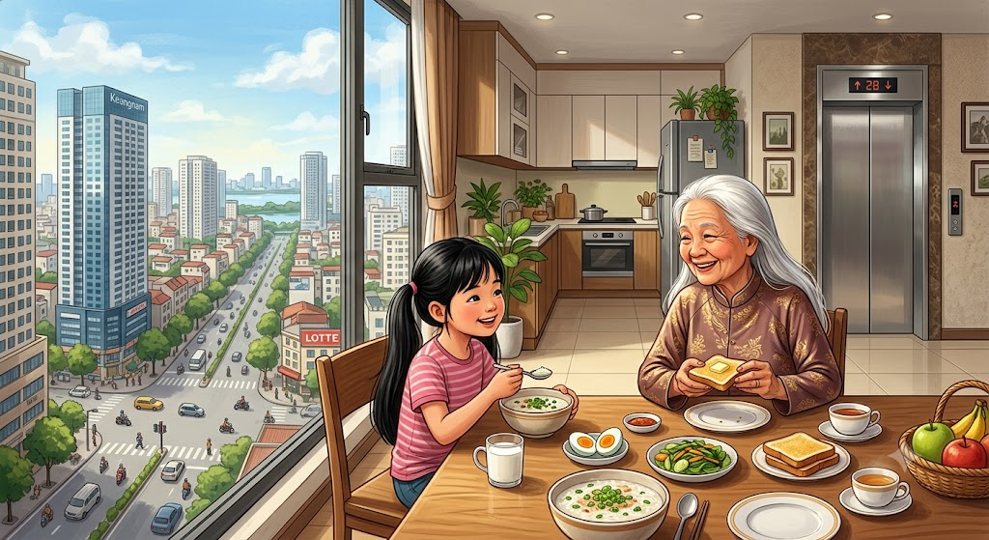
Meera lives in a block of flats in the city. Her parents and her grandmother live there too. Their flat is on the fifth floor. They never use the stairs. On Saturdays, Meera gets up at eight o'clock. Then she has breakfast with her grandmother.
Examples:
0. Meera lives in a block of flatsin the city.
0. Meera's grandmother has got long white hair
Questions:

Meera's family don't use the stairs. They go up in the ___.

On Saturdays, Meera ___ at eight o'clock.

Afterwards, she catches the bus to the park with her friend Peter. Peter has a new red kite with a long tail and shows Meera how to fly it. Peter is very good at flying kites. Meera can't do it.
Questions

Meera and Peter catch the ___.

Peter's new kite is red and it's got a ___.

Peter is very good at ___.
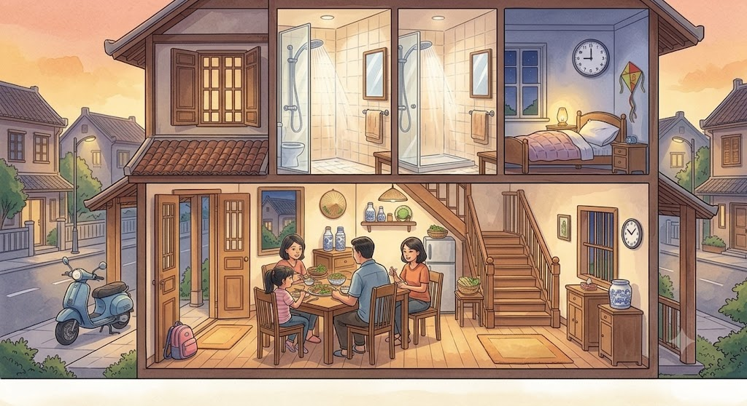
In the evening, Meera comes home, has dinner. Then she has a shower. She goes to bed at nine o'clock
Questions

After dinner, Meera has ___.

Meera goes to bed at ___.
Key
- lift
- gets up
- bus
- long tail
- flying kites / flying a kite
- a shower
- nine o'clock / 9 o'clock / nine / 9

