LISTENING

Part 1. Listen and drag the name. There is one example.
Dạng bài: quiz_type_7
Peter | Zoe | Fred | Lily | Peter | Zoe | Fred
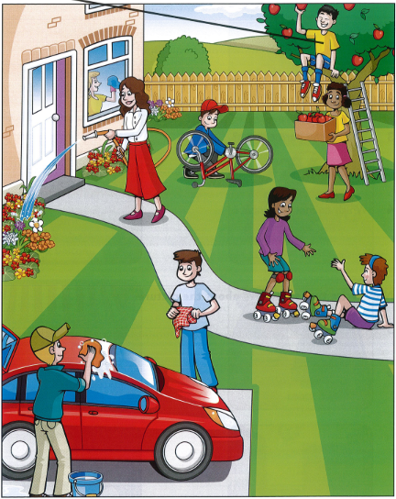

- Example: The boy up in the tree — Peter
- The woman watering plants near the window: (1) _____
- The rollerskating girl who has fallen on the ground: (2) _____
- The boy wearing a baseball cap fixing a bike: (3) _____
- The brown-haired boy drying his hands: (4) _____
- The girl under the tree holding a box: (5) _____

ĐÁP ÁN
- Zoe
- Jane
- Jack
- Charlie
- Lily

Part 2

Listen and write. There is one example.
Dạng bài: quiz_type_7

Zoe’s party

0. Day of birthday party: Saturday

1. Number of children at the party: (1) _____

2. Kind of birthday cake: (2) _____ cake

3. Kind of drinks: some (3) _____

4. Food at the party: (4) _____ with vegetables

5. After the party we: went to funfair in (5) _____

ĐÁP ÁN

14

coconut

lemonade

pasta

Batly

Part 3

Which animal does each person in Anna’s family like?

Listen and write a letter in each box. There is one example.
Dạng bài: quiz_type_7
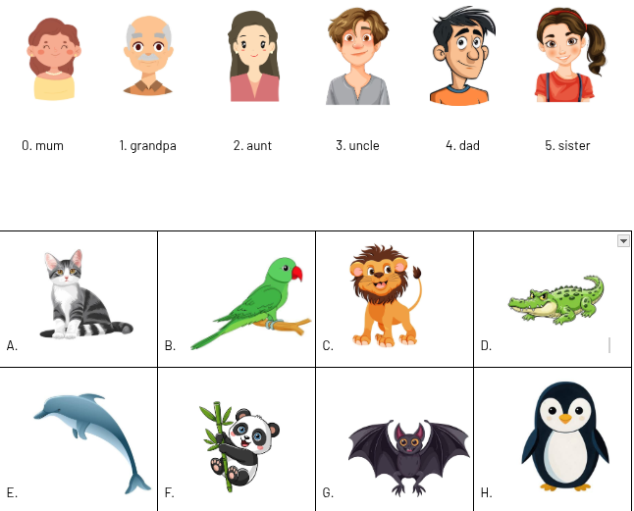
- grandpa: (1) _____
- aunt: (2) _____
- uncle: (3) _____
- dad: (4) _____
- sister: (5) _____

ĐÁP ÁN
- E
- A
- F
- H
- G

Part 4

Listen and choose the correct answer. There is one example.
Dạng bài: quiz_type_1
0. What was the matter with Tom yesterday?
A.   | B.  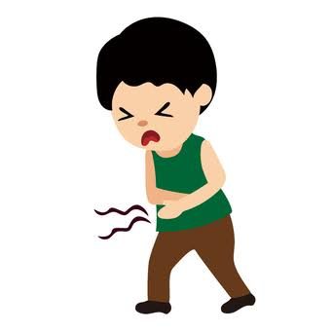 | C.  
- Which man is Lily’s dad?
A.  | B.   | C. 
- What did Peter see first at the zoo?
A.   | B.  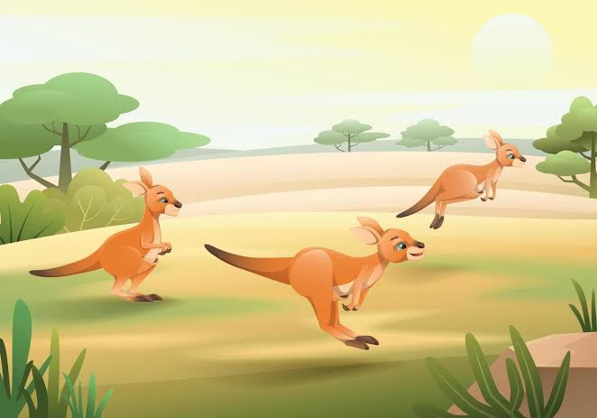 | C.  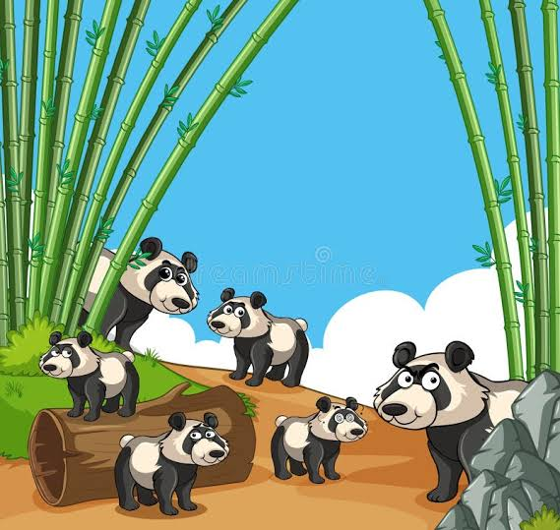
- Where is Lucy’s comic?
A.  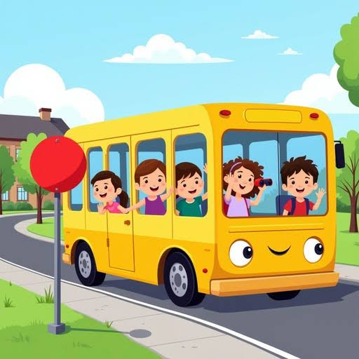 | B.  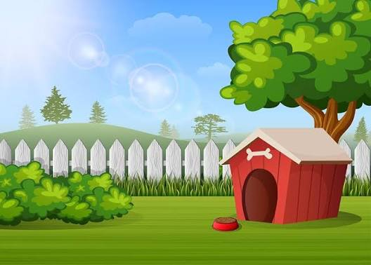 | C.  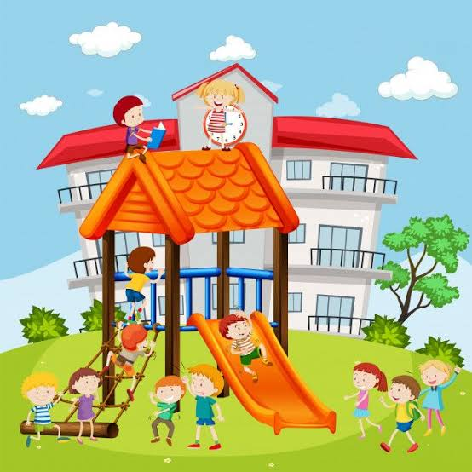
- What is in the picnic box?
A.  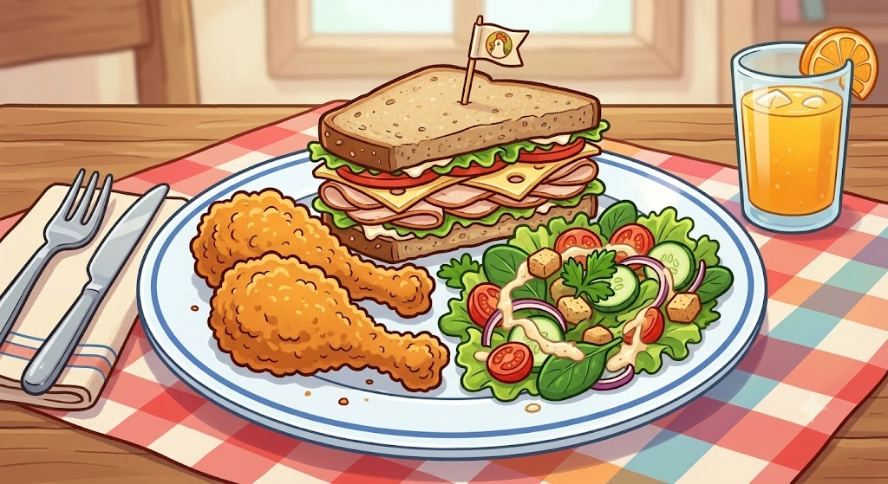 | B.   | C.  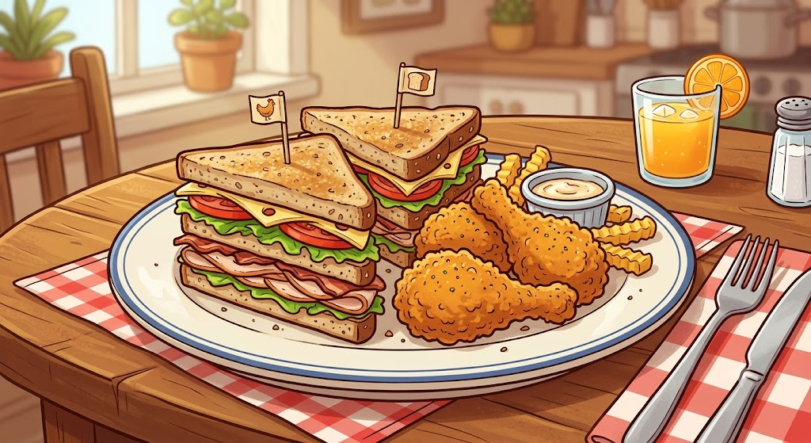
- Why are the girls laughing?
A.   | B.   | C.  

Part 5

Listen and write a colour or a message. There is one example.
Dạng bài: quiz_type_7
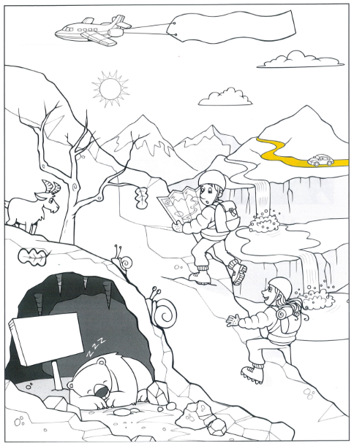

0. The road: Yellow

1. The map that the boy's holding: (1) _____

2. The girl's helmet: (2) _____

3. The plane's message: (3) _____

4. The snail with the bigger shell: (4) _____

5. The leaf on the tree: (5) _____

ĐÁP ÁN

pink

green

SUNNY

orange

purple

VOCABULARY & GRAMMAR

Part 1

Look and read. Choose the correct words and write them on the lines. There is one example.
Dạng bài: quiz_type_7
  a snowboard |   a farmer | 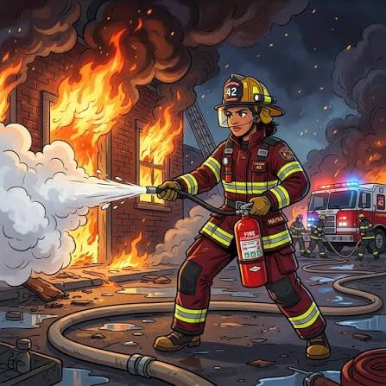  a firefighter |   a helmet
  a rainbow |   a scarf | 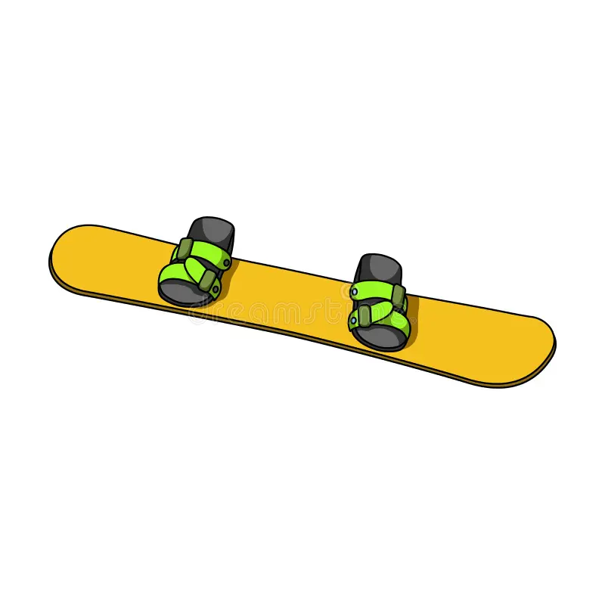  a snowboard |   a swimsuit
Example: You wear this on your head when you ride a bike a helmet
Questions:
- This person works outside with animals and plants. (1) _____
- You wear this when you go swimming. (2) _____
- You can see this in the sky after the rain. It has got a lot of colours. (3) _____
- You stand on this and go down a mountain in the snow. (4) _____
- You wear this around your neck when the weather is cold. (5) _____

ĐÁP ÁN
- a farmer
- a swimsuit
- a rainbow
- a snowboard
- a scarf

Part 2

Read the text. Choose the right words. There is one example.
Dạng bài: quiz_type_14
Roller skating

Every Saturday, my sister Mary and I go to the sports centre in our town. It’s a big building (0) …………… is next to the library. The sports centre is a place (1) …………… children can learn a lot of different sports. Our teacher is called Clarence. He skates very (2) …………… and all the children like him. My first lesson (3) …………… very difficult, but now I can skate quickly. Mary is better than me because she (4) …………… skate for two hours! We always have (5) …………… wear a helmet, because we mustn’t hurt our arms and legs.
Example: | - who | - which | - where
1. | - who | - which | - where
2. | - good | - well | - best
3. | - was | - were | - is
4. | - can | - must | - has
5. | - to | - for | - at

READING & WRITING

Part 1

– 6 questions –

Read the text and choose the best answer.
Dạng bài: quiz_type_1
Example
Alex: What’s the weather like today, Lenny?
Lenny:
- It’s cold and windy.
- It was sunny yesterday.
- I don’t like rain.
Questions
1. Alex: Shall we go ice skating this afternoon?
Lenny:
- Yes, I am.
- Great idea!
- I’m skating now.
2. Alex: Can you skate well?
Lenny:
- No, I can’t.
- No, I haven’t.
- No, it isn’t.
3. Alex: Is ice skating difficult?
Lenny:
- A. Yes, I am.
- At the sports centre.
- No, it's easy.
4. Alex: What do you have to wear?
Lenny:
- I’ve got a helmet.
- In my sports bag.
- A helmet and old boots.
5. Alex: Why do you like ice skating?
Lenny:
- Because it's exciting.
- Yes, I like it.
- At the sports centre.
6. Alex: I must go home now. My mum is waiting for me.
Lenny:
- OK, she's at home.
- OK, see you on Saturday!
- OK, I'm going there.

Part 2:

– 6 questions –

Read the story. Choose a word from the box. Write the correct word next to numbers 1–5. There is one example.
Dạng bài: quiz_type_7
It's Sports Day at Peter's school. In the morning, the weather is terrible.
It's cold and it's raining, so all the children are inside.
At twelve o'clock, their teacher, Mr Frank, looks out of the window. 'Come here, children!' he says. 'Look at the sky! It's (1) _____ now. Let's go outside!'
First, all the children play a game. They have to hop on one leg from the school door to the big tree. May is the (2) _____ girl in the class, so she wins.
After that, Peter and his friends are (3) _____ . Peter is very good at this because he does it every day at home.
'Be (4) _____, children! Don't fall!' says Mr Frank.
'I love Sports Day!' says Peter. 'It's (5) _____!'
Example:    terrible |   boring |   exciting
  hop | 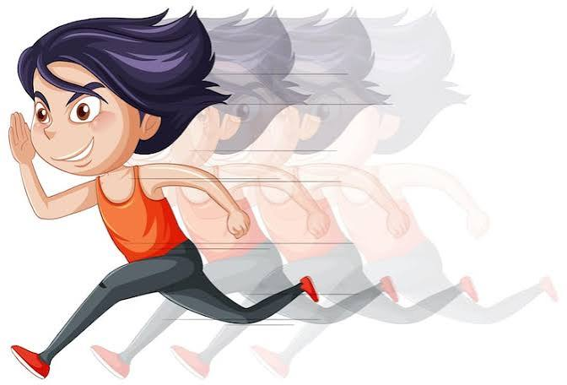  quickest | 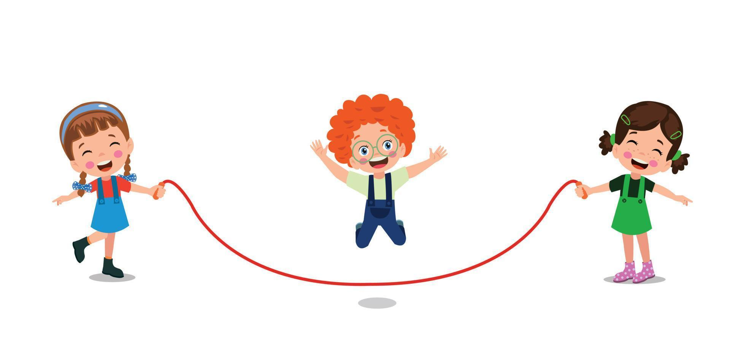  skipping
  snowing |   sunny |   careful
Now choose the best name for the story. Write A, B, or C: (6) _____
- A. Peter’s new teacher
- B. A day of sports at school
- C. May’s birthday party

ĐÁP ÁN
- sunny
- quickest
- skipping
- careful
- exciting
- B

Part 3:

Look at the pictures and read the story. Write some words to complete the sentences about the story. You can use 1, 2 or 3 words
Dạng bài: quiz_type_7
A day at the activity centre
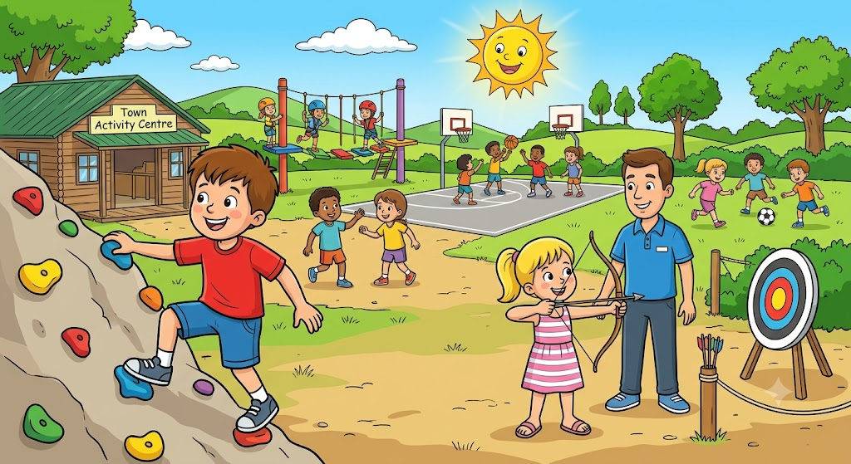
Today Jim and his sister Sophia are at the activity centre near their town. An activity centre is a place where children can learn new sports. Yesterday it was cold and wet, but today the weather is hot and dry.
Examples:
0. Jim is at the activity centre with his sister Sophia
0. Yesterday the weather was cold and wet
Questions:
- Children go to an activity centre to learn (1) _____.
- Today the weather is hot and (2) _____.
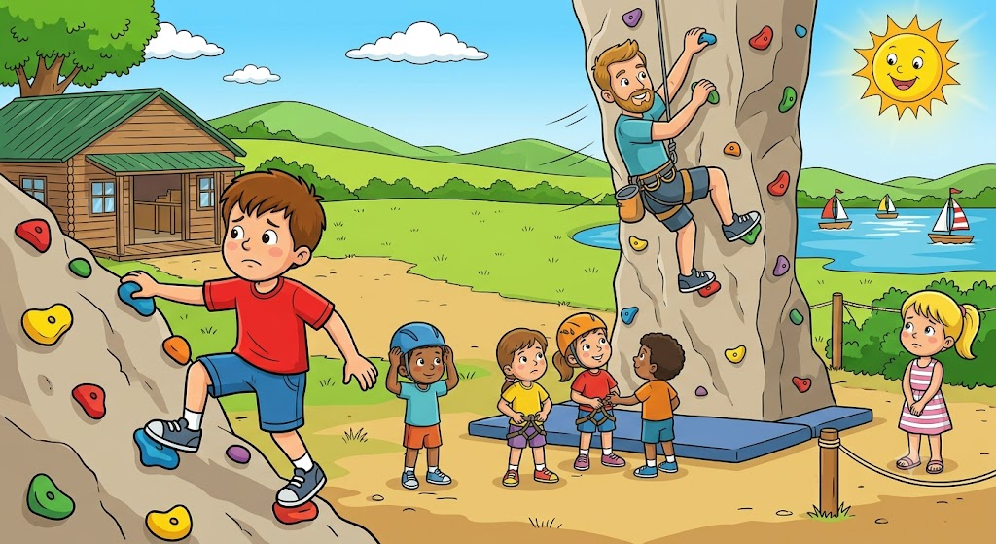
First, the children learn to climb. Their teacher is called Mr Charlie. He climbs the wall very quickly, but Jim climbs slowly because he is careful. Sophia doesn't want to climb. She wants to go sailing on the lake.
Questions:
- First, the children learn to (3) _____.
- Jim climbs the wall (4) _____.
- Sophia wants to go (5) _____.

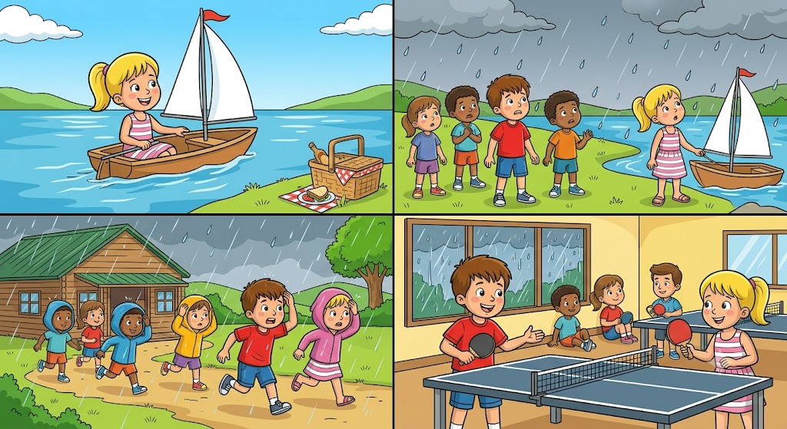
After lunch, Sophia sails her boat very well. Then the sky is grey and it starts to rain, so all the children run inside. 'Let's play table tennis!' says Jim.
Questions:
Sophia sails her boat (6) _____.
When it rains, the children go inside and play (7) _____.

ĐÁP ÁN
- sports
- sunny
- climb
- slowly
- sailing
- well
- table tennis

Part 4

– 4 questions –

Look and read and write.
Dạng bài: quiz_type_7
A windy day in the park
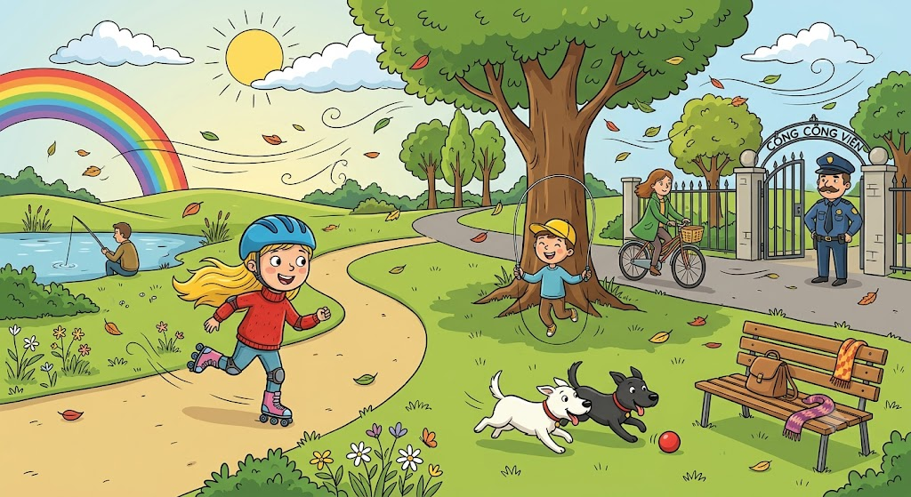
Examples:
0. The girl on the roller skates is wearing a blue helmet
0. What’s the boy under the tree doing? He’s skipping
Complete the sentences.:
- The woman on the bike is wearing a green (1) _____.
- One dog is white and one dog is (2) _____.
Answer the questions:
What’s the man next to the lake doing? (3) _____
Where are the bag and the scarf? (4) _____

ĐÁP ÁN
- coat
- black
- He’s fishing.
- On the seat.

Part 5

– 2 questions –

Now write two sentences about the picture.

Dạng bài: quiz_type_7

A windy day in the park
- ___
- ___
key:
- There is a rainbow in the sky.
- The dogs are playing with a red ball

