LESSON 1

A. Vocabulary

Exercise 1. Choose the correct preposition in each sentence
Dạng bài: quiz_type_7
- There has been a slight rise (1) ___ (in / of / to) the number of men employed.
- Experts expect there to be a fall (2) ___ (by / of / in) approximately 30% over the next decade.
- The introduction of DVDs has led to a decline (3) ___ (of / in / to) video sales.
- We have seen an increase (4) ___ (by / of / in) only 0.5% during the past year.
- Researchers observed changes (5) ___ (of / to / in) educational levels.
- The survey hopes to track trends (6) ___ (for / in / to) consumer spending.
- The health service spent a total (7) ___ (in / of / at) £2.5 billion on staffing last year.
- The new figures show a drop of 5% (8) ___ (in / of / to) student numbers.

ĐÁP ÁN

in

of

in

of

in

in

of

in

Exercise 2. Rewrite the sentences below using the noun form of the underlined verb
Dạng bài: quiz_type_7
- Example:
0. The graph shows that sales have fallen by 8%.
➜ The graph shows a fall of 8% in sales.
- We hope to reduce the number of injuries by 25%.
➜ We hope to achieve a (1) ___ .
- The availability of this treatment varies a great deal from one region to another.
➜ There is (2) ___ .
- House prices have risen by 40% in the past five years.
➜ In the past five years, there has been (3) ___ .
- Daytime temperatures can peak at around 30°C in summer.
➜ Daytime temperatures can (4) ___ .
- The new principal is promising to improve computer access for students.
➜ The new principal is promising (5) ___ .
- We need to invest more money in staff training.
➜ There needs to be (6) ___ .

ĐÁP ÁN
- reduction of 25% in the number of injuries (hoặc: reduction of 25% in injuries / 25% reduction in the number of injuries / 25% reduction in injuries)
- a great deal of variation in the availability of this treatment from one region to another
- a rise of 40% in house prices (hoặc: a 40% rise in house prices)
- reach a peak of around 30°C in summer
- to make improvements in computer access for students (hoặc: improvements in computer access for students)
- more investment in staff training (hoặc: greater investment in staff training)

B. Grammar

Exercise 3. Read the sentences then choose the correct answer
Dạng bài: quiz_type_14
- We (1) ___ (had been making / made) chicken soup so the kitchen was still hot and steamy when she (2) ___ (has been coming / came) in.
- Jenny Fisher (3) ___ (won / had won) her first gold medal in 2004. She (4) ___ (had won / won) two silver medals in previous Olympics, but this was her first gold.
- I (5) ___ (thought / had been thinking) about that before you (6) ___ (mentioned / had been mentioning) it.
- They (7) ___ (didn’t know / hadn’t known) where to meet because nobody (8) ___ (told / had told) them.
- He (9) ___ (was / has been) so active and sporty at university. But after the accident he (10) ___ (has never been / was never) the same.
- When she (11) ___ (arrived / had arrived) in the morning, we (12) ___ (had started / started) work.
- Yesterday Jack (13) ___ (has told / told) me that he would be here today, but he isn’t here. He (14) ___ (was / has been) away all day.

ĐÁP ÁN
- had been making
- came
- won
- had won
- had been thinking
- mentioned
- didn’t know
- had told
- was
- has never been
- arrived
- had started
- told
- has been

Exercise 4. Complete each paragraph with one set of verbs, using the present perfect or past simple
Dạng bài: quiz_type_7
have/not come/tell | become/have/hear | know/meet/start

- I (1) ___ Laura Palmer since we both (2) ___ work on the same day at Thames College about five years ago. She is one of the smartest people I (3) ___ ever (4) ___.
- (5) ___ you (6) ___ the good news yet? Jenny and Michael (7) ___ just (8) ___ parents! Jenny (9) ___ a baby girl last night.
- The plumber (10) ___ me this morning, 'I'll be back to finish the work as soon as I (11) ___ some lunch.' But now it's past three o'clock and he still (12) ___ back.

ĐÁP ÁN
- 've known / have known
- started
- have / 've
- met
- Have
- heard
- have
- become
- had
- told
- have had / 've had
- hasn't come / has not come

Exercise 5. Match the verbs in the box to definitions 1-10. Some words can be used more than once
Dạng bài: quiz_type_7
add | modernize | replace | expand | renovate | develop
remove | extend | reconstruct | improve | reduce

- make something bigger: ______________
- make something new again: ______________
- make something modern: ______________
- take something away and put something else in its place: ______________
- make something better: ______________
- make something smaller: ______________
- build several buildings in an area where there was nothing: ______________
- put in something totally new: ______________
- take something away: ______________
- build something again: ______________
Key:
- extend / expand
- renovate / modernise
- modernise / renovate
- replace
- improve
- reduce
- develop
- add
- remove
- reconstruct

Exercise 6. Look at the pictures then complete the sentences with the correct feature
Dạng bài: quiz_type_7
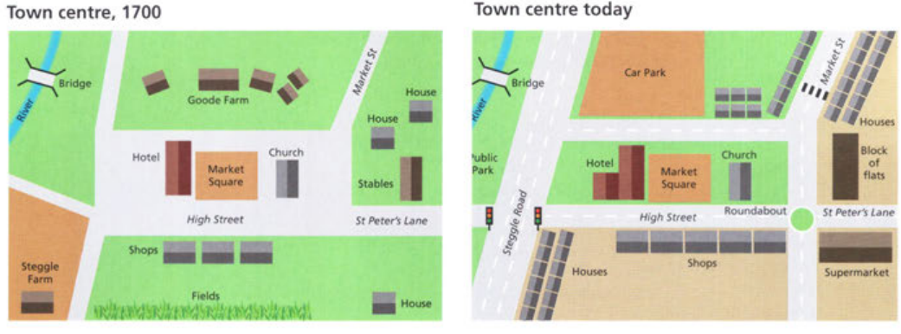
- The ______________ , which is right in the centre of the town, has not changed in 300 years.
- According to the 1700s map, there was a ______________ in the bottom right-hand corner.
- Another feature that has remained the same is the ______________ located in the centre, to the right of the market square.
- The row of ______________ that can be seen in the bottom centre of both maps, has changed little over the years.
Key:
- market square
- house
- church
- shops

Exercise 7. Complete the sentences with the correct location
Dạng bài: quiz_type_14

top left-hand corner of | in the bottom left-hand corner
on the right-hand side of/to the right of | the left of

- Steggle Farm, which can be seen ______________ of the 1700s map, is no longer there.
- To ______________ the market square is the hotel, which has changed considerably over the years.
- In the ______________ both maps, there is a bridge.
- In the 1700s map, there were stables located ______________ the church.
Key:
- in the bottom left-hand corner
- the left of
- top left-hand corner of
- on the right-hand side of/to the right of

C. Writing

Exercise 8. You should spend about 20 minutes on this task. Write at least 150 words

Dạng bài: quiz_type_0

Easy IELTS - Task 1 - 20

The maps show the village of Pebbleton 20 years ago and now.

Summarise the information by selecting and reporting the main features, and make comparisons where relevant.

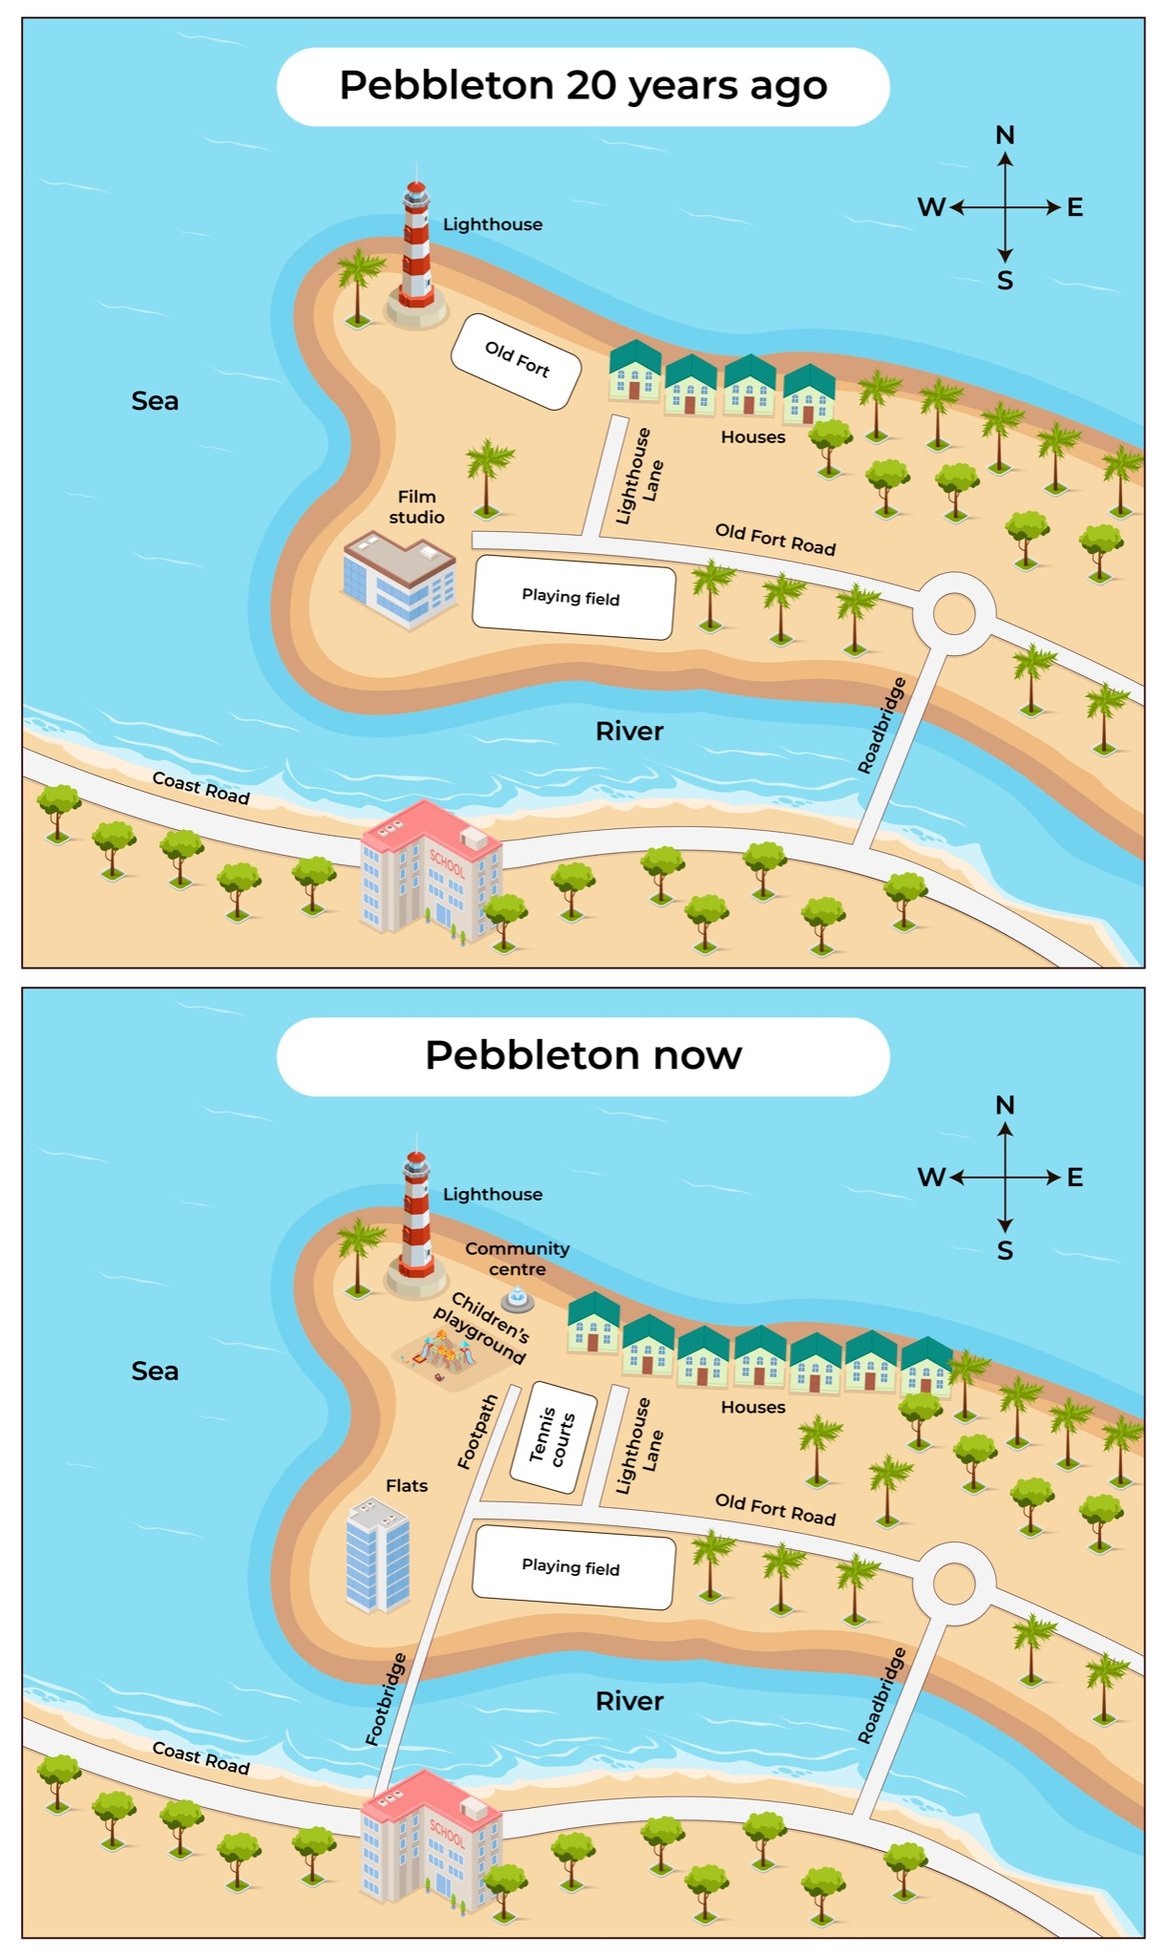

Model Answer

The two maps depict the transformations that took place in Pebbleton village over a span of 20 years. In general, it is evident that the most notable alterations include the addition of residential buildings and various amenities such as pedestrian access, tennis courts, and a community centre. Furthermore, the old fort was replaced with a playground for children.

On the western side of the village, although the lighthouse remains unaltered, there have been changes recorded, such as the substitution of the old fort with a children's playground and the replacement of the film studio with a residential flat. Additionally, a footbridge has been constructed across the river, connecting the coast road to the old fort road. This bridge significantly improves access to the school in the southern area. Furthermore, new facilities were added to the western region, including a footpath at the end of the footbridge and a tennis court positioned in the middle of the footpath and Lighthouse lane.

In the northern part of the map, there were only a few houses at the end of Lighthouse lane two decades ago. However, the current number of houses has nearly doubled. Additionally, a new community centre was built near the residential area. As for the eastern side, it seems that no changes have been made to the existing structures, such as the old fort road, the playing field, and the roadbridge.

(231 words)

LESSON 2

A. Vocabulary

Exercise 1. Put the words in the box in the correct column below
Dạng bài: quiz_type_7
dramatically | jump | halve | rapid | plummet
downturn | trough | steep | peak | slump
gradually | sharp | soar | surge | steady
boost | gain | shrink | rocket | diminish

Words to describe a movement or trend upwards (nouns and verbs):

(1) ___

(2) ___

(3) ___

(4) ___

(5) ___

(6) ___

(7) ___

Words to describe a movement or trend downwards (nouns and verbs):

8. (8) ___

9. (9) ___

10. (10) ___

11. (11) ___

12. (12) ___

13. (13) ___

14. (14) ___

Words to describe a slow change (adjectives and adverbs):

15. (15) ___

16. (16) ___

Words to describe a fast change (adjectives and adverbs):

17. (17) ___

18. (18) ___

19. (19) ___

20. (20) ___

ĐÁP ÁN

boost

jump

gain

soar

peak

surge

rocket

downturn

trough

halve

shrink

plummet

slump

diminish

gradually

steady

dramatically

sharp

steep

rapid

Exercise 2: Look at the following sentences. If a sentence is grammatically correct, select 'True'. If a sentence is grammatically incorrect, select 'False'.
Dạng bài: quiz_type_14
1. There was a slight rising in the cost of fuel at the beginning of winter. | True/False
2. In October, the number of tourists was a plummet. | True/False
3. The price of cat food surged from $1.50 to $2.00 a can in late 2010. | True/False
4. Next year it is projected that the numbers of people using social media will fall gradual. | True/False
5. The price of oil dropped steadily towards the end of the decade. | True/False
6. The percentage of people travelling to work by bus increased dramatic from 11% to 23% while the percentage using cars dropped slightly to 18%. | True/False
7. The stock price of the tech company rocketed after the announcement of their new product. | True/False

B. Grammar

Exercise 3. Put these verbs in the past perfect or past simple
Dạng bài: quiz_type_7
- He (1) ___ (need) the money last week, so I (2) ___ (give) it to him then.
- You (3) ___ (say) during the meeting that you (4) ___ (talk) about that already.
- When he (5) ___ (come) back later, they still (6) ___ (finish) writing their reports.
- Ashley could have done much better if she (7) ___ (work) harder.
- After she (8) ___ (wash) the curtains, she (9) ___ (clean) the windows.
- He (10) ___ (ask) me for her telephone number before he (11) ___ (phone) her.

ĐÁP ÁN
- needed
- gave
- said
- had talked
- came
- hadn’t finished
- had worked
- had washed
- cleaned
- had asked
- phoned

Exercise 4. Complete the text with these verbs
Dạng bài: quiz_type_7
explained | have gone | hadn’t eaten | was (X2) | didn’t eat | had cooked
went | have ever heard | hadn’t even locked | were | didn’t lock | had just reached

One of the four-year-olds in the reading group suddenly said, ‘This is the silliest story I (1) __________________’. I (2) _________________ in the middle of reading Goldilocks and the Three Bears to the group. We (3) __________________ the part in the story where Goldilocks goes into the bears' house and eats some of the food from bowls on the table.
'Where (4) _________________ the bears?' he asked.
'Maybe outside or playing in the woods,' I suggested.
'And their house was wide open? They (5) _________________ the door before going out?'
'Well, in the old days, people (6) _________________ their doors.’
'And their food was on the table, but they (7) _________________ it before they (8) _________________ outside?'
'Maybe they (9) _________________ it because it (10) _________________ too hot.’
'If you (11) _________________ that meal, you wouldn't (12) _________________ out and left it, would you?
'Probably not, but it's just a story,' I (13) _________________ rather weakly.
Key:
- have ever heard
- was
- had just reached
- were
- hadn’t even locked
- didn’t lock
- hadn’t eaten
- went
- didn’t eat
- was
- had cooked
- have gone
- explained

Exercise 5. Look at the maps below and choose the correct answer
Dạng bài: quiz_type_7
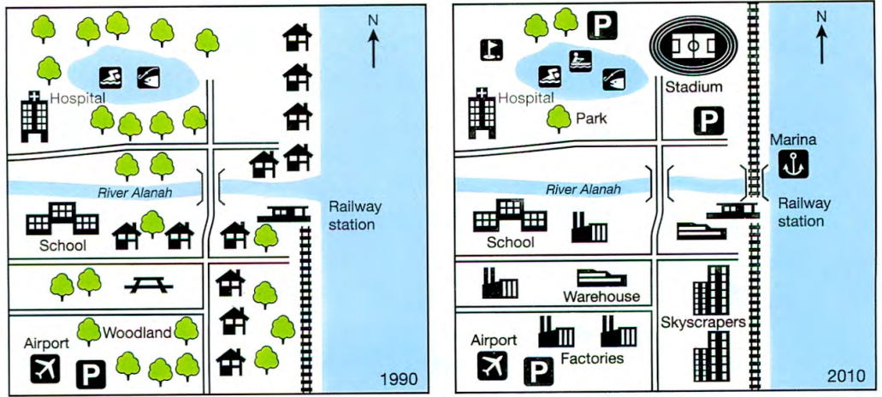

south of the river | north of the skyscrapers | south west of the stadium | just to the north of the river mouth
in the south-west of the town | to the south of the golf course | in the north-east of the town

- Where is the lake? It is _____________________ .
- Where is the hospital? It is _____________________ .
- Where is the railway station? It is _____________________ .
- Where is the airport? It is _____________________ .
- Where is the school? It is _____________________ .
- Where is the stadium? It is _____________________ .
- Where is the marina? It is _____________________ .
Key:
- south west of the stadium
- to the south of the golf course
- north of the skyscrapers
- in the south-west of the town
- south of the river
- in the north-east of the town
- just to the north of the river mouth

Exercise 6. Look at the map again then complete the text below. The first one has been done for you
The maps below show changes that took place in Youngsville in New Zealand over a 20-year period from 1990 to 2010.
Dạng bài: quiz_type_7

houses | noticeable | developments | residential | facilities
experienced | factories | comparison | corner | construction

The maps show the (1) developments which took place in the coastal town of
Youngsville between 1990 and 2010.
In 1990, the town was a much greener (2) ______________ area with a large
number of trees and individual houses, but during the next 20 years the town
(3) ______________ a number of dramatic changes. The most (4) ______________ is that all of the trees south of the River Alanah were cut down, with all the (5) ______________ along the railway line being knocked down and replaced by skyscrapers. Moreover, a new industrial estate with (6) ______________ and warehouses sprang up around the airport and school.
Only a few trees north of the river remained. The woodland was cleared to make way for a park, a golf course and car parking (7) ______________. Further developments were the (8) ______________ of a stadium near the north-east (9) ______________ of the lake and a new stretch of railway from the river running directly north. A marina was also built at the mouth of the river.
Overall, a (10) ______________ of the two maps reveals a change from a largely
rural to a mainly urban landscape.

Key:
2. residential
3,. experienced
4. noticeable
5. houses
6. factories
7. facilities
8. construction
9. corner
10. comparison

C. Writing

Exercise 7. You should spend about 20 minutes on this task.​ Write at least 150 words.

The maps illustrate an industrial area in Norbiton in the present day compared with plans for future development of the site.

Dạng bài: quiz_type_0

Easy IELTS - Task 1 - 20

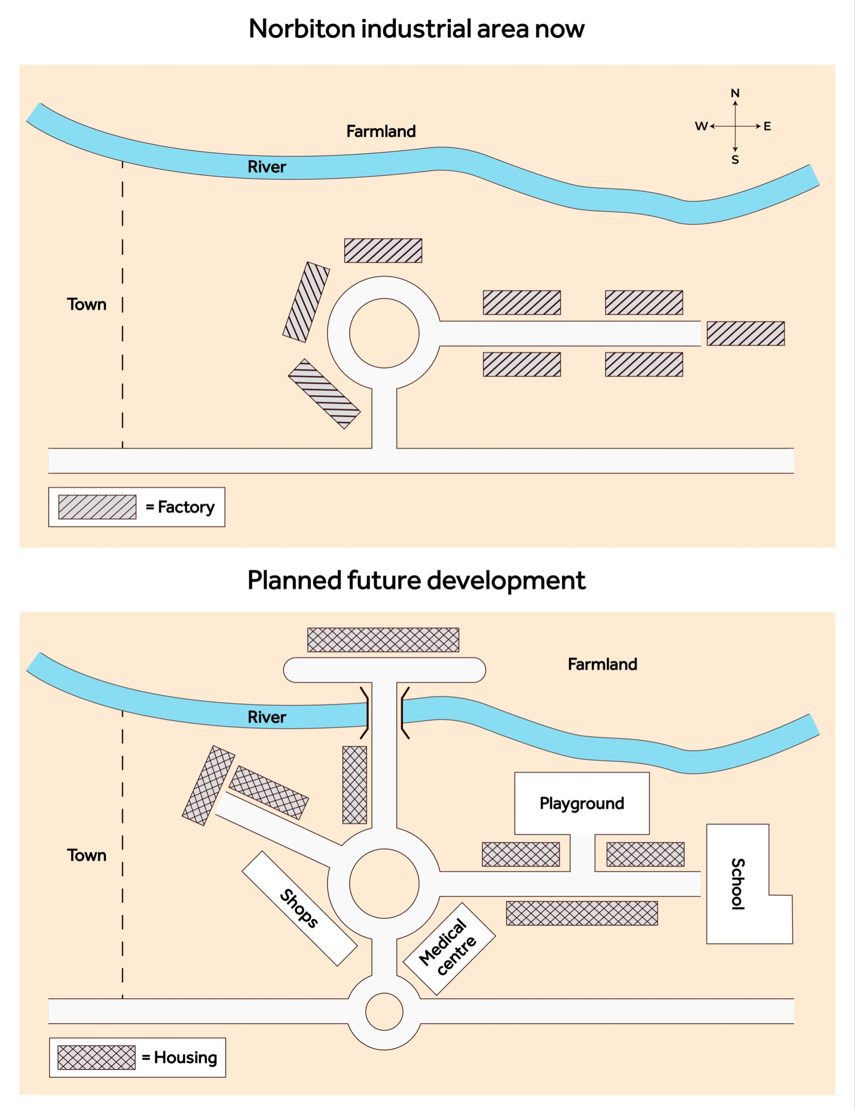

Model Answer

The provided maps illustrate the current state of Norbiton and the proposed development plans for the future.

Overall, the town will undergo a transformation from being predominantly industrial to primarily residential, with the introduction of housing, schools, shopping centres, and medical facilities. This development will mostly occur in the western and northern parts of the town, leaving only a small portion of farmland unaffected.

Currently, the town features a central roundabout surrounded by factories, along with a west-to-east road leading out of Norbiton. In the future, the roundabout will remain, but the surrounding industrial areas will be converted into stores. New residential areas will be constructed along a northwestern route, and a new hospital is planned to be built in the southeast. The original road extending eastward will be lined with houses on both sides. Furthermore, a large playground will be established to the north, and a school will be situated at the eastern border of the town.

Outside the town centre, there are also proposals for a smaller roundabout in the southern region, intersecting an existing roadway. Additionally, a bridge will be constructed across the river in the northern part of Norbiton. Some farmland to the north will be replaced with residential buildings, but there are no planned changes for the eastern area, which will remain unchanged.

(218 words)

LESSON 3

A. Vocabulary
Exercise 1. Read the monologue and write all the discourse markers.
Dạng bài: quiz_type_7
Well, where shall I start? It was last summer and we were just sitting in the garden, sort of doing nothing much. Anyway, I looked up and you see, we have this, kind of, long wall at the end of the garden, and it's like a motorway for cats. That big fat black one you saw, well, that one considers it has a right of way over our vegetable patch, so ... where was I? I was looking at that wall, you know, daydreaming as usual, and all of a sudden there was this new cat I'd never seen before. It wasn't an ordinary cat at all ... I mean, you'll never believe what it was ...
Discourse markers: ___; ___; ___; ___; ___; ___; ___; ___; ___.
Key:
- Well
- sort of
- Anyway
- you see
- kind of
- like
- well
- you know
- I mean

Exercise 2. Here are some short dialogues where there are no discourse markers, which would be unusual in real informal conversation. Use markers from the box to fill the gaps. You can use the markers more than once, and more than one answer may be possible.
Dạng bài: quiz_type_7

I mean | Well | Right | Listen | Anyway
Good | Hang on | Let me see | Still | You know

- A: Are you a football fan?
B: (1) ______________ , I like it but I wouldn't say I was a fan.

- A: I'll take care of these.
B: (2) ______________ . That's everything.
A: (3) ______________ , see you next week.
B: (4) ______________ . That was a very useful meeting.

- A: It was last Monday. I was coming home from work. I saw this funny old man approaching me. I stopped him ...
B: I bet it was Jim Dibble!
A: (5)______________ ! Let me tell you what happened first.

- A: Which number is yours?
B: (6)______________ … it's that one there, yes, that one.

- A: He's looking exhausted.
B: Really?
A: (7) ______________ , look at his eyes - he looks so tired.

- A: What do you mean, 'cold'?
B: (8) ______________ , she's not friendly, very distant. Last week I gave her a nice smile and she scowled at me.
A: (9) ______________, what do you expect? I've seen the way you smile at people; it puts them off.

- A: Money isn't the most important thing in life.
B: (10) ______________ , you can't live without it!
A: I suppose that's true.

- A: What are we going to do?
B: (11) ______________ , I got an idea. Why don't we ask James to help? He's a lawyer.
Key:
- Well
- Right / Good
- Right / Good / Anyway
- Right / Good
- Hang on
- Let me see
- I mean
- Well / You know / I mean
- Well
- Still
- Listen

B. Grammar

Exercise 3. Complete each paragraph with one set of verbs, using the past simple or past continuous
Dạng bài: quiz_type_7
miss/not get / wonder | break/see / steal / teach
come/listen/make/ say | explain/talk/ understand

- We (1) ________ to music when one of the neighbours (2) ________ to the door
and (3) ________ she couldn't sleep because we (4) ________ too much noise.
- Someone (5) ________ into Barbara's office and (6) ________ her computer yesterday afternoon while she (7) ________ her history class. No one (8) ________ the thief.
- Because he never (9) ________ anything very clearly, none of us (10) ________ what the science teacher (11) ________ about most of the time.
- I’m sorry. I (12) ________ here on time and I (13) ________ the beginning of your presentation, bit I (14) ________ if you might have an extra handout left.

Key:
- were listening
- came
- said
- were making
- broke
- stole
- was teaching
- saw
- explained
- understood
- was talking
- didn’t get
- missed
- was wondering/wonder

Exercise 4. Complete this dialogue with these verbs in the present perfect or past simple
Dạng bài: quiz_type_7

ask | make | not eat | not know | tell
be (X2) | have | not call | not seem | say

It's Monday afternoon. Ron is at home, phoning Sue at the office where they both work.
Ron: Hi Sue, it's me.
Sue: Well, hello! Where (1) ___ you (2) ___ all day? The boss (3) ___ me this morning where you (4) ___, but he (5) ___ to be looking for you or anything.
Ron: What (6) ___ you (7) ___?
Sue: I (8) ___ him that I (9) ___. Are you okay?
Ron: I’m sorry I (10) ___ you this morning. I (11) ___ the flu since Saturday. I (12) ___ anything for two days and it (13) ___ me feel really weak. But I’ll probably be there tomorrow.

ĐÁP ÁN
- have
- been
- asked
- were
- didn’t seem (hoặc: did not seem)
- did
- say
- told
- didn’t know (hoặc: did not know)
- didn’t call (hoặc: did not call)
- ‘ve had (hoặc: have had)
- haven’t eaten (hoặc: have not eaten)
- ‘s made (hoặc: has made)

Exercise 5. Look at the plan opposite. The key points 1-11 are listed but one supporting detail for each point is missing. Complete the plan with the correct details a-e.
Dạng bài: quiz_type_7

e.g. younger people tend to want to live in city - work opportunities. But housing very expensive - not enough of it.

e.g. some companies spend money creating beautiful surroundings - improves productivity; many famous buildings used on tourist websites to attract interest.

e.g. megacities - Tokyo, Mexico City, Mumbai - huge. High population and larger areas covered.

e.g. roof-top gardens

e.g. in Dubai tallest building created

Introduction
- Cities: have high density of buildings.
- (1) ___
- I partly agree that space needs to be used well.
Reason 1 - agree because 4. Important to use space effectively - population of world increasing/more people need to live in cities 5. (2) ___
Reason 2 - agree because 6. Design of high-rise architecture suitable for buildings in city - buildings in cities generally contemporary and high rise - economic use of space 7. (3) ___
Reason 1 - disagree because 8. Attractive surroundings improve quality of life/attract tourists and income 9. (4) ___
Reason 2 - disagree because 10. Nowadays good design includes green space but still economic - also better for environment 11. (5) ___
Conclusion
Agree space is important but not the only factor to consider.

ĐÁP ÁN
- c
- a
- e
- b
- d

Exercise 6. Read the introduction and first paragraph of a model answer below. Find and write the phrases that introduce opinions.
Dạng bài: quiz_type_7

It is generally accepted that contemporary cities are growing in size and population. Various recent reports have indicated growth in megacities such as Mumbai, Tokyo and Mexico City, which cover huge areas and are still developing. Along with the increase in population globally, it is therefore commonly acknowledged that there is pressure on available space and housing. I would therefore maintain that space is an important factor in city planning and must be taken into account in any kind of planning activity. However, although space is key to good city design, it is not the only thing that should be considered and this quiz_type_0 will go on to discuss other factors, too.
To begin with, a primary factor for consideration is population. Experts claim that the population of the world is increasing quickly and it is true that urban societies are growing very rapidly. More young people, for instance, are moving to cities for work opportunities as well as all the facilities and opportunities they can find there. For this reason, I believe we need to find more economic ways to live. Good design, with high-rise living space, can help. It seems to me that the cost of accommodation in many cities is prohibitive, which restricts opportunities and could be solved by better town planning.
- ____________________________________________________
- ____________________________________________________
- ____________________________________________________
- ____________________________________________________
- ____________________________________________________
- ____________________________________________________

Key:
- It is generally accepted that
- it is therefore commonly acknowledged that
- I would therefore maintain that
- Experts claim that
- For this reason, I believe
- It seems to me that

C. Writing

Exercise 7. You should spend about 40 minutes on this task. Write about the following topic:

Every year several languages die out. Some people think that this is not important because life will be easier if there are fewer languages in the world.

To what extent do you agree or disagree with this opinion?

Give reasons for your answer and include any relevant examples from your own knowledge or experience. Write at least 250 words

Dạng bài: quiz_type_0

Easy IELTS - Task 2 - 21

Model Answer

Languages are not merely means of communication, but also repositories of cultures, histories, and identities. Unfortunately, every year, several languages disappear, and some people argue that it is not important as it makes life easier if there are fewer languages in the world. From my perspective, I strongly disagree with this opinion as languages play a pivotal role in the lives of many people.

Firstly, languages are an integral part of human culture, and their loss can lead to the erosion of cultural diversity. When a language dies, the cultural practices and traditions that it carried are also at risk of being lost forever. This can lead to the homogenisation of cultures and a loss of a sense of identity among communities. Moreover, linguistic diversity is important for research and the advancement of knowledge. As each language provides a unique perspective on the world, losing it means losing a unique way of thinking.

Secondly, language loss can have a profound impact on the well-being of the affected communities. When a language dies, it can lead to social, emotional, and psychological challenges, as people lose a vital part of their identity. This can have long-term negative effects on the mental health and well-being of individuals, families, and communities. Furthermore, language loss can also lead to the marginalisation and exclusion of certain groups of people, as they are unable to participate fully in political, economic, and social life.

Lastly, preserving linguistic diversity can also have economic benefits. In many parts of the world, indigenous languages are tied to traditional knowledge systems that are essential for biodiversity conservation and sustainable development. By preserving these languages, we can also preserve the knowledge that can help us tackle global challenges such as climate change and sustainable development.

In conclusion, while it may be tempting to view the death of a language as a minor issue, the loss of linguistic diversity has far-reaching implications for cultures, identities, well-being, and knowledge. Therefore, it is important to recognise the value of every language and to work towards preserving and revitalising endangered languages.

(344 words)

LESSON 4

A. Vocabulary

Exercise 1. Read and choose the correct answer
Dạng bài: quiz_type_14
- She has been warned before. __________________, she shouldn’t have repeated this.
- In this case
- In spite of this
- Instead
- In addition
- The flood victims are short of food. __________________, they urgently need medical supplies.
- Similarly
- In addition
- Any how
- For instance
- __________________, doctors are overworked and underpaid.
- In particular
- Broadly speaking
- Especially
- Except for
- The British may have done some good in India. __________________, colonialism is basically bad.
- Even so
- Even as
- Similarly
- In the same way
- I think she should be acquitted. __________________, she is too young to know the difference between right and wrong.
- After all
- At least
- Well
- Honestly
- Arranged marriages are unusual in the West. In the Middle East, __________________, they are common.
- but
- on the other hand
- similarly
- in spite of this
- The boy was sleeping soundly on the river bank. __________________, a crocodile was creeping closer.
- Despite this
- Meanwhile
- As a result
- By contrast
- The job wasn’t very interesting. __________________, the money was OK.
- While
- Mind you
- In addition
- Due to this

Exercise 2. Complete the following sentences using the given words. Remember to use capital letters where necessary
Dạng bài: quiz_type_7

after all | that is to say | furthermore | as far as
by the way | all in all | actually | talking of

- I wanted to save some money, but I __________________ lost a lot of money.
- The game has a single button, __________________, the player must push just one button in order to play.
- __________________ social media marketing is concerned, it's maybe one of the areas of marketing which is changing faster.
- I think Jacky needs to talk to you about some business. __________________, she's lost a few pounds and looks fantastic.
- You should help her in whatever she may need; __________________, she's your sister.
- I saw Jerry and Cath today. __________________ Jerry, do you know that he's going to Australia on a business trip next week?
- Jack is the most ill-mannered and disrespectful person I know. __________________, he's always lying.
- __________________, we liked the technical support we received from the three companies, although X-Tech and Fast-on were a bit faster.
Key:
- actually
- that is to say
- As far as
- By the way
- after all
- Talking of
- Furthermore
- All in all

B. Grammar

Exercise 3. Look at the chart and fill in the gaps with the past simple or present perfect simple of the verbs in brackets to make true sentences.
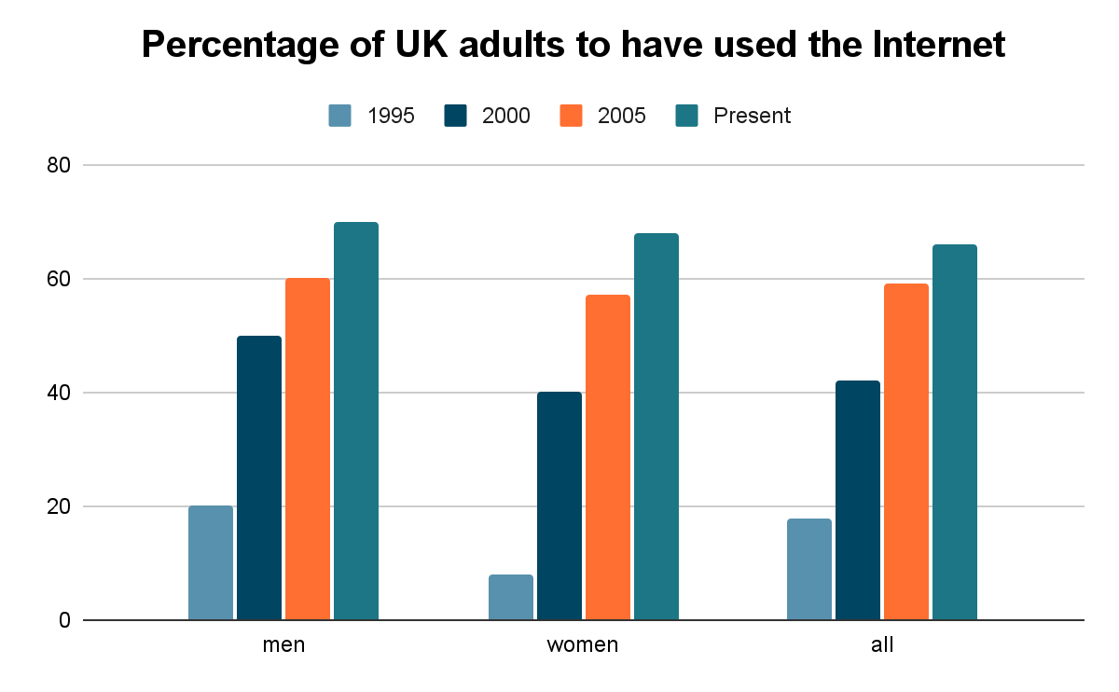
Dạng bài: quiz_type_7
- The chart shows the percentage of British adults who (1) ___ (use) the Internet since 1995.
- The number of women who have ever used the Internet (2) ___ (increase) by more than 60% since 1995.
- The percentage of men who have accessed the Internet (3) ___ (rise) to 60% in 2005.
- The number of women who have accessed the Internet (4) ___ (rise) each year.
- The percentage of men who used the Internet (5) ___ (be) greater than the percentage of women from 1995 to 2005.
- However, British women (6) ___ (overtake) British men in Internet usage since 2005.
- The total number of people accessing the Internet (7) ___ (grow) each year although the most significant rise (8) ___ (occur) between 1995 and 2000.

ĐÁP ÁN
- have used
- has increased
- rose
- has risen
- was
- have overtaken
- has grown
- occurred

Exercise 4. Choose the correct form of the verbs

Dạng bài: quiz_type_7

To: Michael
From: Sunny
Dear Michael,
(1) ___ (I've just received / I've just been receiving) your message to us all about the seminar on Friday. (2) ___ (I've worked / I've been working) on my presentation for the last week, and (3) ___ (have now finished / now finished) it, so I am happy to be one of the first to present it. However, (4) ___ (I've made / I made) an appointment to see the university careers advisor immediately after the seminar, so I will need to leave on time.
I'd like some advice about my presentation. At last week's lecture (5) ___ (you've said / you said) that we should use visual aids as much as possible. (6) ___ (I haven't found / I didn't find) anything to use. Is it essential? (7) ___ (I've done / I did) lots of presentations before, and I feel OK about this one. In my last presentation (8) ___ (I used / I have been using) the overhead projector, and I want to do this again - does this count as a visual aid?
One last question: (9) ___ (I've been / I went) to Professor Russell's lecture yesterday, and (10) ___ (have been learning / learnt) quite a lot that is relevant to this course. Is it okay to refer to another course in my presentation? (11) ___ (I've been wondering / I wondered) about this - maybe it is better to stick to the materials and references (12) ___ (you've given / you've been giving) us. I hope you can let me know.
Thanks for your help.
Sunny

ĐÁP ÁN
- I've just received
- I've been working
- have now finished
- I've made
- you said
- I haven't found
- I've done
- I used
- I went
- learnt
- I've been wondering
- you've given

Exercise 5. Add the following phrases in the correct column

Dạng bài: quiz_type_7

I think

In my opinion

It should be noted that

It is claimed that

To my mind

Many might claim

As far as I’m concerned

Reports show/state/demonstrate/reveal that

Personally, I am certain

A general assertion is

Predictions suggest that

I feel (that)

Personal opinion:

(1) ___

(2) ___

(3) ___

(4) ___

(5) ___

(6) ___

Impersonal idea:

7. (7) ___

8. (8) ___

9. (9) ___

10. (10) ___

11. (11) ___

12. (12) ___

ĐÁP ÁN

I think

In my opinion

To my mind

As far as I'm concerned

Personally, I am certain

I feel (that)

It should be noted that

It is claimed that

Many might claim

Reports show/state/demonstrate/reveal that

A general assertion is

Predictions suggest that

Exercise 6. Match 1-6 with a-f to make sentences

Dạng bài: quiz_type_7

Personally, I feel that green spaces in the city ___

It is commonly accepted that more___

Many might claim that they___

It seems to me ___

In my opinion ___

It should be noted that some cities___

housing would make homes more affordable for people such as key workers.

major cities, Istanbul or Shanghai for instance, are relatively expensive places to live.

make them nicer places. In other words they make cities healthier and more beautiful.

enjoy the benefits of the countryside, for example the fresh air, but others would say it is too boring.

that work opportunities are better in cities. That is to say you have more chance of finding a job.

are known as megacities due to their size. A case in point is Tokyo.

Key:

c

a

d

e

b

f

C. Writing

Exercise 7. ​​You should spend about 40 minutes on this task.

Write about the following topic:

Nowadays celebrities are more famous for their glamour and wealth than for their achievements, and this is a bad example to adolescents.

To what extent do you agree or disagree?

Give reasons for your answer and include any relevant examples from your own knowledge or experience.

Write at least 250 words.

Dạng bài: quiz_type_0

Easy IELTS - Task 2 - 21

Model Answer

Nowadays, there is a contentious discussion surrounding the fact that certain celebrities are primarily recognised for their wealth rather than their accomplishments. Although some argue that celebrities serve as detrimental role models for young individuals, others contend that it is important to acknowledge the presence of numerous other prominent figures who can serve as positive examples to adolescents. In my opinion, both parties are important to help young people have an objective view of celebrities.

To begin with, many celebrities gain their renown and affluence through their extravagant lifestyles, which are not necessarily a result of hard work. These individuals may acquire fame and fortune through their family background, relationships, or by engaging in scandalous activities. Young individuals, however, are still developing their values and beliefs, thus, if influenced by these celebrities, may perceive such superficial success as the ultimate goal in life. Consequently, this can lead to a skewed perception of success and pressure, where monetary gains and external appearances take precedence over personal growth, intellectual pursuits, and genuine achievements. A notable example of this is demonstrated by the Kardashians, who have built an empire of reality shows centred around showcasing their arguments, infidelities, and partying. Such behaviours are not conducive to healthy learning for children.

Nevertheless, there exist individuals within the celebrity sphere who possess admirable qualities and have achieved notable accomplishments, which can positively influence the younger generation. These stars have worked diligently to attain success through their talents, strong work ethics, perseverance and compassionate personalities. Therefore, by showcasing their achievements, they inspire adolescents to pursue their passions and strive for excellence in areas that truly matter. For instance, Keanu Reeves, an internationally renowned actor who is widely recognised for his humility and philanthropic endeavour, donated 70 percent of his earnings from the first "The Matrix" film to leukaemia research. Another well-known figure is Emma Watson, who became a millionaire after her role in the world wide sensation "Harry Potter" franchise. Despite her early financial success, Emma never neglected her education and even graduated from an Ivy-League institution.

In conclusion, while it is evident that the emphasis on celebrity glamour and wealth can have a detrimental impact on adolescents, not all celebrities fall into this category as there are those who have achieved success through genuine hard work and dedication. Therefore, it is imperative for children to discern and distinguish which celebrities to draw inspiration from.

(395 words)

