LESSON 1

A. Vocabulary

Exercise 1. Match the linking words on the left with the appropriate function on the right
Dạng bài: quiz_type_7
- Leaving aside ___ | a. change the topic
- In parenthesis, ___ | b. read something earlier in the text
- Turning to ___ | c. this will not be discussed
- In conclusion, ___ | d. this document is about another one
- With reference to ___ | e. to finish off
- See above ___ | f. as an aside/as a secondary issue

Key:
- c
- f
- a
- e
- d
- b

Exercise 2. Fill the gaps with the given typical linking words or phrases
Dạng bài: quiz_type_7
Lastly | For example | as it were | in other words
In conclusion | Firstly | Next

(1) _____________, it is important to understand why people commit crimes; (2) _____________,what are the motives which make people do things they would never normally do? (3) ______________, a young man steals clothes from a shop - does he do it because it is an exciting risk? (4) _______________, it is essential to consider whether punishment makes any difference, or is it just, (5) ________________, a kind of revenge? (6) ______________, how can we help victims of crime? (7) _____________, how can we get to the roots of the problem, rather than just attacking the symptoms?
Key:
- Firstly
- in other words
- For example
- Next
- as it were
- Lastly
- In conclusion

B. Grammar

Exercise 3. Choose one word or phrase from each pair to complete the text
Dạng bài: quiz_type_7
although/and so | as if/if | as much/as much as | so what/whereas
as easy as/so easy | just/just as | despite/despite the fact that | though/even

(1) _______________ a lot has been written and said about class differences in British society, they no longer mean (2) _______________ they used to. Traditionally, the upper classes were wealthy and powerful (3) _______________ the lower or working classes were poor. Nowadays, some of the upper classes may still seem to behave and speak (4) _______________ their social status continues to be (5) _______________ it was for their aristocratic ancestors, but it is no longer based on exclusive wealth and power. Maintaining large houses with lots of servants is not (6) ______________ it used to be and, strange (7) ______________ it may seem, the new owners of those large houses may speak with distinctly working-class or even foreign accents. (8) ______________ that their parents may have been middle or working class, many of today's wealthy Britons achieved success based on education and enterprise, not birth and inheritance.
Key:
- Although
- as much as
- whereas
- as if
- just as
- as easy as
- though
- Despite the fact

Exercise 4. Complete each sentence in such a way that it is as similar as possible in meaning to the sentence above it.\
Dạng bài: quiz_type_7
- I disagree with his point of view, but I understand why he thinks that way.
→ Although_______________________________________________________________________________.
- Jack is still unemployed in spite of applying for about a dozen different jobs.
→ Though _______________________________________________________________________________.
- While most people agreed that the car was a bargain, none of them wanted to buy it.
→ Even _______________________________________________________________________________.
- The old people didn't have very much money, but they were really generous.
→ Despite _______________________________________________________________________________.
- Although there was a traffic jam, they went to the post office.
→ In spite of _______________________________________________________________________________.
Key:
- Although I understand why he thinks that way, I disagree with his point of view/ Although I disagree with his point of view, I understand why he thinks that way
- Though he has applied for about a dozen jobs, Jack is still unemployed
- Even though most people agreed that the car was a bargain, none of them wanted to buy it / Even though none of them wanted to buy it, most people agreed that the car was a bargain.
- Despite the fact that the old people didn't have very much money, they were really generous/Despite not having very much money, the old people were really generous
- In spite of the traffic jam, they went to the post office

Exercise 5: The bar chart below shows the reduction in traffic accidents in Bridgewater following the introduction of extra lanes on busy roads. Which of the following sentences is an accurate overview sentence of the bar chart?
Dạng bài: quiz_type_14
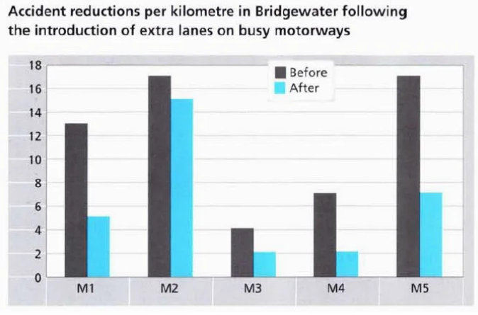
- There were mixed results following the introduction of the new traffic system in Bridgewater.
- On some roads the extra lanes were more popular than on others.
- The roads with the largest amount of traffic are the M1 and M5.
- In every case, adding an extra lane on main roads had a positive effect on traffic incidents.
- All cities should incorporate this system on their main roads.
Answer: ___
Key: D

Exercise 6. Look at sentences 1-6 and decide if the information is:
- a main feature (it should be included)
- a minor detail (it can be left out)
Dạng bài: quiz_type_14
- The M2 and the M3 showed the smallest reduction in accidents. | A/B
- Approximately four accidents per kilometre occurred on the M3 prior to the peak lane being introduced. | A/B
- About 17 accidents per kilometre occurred each year on the M2 following the introduction of extra lanes on busy roads. | A/B
- The greatest reduction in accident numbers occurred on the M1, the M4 and the M5. | A/B
- The introduction of the new system cut the number of accidents occurring on the M1 and the M5 by half. | A/B
- Each year, the greatest number of accidents occur on the M1, the M2 and the M5. | A/B

C. Writing

Exercise 7. You should spend about 20 minutes on this task.

Write about the following topic:

The table shows the number of mobile phones sold in millions for a period of six years. Summarize the information by selecting and reporting the main features, and make comparisons where relevant.

Write at least 150 words.

Dạng bài: quiz_type_0

Easy IELTS - Task 1 - 20

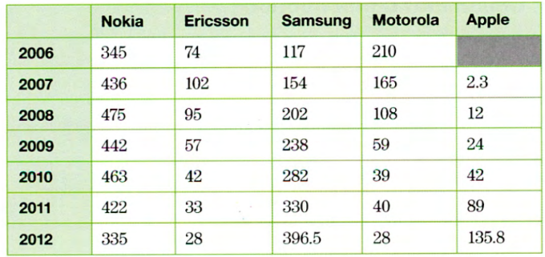

Model answer

The table provides information about the sales rates of five major types of mobile phone from 2006 to 2012.

There are three clear trends visible in the data. Firstly, two phone brands, Samsung and Apple, demonstrated a consistent rise in sales during the six-year period, Samsung finishing with the highest level of sales overall at 396.5 million in 2012. While Apple made the lowest number of sales at the start, with a mere 2.3 million in 2007, this soared to just under 136 million by the end of the period, paralleling the growth of Samsung's sales and putting Apple in third highest position. Nokia had a higher number of sales than Apple at the finish with a total of 335 million; however this was a marked drop from a previous high of 475 million in 2008. Nokia's sales were slightly erratic in general, rising rapidly from 2006 to 2008 before dropping in 2009, then repeating the cycle by improving to 463 million in 2010 before slipping downwards to its final result in 2012. Finally, two other brands, Motorola and Ericsson, followed a more persistently downward pattern. Both suffered the lowest number of sales overall, achieving only 28 million sales each in 2012. Ericsson's sales dropped rapidly from the highest point of 102 million in 2007 before leveling out and decreasing far less dramatically from 2010 where they were at 42 million.

Overall, two brands improved their sales, two brands showed dramatic drops and one brand had a mixed performance with a negative trend at the end of the period.

(257 words)

LESSON 2

A. Vocabulary

Exercise 1. Categorise the following linking words and phrases by their functions. Some words and phrases are used more than once
Dạng bài: quiz_type_7
in comparison | consequently | therefore | but | however
for instance | after that | obviously | if | furthermore
in addition | since | in conclusion | before | like
as a consequence | overall | first | as long as | clearly

- To add information or ideas:
(1) ___
(2) ___
- To indicate the timing of events:
(3) ___
(4) ___
- To show differences or contrasts between ideas:
(5) ___
(6) ___
(7) ___
- To show the reason (cause) and the result (effect):
(8) ___
(9) ___
(10) ___
- To introduce examples:
(11) ___
(12) ___
- To summarise or conclude ideas:
(13) ___
(14) ___
(15) ___
- To emphasise a point:
(16) ___
(17) ___
- To express conditions:
(18) ___
(19) ___
- To show the order of events or ideas:
(20) ___
(21) ___

ĐÁP ÁN
- furthermore
- in addition
- before
- since
- however
- but
- in comparison
- consequently
- as a consequence
- since
- like
- for instance
- therefore
- overall
- in conclusion
- obviously
- clearly
- if
- as long as
- first
- after that

Exercise 2: Look at the bold words in the following sentences. Are they True or False?
Dạng bài: quiz_type_14

1. Despite being very busy, he always makes time for his family. | ______
2. She is friendly, but everyone likes her. | ______
3. She is a talented musician; therefore, she is an excellent painter. | ______
4. The book received a bad review because it was poorly written. Moreover, the reviewer said that the plot didn’t make sense. | ______
5. The space probe will visit several planets in the outer solar system. Although, it will observe several comets. | ______
6. The businessman is focused on success. Likewise, the athlete is focused on winning. | ______
7. Regarding age groups, while young people prioritize education as long as other areas, the elderly put more emphasis on funding for the health sector. | ______

Key:
- True
- False
- False
- True
- False
- True
- False

B. Grammar

Exercise 3. Match to make sentences
Dạng bài: quiz_type_7
- Although _____________________ | a. of being a vegetarian, Aesop does occasionally eat fish.
- Despite _____________________ | b. fact that Aesop is a vegetarian, he does occasionally eat fish.
- Despite the _____________________ | c. Aesop does occasionally eat fish.
- Aesop is a vegetarian _____________________ | d. being a vegetarian, Aesop does occasionally eat fish.
- Despite his vegetarianism, _____________________ | e. although he does occasionally eat fish.
- In spite _____________________ | f. Aesop's a vegetarian, he does occasionally eat fish.
- Despite having _____________________ | g. been a vegetarian for years, Aesop does occasionally eat fish.

Key:
- f
- d
- b
- e
- c
- a
- g

Exercise 4. Complete the sentences using although, despite or however

Dạng bài: quiz_type_7
- ___________ the storm, over ten thousand people took part in the marathon.
- ___________ I wrote myself a note to remind me, I still forgot to call George tonight.
- Most Egyptologists believe that the Sphinx is about 4000 years old. Some geologists, ___________ , argue that it must be at least 14,000 years old.
- ___________ having taken two aspirin, I had such a bad headache that I had to go home.
- I've never seen a UFO. ___________, that doesn't mean that I don't believe in them.
- There are still two million people unemployed ___________ the fact that we're in the middle of an economic boom.
- ___________ no European country carries out capital punishment, it is widely used throughout the United States.
- Technology has benefited humankind enormously. There are drawbacks with our reliance on technology, ___________.
- I couldn't find my keys ___________ searching for them everywhere.

Key:
- Despite
- Although
- however
- Despite
- However
- despite
- Although
- however
- despite

Exercise 5. Look at the following bar chart, then match sentences beginnings 1-6 with endings a-f to form correct sentences about the chart

Dạng bài: quiz_type_7

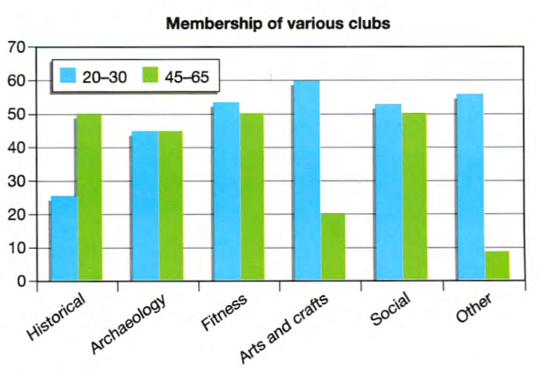

- The arts and crafts club has the greatest number of 20-30 year-olds, ___ | a. whereas the archaeological club is equally popular with both.
- Only 25 people from the younger age group are members of the historical club, ___ | b. in comparison with the historical club.
- Some clubs are clearly more popular with one of the age groups, ___ | c. but it is one of the least popular clubs with the older age group.
- The fitness and social clubs have slightly more members in the younger age group, ___ | d. compared with the older age bracket.
- In general, the 20-30 year-olds are more actively involved in clubs ___ | e. while the figure for 45-65 year-olds is about 50.
- The fitness and social clubs attract a broader range of people ___ | f. although they are fairly popular with both age groups.

Key:
- c
- e
- a
- f
- d
- b

Exercise 6. Look at the chart again, read the following description of the chart and choose the correct answer

Dạng bài: quiz_type_7
The chart provides information about how two age groups participate in several clubs at a centre for adults. We can see from the data that the archaeological, fitness and social clubs are popular with both older and younger people. (1) ___ (While / By contrast), the historical and arts and crafts societies clearly appeal more to one of the age groups. In the historical society, 50 of the members are between 45 and 65, (2) ___ (but / however) there are only 25 from the younger age group. For the arts and crafts society, the pattern is reversed.
There are about 60 members aged between 20 and 30, (3) ___ (whereas / in comparison with) the number of people in the 45 to 65 age group is (4) ___ (slightly / considerably) lower.
The fitness and social clubs are popular with both age groups, (5) ___ (however / although) there are slightly fewer older people. Membership of the archaeological society stands at 45 for both groups.
In general, the younger age group are (6) ___ (significantly / almost) more involved in the various societies than the 45-65 year-olds.

ĐÁP ÁN
- By contrast
- but
- whereas
- considerably
- although
- significantly

C. Writing

Exercise 7. You should spend about 20 minutes on this task.

Write about the following topic:

The bar chart shows the percentage of people in the United Kingdom per age group without any qualifications.

Summarize the information by selecting and reporting the main features and make comparisons where relevant.

Write at least 150 words.

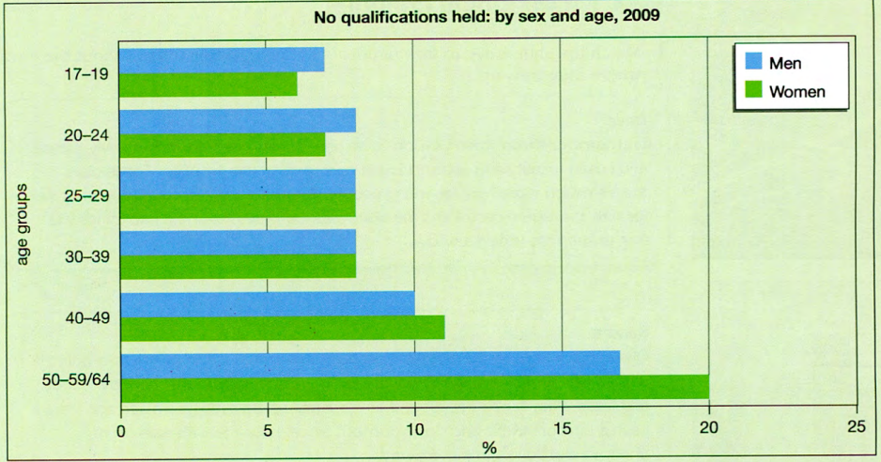

Dạng bài: quiz_type_0

Easy IELTS - Task 1 - 20

Model answer

The chart provides information about the proportions of males and females in the UK by age group in 2009 who did not have any qualifications.

Among those aged 17-19 and 20-24, more males than females lacked qualifications, approximately 7% and 6%, and 8% and 7% respectively. As regards the 25-29 age group, there is no difference in the proportions of men and women without qualifications at around 8% for both sexes with the same pattern being seen for the 30-39 age group. By contrast, among those aged 40-49, the lack of qualifications was greater among women compared to men (12% as opposed to 10%), while more women in the oldest age group (about 20%) did not have any qualifications compared to around 17% for men.

Overall, it is clear that there is a greater proportion of men compared to women without qualifications in the youngest age groups whereas the reverse is true for the oldest age groups.

(159 words)

LESSON 3

A. Vocabulary

Exercise 1. Fill in the gaps with the words below
Dạng bài: quiz_type_7
status | post | share
request | follow | subscribe

- If you liked this video, please ______________ it with your friend.
- I hate it when people __________________ hundreds of photos from their holiday.
- Do you know Monica Coto? She's just sent me a friend ______________ on Facebook.
- I just updated my _______________ to tell people we’ve arrived safely at the hotel.
- You cạn ________________ to our channel, and we’ll email you when a new video comes out.
- Misa likes to _______________ chefs and food writers on Twitter.

Key:
- share
- post
- request
- status
- subscribe
- follow

Exercise 2. Choose the correct answer
Dạng bài: quiz_type_14
- I've just uploaded comments/photos of Saturday's football match to the team Facebook page.
- Yi Ling posts/views a lot of updates about her training for the 10k run.
- Jo posted a really interesting article about Formula 1 racing, but it didn't get any likes/rates.
- To enter the competition, share/view this picture on your timeline before 8 pm on Friday.
- Did you rate/upload that restaurant we went to? I'd give it one star!
- Elena made a video for the animal charity she works for and it got 3,000 views/uploads.
- An old friend commented/viewed on one of my photos, asking where I was living now.

B. Grammar

Exercise 3. Choose the correct answer
Dạng bài: quiz_type_14
- Before meeting/met Harriet, I never knew what real love was.
- I'm sure that after passing/passed your exam, you'll feel a lot better.
- Having finishing/finished the letter, Peter printed it out.
- Looking/Looked through the window, I saw a strange man at the door.
- I cooked dinner and, doing/having done that, I sat down to watch TV.
- Hearing/Heard a noise outside, Janice went to investigate.
- Having lost/Losing my notes, I couldn't revise properly for the test.
- Having been/Being quite intelligent, Matt hopes to get into a good university.
- Having missed/Missing the start of the film, I decided not to bother watching the rest of it.
- After making/made her bed, Cherie had a shower.

Exercise 4. Complete the sentences so that the meaning remains the same
Dạng bài: quiz_type_7
- I suddenly remembered where I'd left my keys when I was waiting for the bus.
→ Waiting __________________________________________________________________________.
- I slipped because I was trying to run in the rain.
→ Trying __________________________________________________________________________.
- I felt quite sorry for Tim when I saw him cry.
→ Seeing __________________________________________________________________________.
- John was depressed because he knew he was going to fail the exam.
→ Knowing __________________________________________________________________________.
- The reason I'm quite good at basketball is that I'm quite tall.
→ Being __________________________________________________________________________.
- Georgia didn't know any Japanese so she used a phrase book when she was there.
→ Not __________________________________________________________________________.
- Ed can afford three holidays abroad each year because he has a lot of money. → Having __________________________________________________________________________.
- Maria began to worry when she realised she was lost.
→ Realising __________________________________________________________________________.
Key:
- for the bus, I suddenly remembered where I'd left my keys
- to run in the rain, I slipped
- Tim cry, I felt quite sorry for him/ Tim cry, I felt quite sorry for Tim
- that he was going to fail the exam, John was depressed/he was going to fail the exam, John was depressed
- quite tall, I'm quite good at basketball
- knowing any Japanese, Georgia used a phrase book when she was there
- a lot of money, Ed can afford three holidays abroad every year
- that she was lost, Maria began to worry/she was lost, Maria began to worry

Exercise 5. Look at the 'Task 2 question below and answer questions a-c with no more than 3 words
Dạng bài: quiz_type_7

You should spend about 40 minutes on this task.

Write about the following topic.
More and more people claim that modern work patterns are a source of stress. What do you think are the causes of this? Can you suggest some possible solutions?

Give reasons for your answer and include any relevant examples from your own knowledge or experience.

Which part of the question states a problem? ___

Which two words in the question are important for the organization of your answer?__

What else do the instructions tell you to include in your answer?___

ĐÁP ÁN

Part 1

Causes, solutions

Reasons and examples

Exercise 6. The paragraph below suggests a solution to the Task 2 question. Complete each gap with one of phrases a-f below

A further step is to

for example
- I think the most obvious solution is
- As a result
- By doing this
- For instance
Dạng bài: quiz_type_7

_______________ for employers to encourage workers to relax. (2) ______________, in some companies, gym facilities or massage therapies are available. (3) ________________, this improves their efficiency and production. (4) ________________ train employees in how to plan their time more effectively, (5) __________________, by stopping people taking work home. (6) ______________________, the workplace will become a lot happier.
Key:
- c
- f
- d
- a
- b
- e

C. Writing

Exercise 7. You should spend about 40 minutes on this task.

Write about the following topic:

The widespread use of the Internet has brought many problems. What do you think are the main problems connected with using the web? What solutions can you suggest?

Give reasons for your answer and include any relevant examples from your own knowledge or experience.

Write at least 250 words.

Dạng bài: quiz_type_0

Easy IELTS - Task 2 - 21

Model answer

Great changes have taken place in our life alongside the development of society. As far as I am concerned, the Internet plays a big part in this.

First of all, with the opportunity of surfing the internet or playing computer and video games, people have a more sedentary lifestyle. Children no longer play games outside and get exercise but they spend time on the computer. This has a bad effect on their health and can cause problems such as obesity.

Another problem is the negative effect on their relationship with their family. Internet access fills most young people's time, and even their leisure time, so this is the cause of their disconnection with their family and ultimately can have an effect on their social behaviour. A third problem is that not all internet sites are useful. Information is often not accurate and some sites are not suitable for children. Some internet sites like chat rooms can even be dangerous because you do not know who the other person is.

As regarding children's use of the Internet, the first solution must be with the parents. They need to limit hours that children spend on the computer and to encourage them to have other hobbies and pastimes. There is an important need for them to spend more time speaking with their family than an electronic connection. Parents should also encourage children to use other means of information in addition to the internet.

To conclude, I would say that the internet has brought many benefits and it will not disappear, therefore it is very important that we learn to use it well so that we can reap the benefits and not the disadvantages.

(278 words)

LESSON 4

A. Vocabulary

Exercise 1. What do we call…?
Dạng bài: quiz_type_7
timeline | profile picture | direct message | notification | profile

- The page with information about the user of social media: ___
- The photo of the user: ___
- The page where a person's photos and posts appear: ___
- The message a person receives when something new happens: ___
- Part of a private conversation:___

Key:
- profile
- profile picture
- timeline
- notification
- direct message

Exercise 2. Fill the gaps with given words
Dạng bài: quiz_type_7
privacy | tag | private
public | account | default

- I'm a teacher, so I make sure everything in my profile is _____________. I don't want my students to see it.
- To find your _____________ settings, click on the 'lock' icon at the top of the screen.
- If you want everyone to be able to see that post, make sure that it's ____________.
- Please don't_____________ me in any of those photos - I look terrible!
- If you want to buy the skirt, please send me a ______________ message.
- To create an ___________________, you have to give your email address and a password.
- The _____________ setting for new posts on this site is Friends Only, but it's easy to change if you want to share something publicly.
Key:
- private
- privacy
- public
- tag
- direct
- account
- default

B. Grammar

Exercise 3. Each pair contains one correct sentence and one with a participle error. Choose the correct sentence.
Dạng bài: quiz_type_14

- Running down the stairs, my phone slipped out of my hand.
- Running down the stairs, I accidentally dropped my phone.

- After completing his research, the report was submitted.
- After completing his research, he submitted the report.

- Walking through the park, the birds were chirping loudly.
- Walking through the park, I enjoyed listening to the birds chirping.

- Having missed the last bus, I decided to walk home.
- Having missed the last bus, walking home was my only option.

- Looking out of the window, a beautiful rainbow appeared.
- Looking out of the window, I saw a beautiful rainbow.

- Not knowing the answer, she hesitated before speaking.
- Not knowing the answer, the question confused her.

- Worried about his health, Tom scheduled a doctor's appointment.
- Worried about his health, a doctor's appointment was scheduled.

Exercise 4. Are the bold words True or False?
Dạng bài: quiz_type_7
Looking through the window, a plane was passing overhead. | ___
Realising that it was late, I ran all the way home. | ___
Having examined me, I was given a prescription by the doctor. | ___
Turning on the television, the newsreader said there had been an explosion. | ___
Dropping the shopping bags on the kitchen floor, Mrs Moorcroft sighed and sat down heavily. | ___
Having practised the piano, I decided to call one of my friends. | ___

Key:
- False
- True
- False
- Flase
- True
- True

Exercise 5. Look at the Task 2 question below. What kind of quiz_type_0 is this? ___

Competition for university study is becoming increasingly strong. Why are universities becoming more competitive? Is this a positive or negative development?

Give reasons for your answer and include any relevant examples from your own knowledge or experience.
Write at least 250 words.

Dạng bài: quiz_type_14
- Discussion quiz_type_0
- Two-Part Question quiz_type_0
- Problem-solving quiz_type_0

Exercise 6. Look at the Task 2 question again. Reorder the paragraphs to make a full

Competition for university study is becoming increasingly strong. Why are universities becoming more competitive? Is this a positive or negative development?

Give reasons for your answer and include any relevant examples from your own knowledge or experience.
Write at least 250 words.

Dạng bài: quiz_type_7

A. The first reason why attending tertiary education nowadays is more competitive than ever is due to the vast investment of parents into their children’s education. In the past, it was acceptable for a child to drop out of school to help with farming. However, most parents now want to ensure a better future for their kids, so they urge them to compete for a slot in the most prestigious university possible. The second reason why universities are getting harder to get into is simply because of the rising population of high schoolers. More universities should have been built to accommodate this demand from upcoming generations. However, because the rate of opening new colleges cannot compete with that of population rise, children would have to compete against one another for college admissions.
B. In conclusion, getting into colleges is more competitive due to children being more competitive and the population rising. Although I think this is a positive development for society, some measures are needed to prevent the ultimate burnout.

C. Regardless of the reason for this development, I do not see this as entirely positive nor negative. On the one hand, there are some benefits to this. Future generations will be more knowledgeable than the current ones. With an influx of fresh graduates equipped with high-level knowledge, the country can expect more technological developments. This can be seen from the growth of entrepreneurship in the technology industry. On the other hand, however, this intense competition will take a toll on both students and parents. More time will be spent studying for the exam, which equates to deteriorating physical and mental health of high schoolers. Parents are also affected by the mental and financial pressure of finding and paying for tutoring centers.
D. In recent years, it has been noticeable that the university entrance exam is getting increasingly competitive, and some have questioned why or whether this is a positive development. I believe there are two main reasons for this, and I don’t think this is either an entirely positive or negative phenomenon.
Answer: ___; ___; ___; ___

Key: D; A; C; B

C. Writing

Exercise 7. You should spend about 40 minutes on this task.

Write about the following topic:

Nowadays, many people choose to be self-employed, rather than to work for a company or organisation. Why might this be the case? What could be the disadvantage of being self-employed?

Give reasons for your answer and include any relevant examples from your own knowledge or experience.

Write at least 250 words.

Dạng bài: quiz_type_0

Easy IELTS - Task 2 - 21

Model answer

In today’s labour market, an increasing number of individuals are opting for self-employment over traditional occupation in particular companies or organisations. This quiz_type_0 will attempt to explore the key factors as to why people seem to prefer entrepreneurship and major drawbacks to it.

The growing trend of being self-employed can be attributed to several factors. One compelling reason is the sense of autonomy and flexibility that it affords. While common jobs in a company require rigid schedules and hierarchical structures, self-employment offers the freedom in which the employee can set their own working hours and establish their preferred work environment, whether it's a home office or a shared workspace. This level of control not only fosters a better work-life balance but also allows self-employed people to allocate time for personal commitments such as family and health, enhancing their quality of life. Additionally, the vast profitability is also a main incentive for many to embark on the entrepreneurial path. Unlike salaried positions, where income is often limited to a fixed amount per month, self-employed individuals have the potential to unlock limitless financial gains if their company does well.

However, easy access to setting up a company, especially for someone inexperienced, may result in a range of problems. The first issue that may perplex an entrepreneur is the numerous skills set required for effective business management. Having taken the responsibilities of an accountant, public relation marketer or even human resource manager at the same time can be a burden and challenge unskilled businessmen's perseverance, leading to stress and reduced overall performance. Furthermore, financial instability is another risky matter of self-employment. In contrast to a steady salary assured by an organisation, entrepreneurs often experience irregular cash flows due to market fluctuations or unforeseen recession. Particularly, in the current competitive reality, the vulnerability of income puts self-employed individuals to end up with unpayable debt from investments and many of them go bankrupt.

In conclusion, the preference towards self-employment is fueled by the appeal of flexibility and profitability, however, certain challenges related to managing skills and financial issues still emerge. Balancing these factors is key to a successful self-employed career.

(355 words)

