LESSON 1

A. Vocabulary

Exercise 1. Complete the sentences using the correct words from the box
half | ratio | total | increase | proportion
percentage | quarter | equivalent | fraction | discount

Dạng bài: quiz_type_7

A ________ is a mathematical way to show a part of a whole using a numerator and a denominator.

The supermarket is offering a 10% ________ on all dairy products this week.

A ________ is a part of something divided into four equal sections.

The price of gas saw a significant ________ last month due to inflation.

0.50 is ________ to one-half.

The ________ of students who passed the exam was 75%.

The ________ of boys to girls in the class is 3:2.

She spent ________ of her savings on a new laptop.

The sales team exceeded their ________ revenue target by 15%.

The government announced a new tax rate, which will be calculated based on a fixed ________.
Key:
- fraction
- discount
- quarter
- increase
- equivalent
- percentage
- ratio
- half
- total
- proportion

Exercise 2. Choose the correct answer for each question
Dạng bài: quiz_type_14
- What is 25% written as a fraction?___
a.¼
b. ⅓
c. ⅕
d. ½
- If a store offers a 20% discount, how much would you pay for an item that originally costs $100? ___
a.$60
b. $70
c. $80
d. $90
- Which term refers to the difference between the original price and the discounted price? ___
a.Fraction
b. Reduction
c. Percentage
d. Ratio
- A group of students is made up of 40 boys and 60 girls. What percentage of the group is female? ___
a.40%
b. 50%
c. 60%
d. 70%
- The ratio 2:5 means that for every 2 parts of one quantity, there are how many parts of another quantity? ___
a.2
b. 3
c. 5
d. 7

B. Grammar

Exercise 3. Complete this news report with these verbs in the passive

block | destroy | flood | knock | report
close | expect | injure | leave | rescue

Dạng bài: quiz_type_7
Many homes on the island of Jamaica (1) _____________ by hurricane Lester yesterday. Today, high winds (2) _____________ to bring more rain and problems for the island's residents. Some parts of the island (3) _____________ without electricity last night and many roads (4) _____________ by fallen trees that (5) _____________ down during the storm. The area around Savanna-La-Mar on the south coast (6) _____________ and some residents have had (7) _____________ from the roofs of their houses. Most businesses and schools in Kingston (8) _____________ today as people emerge from their battered homes to survey the damage. More than 100 people (9) _____________, but no deaths (10)_____________.
Key:
- were destroyed
- are expected
- were left
- are blocked/were blocked/have been blocked
- were knocked
- was flooded/is flooded
- to be rescued
- are closed
- were injured/have been injured/are injured
- were reported/ have been reported

Exercise 4. Complete each sentence with a passive so that it has a similar meaning to the one above
Dạng bài: quiz_type_7
- You can't see the house from the street.
→ The house ______________________________________________________________.
- ‘They won't correct your papers before Friday?’
→ He said our papers ______________________________________________________________.
- Someone must have taken the towels out of the dryer.
→ The towels ______________________________________________________________.
- Nobody's going to steal your books from this room.
→ Your books ______________________________________________________________.
- People were telling me what to do all the time and I didn't enjoy it.
→ I didn't enjoy ______________________________________________________________.

Key:
- can't be seen from the street /cannot be seen from the street
- our papers wouldn't be corrected before Friday/our papers won't be corrected before Friday/our papers would not be corrected before Friday/our papers will not be corrected before Friday
- must have been taken out of the dryer
- aren't going to be stolen from this room/are not going to be stolen from this room
- being told what to do all the time

Exercise 5. Look at the pie charts and the Task 1 question. Complete sentences a-g using the phrases below
that | for example | but | meanwhile | and
respectively | how | which | whereas
Dạng bài: quiz_type_7

The pie charts illustrate the number of journal articles read per week by all students, PhD students and junior lecturers at an Australian university. Summarize the information by selecting and reporting the main features, and make comparisons where relevant.

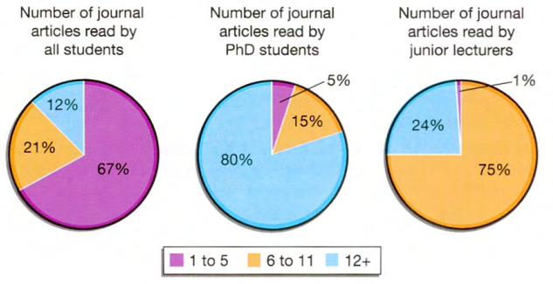

- The three pie charts illustrate (1) ___ many articles from academic journals are read weekly by PhD students (2) ___ junior lecturers compared to other students at an Australian university.
- (3) ___, the overwhelming majority of those studying doctorates read at least twelve articles per week in comparison with the average student.
- The figures were 80 percent and 12 percent (4) ___.
- Furthermore, only five percent of PhD level students read between one and five articles, (5) ___ the average for all students in this category is a hefty 67 percent.
- (6) ___, for junior lecturers the pattern appears to be slightly different.
- Most read six or more articles per week (99 percent), (7) ___ out of this total 24 percent read 12 or more, (8) ___ is almost a third of the corresponding figure for PhD level students.
- It is clear (9) ___ those students who are researching for a PhD read more articles than either junior lecturers or other students.

ĐÁP ÁN
- how
- and
- For example
- respectively
- whereas
- Meanwhile
- but
- which
- that

Exercise 6. Divide the following sentences into general and specific statements
Examples:
General: Postgraduate students tended to be better off than other students.
Specific: 75 percent of schoolchildren read comics each week.
- Far fewer female lecturers than male lecturers are employed at the University, 25 and 75 respectively.
- We can see that there are considerable differences in the proportion of nationalities in each course.
- Only ten percent of postgraduate students attended taught classes.
- Overall, women were more likely to read novels than men.
- Students preparing for their doctorate read the greatest number of journal articles.
- The sales for all four companies showed similar trends.
- The pattern for senior lecturers was very different.
- The vast majority of those students preparing for PhDs read 12 or more journal articles each week.
- General: _____________________
- Specific: _____________________
Key:
- 2, 4, 5, 6, 7
2. 1, 3, 8

C. Writing

Exercise 7. You should spend about 20 minutes on this task

The three pie charts below show the changes in annual spending by a particular UK school in 1981, 1991 and 2001. Summarise the information by selecting and reporting the main features and make comparisons where relevant.

Write at least 150 words.

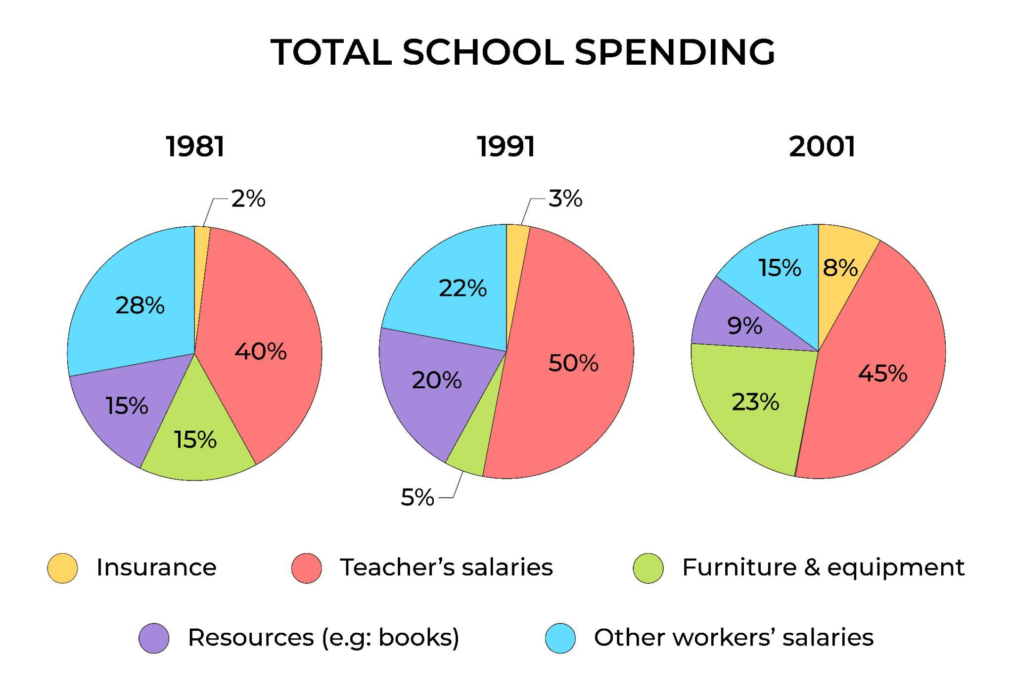

Dạng bài: quiz_type_0

Easy IELTS - Task 1 - 20

Model Answer

The given pie charts illustrate the proportion of yearly expenditure by a specific school in the UK in three separate years, 1981, 1991 and 2001.

It is clear that the majority of expenditures among the three years belonged to teachers' salaries, and while the spending on equipment and insurance saw a dramatic increase, a corresponding decline was recorded by resources and other workers' salaries.

During the period, the most significant school's budget went on staff salaries. While the proportion of spending on other workers' wages dropped steadily from 28% in 1981 to only 15% in 2001, the figures for teachers’ payment remained the largest cost, reaching 50% of total spending in 1991 and ending at 45% in 2001.

The percentages of resources like books had increased to 20% by 1991 before falling to only 9% by the end of the period. In contrast, the opposite trend was true for the cost of furniture and equipment. This figure decreased to only 5% of total expenditure in 1991 but rose considerably in 2001 when it accounted for 23% of the school budget. Similarly, there was a rising trend in expenditure on insurance, ascending from only 2% to 8% by 2001.

(198 words)

LESSON 2

A. Vocabulary

Exercise 1. Choose the correct word to complete each sentence
Dạng bài: quiz_type_14
- The journalist received an award for her outstanding ____.
a. coverage
b. censorship
c. subscription
d. presenter
- Many young people no longer watch traditional TV and prefer to stream content on ____.
a. reporters
b. online platforms
c. breaking news
d. tabloids
- The news program is broadcast ____, meaning it is shown at the same time it happens.
a. objectively
b. live
c. recorded
d. privately
- The government introduced strict ____ to prevent the spread of false information.
a. interview
b. headline
c. censorship
d. anchor
- The sudden resignation of the prime minister was ____, shocking the entire nation.
a. investigative journalism
b. breaking news
c. media coverage
d. press conference
- What is the term for a news program that provides in-depth analysis of important issues? ___
a. Reality show
b. Current affairs program
c. Game show
d. Talk show
- What do we call a news story that is not biased and presents facts objectively? ___
a. Subjective reporting
b. Sensationalism
c. Investigative journalism
d. Balanced reporting
- What is the role of a news anchor? ___
a. To conduct interviews and write investigative reports
b. To present the news on television or radio
c. To censor news before it is aired
d. To manage the technical aspects of a TV broadcast
- What type of journalism focuses on exposing corruption or scandals? ___
a. Investigative journalism
b. Sports journalism
c. Entertainment journalism
d. Opinion journalism
- If a TV program is aired at the same time it is happening, what is it called? ___
a. Pre-recorded
b. Live broadcast
c. Scripted show
d. Delayed telecast

Exercise 2. Complete the sentences using the words in the box
Dạng bài: quiz_type_7
headline | tabloid | airtime
press conference | mainstream media | sensationalism

- The president held a press conference to address questions from (1) ___.
- Many people believe that mainstream (2) ___ outlets do not always report the truth.
- The newspaper’s front-page (3) ___ grabbed everyone’s attention.
- Many news channels are criticized for (4) ___, as they exaggerate stories to attract viewers.
- Sensational stories and celebrity gossip are common in a (5) ___ newspaper.
- Advertisers pay a lot of money for (6) ___ during popular shows.

ĐÁP ÁN
- journalists
- media
- headline
- sensationalism
- tabloid
- airtime

B. Grammar

Exercise 3. Choose one passive verb phrase for each space in these sentences (from a report on the use of DNA testing by the police)
Dạng bài: quiz_type_7

is also called | has also been used | can be used
is believed | have been shown | may have been convicted
was released | had been sentenced | would never have been solved

DNA is the chemical in the cells of plants and animals which carries inherited characteristics, or genetic information. DNA testing (1) ________________ to identify each person as a unique individual on the basis of that genetic information. It (2) ________________. 'genetic fingerprinting’. The results of DNA testing are now being accepted as evidence in cases where it (3) ________________ that the wrong person (4) ________________ of a crime.
In recent years, more than seventy people (5) ________________ to be innocent through DNA testing. Many of those people (6) ________________ to life in prison.
In one case, a man (7) ________________ after nineteen years in prison. DNA testing
(8) ________________ in some murder cases that (9) _________________ without it.
Key:
- can be used
- is also called
- is believed
- may have been convicted
- have been shown
- had been sentenced
- was released
- has also been used
- would never have been solved

Exercise 4. Complete the sentences, using appropriate forms of these verbs in combination
Dạng bài: quiz_type_7

not mention/receive | report/die | request/keep | say/be | tell/not use

- Dog owners are requested to keep their dogs under control in the park.
- There (1) ___ more sheep than people in some parts of Scotland.
- The students (2) ___ their computers yesterday because of a virus.
- Mr Harman's first wife (3) ___ in a boating accident two years ago.
- It (4) ___ earlier, but six more applications (5) ___ last week.

ĐÁP ÁN
- are said to be (hoặc: were said to be)
- were told not to use
- is reported to have died (hoặc: was reported to have died)
- wasn’t mentioned (hoặc: was not mentioned)
- were received

Exercise 5. Connect the sentences below. Use the linking devices in brackets in each case.
Dạng bài: quiz_type_7

Example:

0. The parts of the car are assembled. The cars are exported. (after)

→ After the parts of the car are assembled, the cars are exported.

The snow falls. It covers the ground with a protective layer. (when)
→ ___

Her cubs are born. The lioness licks them all over. (as soon as)
→ ___

The paper is collected. It is sent for recycling. (once)

→ ___

Volcanoes erupt. They send huge amounts of smoke into the air. (before)
→ ___

The plants transpire. The air becomes humid. (when)
→ ___
- The trees are cut down. The forest is gradually destroyed. (and)
→ ___

Key:
- When the snow falls, it covers the ground with a protective layer.
- As soon as her cubs are born, the lioness licks them all over.
- Once the paper is collected, it is sent for recycling.
- Before volcanoes erupt, they send huge amounts of smoke into the air.
- When the plants transpire, the air becomes humid.
- The trees are cut down and the forest is gradually destroyed.

Exercise 6. The diagram below shows how energy is produced from coal. Complete the model text below by choosing the correct alternative in each case
Dạng bài: quiz_type_14
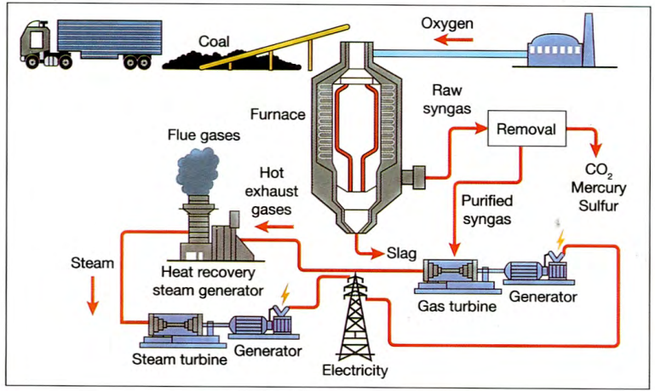

The diagram shows the process involved in the production of energy from coal. (1) ___ (First of all / At first / Once), the coal is delivered by lorry. (2) ___ (Furthermore / After that / As a result), it is carried along a conveyor belt to the power plant, (3) ___ (when / then / where) it is burned in a large furnace to which oxygen is added. (4) ___ (Otherwise / From this / Therefore), raw syngas is produced.

At the next stage of the process, harmful substances like carbon dioxide, mercury and sulfur are removed. (5) ___ (Following that / Following / Subsequent), the purified gas is used to drive a gas turbine. The turbine (6) ___ (in tun / afterwards / therefore) powers a generator, producing electricity.

The gas turbine also produces hot exhaust gases. These are (7) ___ (then / therefore / consequently) piped to a heat recovery steam generator, which converts the heat into steam. The steam is (8) ___ (consequently / subsequent / subsequently) used to power a steam turbine, which again is used to generate electricity. It is clear that the production of energy from coal requires a series of stages, including the use of exhaust gases.
ĐÁP ÁN
- First of all
- After that
- where
- From this
- Following that
- afterwards
- then
- subsequently

C. Writing

Exercise 7. You should spend about 20 minutes on this task

The diagram below shows how salt is removed from sea water to make it drinkable. Summarize the information by selecting and reporting the main features and make comparisons where relevant.

Write at least 150 words.

Dạng bài: quiz_type_0

Easy IELTS - Task 1 - 20

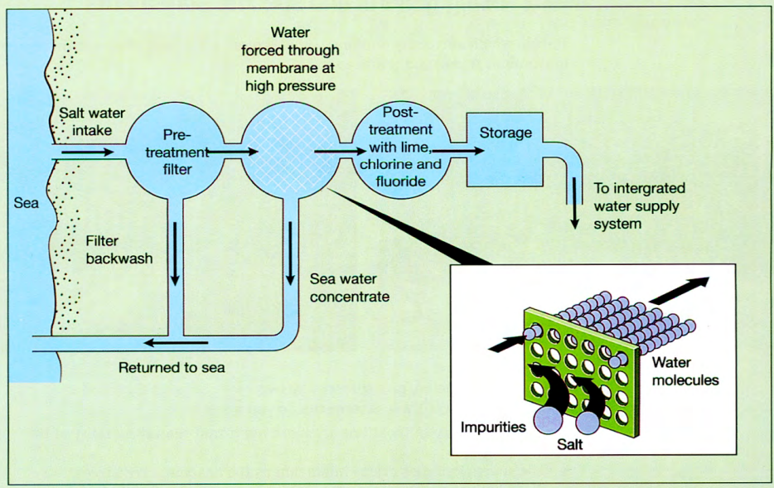

Model answer

The diagram illustrates the process of desalination, in which seawater undergoes multiple stages to become safe for human consumption.

First, seawater is extracted and passed through a pre-treatment filter, where large debris and suspended particles are removed. The waste material, known as backwash, is then discharged back into the sea through a separate filter. Following this, the remaining water undergoes high-pressure membrane filtration, which effectively eliminates salt and microscopic impurities. At this stage, concentrated brine is separated and returned to the ocean, while the purified water proceeds to the next phase.

In the post-treatment stage, chemical agents such as lime, chlorine, and fluoride are added to enhance the water’s safety and quality. Once treated, the potable water is stored in a reservoir before being distributed through an integrated water supply system for public use.

Overall, the desalination process involves a series of filtration, purification, and chemical treatment steps, ensuring that seawater is transformed into drinkable water.

(156 words)

LESSON 3

A. Vocabulary

Exercise 1. Label each verb transitive (T), intransitive (I) or both (B)
Dạng bài: quiz_type_7
- fall (1) ___
- design (2) ___
- produce (3) ___
- rise (4) ___
- send (5) ___
- begin (6) ___
- manufacture (7) ___
- obtain (8) ___
- die (9) ___
- become (10) ___
- dry (11) ___
- grow (12) ___
- cool (13) ___

ĐÁP ÁN
- I
- T
- T
- I
- T
- B
- T
- T
- I
- I
- B
- B
- B

Exercise 2. Below is a list of words related to describing a process. Sort them into the correct category: Verb, Noun, or Adjective.
Dạng bài: quiz_type_7
Transform | Gradual | Development | Increase | Production
Sequential | Expansion | Modify | Continuous | Generate

Verbs:
- (1) ___
- (2) ___
- (3) ___
- (4) ___
Nouns:
5. (5) ___
6. (6) ___
7. (7) ___
Adjectives:
8. (8) ___
9. (9) ___
10. (10) ___

ĐÁP ÁN
- Transform
- Increase
- Modify
- Generate
- Development
- Expansion
- Production
- Gradual
- Sequential
- Continuous

B. Grammar

Exercise 3. Add one set of relative pronouns (not necessarily in this order) to each description. Which one could be left out? Write (O)
Dạng bài: quiz_type_7
that/which/who (X2)/whom | that (X2)/which/who (X2)

Laurel and Hardy were a pair of comedy actors (1) __________________ made over 100 films from 1926 to 1940. Stan Laurel, (2) __________________ was born in Britain, and Oliver Hardy, an American, were first successful in silent films and were famous for their slapstick style of comedy. In their films, Laurel often caused the many accidents (3) ___________________ happened to them both, after (4) _________________ Hardy would get angry and say, ‘This is another fine mess (5) _________________________ you've gotten me into.'
A Jekyll and Hyde is a person (6) ________________ has two personalities, one of
(7) _________________ is bad and the other good. The expression comes from a novel about Dr Jekyll, (8) ___________________ investigates the good and evil parts of human nature and invents a drug (9) ______________________ can separate them. When he takes the drug, he becomes an evil version of himself, (10) ___________________ he calls Mr Hyde.
Key:
- who
- who
- that
- which
- O/that
- who
- which
- who
- that
- whom

Exercise 4. Add one of these clauses to each of the sentences below. Use relative pronouns and make other appropriate changes. Add commas where necessary.
Dạng bài: quiz_type_7
he or she controls a sports game | most people know him as Mark Twain
some of them are poisonous | it uses exaggerated actions, often involving accidents
it consists of nine islands it uses exaggerated actions, often involving accidents | the largest part of it is below the surface of the water
you rent a room or flat from him | each competitor takes part in three different sports in it
✔he has never been married

Example: A bachelor is a man who has never been married.
- Slapstick is a type of comedy _______________________________________.
- A referee is an official _______________________________________.
- A triathlon is a sports event _______________________________________.
- A landlord is a person _______________________________________.
- An iceberg _______________________________________ is a solid mass of ice floating in the ocean.
- Snakes _______________________________________ are long reptiles without legs.
- Tuvalu _______________________________________ is a country in the south Pacific.
- Samuel Clemens _______________________________________ was a major American writer.
Key:
- that uses exaggerated actions, often involving accidents/which uses exaggerated actions, often involving accidents
- who controls a sports game
- in which each competitor takes part in three different sports
- from whom you rent a room or flat/that you rent a room or flat from/who you rent a room or flat from
- , the largest part of it is below the surface of the water,
- , some of which are poisonous,
- , which consists of nine islands,
- , whom most people know as Mark Twain, / who most people know as Mark Twain,

Exercise 5. Find the words with the same meaning as the given words
Dạng bài: quiz_type_7

one third | nearly half | close to one half | just over a quarter | just under one half
almost half | one in three | about one in four | three quarters | three out of four

- 26 percent: _____________________________________________
- 33 percent: _____________________________________________
- 48 percent: _____________________________________________
- 75 percent: _____________________________________________
Key:
- about one in four, just over a quarter
- one third, one in three
- almost half, nearly half, just under one half, close to one half
- three out of four, three quarters

Exercise 6. Read the Task 1 question below and choose the most suitable alternative to complete the sentences below about the data
Dạng bài: quiz_type_7
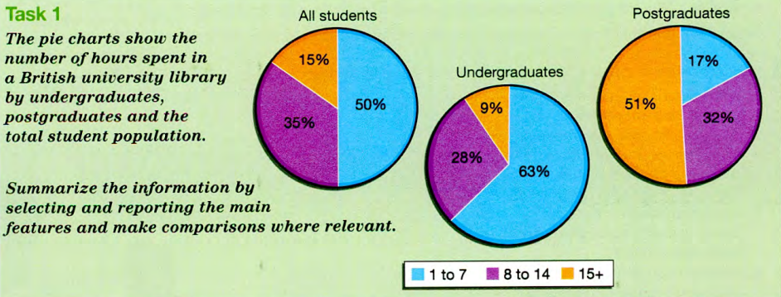
- Meanwhile, the (1) ___ (pattern / amount / majority) for postgraduate students was substantially different.
- Overall, the (2) ___ (pattern / size / proportion) of postgraduate students who spent fifteen hours a week or more in the library was very close to the entire student body who spent 1-7 hours in the library.
- The most striking difference in the data for undergraduates was that a sizable (3) ___ (majority / minority / number) spent only 1-7 hours per week in the library.
- A (4) ___ (majority / minority / total) of undergraduates (nine percent) used the library for fifteen or more hours per week.
- There is a clear (5) ___ (trend / progress / drift) towards using the library more as students move towards graduation and post-graduation.
- Undergraduate students were less likely than postgraduate students to use the library with just under (6) ___ (one quarter / one third / two-thirds) of the first group spending 1-7 hours there.
- About a (7) ___ (third / quarter / minority) of undergraduate students as opposed to nearly a third of postgraduate students spent between eight and fourteen hours studying.

ĐÁP ÁN
- pattern
- proportion
- majority
- minority
- trend
- two-thirds
- quarter

C. Writing

Exercise 7. You should spend about 20 minutes on this task

The charts below show the percentage of electricity consumed by different sectors in Eastern Australia in 2007 and 2010. Summarise the information by selecting and reporting the main features, and make comparisons where relevant.

Write at least 150 words.

Dạng bài: quiz_type_0

Easy IELTS - Task 1 - 20

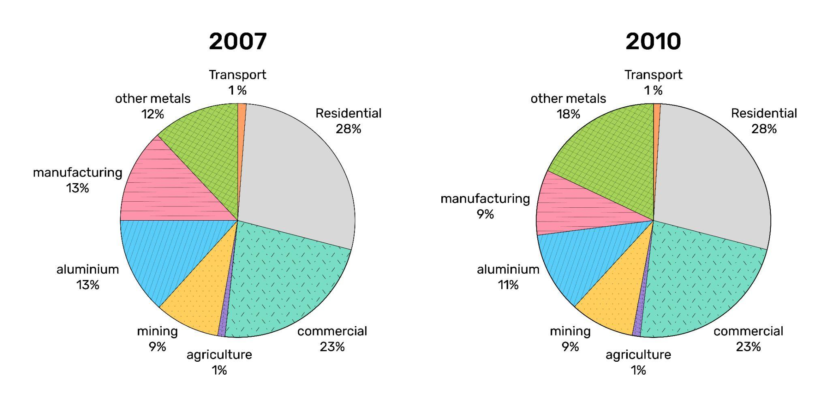

Model answer

The provided charts illustrate the distribution of electricity consumption across various sectors in Eastern Australia in the years 2007 and 2010.

Overall, the consumption of electricity from those sectors remained unchanged except for aluminium, manufacturing and other metal fields over the period shown. Furthermore, the figures for the residential and commercial sectors accounted for the largest portion of electricity usage.

The proportion of electricity consumption in the residential, commercial, transport, and agricultural sectors exhibited a remarkable stability from 2007 to 2010. Throughout both years, the residential and commercial sectors emerged as the dominant consumers, which together made up marginally over half of the total electricity consumption, with specific percentages of 28% and 23% respectively. Meanwhile, the transport and agricultural sectors maintained their consistent low levels of electricity consumption, each representing a mere 1% of the total electricity usage in both 2007 and 2010.

It is worth noting that despite the overall stability, there were noteworthy shifts in the electricity consumption patterns within the industrial sectors during this period. In 2007, the aluminium and manufacturing sectors each consumed 13% of the electricity, while mining and other metals accounted for 9% and 12% respectively. However, by 2010, there were discernible fluctuations. The aluminium sector experienced a moderate reduction in electricity consumption, dropping to 11%. Similarly, the manufacturing sector witnessed a decrease, falling to 9%. Conversely, the other metals sector displayed a substantial increase, consuming 18% of the electricity, indicating a notable shift in energy usage within the industrial landscape.

(246 words)

LESSON 4

A. Vocabulary

Exercise 1. Complete 1-6 with the correct forms of the verbs
Dạng bài: quiz_type_7
Examples
A river runs through London. (active)
Many electronic goods are manufactured in Japan. (passive: be + past participle)

- Manufacturing cement
Limestone is the main ingredient of cement. Firstly, it 1 (extract) ___________ from the ground. Then, at the factory, it 2 (heat) ___________ to a high temperature with other ingredients. After this, it 3 (cool) ___________ with blasts of cold air.
- How rain is formed
When warm air 4 (reach) ___________ high ground, it is forced to rise, and, as a result, it 5 (cool) ___________. Moisture in the air 6 (condense)___________ to form rain.
Key:
- is extracted
- is heated
- is cooled
- reaches
- cools
- condenses

Exercise 2. Match the words (1-10) with their correct definitions (A-J)
Dạng bài: quiz_type_7
- Transform ___ | a. The act of taking something out from a source.
- Extraction ___ | b. The process of improving or perfecting something.
- Gradual ___ | c. To put a plan or system into action.
- Implement ___ | d. A slow and steady process of change.
- Formation ___ | e. The process of creating or shaping something.
- Rapid ___ | f. To change something completely in appearance or form.
- Manufacture ___ | g. The process of making goods in a factory.
- Refinement ___ | h. A process that happens very quickly.
- Mechanized ___ | i. Operated by machines instead of humans.
- Initiate ___ | j. To begin or start something new.

Key:
- f
- a
- d
- c
- e
- h
- g
- b
- i
- j

B. Grammar

Exercise 3. Rewrite the two sentences as one, using a relative clause. Add commas where necessary

Dạng bài: quiz_type_7
- The scientist won an award. He discovered a new element.
______________________________________________________________________________________
- The book is very interesting. It explains climate change in simple terms.
______________________________________________________________________________________
- I met a woman yesterday. Her son works as a data analyst.
______________________________________________________________________________________
- The town has many historic buildings. It is located near the coast.
______________________________________________________________________________________
- The company introduced a new policy. The policy improved employee satisfaction.
______________________________________________________________________________________
- The smartphone has many useful features. I bought it last month.
______________________________________________________________________________________
- The manager gave a speech. His ideas were well received by the employees.
______________________________________________________________________________________
Key:
- The scientist who discovered a new element won an award.
- The book, which explains climate change in simple terms, is very interesting.
- I met a woman whose son works as a data analyst.
- The town, which is located near the coast, has many historic buildings.
- The company introduced a new policy, which improved employee satisfaction.
- The smartphone, which I bought last month, has many useful features.
- The manager, whose ideas were well received by the employees, gave a speech.

Exercise 4. Complete these definitions with the nouns and appropriate forms of the verbs in reduced relative clauses
Dạng bài: quiz_type_7
jigsaw | mermaid | cause | have | send | work
memo | shadow | cut | print | stand

- A (1) ___ is a written note (2) ___ between people (3) ___ in the same organization.
- A (4) ___ is an imaginary creature (5) ___ the body of a woman but a fish's tail instead of legs.
- A (6) ___ is a picture (7) ___ on cardboard or wood and (8) ___ into various shapes that have to be fitted together again.
- A (9) ___ is a dark area on a surface (10) ___ by an object (11) ___ between direct light and that surface.

ĐÁP ÁN
- memo
- sent
- working
- mermaid
- having
- jigsaw
- printed
- cut
- shadow
- caused
- standing

Exercise 5. Templates A and B below can be used for quiz_type_0 questions that involve writing about solutions to problems. Read the quiz_type_0 questions 1 and 2 and complete Templates A and B with the missing information a-h below
Dạng bài: quiz_type_7
- What can governments do to encourage children to eat a healthier diet?

Template A: “What is the solution?” quiz_type_0 questions
 | What are the possible solutions? | What specific action can be taken? | What are the positive consequences? | What are the drawbacks?
1 | Regulate the food industry | Require food producers to fortify their products with vitamins. | (1) ___ | This would be unpopular & expensive for food producers.
2 | Regulate school meals | (2) ___ | Children would have at least 1 healthy meal per day. | This would not stop children from bringing unhealthy packed lunches or going out for lunch to fast food outlets.
3 | (3) ___ | Require schools to teach children to cook healthy foods. | Children can take pride in their learning & transfer these skills to the home. | (4) ___

- Schools may not have the facilities to teach cooking.
- Children would eat healthier food without having to change their habits.
- Require schools to provide only healthy food and drink at lunch time.
- Educate children about healthy eating.
Key:
- b
- c
- d
- a
II. Should the government regulate the fast food industry in the same way that it regulates the drug, alcohol and tobacco industries?
Dạng bài: quiz_type_7

Template B: “Evaluate the solution” quiz_type_0 questions
What are the possible solutions? | What specific action can be taken? | Positive consequence(s) | Drawback(s)
Solution in the question:  Regulate the fast food industry like drug, alcohol & tobacco industries. | Restrict opening hours.  Restrict location, e.g. not near schools. | Send a clear signal that fast food is bad for health.  (5) _______________ | This would not stop people cooking & eating unhealthy food  at home.  (6) _______________
Other possible solution:  public health campaign explaining the dangers of eating too much fast food | television advertising showing long-term consequences of unhealthy diet | Help people change their eating habits fundamentally.  (7) _________________ | People could ignore government advice.  (8) _____________

e. Reduces people's access to unhealthy foods.
f. Effectiveness of public health campaigns can be difficult to measure.
g. Allows freedom of choice.
h. Too much government interference is unpopular with business & bad for the economy.
Key:
- e
- h
- g
- f

C. Writing

Exercise 6. You should spend about 40 minutes on this task

Traffic congestion is becoming increasingly problematic in major cities. What solutions can you suggest to help solve the problem?

Write at least 250 words.

Dạng bài: quiz_type_0

Easy IELTS - Task 2 - 21

Model answer

Major cities around the world are beset by a similar problem: traffic congestion. From Shanghai to New York, key cities in most developing or developed countries are tackling congested roads and all the negative consequences that this brings. Finding answers is an ongoing issue.

One key solution for the problem is public transport. In many places this is not convenient and too expensive which means that people still prefer to take their own cars rather than travel by bus, train or underground. Reducing the cost of public transport and checking that it works smoothly, for example by ensuring that buses link to key train stations and run late enough each day, will entice people back onto public transport systems.

Ensuring that this transport has proper staffing, in other words having ticket inspectors and staff at stations, will also help as people will feel safer. This would, for example, allow women travelling alone late at night to still feel secure.

Another way to persuade people to leave their cars at home is by increasing taxes on driving. Charging tax on parking and petrol could bring in more revenue to fund better roads or support other types of transport. For example, higher road tax could fund cycling paths within cities.

However, making travel by private car more difficult is only viable if reliable and affordable alternatives are in place. Another measure which could help is to develop more 'park and ride' schemes where people can park free at the edge of the city and catch a bus into the centre. There should also be more cycle paths available.

By having better alternatives in place and making them more attractive than using private cars, it may be possible to reduce the increasing problems with traffic congestion that modern cities face.

(301 words)

