LESSON 1

A. Vocabulary

Exercise 1. Put the words in the box in the correct parts of the mind map

Dạng bài: quiz_type_7
a.
Word List:
cottage, countryside, fresh air, pollution, a sense of community, infrastructure, a public transport system, high rises, congestion, open spaces, overdevelopment, slow pace
Rural communities have:
- (1) ___
- (2) ___
- (3) ___
- (4) ___
- (5) ___
- (6) ___
Rural communities don’t have:
7. (7) ___
8. (8) ___
9. (9) ___
10. (10) ___
11. (11) ___
12. (12) ___
b.
Word List:
overpopulated, remote, tranquil, isolated, frantic, traditional, simple, peaceful, crowded
Rural communities are:
13. (13) ___
14. (14) ___
15. (15) ___
16. (16) ___
17. (17) ___
18. (18) ___
Rural communities aren’t:
19. (19) ___
20. (20) ___
21. (21) ___

ĐÁP ÁN
- cottage
- countryside
- fresh air
- a sense of community
- open spaces
- slow pace
- pollution
- infrastructure
- a public transport system
- high rises
- congestion
- overdevelopment
- isolated
- simple
- peaceful
- remote
- tranquil
- traditional
- crowded
- overpopulated
- frantic

Exercise 2. Complete the sentences with the given phrases. Using capital letter if necessary

Dạng bài: quiz_type_7
sewage system | traffic congestion | recreational facilities | urban sprawl
shanty towns | police force | garbage collection

- We need a stronger (1) ___ to help keep the crime levels in our major cities down.
- The city has far more (2) ___ than rural areas, so young people don't get bored so easily.
- An efficient (3) ___ and frequent (4) ___ are both essential to maintaining sanitation in densely populated areas.
- (5) ___ creates enormous problems for people travelling around the city at peak times.
- Many people who move to the city from rural areas end up living in (6) ___ because of a shortage of housing.
- It is difficult to determine where the city ends because of the (7) ___.

ĐÁP ÁN
- police force
- recreational facilities
- sewage system
- garbage collection
- Traffic congestion
- shanty towns
- urban sprawl

B. Grammar

Exercise 3. Complete the following paragraph using the past simple or past continuous
Dạng bài: quiz_type_7
1. The Mysterious Noise
Last night, while I (1) ___ (do) my homework, I (2) ___ (hear) a strange noise outside the window. I (3) ___ (stand up) and (4) ___ (look) out, but I couldn't see anything. While I (5) ___ (try) to listen carefully, my brother suddenly (6) ___ (shout) from his room, which (7) ___ (make) me jump!
2. The Lost Wallet
Yesterday afternoon, while I (8) ___ (walk) home from school, I (9) ___ (notice) something on the ground. I (10) ___ (pick up) a wallet and (11) ___ (look) inside. It (12) ___ (contain) some money and an ID card. While I (13) ___ (decide) what to do, a man (14) ___ (run) towards me, shouting, "That's mine!".

ĐÁP ÁN
- was doing
- heard
- stood up
- looked
- was trying
- shouted
- made
- was walking
- noticed
- picked up
- looked
- contained
- was deciding
- ran

Exercise 4. Choose the correct answer

Dạng bài: quiz_type_7

arrived | break | broke | cancelled
forgot | got | had been cancelled | had broken
had forgotten | had left | had lost | leave
left | lose | lost | send
sent | take | took

- By the time I (1) ___ to the office, I realised I (2) ___ my keys at home.
- I (3) ___ about the meeting until John (4) ___ me a message in the morning.
- They (5) ___ at the airport when they found out the flight (6) ___.
- He (7) ___ his phone before he (8) ___ it to the repair shop.
- By the time they (9) ___ at the hotel, they (10) ___ their luggage.

ĐÁP ÁN
- got
- had left
- had forgotten
- sent
- arrived
- had been cancelled
- had broken
- took
- arrived
- had lost

Exercise 5. The sentences 1-5 on the left describe trends using there be + adjective + noun. Complete the sentences on the right using the corresponding verb + adverb

Dạng bài: quiz_type_7

Example:  There was a steep increase in sales of convenience food. | Sales of convenience food increased steeply.
1. There was a dramatic decrease in the use of dietary supplements. | The use of dietary supplements _____________________________________________.
2. There was a modest dip in levels of obesity. | Levels of obesity ______________________________________.
3. There was a slight fall in the production of genetically modified food. | The production of genetically modified food _________________________________________.
4. There was a significant drop in levels of malnutrition. | Levels of malnutrition _____________________________________________.
5. There was moderate fluctuation in the availability of seasonal produce. | The availability of seasonal produce  __________________________________.

Key:
- decreased dramatically
- dipped modestly
- fell slightly
- dropped significantly
- fluctuated moderately

Exercise 6. Look at the Task 1 question, then read the text and match options a-g with gaps 1-7 in the text

Dạng bài: quiz_type_7

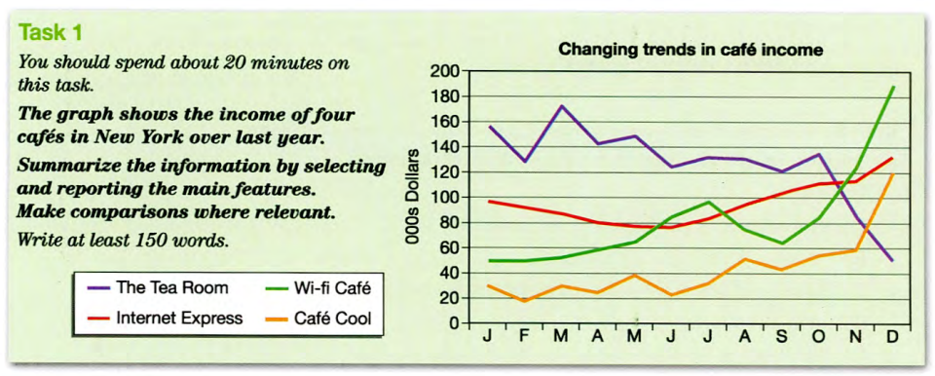
a. steadily
b. then rocketed
c. doubled
d. significantly
e. also went up
f. a steady fall
g. a rise

The graph provides information about the income trends of four cafes over the last year.
Overall, although the income for all four cafes showed some fluctuation from month to month, we can identify some general upward and downward trends. As regards the earnings for The Tea Room, they were down over the year falling 1. ___________ from almost $160,000 earnings a month to around $50,000 in December.
By contrast, the income for the other three cafes went up by varying degrees. There was 2. _________ in Cafe' Cool’s sales over the first ten months, followed by a sudden increase to $120,000. Furthermore, the income for both Internet Express and the Wi-fi Café 3. ________________ in December. The former experienced 4. ____________ to June but after that, income rose 5. __________________, ending the year at approximately $130,000. Likewise, the trend for Wi-fi Café was upward. Between January and July, earnings 6. _________________ from $50,000 to nearly $100,000 and 7. ____________ to around $190,000.
It is noticeable that the income for The Tea Room is lower in the winter months than for the other three cafes.

Key:
- d
- g
- e
- f
- a
- c
- b

C. Writing

Exercise 7. You should spend about 20 minutes on this task

The graph below gives information on the numbers of participants for different activities at one social centre in Melbourne, Australia for the period 2000 to 2020. Summarise the information by selecting and reporting the main features, and make comparisons where relevant.

Write at least 150 words.

Dạng bài: quiz_type_0

Easy IELTS - Task 1 - 20

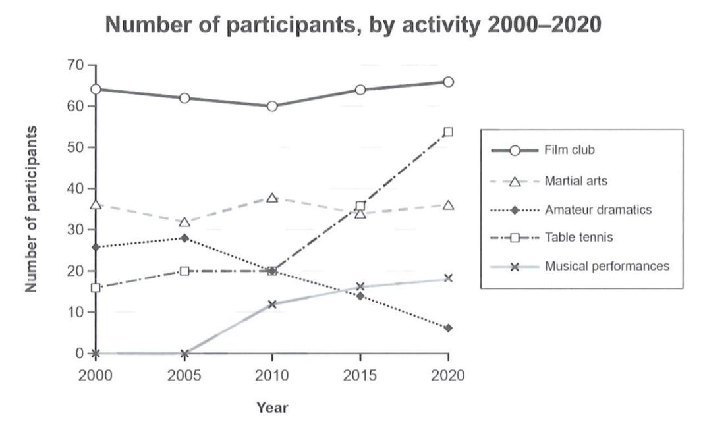

Model Answer

The line chart illustrates the number of participants in various activities at a social center in Melbourne, Australia, over the years 2000 to 2020.

Overall, the film club consistently attracted the highest number of participants, while table tennis experienced the most dramatic growth. In contrast, the popularity of amateur dramatics declined sharply, whereas martial arts participation remained relatively stable throughout the period.

In 2000, the film club was the most popular activity, with approximately 64 participants, and this figure remained relatively steady before rising to nearly 67 by 2020. Martial arts followed a similar pattern, starting at 40 and fluctuating slightly before ending the period at around 37 participants.

By contrast, table tennis showed the most remarkable upward trend, starting at 18 participants in 2000 and surging to 55 by 2020. Conversely, amateur dramatics began with 27 participants but plummeted to only 5 at the end of the period. Musical performances, which were introduced in 2005, witnessed a steady rise, reaching around 20 participants by 2020.

(166 words)

LESSON 2

A. Vocabulary

Exercise 1. Match the adjectives and nouns to make five collocations to fill the gaps in the sentences below
Dạng bài: quiz_type_7
adjectives | nouns
oily processed wholemeal  mental fizzy | drinks bread fish  health foods

- Wholemeal bread is usually considered to be healthy because it contains the complete grain, with nothing taken out.
- __________________ may taste good when you’re very thirsty, but they often have a high sugar content.
- Types of __________________ include salmon.
- __________________ often contain artificial colours to make them look more attractive.
- Some foods can be good for our __________________ as well as our bodies.
Key:
2. Fizzy drinks
3. oily fish
4. Processed foods
5. mental health

Exercise 2. Read the passage then match the words in column A with their correct definitions in column B

Dạng bài: quiz_type_7
Some foods are considered to be superfoods - foods that may prevent diseases and improve mental as well as physical health. Foods that are often listed as superfoods include:
• Blueberries: may improve short-term memory and slow the ageing process
• Apples: a good source of vitamin C; they can also lower cholesterol.
• Spinach: high in vitamin A; it can boost the immune system.
• Vegetable juice (especially tomato): can reduce the risk of heart disease.

A | B
- mental ___ | a. of the body
- physical___ | b. make less likely that it will happen
- short-term___ | c. of the mind
- ageing process___ | d. the changes to our body and mind by which we grow by
- source___ | e. lasting a short time
- reduce the risk___ | f. the place it comes from

Key:
- c
- a
- e
- d
- f
- b

B. Grammar

Exercise 3. Complete the sentences using the correct form of the verbs in brackets (Past Simple, Past Continuous, Past Perfect, or Present Perfect)

Dạng bài: quiz_type_7

I (never/visit) _______________ Italy, but I would love to go there one day.

While we (walk) _______________ in the park, it started to rain heavily.

She (finish) _______________ her homework before the guests arrived.

They (live) _______________ in London for five years before moving to New York.

My friend (call) _______________ me three times this morning.

By the time we got to the cinema, the movie (already/start) _______________.

He (not/see) _______________ his grandparents since last summer.

When I was young, I (play) _______________ football every Sunday.

Key:

have never visited

were walking

had finished

had lived

has called

had already started

has not seen

played

Exercise 4. Rewrite the sentence without changing the meaning

Dạng bài: quiz_type_7

1. I haven’t met my best friend since I was 18 years old.

→ I last ____________________________________________________ .

2. My children haven’t been taken to the supermarket since they were in grade 5.

→ The last time ____________________________________________________ .

3. When did you start waiting for the train?

→How long ____________________________________________________ ?

4. They started studying Spanish and Chinese 5 years ago.

→ They have ____________________________________________________ .

5. My younger sister has not had her hair cut for over five months.

→ It’s ____________________________________________________ .

6. My friend has never seen such a beautiful girl in his life.

→ This is the first time ____________________________________________________ .

7. John hasn’t played piano since 2015.

→ The last time ____________________________________________________ .

8. We have never met such a kind person before.

→ It’s the first time ____________________________________________________ .

9. Have you traveled to Thailand before?

→ Is this ____________________________________________________ ?

10. The last time I saw my father was 10 years ago.

→ I have ____________________________________________________ .

Key:

saw my best friend when I was 18 years old

my children were taken to the supermarket was when they were in grade 5

have you waited for the train

studied Spanish and Chinese for 5 years

been over five months since my younger sister last had her hair cut

my friend has seen such a beautiful girl in his life

John played piano was in 2015

we have met such a kind person

the first time you have traveled to Thailand

not seen my father for 10 years.

Exercise 5. Read the Task 1 question and the model answer. Then write all the examples of the following in the model answer

The maps below show changes in the Spanish city of Castellón in recent times. Summarize the information by selecting and reporting the main features, and make comparisons where relevant.

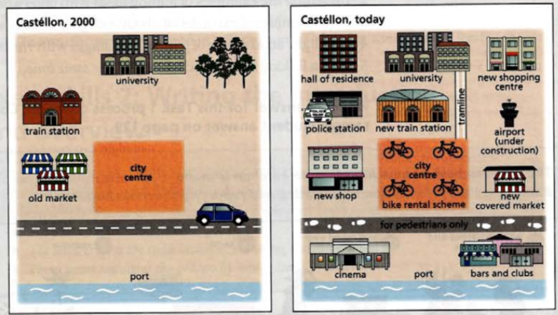

Model Answer
The two maps show the main changes which have taken place in the town of Castellón between the year 2000 and today.
In general, it appears that Castellón has become a much more modern city, with far more shopping and transport facilities.
One interesting change is that a new tram line has been built, to connect the university with the town centre. In 2000, there wasn't any accommodation for students, but a hall of residence has been built near the university. Another striking change is that the old market in the west of the city has been knocked down to make way for new shops. A completely new covered market has also been built on the other side of town.
If we look at the port area, it has been pedestrianized since 2000, and a range of entertainment facilities have been built, such as cinemas, bars and clubs. The north-east of the city used to be a green area, with lots of trees, but the trees have been cut down, and a new shopping complex has been constructed. A final interesting development has been the introduction of a bike-rental scheme in the city centre.

Dạng bài: quiz_type_7
1. Present Perfect Passive:
- Example: has been built
- (1) ___
- (2) ___
- (3) ___
- (4) ___
- (5) ___
- (6) ___
2. Phrases to introduce changes:
- Example: One interesting change is…
- (7) ___
- (8) ___
- (9) ___

ĐÁP ÁN
- has been knocked down
- has also been built
- has been pedestrianized
- have been built
- have been cut down
- has been constructed
- Another striking change is…
- If we look at…
- A final interesting development has been

Exercise 6. Complete these sentences with the given words

Dạng bài: quiz_type_7

conversion | redevelopment | modernization
building | expansion | introduction

- It is interesting to note that there has been a ______________ of the port area.
- Another striking change is the ______________ of the university.
- A notable change has been the ______________of the old train station into a police station.
- The whole city has experienced a significant ______________ in the last ten years.
- An interesting development has been the ______________ of a bike-rental scheme.
- There didn't use to be a cinema or shops near the port, but the last few years have seen the ______________ of new facilities in the port area.
Key:
- redevelopment
- expansion
- conversion
- modernization
- introduction
- building

C. Writing

Exercise 7. You should spend about 20 minutes on this task

The diagram below shows the floor plan of a public library 20 years ago and how it looks now. Summarise the information by selecting and reporting the main features, and make comparisons where relevant.

Write at least 150 words

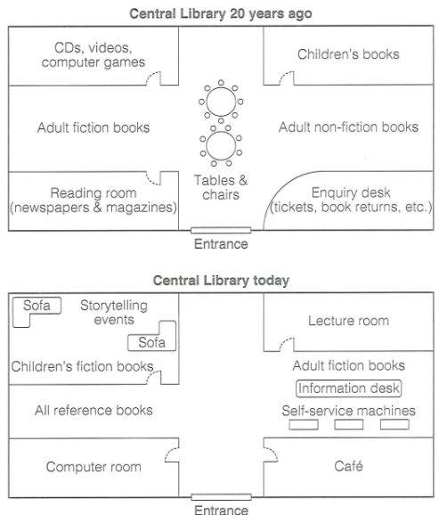

Dạng bài: quiz_type_0

Easy IELTS - Task 1 - 20

Model answer

The diagrams illustrate the layout of a public library two decades ago compared to its current design.

Twenty years ago, the library mainly focused on books and reading materials, with separate sections for adult fiction, non-fiction, children's books, and reference books. The centre of the library was occupied by tables and chairs, and there was an enquiry desk near the entrance.

Today, the enquiry desk has been replaced by self-service machines and an information desk. The area for CDs, videos, and computer games has been transformed into a computer room, while a café has been introduced in the bottom-right corner. Additionally, the children's section now includes storytelling events and sofas, making the library more child-friendly.

Overall, the library has undergone significant renovations, with the addition of modern facilities such as a computer room, café, and self-service machines. While some sections like adult fiction books have remained in the same location, others have been replaced or repurposed to accommodate new services.

(160 words)

LESSON 3

A. Vocabulary

Exercise 1. Match the words below with their correct definitions
Dạng bài: quiz_type_7
Words | Definitions
- Attic ___ | a. An outdoor area at the back or front of a house, often paved
- Balcony ___ | b. A small platform with a railing, accessible from an upper-floor room
- Basement ___ | c. A long passage inside a building that connects rooms
- Bay window ___ | d. A large window that projects out from a wall, often creating a small seating area
- Chimney ___ | e. An enclosed space at the top of a house, often used for storage
- Corridor ___ | f. A structure on the roof that allows smoke to escape from a fireplace
- Patio ___ | g. An underground level of a building, often used for storage or living space
- Porch ___ | h. A covered shelter at the entrance of a house
- Terrace ___ | i. A flat outdoor area connected to the house, often on an upper floor
- Vaulted ceiling ___ | j. A ceiling with arches that adds height and elegance to a room

Key:
- e
- b
- g
- d,
- f
- c
- a
- h
- i
- j

Exercise 2. Complete the sentences using the correct word from the list
Dạng bài: quiz_type_7

attic | balcony | basement | bay window | chimney
corridor | patio | porch | terrace | vaulted ceiling

- The __________ provided extra storage space for old furniture and boxes.
- The __________ was decorated with plants and comfortable chairs.
- The living room felt larger thanks to the __________ that let in more sunlight.
- The house had a __________ with a table and chairs, perfect for outdoor dining.
- Smoke from the fireplace rose through the __________.
- The __________ connected the bedrooms to the bathroom.
- The master bedroom opened onto a small __________ overlooking the garden.
- The __________ design made the living room feel more spacious and elegant.
- The children loved playing in the __________ on rainy days.
- Guests waited on the __________ before entering the house.
Key:
- attic
- patio
- pay window
- terrace
- chimney
- corridor
- balcony
- vaulted ceiling
- basement
- porch

B. Grammar

Exercise 3. Rewrite the following statements as either WH-questions or Yes/No questions.
Dạng bài: quiz_type_7

1. She studies English because she wants to study abroad.

→ Why _________________________________________________ ?
2. They completed the project last Monday.
→ When _________________________________________________ ?
3. This painting belongs to Sarah.
→ Whose _________________________________________________ ?
4. The library closes at 7 PM.
→ What time _________________________________________________ ?
5. He has been working here for five years.
→ How long _________________________________________________ ?
6. There are three international airports in this country.
→ How many _________________________________________________ ?
7. The manager approved the new policy.
→ Did _________________________________________________ ?
8. The company will launch a new product next month.
→ Will _________________________________________________ ?
Key
- does she study English
- did they complete the project
- painting is this
- does the library close
- has he been working here
- international airports are there in this country
- the manager approve the new policy
- the company launch a new product next month

Exercise 4. Each sentence below contains a mistake in the WH-question or Yes/No question. Identify the mistake and rewrite the correct version.
Dạng bài: quiz_type_7

What time the meeting starts? ___

Do can you help me with this assignment? ___

Where you went for your last vacation? ___

Is she liking her new job? ___

How much costs this laptop? ___

Does she can speak French fluently? ___

Who does wrote this book? ___

Why you didn’t call me yesterday? ___
Key
- What time does the meeting start?
- Can you help me with this assignment?
- Where did you go for your last vacation?
- Does she like her new job?
- How much does this laptop cost?
- Can she speak French fluently?
- Who wrote this book?
- Why didn’t you call me yesterday?

Exercise 5. The diagram shows what happens when a tourist arrives at a US airport. Number the sentences a-g in the correct order to describe the process.

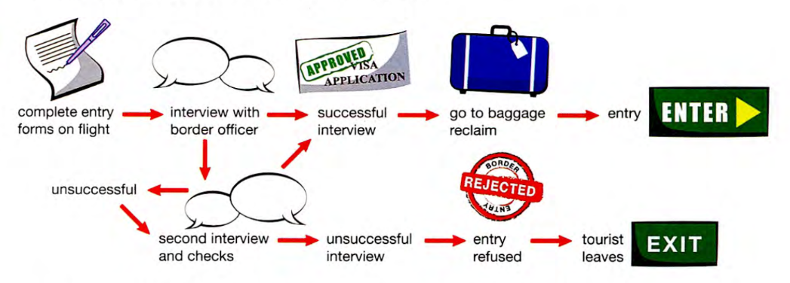
Dạng bài: quiz_type_7
Sentences to complete and order:
a. In this final phase, the second interview may resolve any problems and for this reason the tourist will be approved for entry. However if the second interview is still a problem, the tourist may have to leave due to the negative outcome.
b. First of all, the tourist completes an entry form during the flight and (1) ___ (get) his/her passport and visa ready.
c. If approved, the tourist then (2) ___ (go) to baggage reclaim to collect his/her luggage and can enter the country.
d. The process shown in the diagram illustrates the steps followed when a tourist goes through the immigration process to enter the USA.
e. The next stage is at the airport. On arrival, the form (3) ___ (inspect) by a border officer and the tourist is asked questions. A decision (4) ___ (make) as a consequence of this interview.
f. This decision is the end of the process for most people because there is no complication and therefore entry is approved.
g. Occasionally there are some concerns in the interview and because of this, a second interview may be required.
Ordering the process (Sequence 1 to 7):
- Step 1 (Introduction): (5) ___
- Step 2: (6) ___
- Step 3: (7) ___
- Step 4: (8) ___
- Step 5: (9) ___
- Step 6: (10) ___
- Step 7: (11) ___

ĐÁP ÁN
- gets
- goes
- is inspected
- is made
- d
- b
- e
- f
- c
- g
- a

Exercise 6. Complete the sentences with the active or passive form of the verbs in brackets
Dạng bài: quiz_type_7
- The process shown in the diagram illustrates the steps followed when a tourist goes through the immigration process to enter the USA.
- First of all, the tourist completes an entry form during the flight and (1) ___ (get) his/her passport and visa ready.
- The next stage is at the airport. On arrival, the form (2) ___ (inspect) by a border officer and the tourist is asked questions. A decision (3) ___ (make) as a consequence of this interview.
- This decision is the end of the process for most people because there is no complication and therefore entry is approved.
- If approved, the tourist then (4) ___ (go) to baggage reclaim to collect his/her luggage and can enter the country.
- Occasionally there are some concerns in the interview and because of this, a second interview may be required.
- In this final phase, the second interview may resolve any problems and for this reason the tourist will be approved for entry. However if the second interview is still a problem, the tourist may have to leave due to the negative outcome.

ĐÁP ÁN
- gets
- is inspected
- is made
- goes

C. Writing

Exercise 7. You should spend about 20 minutes on this task.

The picture shows the process of making wool.

Summarise the information by selecting and reporting the main features and make comparisons where relevant.

Write at least 150 words.

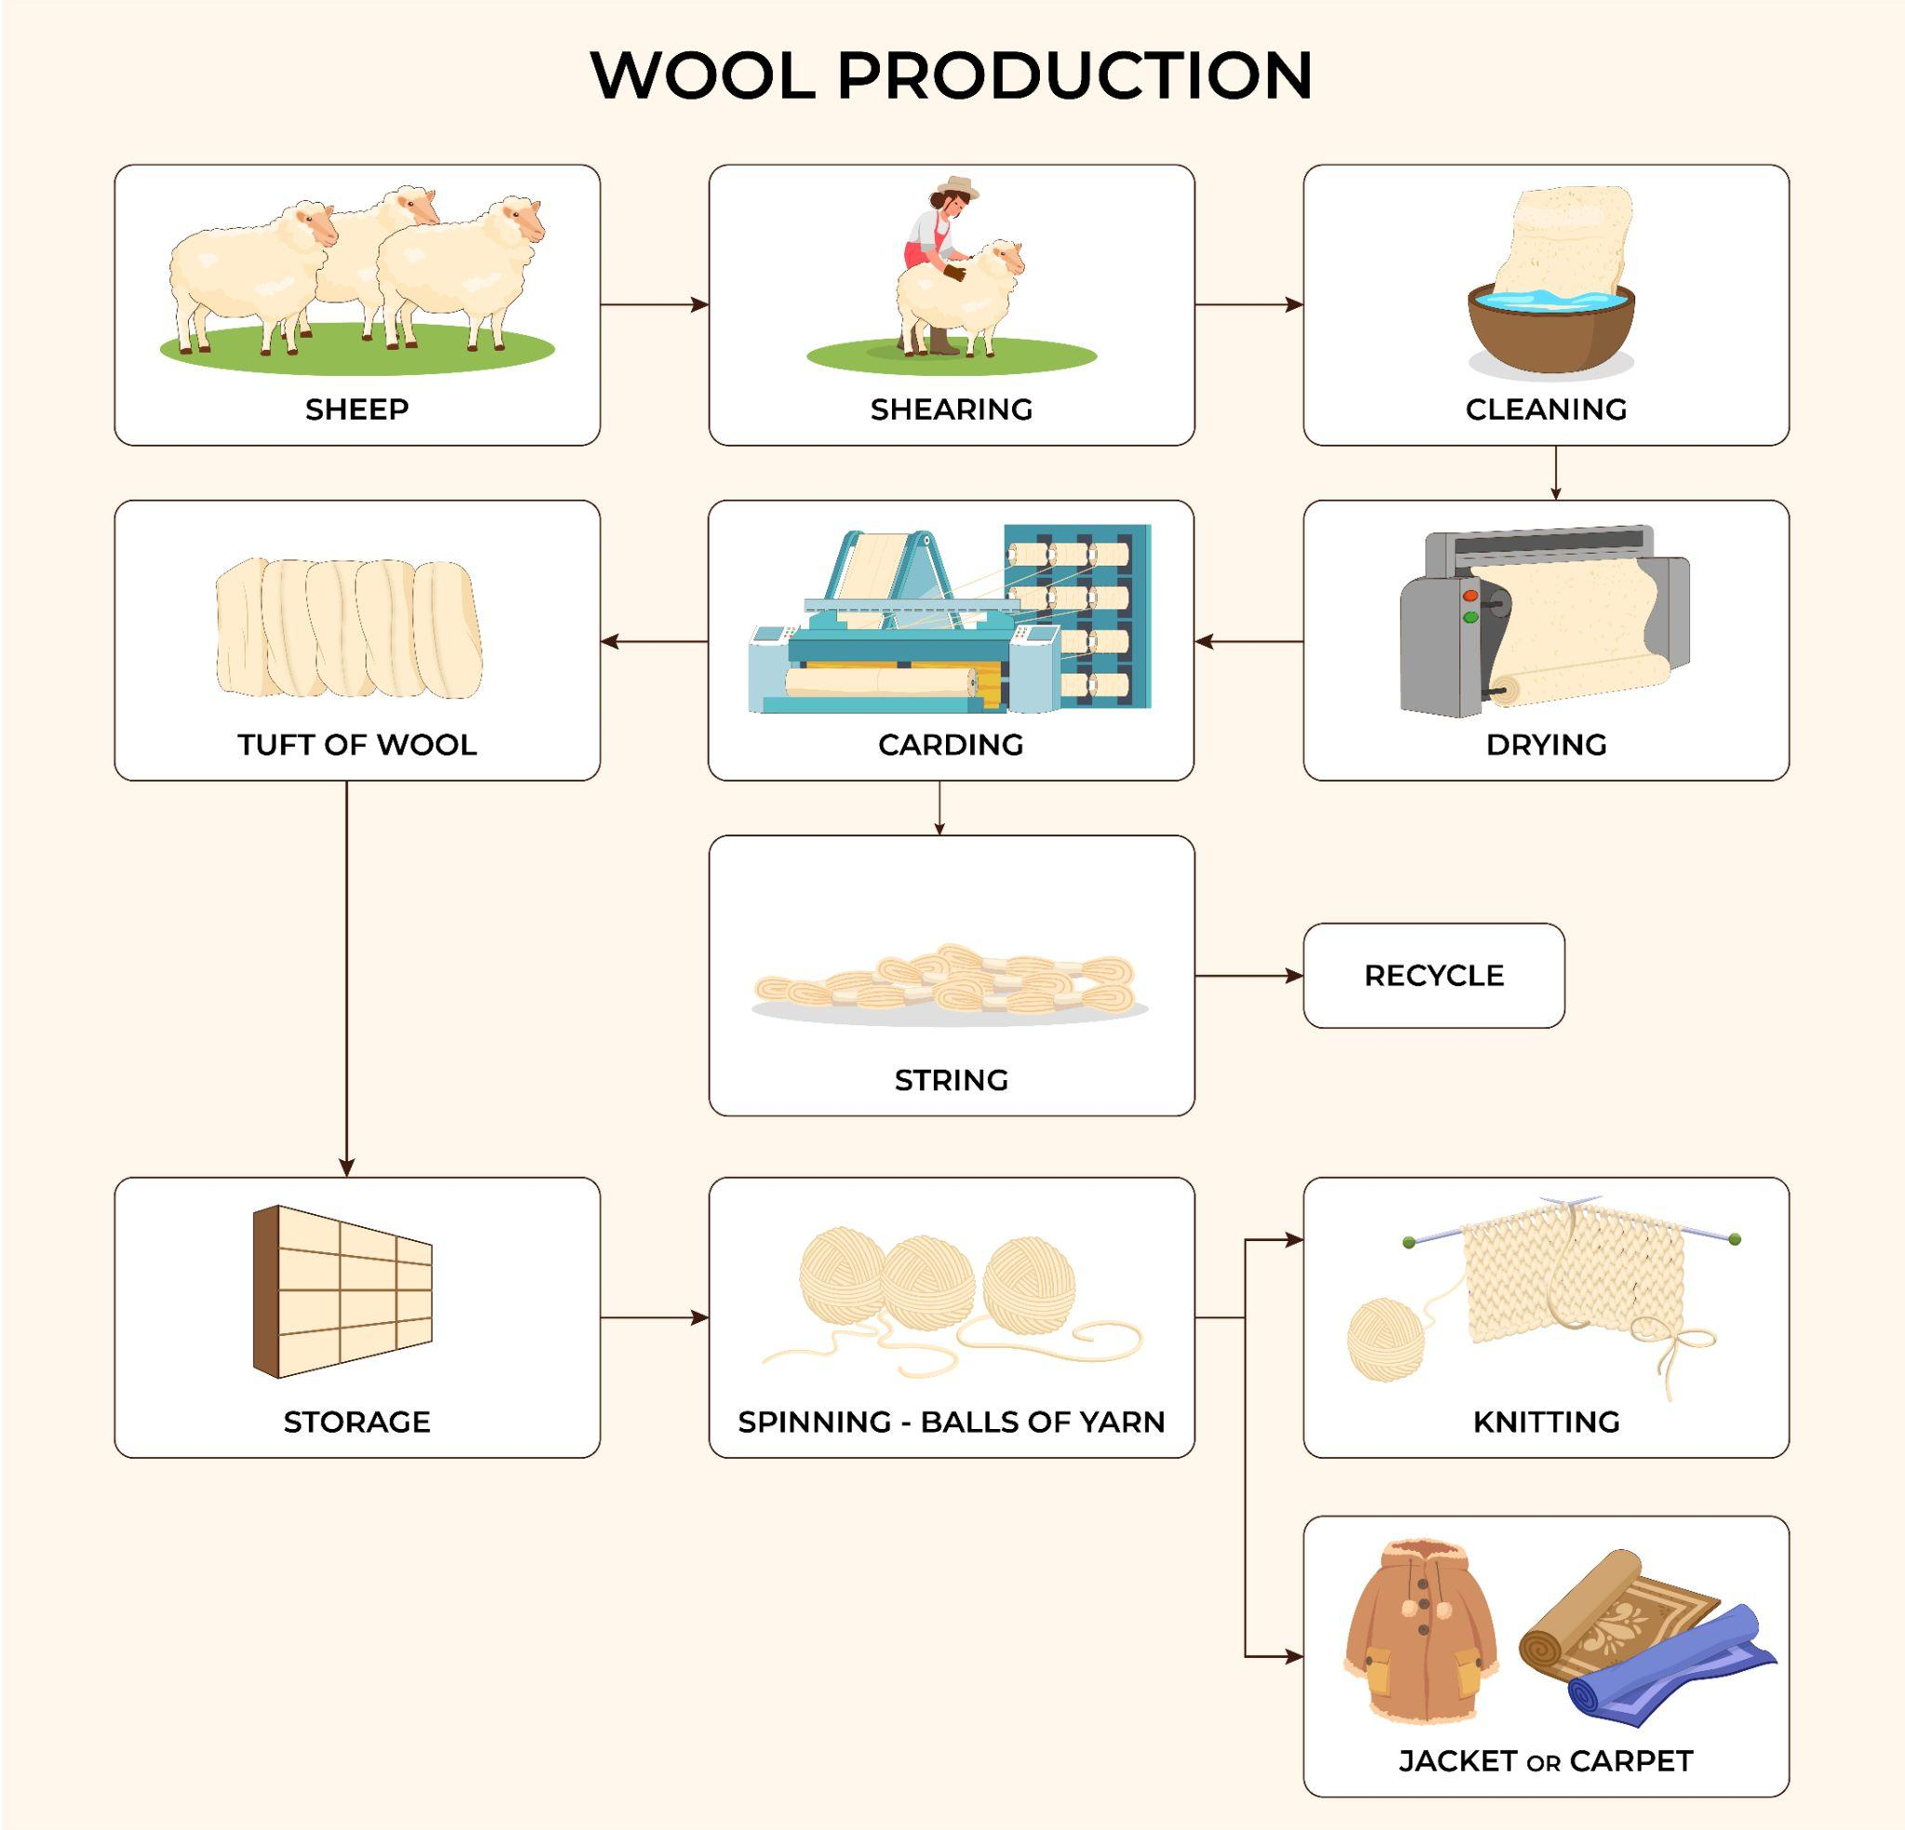

Dạng bài: quiz_type_0

Easy IELTS - Task 1 - 20

Model answer

The diagram illustrates the intricate process involved in the production of wool.

Overall, the wool production procedure involves two primary stages, commencing with sheep herding and ending with the transformation of yarn into various industrial products through knitting or weaving processes.

The first stage involves collecting raw materials and preparing them. Specifically, sheep are nurtured until they reach maturity, developing a thick layer of fur. This fur is then carefully sheared and subjected to a thorough cleansing process, involving water, to eliminate any dirt and impurities. Once cleaned, the damp fur is transferred to a drying machine to remove excess moisture. Subsequently, the dried fur undergoes carding, a process in which a wire instrument is used to brush and align the wool fibres, transforming them into a unified strand ready for further manufacturing stages.

The processing of the prepared materials is shown in the second stage. The wool is transformed into sizable wool tufts, which are then stored, while the leftover strings, considered by-products, are recycled at a later stage. In the final step, the wool tufts are spun into yarn balls that serve multiple purposes, including knitting or manufacturing various woollen products like jackets and carpets.

(197 words)

LESSON 4

A. Vocabulary

Exercise 1: Look at the maps of Sunnyhill University campus in 1995 and today then find the information below in the model answer

Dạng bài: quiz_type_7
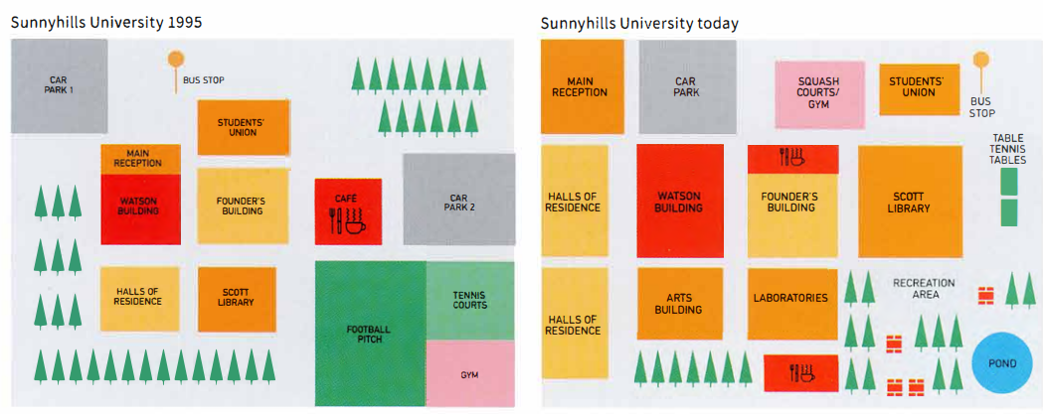

The two maps show changes to the campus of Sunnyhills University between 1995 and today. We can see that the university made many changes during this period, including new buildings and recreation facilities.
In the past, the Scott Library was in front of the Founder's Building. It was relocated to the right, and in addition, it increased in size. The old library building now contains laboratories. In 1995 there was a car park in the top left-hand corner of the campus, whereas now the main reception is there. The halls of residence were moved to the far left of the campus and a new Arts Building was built opposite them.
The old sports ground, gym and tennis courts were demolished; however, in their place the university created a new recreation area with a pond, trees and seating areas. What is more, the university developed new sports facilities, including table tennis tables, a new gym and squash courts. They also built two new cafés.
So, it is clear that the university changed and expanded during this period.

1. Verbs describing change:
Example: was relocated
(1) ___
(2) ___
(3) ___
(4) ___
(5) ___
(6) ___
(7) ___
(8) ___
2. Expressions describing where things are:
Example: in front of
(9) ___
(10) ___
(11) ___
(12) ___

ĐÁP ÁN
- increased
- were moved
- was built
- were demolished
- created
- developed
- changed
- expanded
- to the right
- in the top-left hand corner
- the far left of the campus
- opposite

Exercise 2: Fill in the blanks using the correct word from the box.
Dạng bài: quiz_type_7

(expand, demolish, convert, replace, construct, widen, develop, reduce, renovate, relocate)

The old factory was _________ to make space for a new shopping mall.

The town council decided to _________ the narrow road to ease traffic congestion.

The number of trees in the park was _________ due to new housing developments.

A new hospital will be _________ in the city center next year.

The old library was _________ into a modern community center.

The school was _________ to a larger building to accommodate more students.

The company plans to _________ its offices to other regions in the country.

The government has a plan to _________ the town by adding more facilities.

The historic building was _________ to preserve its original design.

The outdated bridge will be _________ with a more modern structure.

Key:
- demolished
- widen
- reduced
- constructed
- converted
- relocated
- expand
- develop
- renovated
- replaced

B. Grammar

Exercise 3. Choose the correct modal of obligation to complete the sentence
Dạng bài: quiz_type_14

- You __________ submit your quiz_type_0 by tomorrow. It's the final deadline.
a) must
b) have to
c) need to
- We __________ wear a uniform at school. It's the rule.
a) have to
b) should
c) ought to
- He __________ call his boss if he wants to take a day off.
a) must
b) should
c) needs to
- You __________ eat more vegetables if you want to stay healthy.
a) must
b) should
c) have to
- The students __________ bring their ID cards to enter the library.
a) need to
b) have to
c) ought to
- You __________ follow the rules when using the computer lab.
a) must
b) need to
c) should
- Everyone __________ be on time for the meeting.
a) must
b) ought to
c) need to

Exercise 4. Complete the sentences using the correct modal of obligation in the past (had to, didn't have to, should have, needn't have)
Dạng bài: quiz_type_7

- We __________ leave early because the meeting was cancelled.
- You __________ called me last night. I was waiting for your answer!
- They __________ study hard for the exam because the questions were really difficult.
- I __________ bought so much food. There was already enough at home.
- She __________ tell the manager about the mistake, but she didn't.
- He __________ apologize for being late, but he didn't think it was necessary.
- We __________ book a taxi because the train was on time.
- They __________ paid for the tickets in advance, but they waited until the last minute.
Key
1. didn't have to/did not have to
2. should have
3. had to
4. needn't have/ need not have
5. should have
6. should have
7. didn't have to/ did not have to
8. should have

Exercise 5. Nouns can be used to express advantages and disadvantages. Complete sentences with words from the box
Dạng bài: quiz_type_7

benefit | problems | chance | gain
opportunities | handicap | drawbacks

Not knowing a foreign language has its __________________, such as when one tries to make contact with people in other countries.

Visiting other countries gives people the __________________ to experience cultures first hand.

The financial __________________ to any nation exceeds all other benefits.

If people take time to find out about the country they are travelling to, they will face fewer __________________.

These days, not having access to the Internet to find out what is going on is a serious __________________.

Cultural exchanges offer enormous __________________ to the nations that are involved.

Being culturally aware is of great __________________ in business.

Key:

drawbacks

chance

gain

problems

handicap

opportunities

benefit

Exercise 6. Look at the Task 2 questions and skim the model answer below to find the main points, then complete this table about moving away

Dạng bài: quiz_type_7
Write about the following topic:
These days, more and more people are going to other countries for significant periods of time, either to find a job or to study. There are clearly many benefits to doing this, but people who live abroad can also face some difficulties.
Discuss the advantages and disadvantages of living and working in a foreign country. Give reasons for your answer and include any relevant examples from your own knowledge or experience.
Write at least 250 words.

Model answer
Nowadays, taking a year out to live or study abroad is becoming increasingly popular. For many people, especially young adults, the chance to spend an extended period of time overseas is an attractive one. However, there are both pros and cons to deciding to do this. In this quiz_type_0, I will discuss some of the reasons why moving abroad is so popular and some of the challenges to be overcome.
Let's begin by looking at the advantages of moving away. One of the main positives of heading overseas is that it broadens your horizons. What I mean by this is that you have the chance to meet people from different cultural backgrounds and learn to cope with foreign customs and food. This can make you more rounded as a person.
Secondly, moving abroad can lead to a better quality of life. Take British people for example. Thousands of people from the UK move to Spain and Australia every year. These countries have warmer climates and encourage a better work-life balance. In addition, by living overseas, you can gain qualifications and language skills, which may improve promotion prospects on your return.
Turning to the other side of the argument, culture shock is a major problem. Many people who take a year out find it hard to cope with the language barrier, the food and general cultural differences. This often leads to homesickness and in some cases a sense of isolation.
Another issue is that it can be difficult to start a new life from scratch. In other words, when you move abroad, you have to make new friends and find your place in the community. This process takes time and can be especially challenging if there is also a language barrier to deal with.
All things considered, starting life in a foreign country is never easy. You need to weigh up the pros of the better lifestyle, weather and so on, and the cons of culture shock and language barrier. Personally, I believe the benefits in terms of personal growth eventually outweigh any negatives.

Advantages & Examples:
- Advantage 1: (1) ___
  - Example 1a: (2) ___
  - Example 1b: (3) ___
- Advantage 2: (4) ___
  - Example 2: (5) ___
- Advantage 3: (6) ___
  - Example 3: (7) ___
Disadvantages & Examples:
- Disadvantage 1: (8) ___
  - Example 1: (9) ___
- Disadvantage 2: (10) ___
  - Example 2: (11) ___

ĐÁP ÁN
- broaden horizons
- meet people from different cultural backgrounds
- experience new food, customs
- improved quality of life
- weather - Spain/Australia
- gain qualifications and language skills
- improve promotion prospects
- culture shock
- language barrier, the food and general cultural differences
- difficult to start a new life
- make new friends

C. Writing

Exercise 7. You should spend about 40 minutes on this task.

Write about the following topic:

Travellers and business people often come into contact with other cultures briefly. What are the main advantages and disadvantages of doing so? Give reasons for your answer and include any relevant examples from your own knowledge or experience.

Write at least 250 words

Dạng bài: quiz_type_0

Easy IELTS - Task 2 - 21

Model answer

In the era of globalization, it is increasingly common for travellers and business professionals to interact with foreign cultures during short visits. This type of brief cultural exposure presents both benefits and drawbacks, which will be discussed in this quiz_type_0.

One significant advantage of such interactions is the opportunity to broaden one’s cultural awareness. Even short-term exposure to different traditions, languages, and customs can foster greater tolerance and understanding between people of diverse backgrounds. For instance, business people working with international partners may develop a more open-minded perspective on different working styles, which can enhance collaboration and productivity. Additionally, travellers can gain valuable insights into local customs, enriching their personal experiences and promoting cross-cultural appreciation.

However, there are also notable disadvantages associated with brief cultural encounters. One key drawback is the risk of forming superficial or stereotypical perceptions of other cultures. Limited interactions may not provide a full understanding of the complexities of a society, potentially leading to misunderstandings or reinforcing cultural biases. For example, a tourist who only visits popular tourist attractions might view a country solely through a commercialized lens, missing out on deeper aspects of its traditions and way of life. Moreover, short visits may not allow enough time to overcome language barriers, which can hinder meaningful communication.

In conclusion, while brief contact with foreign cultures can promote cultural exchange and broaden perspectives, it also poses the risk of reinforcing stereotypes and limiting deeper understanding. To fully benefit from such experiences, it is essential to approach them with an open mind and a willingness to learn. Both travellers and business people should strive to engage more actively with local communities to gain a more comprehensive appreciation of other cultures.

(282 words)

