LESSON 1

A. Vocabulary

Exercise 1. Choose the correct answer
Dạng bài: quiz_type_14
- If he's been bitten by a snake, we'll have to get him to a hospital to get the (1) ___ (vaccine / antidote) immediately.
- They give most children a number of (2) ___ (vaccines / antidotes) these days to stop them getting serious diseases.
- Have you been (3) ___ (inoculated / injected) against tetanus?
- The symptoms are small red spots and slight skin (4) ___ (irritation / annoyance).
- I've cut my finger. Have you got (5) ___ (plaster / a plaster)?
- Richie's broken his leg and it's in (6) ___ (plaster / a plaster).
- My (7) ___ (diagnosis / prognosis) is that you're suffering from stress.
- If you carry on taking the tablets, then your (8) ___ (diagnosis / prognosis) is excellent.
- (9) ___ (Preventive / Protective) medicine's all about not getting diseases rather than curing them after you've got them, isn't it?
- My grandmother spent the last two years of her life in a nursing (10) ___ (house / home).

ĐÁP ÁN
- antidote
- vaccines
- inoculated
- irritation
- a plaster
- plaster
- diagnosis
- prognosis
- Preventive
- home

Exercise 2. Complete using the words in the box in the correct form
Dạng bài: quiz_type_7
administer | admit | agony | consultant | diagnosis | leave
numb | paralysis | prescribe | side | syringe | ward

26th August
I haven't written anything for about two weeks, so it's time to catch up on what's been going on. So, the morning after my last entry, I woke up in (1) _____________. I've never felt so bad in my life. In fact, it felt like I'd been shot in the stomach. I immediately arranged to go on sick (2) _____________ from work. Then I called the doctor, who came that morning and (3) _____________ some medicine for me. I took
it for about two days but my stomach was still really bad, so I called the doctor again. He said I'd have to be (4) ______________ to hospital! Well, I've never been in hospital in my life. They took me in an ambulance and put me in a (5) _______________
with about 20 other people. In the afternoon, the (6)_________________ came to see me. Her (7) __________ was that I'd got some kind of ulcer caused by bacteria. She said they'd have to (8) ______________ antibiotics via an intravenous drip. So, basically for the next six days I had a big (9) __________ sticking into my arm pumping in antibiotics on a regular basis. It wasn't much fun, but I did start to feel better pretty quickly. One problem, though, was that the drugs did produce one strange (10)________ effect. Apparently that sometimes happens. The whole of the left side of my face went (11) _________. It wasn't exactly (12) ___________ because I could still move my cheek -I just couldn't feel it. Very weird! Anyway, I'm home now, and feeling fine. And back to work tomorrow, thank goodness.
Key:
- agony
- leave
- prescribed
- admitted
- ward
- consultant
- diagnosis
- administer
- syringe
- side
- numb
- paralysis

Exercise 3. Complete using the correct form of the words in the box
bureaucracy | convict | deterrent | legislation | reform
community | corruption | institution | prejudice | state

Dạng bài: quiz_type_7
The demand for prison (1) _____________ has steadily increased as more and more people have come to see that locking people up in (2) ______________ simply doesn't reduce crime. Not only does it fail to act as a (3) ________________, but it does very little to help (4) _______________ readjust to life back in the (5) _____________ after they have served their time. Prisons are isolated places, where prisoners learn from other criminals, and where bullying, bribery and other forms of (6) _____________ spread. Once outside prison, offenders face (7) ________________, which tends to force them back into a life of crime. Even once the (8) _____________ recognises the need for change, it is notoriously slow. It usually demands new (9) ____________ to change the system, and while the slow processes of (10)______________ go on, more and more lives are affected.
Key:
- reform
- institutions
- deterrent
- convicts
- community
- corruption
- prejudice
- state
- legislation
- bureaucracy

B. Grammar

Exercise 4. Match to make sentences
Dạng bài: quiz_type_7
1 If you stay with us for three days, | - we might get served a bit more quickly.
2. If you decide not to vote in the election, | - give us a call and we'll come to pick you up.
3. If you didn't eat your lunch so fast, | - very few people would obey the law.
4. If there were a few more people working, | - you wouldn't get hiccups, would you?
5. If you forget to take your passport, | - they have to go through a complicated procedure.
6. If the hire car isn't there when you arrive, | - we'd be happy to give you a good reference.
7. If the city continues to expand, | - I'm pretty sure they won't let you check in.
8. If the police didn't fine people, | - more areas of natural beauty will be destroyed.
9. If you did decide to leave the company, | - we'll have enough time to see a few sights.
10. If MPs wish to resign, | - you can't really complain about the government.

Key:
1 I 2 J 3 D 4 A 5 G
6 B 7 H 8 C 9 F 10 E

Exercise 5. Rewrite using an appropriate conditional form, starting with the words given
Dạng bài: quiz_type_7

- Sarah didn't get me a birthday present, which is why I didn't get her one.
→ If Sarah ________________________________________________________________________________.
- We didn't pay them on time because they made a mistake with our order.
→ If they ________________________________________________________________________________.
- The climate is undergoing such radical changes that scientists are worried.
→ If ________________________________________________________________________________.
- Did California become an important area because they found gold there?
→ Would ________________________________________________________________________________.
- It's the sunset that attracts tourists to that place.
→ If it ________________________________________________________________________________.
- There was a traffic jam on the motorway so I was late for my interview.
→ If there ________________________________________________________________________________.
7. I suggest you use a sunblock, and then you won't go red.
→ If I were ________________________________________________________________________________.
8. The accident happened as a result of the driver's not paying attention to the road.
→ If the driver ________________________________________________________________________________.

Key:

1 had got me a birthday present, I would have got her one

2 hadn't made a mistake with our order, we would have paid them on time/had not made a mistake with our order, we would have paid them on time

3 the climate weren't undergoing such radical changes, scientists wouldn't be so worried/ the climate were not undergoing such radical changes, scientists would not be so worried

4 California have become an important area if they hadn't found gold there/California have become an important area if they had not found gold there

5 weren't for the sunset, tourists wouldn't be attracted to that place/were not for the sunset, tourists would not be attracted to that place

6 hadn't been a traffic jam on the motorway, I wouldn't have been late for my interview/had not been a traffic jam on the motorway, I would not have been late for my interview

7 you, I would use a sunblock and then you wouldn't go red/ you, I would use a sunblock and then you would not go red

8 had been paying attention to the road, the accident wouldn't have happened/had been paying attention to the road, the accident would not have happened

Exercise 6. Complete using the correct form of the verbs in bold. Add any other necessary words, using no more than three

Dạng bài: quiz_type_7
17th March
So, today marks one year since I became a Park Ranger. If I (1) __________ (do) that then, I never (2) __________ (have) so many fantastic experiences. If you (3) __________ (ask) me now, I would say that I knew nothing when I started, but I've learnt a huge amount. In a typical day, I'll deal with complaints, check on the running of the park and lead guided tours, if any (4.) __________ (book). If it's low season, I (5) __________ (have) time to check on forest management and fire control measures.
It can get stressful at times, especially if visitors to the park (6) __________ (get) lost or injured. We had a case last week, which wouldn't (7) __________ (happen) if the woman involved (8) ____________ (be) a bit more careful. You see, if you (9) ____________
(wander) around a large National Park like this without a map, you're bound to get lost. This particular case might (10.) ____________ (be) so bad. if it (11). ____________ (start) raining. She was only wearing light clothes, so she was wet through and freezing when we found her. I dread to think what might (12). ____________ (happen) if we hadn't!

KEY

hadn't done/had not done

would have had

asked

are booked/have been booked

have/will have

get/have got

have happened

had been

wander

not have been

hadn't started/had not started

have happened

C. Writing

Exercise 7. You should spend about 20 minutes on this task.

Write about the following topic:

The chart below shows the results of a survey about people's coffee and tea buying and drinking habits in five Australian cities.

Summarise the information by selecting and reporting the main features, and make comparisons where relevant.

Write at least 150 words.

Dạng bài: quiz_type_0

Easy IELTS - Task 1 - 20

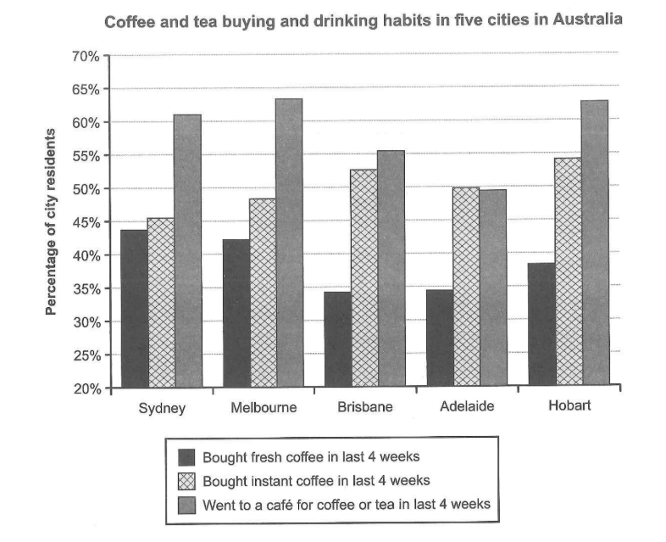

Model answer

The bar chart provides insights into the purchasing and consumption habits of urban residents regarding two popular beverages, coffee and tea, across five cities in Australia over the past four weeks.

Overall, there was a prevalent preference among urbanites for consuming coffee or tea in cafes rather than purchasing fresh or instant coffee, with the exception of Adelaide, where instant coffee consumption slightly outweighed other options.

In Sydney, Melbourne, and Hobart, the majority of city dwellers, constituting approximately 65% in each city, favored indulging in coffee or tea at cafes over the surveyed period. Brisbane also displayed a notable inclination towards cafe consumption, albeit with a lower percentage, standing just above 55%. Conversely, Adelaide ranked second in this aspect, with nearly 50% of residents opting for cafe visits for their coffee or tea fix.

Regarding the purchasing behavior, instant coffee emerged as the preferred choice across all five cities. The data indicates a significant disparity between the consumption of instant and fresh coffee, particularly evident in Brisbane, Adelaide, and Hobart, with discrepancies exceeding 15% for each city. However, in Sydney and Melbourne, the disparities between the two purchasing habits were less pronounced, with both hovering around 45%.

(197 words)

Exercise 8. You should spend about 40 minutes on this task.

Write about the following topic:

In the future all cars, buses and trucks will be driverless. The only people travelling inside these vehicles will be passengers. Do you think the advantages of driverless vehicles outweigh the disadvantages?

Write at least 250 words.

Dạng bài: quiz_type_0

Easy IELTS - Task 2 - 21

Model answer

In the future, all vehicles, including cars, buses, and trucks, are expected to become driverless, meaning that only passengers will be inside these vehicles. From my perspective, the benefits of driverless transportation greatly outweigh the drawbacks.

On one hand, driverless vehicles do present certain disadvantages. A significant concern is the potential loss of employment for professional drivers. Millions of people around the world rely on driving jobs for their livelihoods, and the widespread adoption of autonomous vehicles could result in large-scale unemployment. Additionally, there is the issue of cybersecurity. As driverless vehicles are controlled by complex software, they could be vulnerable to hacking or technical malfunctions, posing a risk to passenger safety. These incidents, although rare, could undermine public trust in the technology.

Nevertheless, the benefits of driverless vehicles are far more significant. One of the most important advantages is their potential to drastically reduce traffic accidents. Human error is responsible for the majority of road accidents, often caused by distractions, fatigue, or impaired driving. Autonomous vehicles, with their advanced sensors and algorithms, can process data more efficiently and respond faster, potentially saving countless lives. Furthermore, driverless technology could significantly improve traffic flow. With vehicles communicating with each other and operating efficiently, congestion in urban areas could be reduced, leading to shorter travel times and lower fuel consumption, which would also decrease carbon emissions.

In conclusion, while driverless vehicles do have some drawbacks, such as the risk of job loss and cybersecurity concerns, I believe the advantages far outweigh these issues. The improvements in road safety, efficiency, and environmental impact make autonomous vehicles a promising innovation that could transform the way we travel in the future. The potential benefits make it a technology worth embracing.

(285 words)

LESSON 2

A. Vocabulary

Exercise 1. Complete the sentences using the given words
Dạng bài: quiz_type_7

action | abolish | alleviate | prosecute | immigration
class | privileged | charity | heritage | advocate

- It's ridiculous to think that we should (1) ___ passports and just let everyone go where they like.
- What I don't understand is why the government isn't doing the work that this (2) ___ is doing.
- Don't you think that our library system is an important part of our national (3) ___?
- Unions are threatening industrial (4) ___ unless the pay offer is increased.
- Do you (5) ___ capital punishment for very serious offences?
- Derren came from a working (6) ___ background but eventually became a lord.
- Warning: We will (7) ___ anyone caught shoplifting.
- I suppose I was (8) ___ to go to private school, but I don't think about it much.
- More must be done to (9) ___ the suffering of the poorest in society.
- High levels of (10) ___ to Australia from Europe in the nineteenth century meant there was a rapid increase in its population.

ĐÁP ÁN
- abolish
- charity
- heritage
- action
- advocate
- class
- prosecute
- privileged
- alleviate
- immigration

Exercise 2: Read and choose the correct word
Dạng bài: quiz_type_14
- All twelve members of the (1) ___ (witness / jury) were convinced of Davidson's guilt.
- I don't think I'd ever (2) ___ (commit / break) a serious crime.
- If the school (3) ___ (rules / laws) aren't written down anywhere, how are we supposed to know what they are?
- A psychiatrist was called as an expert (4) ___ (witness / judge) during the trial.
- If a parent smacks a child, that's an example of (5) ___ (commit / corporal) punishment.
- Everyone should have the (6) ___ (right / jury) to a fair trial.
- If you (7) ___ (break / sentenced) the law, you deserve to be punished!
- Governments must be allowed to introduce, change and scrap (8) ___ (bystanders / laws).
- Can you imagine what it's like being (9) ___ (imprisoned / justice) for years in a cell?
- It's very important that (10) ___ (capital / justice) is seen to be done.

ĐÁP ÁN
- jury
- commit
- rules
- witness
- corporal
- right
- break
- laws
- imprisoned
- justice

Exercise 3: Complete the following sentences with either crime or criminal(s). Use the words in bold to help you

Dạng bài: quiz_type_7
- Vandals are generally seen as petty (1) ___.
- If young people become involved in juvenile (2) ___, they are more likely to have a (3) ___ record when they are older.
- The (4) ___ rate has actually decreased in some parts of New York in recent years.
- He was a hardened (5) ___ with a long list of previous convictions.
- Prosecutors have launched a (6) ___ investigation into the film’s accounting practices.
- Police and federal officials are working together to target gun (7) ___.

ĐÁP ÁN
- criminals
- crime
- criminal
- crime
- criminal
- criminal
- crime

B. Grammar

Exercise 4. Choose the correct word or phrase. If both are correct, choose both

Dạng bài: quiz_type_14

You _______ really talk when you were one year old,could you?
- can’t - can
- couldn’t
- both

2. We ____________ give you a lift home tonight, if you want.
- can
- could
- both

3. I wish I _________ speak Russian, then I'd be able to read Tolstoy in the original.
- can
- could
- both

4. Excuse me, ______________ you tell me how to get to the leisure centre from here?
- can
- could
- both

5. I'm afraid we _____________ be able to come to the wedding after all.
- can’t
- won’t be able to
- both

6. Thankfully, we ____________ to get to the airport just in time so we didn't miss the plane.
- could
- managed to
- both

7. Dawn couldn’t _____________ to the barbecue as she had to work.
- go
- have gone
- both

8. Would you like to ____________ buy the flat you're renting?
- could
- be able to
- both

9. In a thousand years, ______________ travel faster than the speed of light?
- can humans
- will humans be able to
- both

10 . 'Mum, can I watch TV and do my homework later?'

'No, you _______ not!
- may
- might
- both

Exercise 5. Decide on the correct modal or semi-modal form and finish the sentences. There may be more than one answer.

Dạng bài: quiz_type_7
- I believe it is better for criminals to go to prison than to do community work.
➜ Criminals (1) ___ to prison instead of doing community work.
- It is necessary to follow all the laws in a country.
➜ You (2) ___ all the laws in a country.
- I think it is possible that the crime rate will increase in the future.
➜ I think the crime rate (3) ___ in the future.
- Sometimes offenders can choose between paying a fine or doing community service.
➜ Sometimes offenders (4) ___. They can do community service instead.
- Police officers are able to take early retirement because of the demands of their job.
➜ Police officers (5) ___ early retirement because of the demands of their job.

ĐÁP ÁN
- should go / ought to go
- have to follow / must follow
- might increase / could increase / may increase
- don't have to pay a fine / do not have to pay a fine
- can take / are able to take

Exercise 6. Decide on an appropriate past modal verb and the correct form of the verb in brackets to finish the sentences.

Dạng bài: quiz_type_7

- When fossil fuels were discovered, people____________ (know) the negative effects they would eventually cause as no research had been done on them.
- In early civilisations, people____________ (hunt) for their own meat.
- People_____________(take) more care of endangered species. Over a hundred species have become extinct in the last 50 years and it’s a terrible shame.
- It _____________(be) difficult to survive in the days before modern medicine and hygiene standards.
- A new lizard has been discovered in the rainforests of Sumatra. Some experts say they ___________ (inhabit) the deeper rainforests for up to a million years.
- People_____________(travel) across borders quite easily in the past. Nowadays there are many more immigration rules.
- Before organised forms of rule such as kingdoms or governments, people ___________ (pay) taxes.
- Resentment among the citizens ____________ (develop) for a long time before the overthrow of the Empire, because popular support for a revolt had been growing for decades.

- couldn't have known/could not have known
- must have hunted
- should have taken/ought to have taken
- must have been
- might have been inhabiting/may have been inhabiting/could have been inhabiting/ might have inhabited/may have inhabited/could have inhabited
- could have travelled
- can’t have paid
- must have been developing/must have developed

C. Writing

Exercise 7. You should spend about 20 minutes on this task.

Write about the following topic:

The graph below shows the number of tourists visiting a particular Caribbean island between 2010 and 2017. Summarise the information by selecting and reporting the main features, and make comparisons where relevant.

Write at least 150 words.

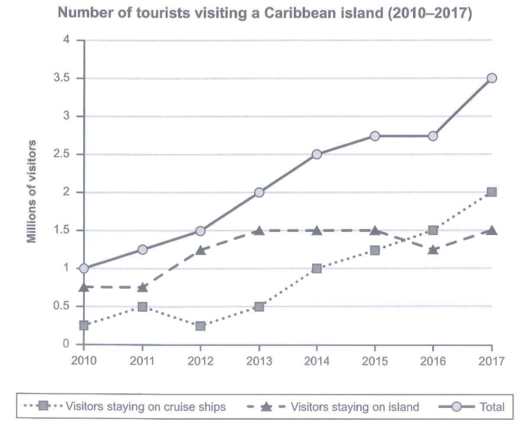

Dạng bài: quiz_type_0

Easy IELTS - Task 1 - 20

Model answer

The given line graph illustrates how many visitors traveled to a particular Caribbean island over the course of 7 years starting from 2010.

In general, the total number of tourists visiting the Caribbean island always increased during the whole period. Additionally, the figure for visitors staying on cruise ships was lower than that for those choosing to stay on the island during most of the period.

In 2010, the total number of tourists traveling to the Caribbean island stood at exactly 1 million, with 75.000 opting for staying on the island, whereas the rest decided to stay on cruise ships. Over the following 2 years, while there was an insignificant drop to the lowest point of just below 0.25 million in the number of visitors staying on cruise ships, staying on the island was still a more popular choice with 1.25 million visitors.

In the final year, the Caribbean island witnessed a sharp rise to 3.5 million in the total number of visitors. Likewise, the number of tourists who stayed on cruise ships experienced a sharp increase to precisely 2 million, surpassing the figure for those staying on the island (1.5 million).

(197 words)

Exercise 8. You should spend about 40 minutes on this task.

Write about the following topic:

Some people say that the main environmental problem of our time is the loss of particular species of plants and animals. Others say that there are more important environmental problems.

Discuss both these views and give your own opinion.

Give reasons for your answer and include any relevant examples from your own knowledge or experience.

Write at least 250 words.

Dạng bài: quiz_type_0

Easy IELTS - Task 2 - 21

Model answer

The issue of environmental problems has become a pressing concern in modern times. While some argue that the loss of some particular species of plants and animals is the main environmental problem, others contend that there are more critical issues that demand immediate attention and action. This quiz_type_0 will discuss both perspectives and present arguments for why the loss of biodiversity might not be the central environmental problem of our time.

Those who think that loss of certain animals and plants are the main environmental crisis in modern times argue that the process can disrupt the ecological balance, leading to negative cascading effects on the entire ecosystem. Coral reefs, often referred to as the "rainforests of the sea," are home to an incredible diversity of marine life. The decline of certain coral species due to factors like ocean warming and acidification not only affects the corals themselves but also endangers the countless species that rely on these ecosystems for food and shelter. Thus, it starts a chain reaction that puts the whole world in danger.

On the contrary, others who are against this notion say that the primary environmental problem lies in the presence of other pressing issues, such as climate change and pollution. The consequences of global warming, including extreme weather events, rising sea levels, and disruptions to ecosystems, affect all living beings, not just specific plant or animal species. For example, the emission of greenhouse gases from industrial activities and deforestation has led to a rise in global temperatures, resulting in the melting of polar ice caps and threatening the survival of numerous species. Additionally, air and water pollution from various sources have detrimental effects on entire ecosystems, endangering the health and well-being of both humans and wildlife.

In conclusion, although the loss of particular species of plants and animals is an important environmental concern, it is crucial to recognise that there are other pressing issues, such as climate change and pollution, that demand urgent attention. By addressing environmental challenges effectively, we can ensure a sustainable and healthy planet for all living creatures.

(345 words)

LESSON 3

A. Vocabulary

Exercise 1. Fill in the blanks with the given words

a detailed knowledge of | prior knowledge | common knowledge
broaden my knowledge of | a limited knowledge of

Dạng bài: quiz_type_7
- Thanks to a few classes at university, I have _____________ Russian.
- Since the news report, details of the business deal are now _____________.
- Being a political reporter requires _____________ national and international affairs.
- Visiting the country did so much to _____________ the language and people.
- The Spanish course is for absolute beginners so no _____________ is required.

Key:
- a limited knowledge of
- common knowledge
- a detailed knowledge of
- broaden my knowledge of
- prior knowledge

Exercise 2. Match the words and phrases (1-10) from the recording with the definitions (a-j)

Dạng bài: quiz_type_7
job market | a. term used to describe jobs done with the hands
employable | b. areas of interest or study
a living wage | c. the supply of jobs available
blue-collar jobs / manual labour | d. a term used to describe office jobs
white-collar jobs | e. a series of jobs that will lead to your goal
job vacancies | f. learning while you work
career paths | g. enough pay to live on
vocational education | h. having the right skills to get a job
on-the-job training | i. positions available
fields | j. skills and education that prepare you for a job

Answer: 1. ___; 2. ___; 3. ___; 4. ___; 5. ___; 6. ___; 7. ___; 8. ___; 9. ___; 10. ___
Key:
- c
- h
- g
- a
- d
- i
- e
- j
- f
- b

Exercise 3. Choose the correct alternative to complete the sentences

Dạng bài: quiz_type_14
- Finding the cure was a process of (1) ___ (trial and error / give and take). We tried out many theories and failed many times before finally succeeding.
- We are making a (2) ___ (human endeavour / concerted effort) to solve this problem.
- It was only after several weeks of (3) ___ (strenuous exercise / feeble attempts) that I finally regained my fitness levels.
- Building the pyramids was an amazing feat of (4) ___ (human endeavour / physical activity).
- He's currently employed as a labourer, which requires far too much (5) ___ (mental concentration / physical exertion).

ĐÁP ÁN
- trial and error
- concerted effort
- strenuous exercise
- human endeavour
- physical exertion

B. Grammar

Exercise 4. Complete the spaces with the, a, an or no article (-)

Dạng bài: quiz_type_14

Economic advisors to ______ government warned against not regulating larger businesses.
- a
- an
- the

(-)

2. I believe that there should be ______system to manage economic instability.
- a
- an
- the

(-)

3. ______ inflation is a constant worry for ______ employers.

a; (-)

an; (-)

the; (-)

(-) ; (-)

4. _____ Toyota has one of _______ highest revenues for any company in Japan.
- a; (-)
- an; the
- the; the
- (-); the

5. Every company needs______good staff.
- a
- an
- the

(-)

6. My father is ______employment lawyer.
- a
- an
- the
- (-)

7. ______world economy, although presently unstable, will soon recover.
- a
- an
- the
- (-)

Exercise 5. Complete the spaces in the text below with the, a, an or no article (-).

Dạng bài: quiz_type_7
(1)___ third of all employees in (2)____ UK see 'taking a sickie’ as an acceptable part of (3)___ work, nothing more than light-hearted flexibility with working hours, yet taking days off when not actually sick is costing (4)____economy (5)____ billions of pounds (6)___ year in (7)____ UK alone. As such, (8)____ reasons for these days off of work need to be addressed to counteract (9)____'sick culture’ embracing society.
The reasons for these ‘sick’ days are quite complex. One of (10)___ main reasons for this kind of absence is 'work fatigue’, (11)____fact that (12)____ people are bored with their jobs. As one leading professor states, 'jobs have become more fragmented and as such, people cannot give meaning to their work and feel alienated from their main roles. This can be seen by (13)____masses of people who are sitting at (14)____ workstation every day for seven or eight hours doing a job which is only one small part of a process.' Bringing back this kind of meaning into work could be (15)____difficult task, one which may not even be possible.
However, (16)___ most cited reason for taking 'sick days' is (17)____ family commitments, such as childcare or illness within (18)___ family. This is an issue which can be addressed with such things as (19)___ flexible working hours and home working. Perhaps, if employers can be a bit more forward thinking in these areas, they will, in the long run, be (20)___ ones to benefit the most.
Key:
- A 2. the 3. (-)/- 4. the 5. (-)/-
6. a 7. the 8. the 9. the 10. the
11. the 12. (-)/- 13. the 14. a 15. a
16. the 17. (-)/- 18. the 19. (-)/- 20. the

Exercise 6. Write the extra word in each line

Dạng bài: quiz_type_7
Being in the news
1 | The many people who appear in the news for the first time
2 | find that a sudden fame has a negative effect on their lives.
3 | The national press can be an unforgiving and the loss of
4 | the privacy that comes with fame is an extra problem at a
5 | difficult time. This is especially the case when a someone is
6 | in the news because of a tragedy or the serious crime. Just
7 | at the moment when you are under a most stress, you find
8 | microphones and the cameras in your face. The media have
9 | a responsibility to inform the public, but an innocent people
10 | are often hurt by the demand for the scandal.

Answer: 1. ___, 2. ___, 3. ____, 4. ___,5. ___, 6. ___, 7.___, 8.___, 9.___, 10.___
Key:
- The 2. a 3. an 4. the 5. a
6. the 7. a 8. the 9. an 10. the

C. Writing

Exercise 7. You should spend about 20 minutes on this task.

Write about the following topic:

The chart below shows what Anthropology graduates from one university did after finishing their undergraduate degree course. The table shows the salaries of the anthropologists in work after five years.

Summarise the information by selecting and reporting the main features, and make comparisons where relevant.

Write at least 150 words.

Dạng bài: quiz_type_0

Easy IELTS - Task 1 - 20

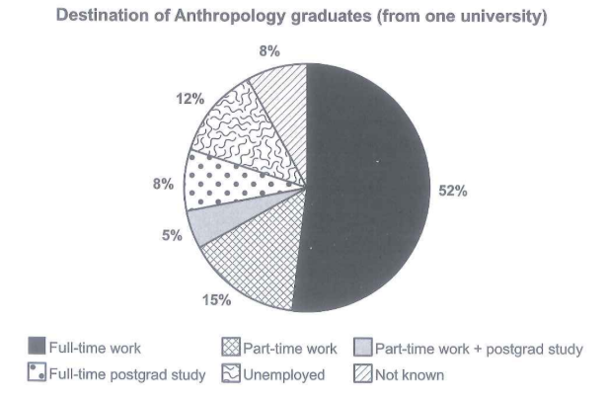

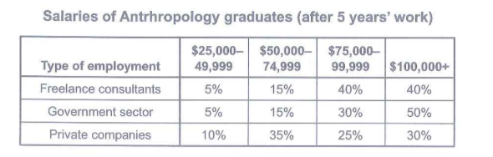

Model Answer

The pie chart details the initial occupations of Anthropology students after graduation and the table records their salaries following 5 years of work in various sectors.

In general, while the percentage of Anthropology graduates doing full-time work after receiving their undergraduate degree was highest, the opposite was true for those choosing part-time work and postgraduate study. Furthermore, after 5 year’s work, the proportions of anthropologists working as freelance consultants and in the government sector with the lowest salary range were exactly the same, while the highest figure can be seen in the proportion of those working in the government sector with the highest-paid.

Regarding the pie chart, more than half of Anthropology graduates had a full-time job, at 52%, while the proportions of those only working part-time and the unemployed were significantly lower, at only 15% and 12% respectively. Meanwhile, the figures for Anthropology graduates choosing full-time postgraduate study and the unknown group were identical, at 8%, whereas only 5% of graduates majoring in Anthropology chose to do part-time work and pursue postgraduate study at the same time.

Regarding the table, Anthropology graduates with a salary range between 25.000 and 49.999 dollars accounted for the smallest proportion of those working as freelance consultants and in the government sector after 5 years, at only 5%, which was half the figure for private companies. By contrast, the percentages of those working as freelance consultants, in the government sector and in private companies with the most generous salary were considerably higher, at 40%, 50% and 30% respectively.

(256 words)

Exercise 8. You should spend about 40 minutes on this task.

Write about the following topic:

In spite of the advances made in agriculture, many people around the world still go hungry.

Why is this the case?

What can be done about this problem?

Give reasons for your answer and include any relevant examples from your own knowledge or experience.

Write at least 250 words.

Dạng bài: quiz_type_0

Easy IELTS - Task 2 - 21

Model answer

The issue of environmental problems has become a pressing concern in modern times. While some argue that the loss of some particular species of plants and animals is the main environmental problem, others contend that there are more critical issues that demand immediate attention and action. This quiz_type_0 will discuss both perspectives and present arguments for why the loss of biodiversity might not be the central environmental problem of our time.

Those who think that loss of certain animals and plants are the main environmental crisis in modern times argue that the process can disrupt the ecological balance, leading to negative cascading effects on the entire ecosystem. Coral reefs, often referred to as the "rainforests of the sea," are home to an incredible diversity of marine life. The decline of certain coral species due to factors like ocean warming and acidification not only affects the corals themselves but also endangers the countless species that rely on these ecosystems for food and shelter. Thus, it starts a chain reaction that puts the whole world in danger.

On the contrary, others who are against this notion say that the primary environmental problem lies in the presence of other pressing issues, such as climate change and pollution. The consequences of global warming, including extreme weather events, rising sea levels, and disruptions to ecosystems, affect all living beings, not just specific plant or animal species. For example, the emission of greenhouse gases from industrial activities and deforestation has led to a rise in global temperatures, resulting in the melting of polar ice caps and threatening the survival of numerous species. Additionally, air and water pollution from various sources have detrimental effects on entire ecosystems, endangering the health and well-being of both humans and wildlife.

In conclusion, although the loss of particular species of plants and animals is an important environmental concern, it is crucial to recognise that there are other pressing issues, such as climate change and pollution, that demand urgent attention. By addressing environmental challenges effectively, we can ensure a sustainable and healthy planet for all living creatures.

(345 words)

LESSON 4

A. Vocabulary

Exercise 1. Match the words in bold with these synonyms

Dạng bài: quiz_type_7

- unspoiled | a. unprecedented
- crucial | b. pristine
- unparalleled | c. insoluble
- extremely harmful | d. devastating
- insurmountable | e. immune
- unaffected | f. pervasive
- omnipresent | g. chronic
- unavoidably | h. inexorably
- persistent | i. vital
- challenging | j. taxing

Answer: 1. ___, 2. ___, 3. ____, 4. ___,5. ___, 6. ___, 7.___, 8.___, 9.___, 10.___
Key:
- b 2.i 3. a 4. d 5. c
6. e 7.f 8.h 9.g 10.j

Exercise 2. Complete the text with the given words

Dạng bài: quiz_type_7

acid | biodiversity | environmental | erosion
exhaust | deforestation | drought | ecosystems
fertilisers | greenhouse | waste | contaminated
emissions

The advances made by humans have made us the dominant species on our planet. However, several eminent scientists are concerned that we have become too successful, that our way of life is putting an unprecedented strain on the Earth's 1. __________ and threatening our future as a species. We are confronting 2. __________
problems that are more taxing than ever before, some of them seemingly insoluble. Many of the Earth's crises are chronic and inexorably linked. Pollution is an obvious example of this, affecting our air, water and soil.

The air is polluted by 3. ___________ produced by cars and industry. Through 4. ___________ rain and 5. ___________ gases these same 6. ___________ fumes can have a devastating impact on our climate. Climate change is arguably the greatest environmental challenge facing our planet with increased storms, flood, 7. ________ and species losses predicted. This will inevitably have a negative impact on 8. ___________ and thus our ecosystem.
The soil is 9. ____________ by factories and power stations, which can leave heavy metals in the soil. Other human activities such as the overdevelopment of land and the clearing of trees also take their toll on the quality of our soil; 10. ____________ has been shown to cause soil 11. ____________. Certain farming practices can also pollute the land though the use of chemical pesticides and 12. _____________. This contamination in turn affects our rivers and waterways and damages life there. The chemicals enter our food chain, moving from fish to mammals to us. Our crops are also grown on land that is far from pristine. Affected species include the polar bear, so not even the Arctic is immune.
Reducing 13. __________ and clearing up pollution costs money. Yet it is our quest for wealth that generates so much of the refuse. There is an urgent need to find a way of life that is less damaging to the Earth. This is not easy, but it is vital, because pollution is pervasive and often life-threatening.

Key:
- ecosystems 2. environmental 3. emissions 4. acid
5. greenhouse 6. exhaust 7. drought 8. biodiversity
9. contaminated 10 deforestation 11 erosion 12 fertilisers 13 waste

Exercise 3. Complete the sentences using the negative form of the words in brackets

Dạng bài: quiz_type_7

- It is unrealistic (realistic) unrealistic to expect everyone to change their buying habits overnight.
- When it comes to protecting the environment, cost should be (relevant) ______________.
- It is (reasonable) ______________ for rich countries to expect developing countries to reduce carbon emissions immediately.
- People who dump chemical waste into our waterways are very (responsible) ______________.
- The oil spill has caused (repairable) ______________ damage to several marine species.
- Scientists believe that the damage to this area is (reversible) ____________.
- These species are (replaceable) _______________. Once they are lost our ecosystem will be changed.
- It is a mistake to think that increased consumerism and environmental damage are (related) _______________.
Key:
2 irrelevant 3 unreasonable 4 irresponsible 5 irreparable 6 irreversible 7 irreplaceable 8 unrelated

B. Grammar

Exercise 4. Complete using the correct passive form of the verbs in brackets
Dạng bài: quiz_type_7
- The Earth (hold) ______________________ by the gravity of the Sun and orbits around it.
- I don’t know whether our tests (mark) ______________________ yet or not.
- The first feature-length comedy film (create) ______________ by Charlie Chaplin.
- Two men (question) _______________ at this moment by police in connection with the burglary.
- Chess (play) ______________________ for around two thousand years now.
- The entertainment industry (know) __________________ to be very competitive.
- Once the barbecue (lit) ________________ we'll be able to start cooking.
Key:
- is held 2. have been marked 3. was created
4. are being questioned 5. has been played 6. is known 7. is lit/ has been lit/is lighted/has been lighted

Exercise 5. Write a verb from the box in the correct passive form in each gap

Dạng bài: quiz_type_7
delay | ask | find | find
write | pay | fire

- The stolen items (1) ___ in the attic of an empty house last week.
- Questions (2) ___ in Parliament about the Minister's business interests.
- Just imagine that when these words (3) ___, Europeans had not yet discovered America.
- (4) ___ your ticket for the concert tomorrow (5) ___ for by you or your parents?
- It was a real shock when my dad (6) ___ from his job.
- When we got to the airport, we learned that our flight (7) ___.

ĐÁP ÁN
- were found
- were asked
- were written
- Has
- been paid
- was fired
- had been delayed

Exercise 6. Write sentences in the passive

Dạng bài: quiz_type_7
- Our car/service/a mechanic/ at the moment.
→ ___________________________________________________.
- A man/shoot/an air gun/outside the petrol station last night.
→ ___________________________________________________.
- Gunpowder/invent/the Chinese.
→ ___________________________________________________.
- At the surgery yesterday, I/examine/Dr Peterson/and I/give/a prescription.
→ ___________________________________________________.
- I went to see it because I/tell/it was a good film/all my friends.
→ ___________________________________________________.
- This photograph/take/my grandfather.
→ ___________________________________________________.
- It looked like the window/break/a hammer/some time before.
→ ___________________________________________________.
Key:
- Our car is being serviced by a mechanic at the moment
- A man was shot with an air gun outside the petrol station last night
- Gunpowder was invented by the Chinese
- At the surgery yesterday, I was examined by Dr Peterson and I was given a prescription
- I went to see it because I had been told it was a good film by all my friends
- This photograph was taken by my grandfather
- It looked like the window had been broken with a hammer some time before

C. Writing

Exercise 7. You should spend about 20 minutes on this task.

Write about the following topic:

The diagram below shows the process for recycling plastic bottles.

Summarise the information by selecting and reporting the main features, and make comparisons where relevant.

Write at least 150 words.

Dạng bài: quiz_type_0

Easy IELTS - Task 1 - 20

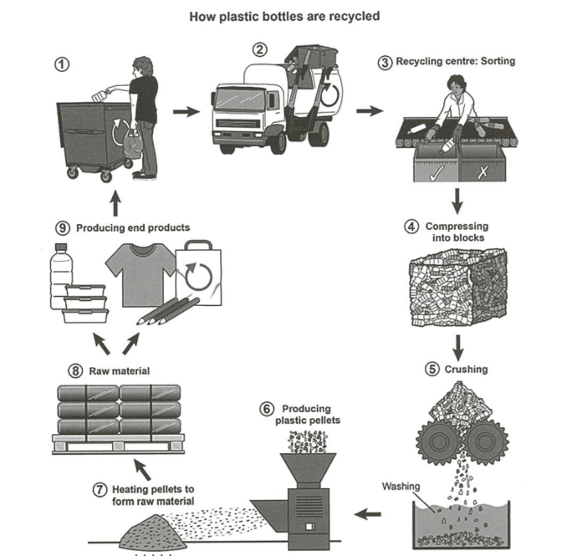

Model Answer

The diagram demonstrates steps taking place in the plastic bottle recycling process.

An initial glance at the diagram reveals that this process consists of nine main phases, commencing with the disposal of plastic bottles and culminating with the production of end goods.

A closer examination of the drawing shows that individuals discard used plastic bottles in designated rubbish bins. These bottles are subsequently collected by trucks and transported to a recycling center. At the center, the bottles undergo a sorting process to separate recyclable bottles from non-recyclable ones, which are removed from the line. Once sorted, the selected bottles are compressed into dense blocks to facilitate easier handling and processing. In the next step, these compressed blocks are broken down into smaller pieces. During the fifth stage, the crushed plastic pieces are thoroughly washed with water to remove any impurities and prepare them for further recycling steps.

According to the picture, the plastic pieces are fed into a machine that transforms them into pellets. These pellets are then heated to produce raw materials, which are subsequently stored and utilized to manufacture various products, such as plastic containers, bags, and clothing. This recycling process is repeated each time bottles are used and discarded.

(202 words)

Exercise 8. You should spend about 40 minutes on this task.

Write about the following topic:

Living in a country where you have to speak a foreign language can cause serious social problems, as well as practical problems.

To what extent do you agree or disagree with this statement?

Give reasons for your answer and include any relevant examples from your own knowledge or experience.

Write at least 250 words.

Dạng bài: quiz_type_0

Easy IELTS - Task 2 - 21

Model Answer

Many people migrate to foreign countries in search of better work and living environments. Living in such countries where you have to use an entirely unknown language leads to difficulty in social and practical scenarios. This quiz_type_0 will argue that although there are many issues arising from the language barriers, these are not so serious that they cannot be resolved.

In my opinion, although language barriers may create many issues, these are not so serious that they cannot be resolved. The practice of shifting base to a new country is common amongst all classes of people. It is obvious that they will encounter problems when it comes to conversing with the local people and may also face similar issues at work. As they do not know how to speak the local dialect, their ability to socialise and perform various day to day activities will be hampered.

For example, shopping in the vegetable market may seem a huge task. Thus living in such countries where one ought to speak the country’s native language is certainly going to be challenging at least in the first few months. There are multiple factors that one must consider prior to moving to a new land. The factors will help to cope up with the language barrier. Prior to moving to a foreign land, one must prepare oneself for what lies ahead.

For example, before migrating to Germany where the majority speaks German, one must get acquainted with the basics of the language. In this age of the internet and online forums, learning a new language is easier than ever before. Taking help of one’s own compatriots living abroad is another way to overcome this problem.

In conclusion, I absolutely concur with the notion that living in another country where conversing in the local language is a must is troublesome, but this trouble is often short lived and brief and can be taken care of by making prior preparations and seeking help from the natives.

(329 words)

