LESSON 1

A. Vocabulary

Exercise 1. Match the words on the left with their collocations on the right.
Dạng bài: quiz_type_7

holiday | a. catering
full | b. for money
self- | c. mileage
unlimited | d. bus
exotic | e. of a lifetime
value | f. board
shuttle | g. train
through | h. airline
low-cost | i. class
economy | j. island

Answer: 1. ___, 2. ___, 3. ____, 4. ___,5. ___, 6. ___, 7.___, 8.___, 9.___, 10.___
Key: 1. e 2. f 3. a 4. c 5. j
6. b 7. d 8. g 9. h 10. i

Exercise 2. Complete the passage using the given words

Dạng bài: quiz_type_7
a.
restrictions | cancellation fee | transfers | charter flight
shuttle bus | scheduled flight | non-refundable | stopover
all-inclusive | value for money | a package

A (1) ______________ is a normal, regular flight; a (2) ______________ is a special flight
taking a group of people, usually to the same holiday destination. Some airline
tickets may have (3) ______________ (e.g. you can only travel on certain days). Such tickets can offer good (4) ______________ but, if you cancel, they are (5) ______________
or you may have to pay (6) ______________. Some tickets allow a (7) ______________. (8) ______________ holiday normally includes accommodation and (9) ______________, e.g. a coach or a (10) ______________ to and from your hotel. An (11) ______________ holiday includes your flight, accommodation and all meals, drinks and snacks in the hotel.

1. scheduled flight 2. charter flight 3. restrictions
4. value for money 5. non-refundable 6. cancellation fee
7. stopover 8. A package 9. transfers
10. shuttle bus 11. all-inclusive

b.

go on a cruise | ferry | shared cabin | berth | get away from it all
holiday of timeline | deluxe | exotic | crossing | upper deck

Sea travel is normally on a (1) _____________, and the journey is called a (2) _____________, but you can have a holiday on the sea if you (3) _____________. For some people, a luxury cruise is the (4) _____________. You may decide to book a (5) _____________ in a (6) _____________, or to have a single or double cabin. For more money, you can often get a (7) _____________ cabin, perhaps on the (8) _____________. Cruises often go to (9) _____________ islands where you can (10) _____________.
1. ferry 2. crossing 3. go on a cruise 4. holiday of timeline
5. berth 6. shared cabin 7. deluxe 8. upper deck
9. exotic 10. get away from it all

Exercise 3. Read the passage then match the word with its meaning

Dạng bài: quiz_type_7
Some people like camping while others prefer hotels. Or you can have a self-catering holiday, such as staying in an apartment or chalet. You can also choose to stay in a guest house or an inn. Some types of accommodation offer half board or full board.
- camping | a. small cottage or cabin specially built for holiday-makers
- self-catering | b. all meal
- chalet | c. sleeping in a tent or a caravan
- guest house | d. similar to a pub, but also offering accommodation; sometimes in an attractive old building
- inn | f. where you do your own cooking
- half board | g. small, relatively cheap hotel
- full board | h. usually breakfast and one other meal

Answer: 1. ___, 2. ___, 3. ____, 4. ___,5. ___, 6. ___, 7.___,
1. c 2. f 3. a 4. g 5. d 6. h 7. b

B. Grammar

Exercise 4. If a word or phrase in bold is correct, write “correct”. If it is incorrect, rewrite it correctly
Dạng bài: quiz_type_7

We took the dog who we'd found it abandoned in the street straight to the vet.

_____________________________________________________________________

Would any boys who's surnames begin with M please raise your hands?

_____________________________________________________________________

The day which I first met your mother was the best day of my life.

_____________________________________________________________________

Alfredo thought for a second, and then began to write: 'To Whom It May Concern ...'

_____________________________________________________________________

The woman who I spoke to was extremely helpful.

_____________________________________________________________________

The film which I really want to see it is the new one with Johnny Depp.

_____________________________________________________________________

No, the hospital where you were born there was closed down quite a while ago.

_____________________________________________________________________

Could you just give me one reason why you would say something like that?

_____________________________________________________________________

The table where we sat at had a lovely view of the Acropolis.

_____________________________________________________________________

That bothers me is why the police took so long to charge them.

_____________________________________________________________________

- which we’d found/that we’d found
- whose
- when/that/on which
- correct
- correct
- which I really want to see/I really want to see
- you were born
- correct
- which
- What

Exercise 5. Write one word in each gap
Dạng bài: quiz_type_7

Do you really think the month _______ which you're born affects your character?

They declared war on Austria, the reason _______ which completely escapes me now.

There are five slices of pizza left, two _______ which we'd better save for Justin.

Is the ___________ which you arrive on Friday?

Josephine came to the rescue, of course, _______ which I'm eternally grateful.

There were 20 people at the meeting, some _________ whom I'd never met before.

The law needs to be strengthened, __________ which I mean the police need to be given new powers.

____________ whom did you speak?

I looked at several possible presents, none _______ which were appropriate.

She studied in Berlin from 1916 to 1923, ___________ which time many people still believed that women had no role in scientific research.

1. in 2. for 3. of 4. on 5. for

6. of 7. by 8 .To/With 9. of 10. at

Exercise 6. Rewrite as one sentence using a relative clause

Dạng bài: quiz_type_7

That tree is an oak. My grandfather planted it 60 years ago.
_____________________________________________________

Tina and Charlie are having a party this Saturday. They're identical twins.
_____________________________________________________

On Friday, we spent most of the day sitting in the port. On Friday, the ferry was delayed.
_____________________________________________________

Barbara used to work in the Personnel Department. You met her at Libby's last Thursday.
_____________________________________________________

Let's go to da Vinci's. They do a great pepper steak there.
_____________________________________________________

This book was once owned by Sir Francis Drake. It was given to me by my great aunt.
_____________________________________________________

Why did Danny decide to enter the marathon? Danny's totally unfit.
_____________________________________________________

Guy is now engaged to my sister. His sister is married to my brother.
_____________________________________________________
- That tree, which my grandfather planted 60 years ago, is an oak.
- Tina and Charlie, who are identical twins, are having a party this Saturday.
- On Friday, when the ferry was delayed, we spent most of the day sitting in the port.
- Barbara, who you met at Libby's last Thursday, used to work in the Personnel Department.
- Let's go to da Vinci's, where they do a great pepper steak.
- This book, which was given to me by my great aunt, was once owned by Sir Francis Drake.
- Why did Danny, who's totally unfit, decide to enter the marathon?
- Guy, whose sister is married to my brother, is now engaged to my sister.

C. Writing

Exercise 7. You should spend about 20 minutes on this task.

Write about the following topic:

The maps show the outskirts of the town of Fosbury in 1980 and 2015.

Summarise the information by selecting and reporting the main features and make comparisons where relevant.

Write at least 150 words.

Dạng bài: quiz_type_0

Easy IELTS - Task 1 - 20

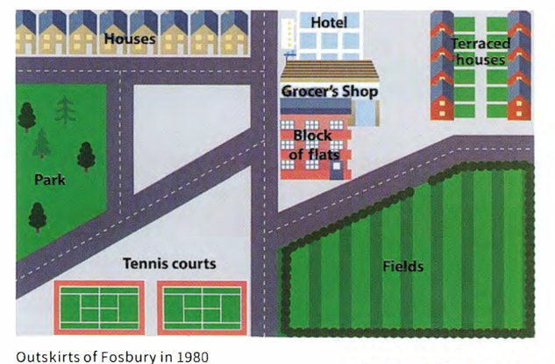

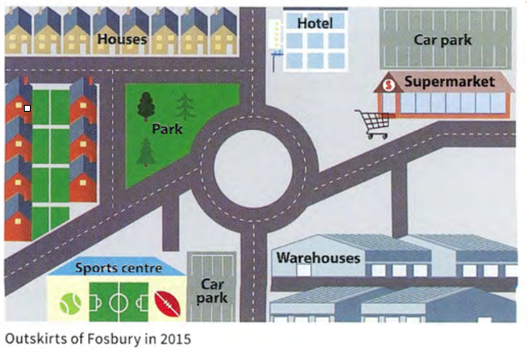

Model answer

The maps depict the suburban area of Fosbury as it appeared in 1980 and 2015. The 35-year period saw changes to the road layout, and to the residential, recreational and commercial facilities.

In terms of the road layout, the main change was the addition of a roundabout in the centre of this area, which necessitated the demolition of a block of flats and a grocer's shop. The residential accommodation underwent further changes with the removal of a street of terraced houses on the right side of the map and the construction of additional housing on the left side. New houses replaced the park, which was relocated to the other side of the road and decreased in size. By 2015 a supermarket with a car park had been erected on the site of the terraced houses.

The area industrialised further during the 35-year period, with warehouses being put up where fields had been earlier. The area's sporting facilities had also been developed, with a new sports centre taking the place of the old tennis courts.

In summary, the area of Fosbury shown on the maps modernised and developed between 1980 and 2015.

(191 words)

Exercise 8. You should spend about 40 minutes on this task.

Write about the following topic:

In many countries around the world, life expectancy is increasing.

Discuss the advantages and disadvantages of this situation and give your own opinion.

Write at least 250 words.

Dạng bài: quiz_type_0

Easy IELTS - Task 2 - 21

Model answer

Medical care over the past century has improved dramatically. As a consequence, the world's population is increasingly living long into old age. Is this having a harmful effect on societies across the globe, or are there more benefits than drawbacks?

One obvious issue with an ageing population is that it can create enormous demands on a nation's health service. As people live longer into their old age, the chances of them suffering from serious illnesses increases. As a result, the likelihood of them requiring medical treatment becomes higher, and it becomes more difficult to provide care for everyone. A further downside is that living longer does not necessarily bring happiness. By this I mean, an older person is unable to do many of the activities that they want to do, leading to the likelihood of depression and a deterioration in their physical health.

Having said that, one obvious benefit to people living longer is that young people can benefit for a longer time from the wisdom handed down to them by older members of their families. In today's fast-paced world, it is often comforting to seek advice from older generations. Consequently, the physical health of a grandparent is almost irrelevant, as the children and grandchildren will benefit from the experience of an older mind. What is more, retired people today are generally much healthier than they have ever been, and often enjoy their lives more than they did when they were young. They have the best of both worlds - a family that can care for and look up to them, and better health than at any time in human history.

Weighing up both sides of the argument again, although there are a number of problems that old age brings - predominantly health-related - the benefits that it brings to the family unit and to society as a whole are impossible to ignore.

(310 words)

LESSON 2

A. Vocabulary

Exercise 1. Match the adjectives with their meanings
Dạng bài: quiz_type_7
Adjective | Meaning
- rewarding | a. produces good results
- fruitful | b. reduces stress, gives a peaceful feeling
- lucrative | c. gives you a lot of positive experiences
- therapeutic | d. makes a lot of money
- relaxing/calming | e. makes you healthy in body and/or mind
- time-consuming | f. takes a long time to do
Answer: 1. ___, 2. ___, 3. ____, 4. ___,5. ___, 6. ___

- c 2. a 3. d 4. e 5. b 6. f

Exercise 2: Fill the gaps with a suitable adjective
Dạng bài: quiz_type_7

relaxing | therapeutic | lucrative
fruitful | rewarding | time-consuming

- I find writing poetry very _________. It helps me to get a truer understanding of myself and gives me a good feeling inside.
- I enjoy selling the pictures I paint, but it’s not very _________. I only made £300 last year.
- Gardening is very _________. It reduces stress levels and calms you down.
- I’ve had a _________ partnership with Jane for several years: she plays the piano and I play the violin. It’s been very good for both of us.
- Doing unpaid work at the hospital has been a _________ experience for me.
- I would like to be on the club committee, but I’ve heard it’s very _________, and I don’t have a lot of free time.

1 therapeutic 2 lucrative 3 relaxing
4 fruitful 5 rewarding 6 time-consuming

Exercise 3: Complete the dialogues with a word or expression from the box. B agrees with A by saying the same thing in a different way.

couch potato | full diary | gone off
time-consuming | therapeutic | lucrative

Dạng bài: quiz_type_7

A: Going for a swim helps you forget your everyday worries, doesn’t it?

B: Yes, it’s very _____________.

A: Dan spends every evening watching rubbish TV.

B: That’s true. He’s a terrible _____________.

A: I’m not so keen on playing in the school orchestra as I used to be.

B: Yes, I’ve _____________ it too.

A: I’d like to join a drama group but it would mean giving up lots of evenings and weekends.

B: Yes, it can be a very _____________ activity.

A: I don’t think I can fit in a tennis match with you for another couple of weeks.

B: No problem. I’ve got a very _____________ too.

A: Someone said I could make some money out of those necklaces I make in my spare time.

B: I agree. I think it could prove very _____________ for you.
1 therapeutic 2 couch potato 3 gone off
4 time-consuming 5 full diary 6 lucrative

B. Grammar

Exercise 4. Choose the correct word or phrase.

Dạng bài: quiz_type_14

- Tom Cruise wouldn't be the star he is today (1) ___ (had he not / should he not have) made a good impression in his early films.
- (2) ___ (Weren't we / Were we not) to build more roads, the traffic system would collapse by 2020.
- It would be hard enough to pass the exam tomorrow even if you (3) ___ (went / had gone) to all the lectures this year.
- You can contact the hotel manager on extension 142 (4) ___ (should / could) you need to.
- (5) ___ (Shouldn't you / Should you not) receive confirmation of your flight by e-mail, please click the link below.
- I would have asked the person for ID before I let him in, if I (6) ___ (were / have been) you.
- If you (7) ___ (worked / had worked) last weekend when the boss asked you, then you wouldn't have to work this weekend.
- Were all the members of staff to attend the conference, would the hotel (8) ___ (have / have had) enough rooms for everyone?

ĐÁP ÁN
- had he not
- Were we not
- went
- should
- Should you not
- were
- had worked
- have

Exercise 5. Complete using the words in the box

Dạng bài: quiz_type_7

case | condition | long | otherwise
provided | so | suppose | unless

- Do you want a highly-paid career, and, if ____________ are you prepared to retrain? Contact us.
- I'm quite happy to lend you money, as ____________ as you make sure I get it back.
- The village fair should be a great success, ________ we don't have the same problems with the weather as last year.
- It'd be great to see you on Saturday evening, ___________ you've already got other plans.
- Could you go to the shop for me? I have to stay in in ___________ the courier comes.
- Your idea sounds fine in theory, but just _____________ something goes wrong. What then?
- Write your name at the top of your quiz_type_0, _____________ I won't know which one's yours.
- The judge allowed the accused to stay at home on ____________ she reported to the police every morning.
1. so 2. long 3. provided 4. unless
5. case 6. suppose 7. otherwise 8 .condition

Exercise 6. Rewrite the sentences, starting with the words given.

Dạng bài: quiz_type_7

The only reason we won the contract was Debbie's fantastic presentation.

→ We wouldn't have _______________________________________________________________.

The eventual arrival of the ferry prevented a fight from breaking out amongst the passengers.

→ If it hadn't been for _______________________________________________________________.

None of the passengers was injured because of the driver's quick reaction.

→ But _______________________________________________________________.

We'll have to cancel the meeting if Wendy doesn't turn up soon.

→ Unless _______________________________________________________________.

Mr Jones would be quite lonely if he didn't have his daughter's visits.

→ Were it _______________________________________________________________.

Here's my phone number, because you might need it.

→ In case _______________________________________________________________.

Agree to be back by midnight and you can go.

→ Providing _______________________________________________________________.

Officer Hughes prevented the robbers from escaping.

→ Had it _______________________________________________________________.

won the contract if it hadn't been for Debbie's fantastic presentation/won the contract had it not been for Debbie's fantastic presentation
- the eventual arrival of the ferry, a fight would have broken out amongst the passengers
- for the driver's quick reaction, some of the passengers would have been injured/for the driver's quick reaction, the passengers would have been injured
- Wendy turns up soon, we'll have to cancel the meeting
- not for his daughter's visits, Mr Jones would be quite lonely
- you need it, here's my phone number
- you are back by midnight, you can go/you agree to be back by midnight, you can go
- not been for Officer Hughes, the robbers would have escaped

C. Writing

Exercise 7. You should spend about 20 minutes on this task.

Write about the following topic:

The line chart below shows the results of a survey giving the reasons why people moved to the capital city of a particular country.

Summarise the information by selecting and reporting the main features, and make comparisons where relevant.

Write at least 150 words.

Dạng bài: quiz_type_0

Easy IELTS - Task 1 - 20

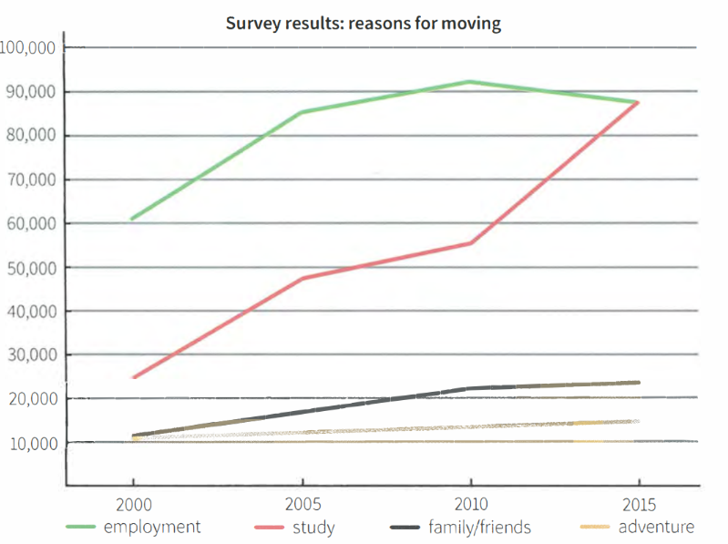

Model answer

The line graph sets out the key motivations for people relocating to the capital of a specific country between 2000 and 2015.

Moving for the purpose of study saw the greatest rise overall, with a jump of approximately 62,000. It rose considerably in two periods - from 2000 to 2005 (by 22,000), and then again from 2010 to 2015 (by 33,000), with a more gentle growth of around 7,000 in between. Elsewhere, the figure of people relocating for work began at 61,000 in 2000, then peaked at 92,000 in 2010 - the highest of any reason, in any year- before finishing as the joint-highest in 2015 (87,000 - on a level with those relocating in order to study). Notably, this category was the only one of the four that underwent a downturn.

Turning to 'adventure', this category rose the most stably and steadily of all four categories, from 11,000 to 15,000 over the fifteen-year period. Meanwhile, the number of people relocating for 'family and friends' reasons climbed gently in the first five years (12,000 to 14,000), followed by an upswing to 22,000, before eventually leveling off at around 23,000 in 2015. All in all, the graph tells us that, 'employment' aside, there was an increase in each of the four reasons for moving over the period in question, with the greatest rise occurring in those citing study as the main motivating factor.

(212 words)

Exercise 8. You should spend about 40 minutes on this task.

Write about the following topic:

The most important consideration when choosing any career or job is having a high income. To what extent do you agree or disagree?

Write at least 250 words.

Dạng bài: quiz_type_0

Easy IELTS - Task 2 - 21

Model answer

It is widely accepted that, for most people, their daily working lives will not be spent in their dream jobs. Despite this, I do not feel that people should instead prioritise becoming a high earner above all other concerns.

To begin with, I strongly believe that people need stimulation in their daily working lives in order to feel a sense of reward. Very few of us can go through an entire career staying in a position or an industry that we find boring purely for the financial incentive. Secondly, there are so many people who see their working life as a search for fulfilment and contentment in helping others, rather than a search for wealth. It seems unlikely that the priority for, say, every nurse or teacher in the world is to become well-off, and jobs such as these are rarely extremely well-paid.

Despite this, some would argue that those people who have families to support should always prioritise earning a high income; after all, it means securing their children's future. Others point out that, as the job market becomes increasingly unstable across the globe, it is vital to earn more and therefore save more. However, I do not agree that a good salary should necessarily be the number one concern for everyone. Too many people become preoccupied with the next pay rise or career move, and eventually become unhappy or even depressed, neither of which helps them to save or to provide for their family.

In summary, earning as much money as is humanly possible should not be anyone's main concern. Granted, it arguably brings financial stability, for individuals and for their families, but it is simply not worth tolerating a lifetime of unhappiness at work purely for the money.

(291 words)

LESSON 3

A. Vocabulary

Exercise 1. Write the words for the following definitions

Dạng bài: quiz_type_7

deserted | spacious | packed | filthy
bustling | run-down | picturesque

- _____________: very pretty and attractive
- _____________: with plenty of space
- _____________: no one on the streets, e.g. at night
- _____________: with lots of movement
- _____________: very crowded
- _____________: very dirty
- _____________: in a very bad condition

1. picturesque 2. spacious 3. deserted
4. bustling 5. packed 6. filthy 7. run-down

Exercise 2. Fill in the gaps in this description of a town

Dạng bài: quiz_type_7

area | market | tends | site
distance | exhibitions | overlook | outskirts
worth | facilities | population

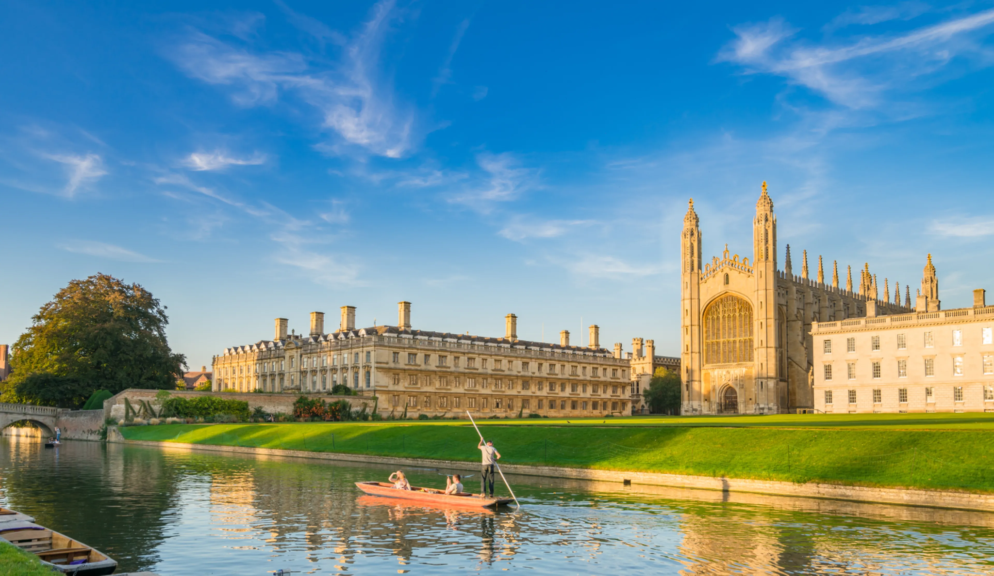
Cambridge has the second oldest university in England (after Oxford). It has a 1. ____________ of around 108,900, many of whom are students. The main tourist 2. ____________of the town lies in the city centre, around the university colleges. A number of the old university buildings are built on the 3. ____________ of former monasteries or convents. Most of the more picturesque colleges 4. ____________ the River Cam.
Most of the main hotels in the town are within walking 5. ____________ of the centre. The town centre has a lively fruit and vegetable 6. ____________and it 7. ____________ to be very crowded on Saturdays. The Fitzwilliam Museum is well 8. ____________ visiting as is an art gallery called Kettle’s Yard which regularly puts on quite varied 9. ____________ by a range of artists. The town also has plenty of sports 10. ____________ catering for both young and old. An interesting new Science Park has been built on the 11. ____________ of the town, about two kilometres from the city centre.

1. population 2. area 3. site 4. overlook 5. distance

6. market 7. tends 8. worth 9 .exhibitions 10 .facilities

11. outskirts

Exercise 3. Read the passage and answer the questions below

Dạng bài: quiz_type_7
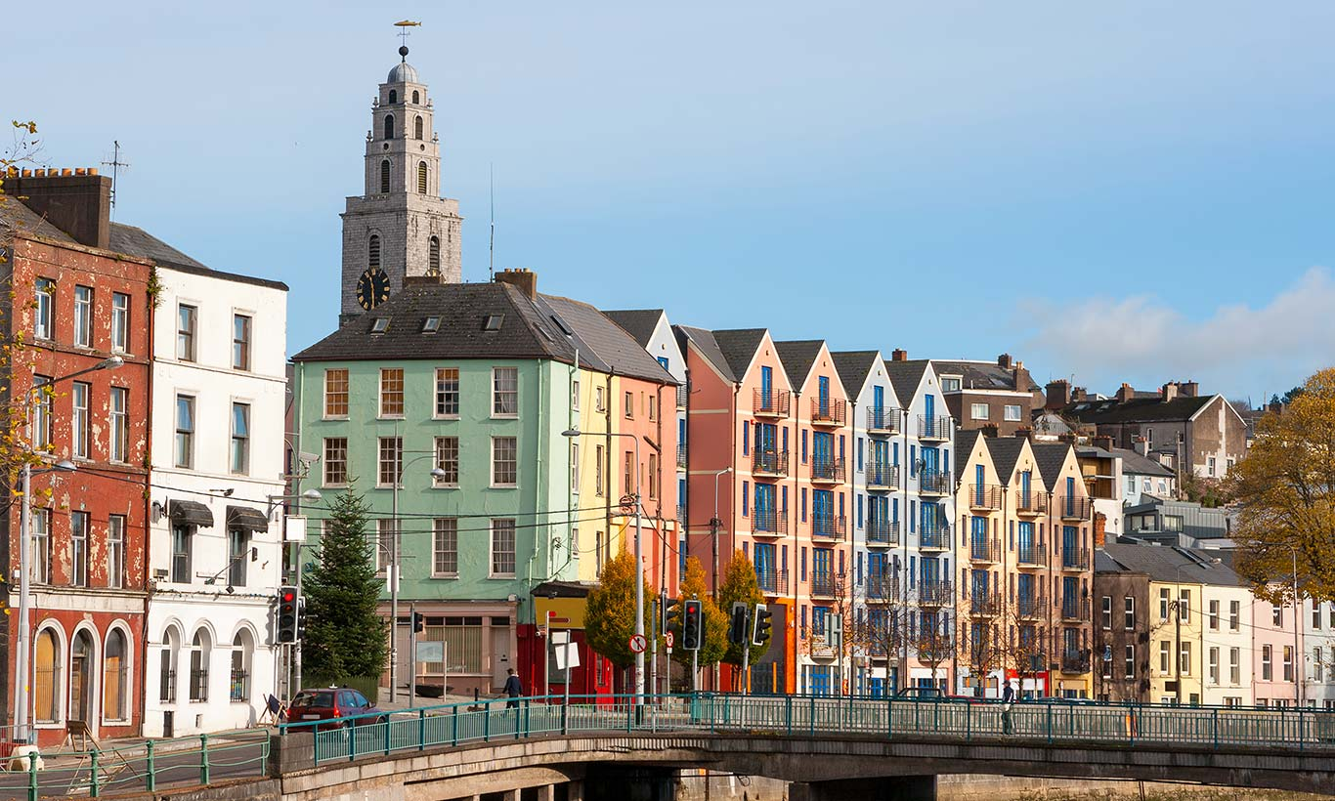

Cork city is the major metropolis of the south; indeed, with a population of about 119,500, it is the second largest city in the Republic. The main business and shopping centre of the town lies on the island created by two channels of the River Lee, with many of the suburbs within walking distance of the centre. The buses tend to be overcrowded and the one-way traffic system is extremely complicated. In the hilly area of the city is the famous Shandon Steeple, the bell-tower of St Anne’s Church, built on the site of a church destroyed when the city was besieged by the English in 1690.
Back across the River Lee lies the city’s cathedral, an imposing 19th-century building in the French Gothic style. Cork has two markets. Neither caters specifically for tourists but those who enjoy the lively atmosphere of a real working market will appreciate their charm. The town has good sports and arts facilities. The Crawford Art Gallery is well worth a visit. It regularly puts on adventurous exhibitions by contemporary artists. The fashionable residential districts of Cork city overlook the picturesque harbour. There are other residential areas on the outskirts.
- Where is Cork?
➜ Cork is in the south of the Republic of Ireland.
- Where is the shopping and business centre of Cork?
➜ It lies on (1) ___ between (2) ___ of the River Lee.
- What is Cork’s traffic system like?
➜ It has (3) ___. Moreover, its buses are (4) ___.
- What is special about the site of St Anne’s Church?
➜ St Anne’s Church was built on a site where (5) ___. That church was destroyed during (6) ___ of the city.
- In what style is the architecture of Cork Cathedral?
➜ In the (7) ___ style.
- Can you buy souvenirs at the markets?
➜ (8) ___, as they do not (9) ___ tourists.
- Why is the Crawford Gallery worth visiting?
➜ It is worth visiting because it (10) ___ interesting (11) ___ of modern art.
- Where do Cork people live?
➜ Well-off people live in (12) ___ overlooking the harbour, while others live in (13) ___ on the edge of the city.

ĐÁP ÁN
- an island
- two channels
- a very complex one-way traffic system
- extremely crowded
- another church stood previously
- a siege
- French Gothic
- Probably not
- cater specifically for
- regularly puts on
- exhibitions
- fashionable residential areas
- suburbs

B. Grammar

Exercise 4. Use the correct conjunction from the box to complete each sentence

although | whereas | unless | in order to | despite
so that | as long as | therefore | nevertheless | while

Dạng bài: quiz_type_7

________ having little experience in project management, she was given the responsibility of leading a multimillion-dollar campaign.

He had meticulously planned the event, ________ unexpected problems still arose at the last minute.

You will not be eligible for a scholarship ________ your academic performance improves significantly.

The scientist conducted multiple experiments ________ prove his hypothesis beyond any doubt.

________ we had warned him about the risks, he chose to invest in the volatile stock market.

The government has implemented stricter environmental policies ________ reduce carbon emissions within the next decade.

The two politicians agreed on the need for economic reform, ________ they strongly disagreed on how to implement it.

The athlete continued training, ________ her injury, determined to compete in the upcoming championship.

You are free to express your opinion ________ you do so in a respectful and constructive manner.

He was negotiating a crucial business deal ________ handling multiple urgent calls from his clients.
1. Despite 2. nevertheless 3. unless 4. in order to 5. Although
6. so that 7. whereas 8. despite 9. as long as 10. while

Exercise 5. Rewrite the sentences using the conjunction in parentheses while maintaining the original meaning.

Dạng bài: quiz_type_7

Despite the heavy rain, the football match continued as scheduled. (although)
______________________________________________________________________________

She worked overtime to complete the report on time. (in order to)
______________________________________________________________________________

He was exhausted; however, he pushed himself to finish the marathon. (nevertheless)
______________________________________________________________________________

I will lend you my car, but you must promise to return it by tomorrow. (as long as)
______________________________________________________________________________

He was warned about the consequences, yet he refused to change his behavior. (despite)
_____________________________________________________________________________
- Although it was raining heavily, the football match continued as scheduled.
- She worked overtime in order to complete the report on time.
- He was exhausted; nevertheless, he pushed himself to finish the marathon.
- I will lend you my car as long as you promise to return it by tomorrow.
- Despite being warned about the consequences, he refused to change his behavior.

Exercise 6. Each sentence contains an incorrect conjunction. Identify and rewrite the sentence.

Dạng bài: quiz_type_7

He stayed up all night whereas he wanted to finish his thesis before the deadline.
_____________________________________________________________________________

The teacher explained the topic thoroughly unless the students still seemed confused.
_____________________________________________________________________________

She spoke in a whisper in order to nobody could hear her conversation.
_____________________________________________________________________________

We decided to extend our stay therefore the hotel had no available rooms.
_____________________________________________________________________________

The CEO approved the project, despite he had some reservations about its feasibility.
_____________________________________________________________________________
- He stayed up all night so that he could finish his thesis before the deadline./ He stayed up all night, so he could finish his thesis before the deadline.
- The teacher explained the topic thoroughly, yet the students still seemed confused.
- She spoke in a whisper so that nobody could hear her conversation.

- We decided to extend our stay, but the hotel had no available rooms.
- The CEO approved the project, although he had some reservations about its feasibility.

C. Writing

Exercise 7. You should spend about 20 minutes on this task.

Write about the following topic:

The bar chart shows the percentages of the UK workforce in five major

industries in 1841 and 2011.

Summarise the information by selecting and reporting the main features, and make comparisons where relevant.

Write at least 150 words.

Dạng bài: quiz_type_0

Easy IELTS - Task 1 - 20

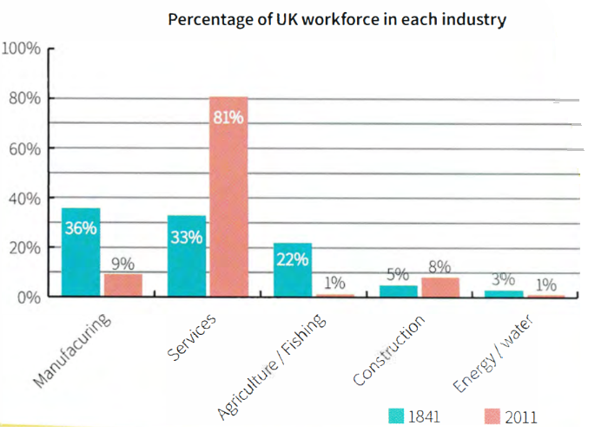

Model Answer

The bar chart compares the percentage of the UK workforce employed in different industries in 1841 and 2011. The sectors represented include manufacturing, services, agriculture and fishing, construction, and energy and water.

Overall, there was a significant shift in employment patterns over the period, with a dramatic rise in the services sector and a sharp decline in agriculture and fishing. Other industries, such as manufacturing and energy/water, also saw reductions in employment, while construction remained relatively stable.

In 1841, agriculture and fishing was the dominant industry, employing over 80% of the workforce. However, by 2011, this figure had plummeted to just 1%. Similarly, manufacturing, which accounted for 36% of jobs in 1841, saw a steep decline to 9% in 2011.

In contrast, the services sector experienced remarkable growth, rising from 33% in 1841 to 81% in 2011, making it the largest employer by the end of the period. Construction remained relatively stable, with a slight decrease from 5% to 8%, while employment in energy and water was always low, dropping from 3% to 1%.

(160 words)

Exercise 8. You should spend about 40 minutes on this task.

Write about the following topic:

Some believe that people today have no interest in maintaining the traditional culture of their country or region. Others believe that it is still important to people that we preserve a traditional way of life. Discuss both these views and give your own opinion.

Give reasons for your answer and include any relevant examples from your own knowledge or experience.

Write at least 250 words.

Dạng bài: quiz_type_0

Easy IELTS - Task 2 - 21

Model answer

Some people argue that modern society has become less interested in preserving traditional culture, while others believe that maintaining cultural heritage remains important to many. This quiz_type_0 will discuss both perspectives before presenting my own view.

On the one hand, many people today prioritize modern lifestyles over traditional customs. Globalization, technological advancements, and changing social norms have led to the decline of certain cultural practices. For example, in many countries, traditional clothing is now only worn on special occasions, while Western-style fashion dominates everyday life. Additionally, younger generations often prefer digital entertainment over traditional storytelling, folk music, or dance, which may result in the gradual disappearance of these cultural elements. As societies become more interconnected, local traditions may be seen as outdated or less relevant in daily life.

On the other hand, many individuals and communities continue to value and actively preserve their cultural heritage. Festivals, traditional food, language, and crafts remain significant aspects of identity and are often passed down through generations. Governments and cultural organizations also play a role in maintaining traditions by organizing cultural events and supporting local artisans. For instance, in countries like Japan and India, there is still strong appreciation for traditional arts, such as tea ceremonies and classical dance forms, which are promoted through education and tourism. These efforts show that many people still see cultural heritage as an essential part of their national or regional identity.

In my opinion, while modernization has led to some decline in traditional customs, cultural preservation remains important to many people. Traditions help maintain a sense of belonging and historical continuity, and efforts should be made to balance progress with cultural heritage. By integrating traditional practices into modern life, such as through digital media or education, it is possible to keep cultural traditions alive while adapting to contemporary society.

(270 words)

LESSON 4

A. Vocabulary

Exercise 1. Match the words in box A with the words in box B to make 10 compound nouns. You will need to use some words more than once

Dạng bài: quiz_type_7

A
active family maternal sibling stable
extended immediate physical striking

B
family instinct rivalry upbringing
gatherings resemblance role

- (1) ___ family
- (2) ___ family
- family (3) ___
- (4) ___ rivalry
- (5) ___ upbringing
- (6) ___ role
- family (7) ___
- (8) ___ resemblance
- (9) ___ resemblance
- (10) ___ instinct

ĐÁP ÁN
- immediate
- extended
- gatherings
- sibling
- stable
- active
- resemblance
- physical
- striking
- maternal

Exercise 2. A lot of words connected with families and relationships can also be used in a different context. Complete the sentences with a word from the box.

nurture | related | relation | family
conflict | relative | adopt | relationship

Dạng bài: quiz_type_7

1. The wolf is a member of the dog _________________.

2. The company decided to _________________ a new approach to staff recruitment.

3. The study found a strong __________ between a lack of friends and sibling rivalry.

4. Whether you think the price of goods is high is ___________ to the amount of money you earn.

5. Studies have shown that stress in adulthood can be _______________ to an unhappy childhood.

6. Good teachers identify the talents of their students and ____________ them.

7. This evidence seems to ________ with the findings from previous studies.

8. I am writing in ________________ to the job advertisement in yesterday's paper.

1. family 2. adopt 3. relationship 4. relative

5. related 6. nurture 7. conflict 8. relation

Exercise 3. Read the text and match the highlight words with their definitions

Dạng bài: quiz_type_7

Study links early friendships with high-quality sibling relationships

Children who experience a rewarding friendship before the birth of a sibling are likely to have a better relationship with that brother or sister that endures throughout their childhood, said Laurie Kramer in a University of Illinois study published in December's Journal of Family Psychology.

"When early friendships are successful, young children get the chance to master sophisticated social and emotional skills, even more than they do with a parent. When parents relate to a child, they do a lot of the work, figuring out what the child needs and then accommodating those needs,' says Kramer. However, this is not usually the case when two children are interacting.

The research showed that the benefits of early friends are long-lasting. Children who had a positive relationship with a best friend before the birth of a sibling ultimately had a good relationship with their sibling that lasted throughout adolescence, Kramer said. And children who as preschoolers were able to coordinate play with a friend, manage conflicts, and keep an interaction positive in tone were most likely as teenagers to avoid the negative sibling interaction that can sometimes launch children on a path of anti-social behavior, she added. 'From birth, parents can nurture and help develop these social competencies (or skills) by making eye contact with their babies, offering toys and playing with them,' she said.

help someone/something develop and grow: _______________
- brother or sister: _______________
- respond to somebody: _______________
- to show or establish a connection between things: _______________
- the stage between childhood and adulthood: _______________
- giving a lot of pleasure: _______________
- communication: _______________

1. nurture 2. sibling 3. accommodating 4. relate
5. adolescence 6. rewarding 7. interaction

B. Grammar

Exercise 4. Fill in the gaps with the adjectives in the box in a comparative or superlative form

Dạng bài: quiz_type_7

I travelled through Turkey by train because it was the fastest way to cross the country.

Scientists have discovered a tiny bacteria living in the deep ocean. They say it is _____________ living organism known to man.

It is almost impossible to find a parking space in the city centre so it is ________________ to travel by public transport if you need to go there.

Pain killers are much ___________ now so they reduce pain a lot faster than in the past.

I like all kinds of sports, but I think football is __________ game to watch because it is so fast-moving.

Nick did a bungee-jump, but I was too scared. He's much ___________ than me.

I think people from the north of my country are ___________ than people from the south. In the south no one ever seems to smile, but it's the opposite in the north.

The website listed hotels in a wide price range. I was amazed that the ___________ ones cost over $500 a night.

Weightlifters these days are lifting ____________ weights than ever before.

2. the smallest 3. better/best 4. more effective 5. the most exciting
6. braver 7. happier 8. most expensive 9. heavier

Exercise 5. Fill in the gaps in the model answer below. Use one word in each gap.

Dạng bài: quiz_type_7

The charts below show the number and types of books bought by men and women and four different age groups in the UK.

Summarise the information by selecting and reporting the main features, and make comparisons where relevant.

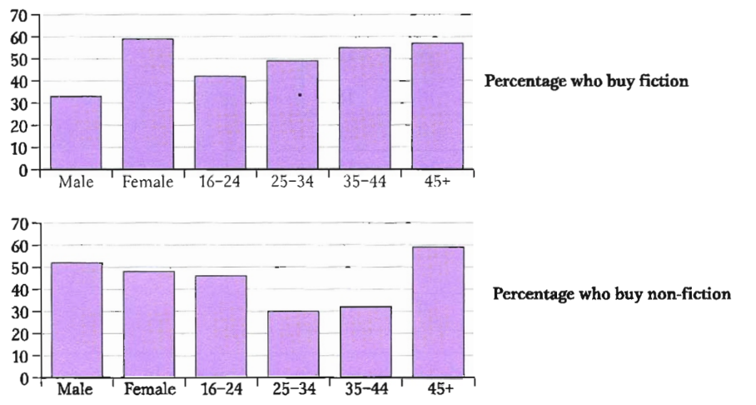

The charts give information about the types of books that British men and women and different age groups buy. The initial impression from the charts is that women tend to buy 1. more books than men overall, although they buy slightly 2. ____________
non-fiction books. The people that buy the 3. ____________ books are in the 45+ age group.
Nearly 60% of women buy fiction, which is almost 4. ____________ as many as the number of men who choose this type of book. Nevertheless, most age groups buy 5. ____________ fiction books than non-fiction ones showing that non-fiction is generally 6. _______________ popular than fiction.
The number of people buying fiction increases steadily from ages 16 to 45 with the 7. _______________ number of books, at just over 40% of the age group, bought by 16- to 24-year-olds and the 8. _______________ number, at just over 50%, bought by the over 45s.
However, the pattern is different for non-fiction. The number of books bought by 25- to 44-year-olds is 9. _______________ lower than the number bought by 16- to 24-year-olds and those over 45. Just over 40% of 16- to 24-year-olds buy non-fiction, but this number is not 10. _______________ high as the number of people aged 45 and over buying non-fiction, at nearly 60%. Only 31% of 35- to 44-year-olds buy non-fiction, and the number of 24- to 34-year-olds is 11. _______________ lower at 28%.

2. fewer 3. most 4. twice 5. more 6. less

7. lowest/smallest 8. highest/biggest/largest/greatest

9. significantly/considerably/much/far

10. as 11. slightly/even

Exercise 6. Read the description of the table below. Decide if the underlined comparisons are correct or not. Write “correct” if they are right and correct them if they are wrong.

Dạng bài: quiz_type_7
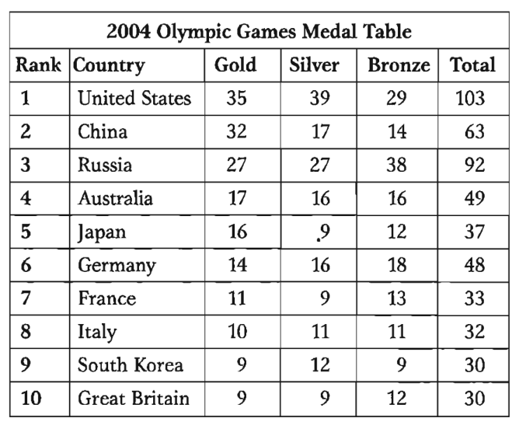

The table shows the number of medals won by the top ten countries in the 2004 Olympic Games. The USA won 1. greatest number of medals overall with a total of 103. They won 2. more silver medals as gold and 3. more medals than any other country in both categories. China had 4. the second high number of medals at 63, but unlike the USA, China won 5. less silver medals than gold medals. While Russia's silver medal total was 6. more good than China's, they did not do 7. well as China in the gold medals, winning just 27. In fact China had a 8. more lower overall medal total than Russia but, as the table is based on the number of gold medals won, they were placed second. Similarly, Germany was 9. significantly successful at winning medals than Japan, with a total of 48 compared to Japan's 37, but because Japan won 10. two more gold medals that Germany they were ranked 11. higher. Great Britain gave 12. the worse performance in this group, winning only nine gold and nine silver medals. | 1. the greatest  2. ____________  3. ____________  4. ____________  5. ____________  6. ____________  7. ____________  8. ____________  9. ____________  10. ____________  11. ____________  12. ____________

2. more silver medals than gold 3. correct 4. the second highest
5. fewer silver medals than gold medals 6. better than 7. as well as
8. much lower/lower 9. significantly more successful
10. two more gold medals than 11. correct 12. the worst

C. Writing

Exercise 7. You should spend about 20 minutes on this task.

Write about the following topic:

The diagram illustrates the process of making traditional wooden shoes called clogs.

Summarise the information by selecting and reporting the main features and make comparisons where relevant.

Write at least 150 words.

Dạng bài: quiz_type_0

Easy IELTS - Task 1 - 20

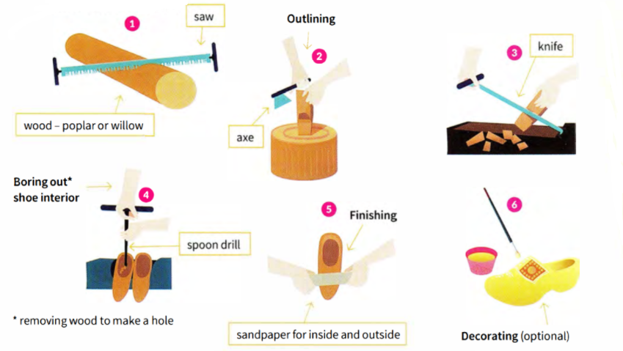

Model Answer

The diagram illustrates the step-by-step process of crafting traditional wooden shoes, known as clogs, from raw wood to a finished product.

Overall, the production involves six main stages: cutting the wood, shaping it, hollowing out the interior, refining the surface, and optionally decorating the final product. Various tools such as saws, axes, knives, and drills are used throughout the process.

The process begins with cutting a log of poplar or willow wood using a saw. Next, the general shape of the shoe is carved out with an axe. This rough shape is then further refined with a knife, removing excess wood for a smoother appearance.

Once the outer shape is formed, a spoon drill is used to bore out the interior, creating space for the wearer’s foot. The clog is then smoothed using sandpaper, ensuring a polished surface both inside and outside. Finally, decoration, such as painting or engraving, can be applied to enhance its appearance.

Overall, the process combines precision cutting, shaping, and finishing techniques to transform raw wood into traditional footwear.

(170 words)

Exercise 8. You should spend about 40 minutes on this task.

Write about the following topic:

We are becoming increasingly dependent on computer-based technology.

How do you think it will change in the future?

Is it good for us to rely so much on computers?

Write at least 250 words.

Dạng bài: quiz_type_0

Easy IELTS - Task 2 - 21

Model Answer

In today’s world, people are becoming more dependent on computer-based technology, and this trend is likely to continue in the future. While technological advancements bring numerous benefits, over reliance on computers also raises concerns. This quiz_type_0 will discuss how computer technology may evolve and whether heavy dependence on it is beneficial.

In the future, computers will likely become even more advanced and integrated into everyday life. Artificial intelligence (AI) and automation are expected to improve efficiency in various industries, such as healthcare, education, and business. For instance, AI-driven doctors may assist in diagnosing diseases, while online learning platforms could become more interactive. Additionally, smart home systems and self-driving cars may become widespread, making daily tasks easier and more convenient. These developments will likely enhance productivity and quality of life.

However, relying too much on computers has potential drawbacks. Firstly, excessive dependence on technology can reduce human skills. For example, many people now struggle with basic math or navigation because they rely on calculators. Secondly, cybersecurity threats, such as hacking and data breaches, are increasing, putting personal and financial information at risk. Furthermore, the widespread use of automation may lead to job losses, as machines replace human workers in various fields.

In conclusion, computer-based technology will continue to evolve and bring significant improvements in many aspects of life. However, it is important to maintain a balance and ensure that humans do not become overly dependent on computers, as this could lead to skill loss, security risks, and unemployment.

(260 words)

