LESSON 1

A. Vocabulary

Exercise 1. Complete the missing information in the jobs advertisement using the words in the box.
Dạng bài: quiz_type_7

experience | friendly and helpful | sports, art or music | energy
long hours | speak another language | hard-working | weekend

SUMMER JOBS FOR STUDENTS
Waiter/Waitress needed for popular Italian restaurant. You do not need to have
1. ____________________ of working in a restaurant, but you should be 2. ________________ and happy to work in a team.
You will work 3. __________________ especially at the weekends when we are very busy.
Receptionist for busy city hotel, who can 4. _______________ (French, German or Spanish).
You should be 5. _______________ to guests and tell them any information that they need about tourist attractions, local restaurants and transport in the city.
Summer Camp Leaders to teach children 6. _______________ at a summer camp. You should have a lot of 7. ________________ because you will spend all day with the children. You will need to work weekdays and at the 8. ______________, but you will have one day off each week.

Key:
1. experience 2. hard-working 3. long hours
4. speak another language 5. friendly and helpful 6. sports, art or music
7. energy 8. weekend

Exercise 2. Complete the categories with the correct words from the box.

Dạng bài: quiz_type_7

waiter | clothes | receptionist | tables | rooms
chef | guests | cash | desk | meal
lift | cleaner | changing rooms | shop assistant

Restaurant | Hotel | Shop
___  ___  ___  ___ | ___  ___  ___  ___ | ___  ___  ___  ___  ___

key
Restaurant | Hotel | Shop
waiter  tables  chef  meal | receptionist  rooms  guests  lift  cleaner | cash  desk  clothes  changing rooms  shop assistant

Exercise 3. Complete the sentences with the prepositions, in/on/ at.

Dạng bài: quiz_type_7
- My brother is working as a lifeguard _______ the swimming pool.
- My cousin studies nursing _______ university.
- I wouldn't like to work _______ a restaurant. I think it would be too stressful.
- I'm not working _______ Monday. It is my day off.
- My friend wants to be a chef _______ a top restaurant.
- I was _______ work yesterday, so I didn't watch the football match on TV.
- I usually finish work _______ five o'clock.

1. at 2. at 3. in 4 .on 5. in/ at 6. at 7. at

B. Grammar

Exercise 4. Complete using the correct form of the verbs in brackets.

Dạng bài: quiz_type_7

I wish I (have) ____________ a million euros! I'd buy lots of great things.

I wish we (live) ____________ in a bigger house. This one is too small.

Becca wishes she (be) ______________ old enough to drive a car.

Do you wish you (feel) ___________ more confident about the exam tomorrow?

I wish my computer (not/be) ______________ broken. I can't check my email.

I wish I (not like) _____________ chocolate so much! I eat three bars a day!

Grant wishes he (not/make) ______________ so many mistakes all the time.

Look what they're wearing! I bet they wish they (not/look) ___________ so silly!
1. had 2. lived/could live 3. was/were 4. felt
5. wasn’t/weren’t/was not/were not 6. didn’t like/ did not like
7. didn’t make/did not make 8. did not look/didn’t look

Exercise 5. Complete using the correct form of the verbs in the box. You may have to use some negative forms.
Dạng bài: quiz_type_7
feel | give | have
live | spend | wear

I wish ____________ in the countryside. The city is so noisy!

Tracy has got curly hair but she often wishes she _____________ straight hair.

I wish our teachers ______________ us less homework every day, but there's nothing I can do about it.

I wish I ________________ so scared, but I do!

Do you wish you ______________ contact lenses or are you happy with glasses?

Jake's mum wishes he _______________ so much money on clothes whenever he goes

shopping.
- lived/could live 2. had 3. gave/would give
4. didn’t feel/did not feel 5. wore
6. didn’t spend /wouldn’t spend/did not spend/ would not spend

C. Speaking

Exercise 6. Listen to Speakers 1-3 talking about their countries' climates. Which country is each speaker talking about? Choose Wales, Saudi Arabia or Iceland.

Dạng bài: quiz_type_7

Speaker 1: ___

Speaker 2: ___

Speaker 3: ___
Key

Saudi Arabia

Wales

Iceland

Exercise 7. Listen to the recording again then find words and expression in audio associated with “hot, cold, wet and dry climates” and write them in the table below

Dạng bài: quiz_type_7

Hot climate | Cold climate | Wet climate | Dry climate
- ___ | - ___ | - ___ | - ___

key:
- sweltering, it can exceed 50°C
- wrap up warm, it never gets above 25°C
- it’s constantly drizzling, lush countryside
- arid, precipitation is very low

Exercise 8. Answer the IELTS Speaking Part 1 questions below. Record your answers.

Dạng bài: quiz_type_13

Tell me about your country's climate.

What's your favourite kind of weather?

Does the weather influence your mood?

Is it worse to feel too hot or too cold?
Suggested answer:
- Well, my country has a tropical climate, so it's generally hot and humid throughout the year. We have a rainy season that usually lasts from May to October, and a dry season during the rest of the year. While some parts of the country experience cooler temperatures in the highlands, most areas stay quite warm.
- I really enjoy cool and breezy weather, especially when it's slightly cloudy. It's comfortable and refreshing, and it allows me to go outside without feeling exhausted by the heat. It also makes activities like walking or jogging much more pleasant.
- Yes, definitely. When it’s sunny but not too hot, I usually feel more motivated and energetic. On the other hand, if it’s gloomy or raining heavily, I tend to feel lazy and a bit down. The weather really has a strong effect on how productive I am during the day.
- In my opinion, feeling too hot is worse because it makes me feel sweaty and uncomfortable. At least when it's cold, I can wear more layers or drink something warm. But when it's extremely hot, especially with high humidity, it's really hard to concentrate or even sleep properly.

LESSON 2

A. Vocabulary

Exercise 1. Complete the paragraphs using the given words
Dạng bài: quiz_type_7
- Getting a job
interviews | applied for | employed | CVs | training

“When I left school, I 1. ____________ jobs in different companies, and finally, after sending out lots of 2. ____________ and having some 3. ____________, a small company 4. ____________ me. I didn’t earn a lot, but the company gave me some 5. ____________, which was good.”
- applied for 2. CVs 3. interviews 4. employed 5. training
- Promotion
experience | pay rise | promotion | promoted

“I worked hard and soon I was 6. ____________. They also gave me a good 7. ____________. It was really good 8. ____________, and when my boss left the company a few years later, they gave me an important 9. ____________.”
6. promoted 7. pay rise 8. experience 9. promotion

Resignation* and Unemployment

(* when you say officially you are leaving a job)

quit my job | unemployed | sacked | part-time | abroad

“By my mid-twenties, I was getting a bit bored, and decided I wanted to work 10. ____________. So, I 11. ____________ and started looking for jobs in the UK. After a couple of months, I got a job in London. At first I liked it, but after six months, I got fed up with the job – and I think I was enjoying myself too much to work very hard. Finally, the company 12. ____________ me, and after that I was 13. ____________ for two months. Finally, I got a 14. ____________ job in the kitchen of a restaurant.”

10. abroad 11. quit my job 12. sacked 13. unemployed 14. part-time

Success and retirement

successful | owner | retired | own | owned | succeed

“I loved the restaurant. I learned how to cook, and two years later I became a manager. Three years after that I opened my 15. _____________ restaurant. It was very 16. _____________, and twenty years later, I 17. _____________ five restaurants, and I was the 18. _____________ of two hotels. I believe anyone can 19. _____________ if they work hard enough – and have a little bit of luck. Last year, aged sixty, I 20. _____________ and went back to Italy.”
15. own 16. successful 17. owned 18. owner 19. succeed 20. retired

Exercise 2. Complete the table.
Dạng bài: quiz_type_7
Verb | Noun | Adjective
employ | (un) employment | - _________________
promote | - _________________
retire | - _________________ | - _________________
resign | - _________________
- _________________ | success | - _________________
own | - _________________

1. (un)employed/employed/unemployed 2. promotion
3. retirement 4. retired 5. resignation
6. succeed 7. successful 8. owner

B. Grammar

Exercise 3. The words in bold in each sentence are wrong. Write the correct word or phrase.

Dạng bài: quiz_type_7

I wish I can speak German, but I never learnt it at school.

I wish you will put your toys away! It's not difficult!

Do you sometimes wish you can fly?

I wish you won't lie to me all the time!

I wish the neighbours won't make so much noise.

If only she will ask me to go to the disco with her!

If only you can come with us!
Answer: 1. ___, 2. ___, 3. ____, 4. ___,5. ___, 6.___ , 7.___
1. could 2. would 3. could 4. wouldn't/didn't/would not/ did not
5. wouldn't/didn't/wouldn't/didn't/would not/ did not 6. would 7. could

Exercise 4. Circle the correct word or phrase.
Dạng bài: quiz_type_7

26th April 3500

I wish today (1) ___ has / had never happened! If only I (2) ___ could / would start the day again, I'd do everything differently. Why did I forget to set the alarm last night? I really wish I (3) ___ haven't / hadn't done that! I also wish I (4) ___ live / lived nearer the Earth. It takes such a long time to get there from Mars especially when the traffic is bad. (5) ___ If only / Only if I (6) ___ have / had a faster spaceship. Anyway, the point is, I was late for my job interview. The first question they asked was why I wanted to be an Environmental officer on the moon. Do you know what I said? Because I really wanted to look at the aliens in the Super Alien Zoo. Oh, I wish I (7) ___ didn't say / hadn't said that. Why am I so stupid? I (8) ___ wish / hope now that I'd never applied for the job in the first place. I'm sure I won't get the job. I just (9) ___ wish / hope tomorrow is better than today was.

Key:

had

could

hadn't

lived

If only

had

hadn't said

wish

hope

C. Speaking

Exercise 5. Complete the text with words a-j that combine with the words in italics.

Dạng bài: quiz_type_7
a. biting | b. bitterly | c. hot | d. heavy | e. high
f. boiling | g. rainy | h. flooding | i. rain | j. unbearable

In my country, we have a (1) ______________ season. During this time, there is really (2) ___________ humidity so it gets awfully (3) ______________ and sticky, and we often get torrentially (4) _____________, which can cause severe (5) ____________. In the early summer, before the rains come, it tends to be (6) _____________ hot. Most tourists find the heat

(7) _____________, actually, so I wouldn't recommend visiting then.

In the winter, it gets (8) ____________ cold. We get (9) ____________ winds, so cold that I have heard of people's ears freezing and then snapping off! Not only that but we get such (10) ____________ snow that some people's houses get completely covered by snowdrifts and they have to be dug out.
- g 2. e 3. c 4. d 5. h 6. f 7. j 8. b 9.a 10. d

Exercise 6. Match sentences 1-8 to the people a-c in the photos

Dạng bài: quiz_type_7
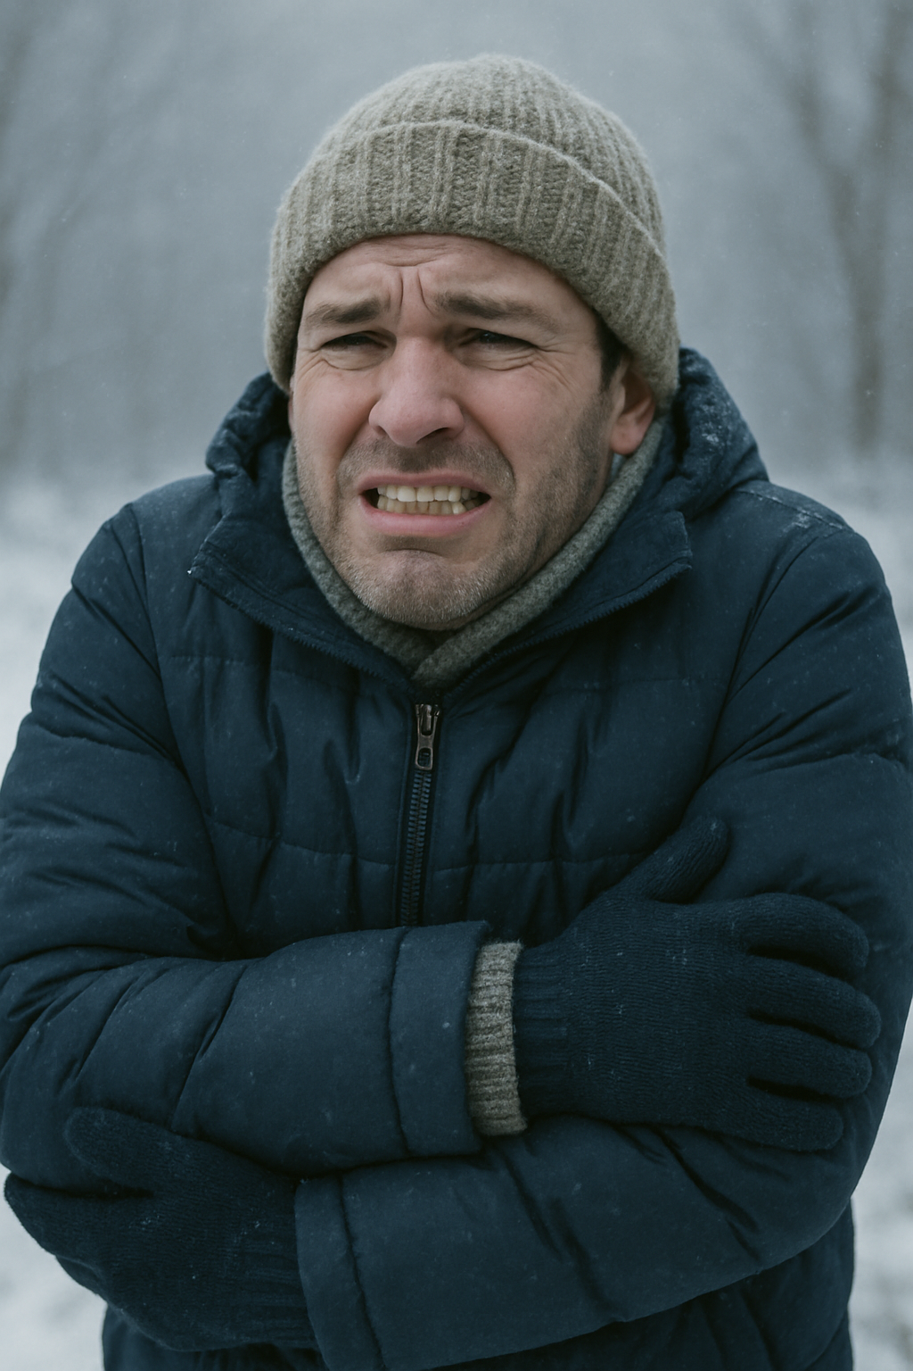  - _______________ | 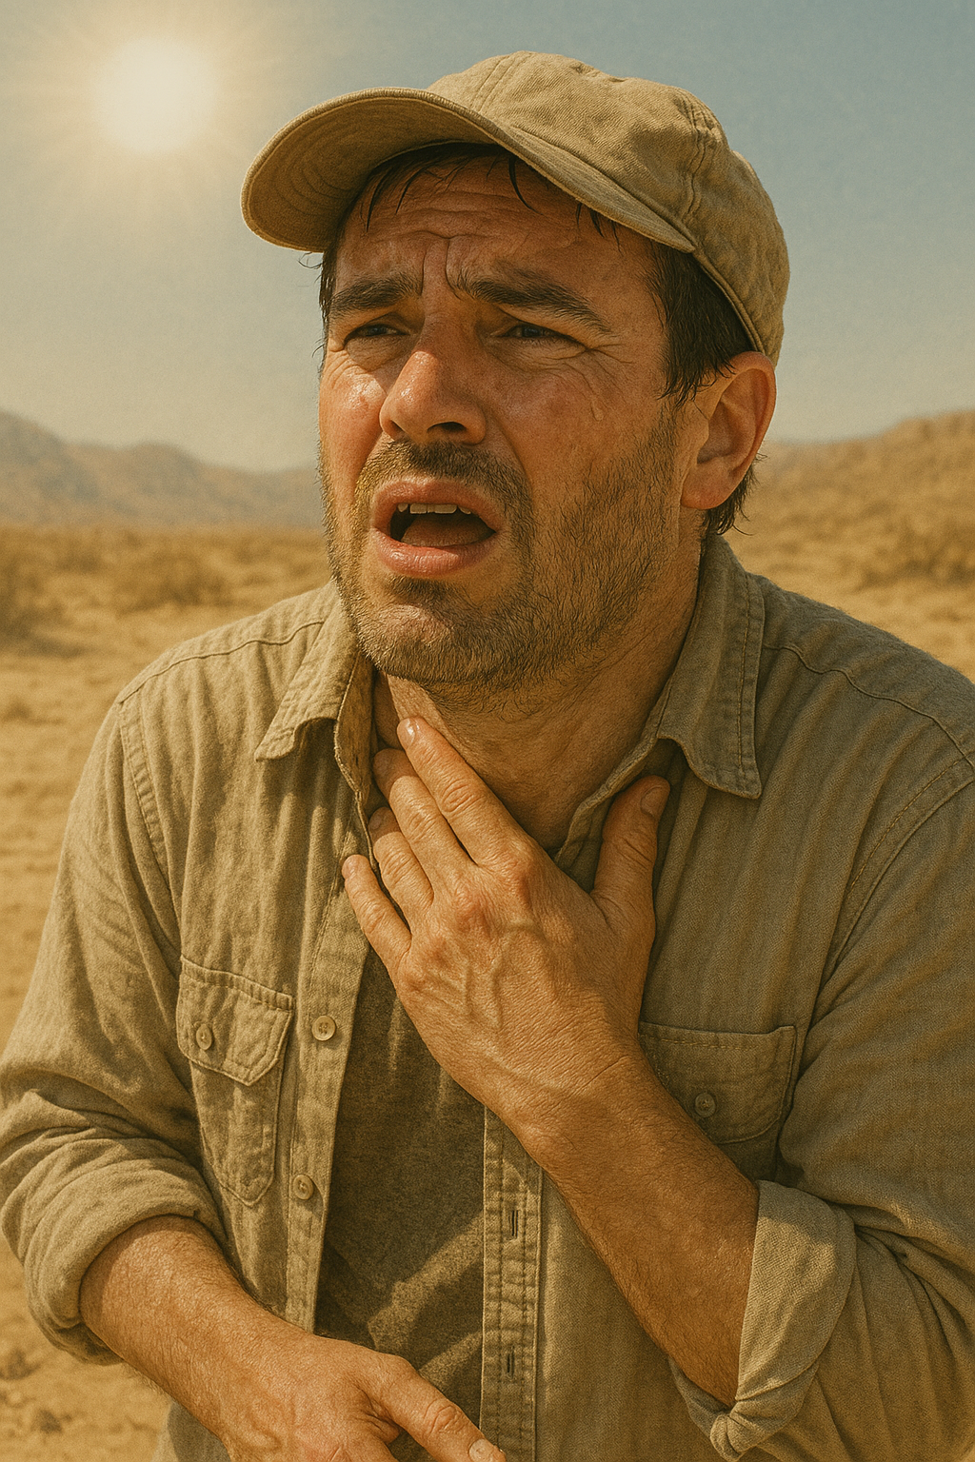  - _______________ | 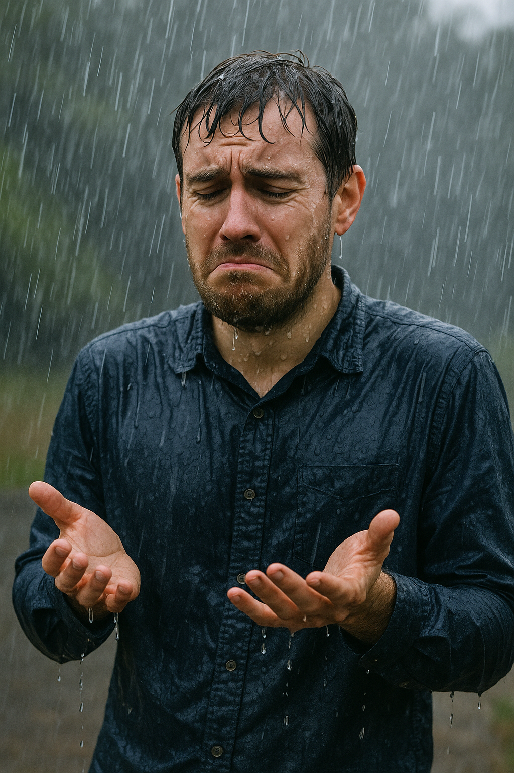  - _______________

- I'm soaked to the skin.
- I feel so dehydrated.
- I wish I had my waterproofs on.
- I'm drenched.
- My teeth are chattering.
- I wish I was wearing more layers.
- I'm frozen to the bone.
- I wish I could find some shade.
Answer: 1. ___, 2. ___, 3. ____, 4. ___,5. ___, 6. ___,7. ___, 8. ___

- c 2. b 3. c 4. c 5. a 6. a 7. a 8. b

Exercise 7. Answer the IELTS Speaking Part 2 questions below. Record your answers.

Dạng bài: quiz_type_13
Describe your favourite season.
You should say:
- what the season is and when it occurs
- what the weather is like during this season
- what your typical activities are during this season
and explain why it is your favourite season.

Suggested answer:

One of my favourite seasons is autumn, which usually occurs from late September until early December in my country. It is a transitional period between the hot summer and the cold winter, and I find the weather during this time really pleasant.

The temperature is generally mild, not too hot or too cold, and there is often a crispness in the air that I really enjoy. The skies tend to be clear, and the leaves on the trees change colour, turning beautiful shades of red, orange, and yellow. I think the atmosphere becomes more peaceful and relaxing.

During autumn, I often go for walks in the park or take short weekend trips to the countryside to enjoy the scenery. It is also the perfect time for reading outside or having coffee in outdoor cafés. There are also some traditional festivals and holidays around this time, which makes it feel special.

The main reason why autumn is my favourite season is that it feels like a fresh start. The weather is ideal for spending time both indoors and outdoors, and I feel more balanced and inspired during this season. It is also a time when I am most productive because the temperatures are just right for focusing and staying active.

LESSON 3

A. Vocabulary

Exercise 1. Complete using the words in the box.
Dạng bài: quiz_type_7
extinct | global | mild
freezing | local | wild

- Britain generally has very ______________ winters. It never gets very cold.
- It's ______________! Do you think it might snow tonight?
- Save the polar bears before they become ______________!
- A ______________ problem is a problem that affects the whole world.
- What kind of __________ animals live in the mountains round here?
- There are several large forests in the __________ area.
- mild 2. freezing 3. extinct 4. global 5. wild 6. local

Exercise 2. Complete by changing the form of the word in capitals.
Dạng bài: quiz_type_7
- They closed the airport because it was so ________________ (FOG).
- High winds can be very _______________ (DESTROY).
- Lots of _______________ (NATURE) things are poisonous to humans.
- Air _______________ (POLLUTE) isn't really a serious problem where we live.
- Isn’t ______________ (GARDEN) a bit of a boring hobby?
- The submarine went down to a _______________ (DEEP) of 200 metres.
- The island isn't square - it's almost completely _____________ (CIRCLE).
- Is it ______________ (DANGER) to swim in that lake?

1. foggy 2. destructive 3. natural 4. pollution 5 .gardening
6. depth 7. circular 8. dangerous

B. Grammar

Exercise 3. Choose the correct answer.

Dạng bài: quiz_type_14
1. I wish _______________ an MP3 player.
- have B. had C. would have
2. We all wish Tim ____________ with the housework.
- helps B. will help C. would help
3. I wish ____________ to buy a lottery ticket last night.
- remember B. remembered C. had remembered
4. I wish you ___________ live so far away.
- don't live B. didn't C. won’t
5. I wish they ___________ keep changing the time of this programme.
- couldn't B. wouldn't C. don't
6. Do you wish you ________ to help Michael in the shop last weekend?
- hadn't offered B. didn't offer C. haven't offered

Exercise 4. If the word or phrase in bold is correct, write “correct”. If it is wrong, write the correct word or phrase.
Dạng bài: quiz_type_7

Could you show to me your book about the moon? _________________

Do you sometimes wish you have a bigger boat? _________________

I wish people didn't cause so much damage to the environment. _________________

Harry wishes that he has studied astrophysics instead of Latin when he was at university. _________________

I wish you wouldn't throw rubbish out of the car window! _________________

Laura sometimes wishes she can breathe underwater for hours. _________________

I bought a new telescope for my dad. _________________

I wish it snows during the night! _________________
1. me 2. had 3. correct 4. had 5. correct
6. could 7. correct 8. hope

C. Speaking

Exercise 5. Choose the correct answer for each question.

Dạng bài: quiz_type_7

Oh, I hardly know where to start! Pollution in the oceans kills fish and so unbalances the ecosystem. Pollution on land means that whole areas become unfit to live on or to farm. Habitats are destroyed, which leads to the extinction of hundreds of animal and plant species.
- To be honest, no. I think the middle and upper classes are more interested in earning as much money as they can in order to buy as much stuff as they can. And there are many people in my country who live below the poverty line and they quite literally can't afford to worry about the environment when they're struggling to put food on the table and just survive.

In my view, the responsibility lies with all of us. However, individuals, at least in my country, aren't taking action of their own accord, and nor are businesses; they're just out to make a profit. Therefore, it falls to governments to force people to be more green, for example, by fining companies that release toxic waste into our rivers, or incentivizing us to recycle.

Well, yes, overall. I'd say, though, that richer countries pollute less themselves, but export their pollution elsewhere, by which I mean that they consume foreign products that have a large carbon footprint. It has become fashionable to be green in wealthier nations, especially Western ones, so people make an effort to cycle to work and recycle their waste. However, it's quite a shallow attempt at being green, in my opinion, because they still live in big houses using lots of energy and go on holidays abroad, leaving a trail of pollution in their wake.

Oh, I think the effects will be catastrophic! While many governments are acting, they are not acting quickly enough. It's frustrating and it's causing our climate to change beyond recognition. There is hope, though. I read an article recently that suggested rewilding as one possible solution to the environmental crisis. That's where you restore areas of land to their natural state. It's a brilliant idea and I hope it catches on, otherwise pollution will keep getting worse and we'll see more problems with people's health, like asthma, and more and more species of animals and plants will become extinct.
- Almost certainly it does because it is the next generation who will have to take on the huge burden of saving the planet. My generation isn't doing enough and is too worried about money, but we can already see that young people appreciate the urgency of the situation, and part of the reason for that is that they learn about the repercussions of a polluting lifestyle in schools.

Question 1: Are people in your country concerned about protecting the environment? _____________

Question 2: Does the responsibility for protecting the environment lie with governments or with individuals? _____________

Question 3: Does it help to educate young people on being green? _____________

Question 4: What effects does pollution have on the environment? _____________

Question 5: Do you think we pollute more now than we did fifty years ago? _____________

Question 6: What do you think will happen if we don't reduce current levels of pollution? _____________
1. B 2. C 3. F 4. A 5. D 6. E

Exercise 6. Answer the IELTS Speaking Part 2 questions below. Record your answers.

Dạng bài: quiz_type_13

Describe a place you visited where the air was polluted.
You should say:
- where the place is
- when you visited it
- why the air was not good
and explain how you felt about the place

Suggested answer:
During my travels, I unfortunately found myself in a seriously polluted place: Beijing, China. It was the summer of 2018, and I was excited to dive into the city's rich history and cultural wonders. However, my enthusiasm quickly waned as I discovered the shockingly terrible air quality that plagued Beijing during my entire stay. The main culprits for the inhospitable air were the massive amounts of industrial emissions and the constant flow of traffic. The rapid urbanisation and exponential growth of industries in Beijing had taken a heavy toll on the environment. To make matters worse, unfavourable weather conditions like stagnant air and weak winds trapped the pollutants close to the ground, intensifying the problem. The moment I arrived, the stark contrast in air quality hit me. The sky was a dreary grey, enveloping the city in a foreboding haze. The air carried a pungent smell of pollutants, making every breath a struggle. It felt heavy and oppressive, making it difficult to breathe comfortably. I had no choice but to wear a protective mask to alleviate the irritation in my eyes and throat caused by the noxious mix of pollution. The pervasive pollution deeply affected my perception of the place. It obscured the magnificence of the city's architectural wonders and cultural heritage, casting a sombre shadow over my overall experience. My time in Beijing served as a powerful reminder of the urgent need for environmental conservation and sustainable progress and highlighted the collective responsibility we all share in safeguarding our environment.

Exercise 7. Answer the IELTS Speaking Part 2 questions below. Record your answers.

Dạng bài: quiz_type_13
1. Is there more pollution now than in the past?
2. In what ways can air pollution be reduced effectively?
3. Do you think the city is cleaner or dirtier than the countryside? Why?
4. What can factories and power plants do to reduce pollutants?
5. Do you think the wind has any effect on pollution? How?
Suggested answer
- Yeah, pollution has definitely spiked compared to the past. The rapid industrialisation and urbanisation have pumped out tons of harmful pollutants into the environment. Just look at the number of cars on the roads now, emitting greenhouse gases and nasty stuff into the air. And with our fancy technology, we've introduced even more sources of pollution. Think about all the electronic waste we generate and the mountains of plastic we use every day. Plus, our growing population and changing lifestyles have put a strain on resources, leading to more waste and pollution. However, there are efforts being made to control pollution through stricter regulations and individual actions, so let's keep working towards a cleaner future.
- To effectively combat air pollution, various measures can be implemented. Firstly, the adoption of advanced clean technologies in industries and transportation can significantly reduce pollutant emissions. This entails embracing renewable energy sources, enhancing fuel efficiency, and enforcing stringent emission standards. Secondly, raising public awareness and educating individuals about the detrimental effects of air pollution can foster a culture of sustainable choices. Encouraging alternatives to private vehicles, such as public transportation, cycling, and walking, can play a pivotal role in mitigating pollution levels. Moreover, the creation of green spaces and the planting of trees can effectively combat air pollution by acting as natural filters, absorbing carbon dioxide, and releasing oxygen.
- I’d say it largely depends on specific locations and situations. Cities often exhibit higher population densities and a greater presence of industrial activities, which can contribute to elevated pollution levels. The concentration of vehicles, factories, and urban infrastructure can result in increased air and noise pollution within cities. Conversely, the countryside typically experiences less human activity and fewer pollution sources, thus enjoying comparatively cleaner air, serene natural surroundings, and reduced noise pollution. However, it's worth considering that agricultural practices and the use of pesticides in rural areas may have adverse environmental implications. In essence, the cleanliness of a city or countryside is contingent upon various factors such as governmental regulations, infrastructural provisions, waste management systems, and individual behaviours.
- Factories and power plants can take several steps to reduce pollutants. Firstly, they can install advanced emission control technologies like filters and scrubbers to capture and remove pollutants before they are released into the air. This helps in minimising their environmental impact. Secondly, optimising production processes and adopting cleaner technologies can significantly reduce pollutant emissions. By improving efficiency and minimising waste, factories and power plants can decrease the generation of harmful pollutants. Moreover, transitioning to renewable energy sources, such as solar and wind power, can greatly reduce reliance on fossil fuels and cut down greenhouse gas emissions.
- Definitely! The wind does have an impact on pollution. It plays a crucial role in dispersing and diluting pollutants in the air. When there's a strong breeze, it helps carry the pollutants away, reducing their concentration in one area. For instance, if there's a factory spewing harmful gases, a powerful gust of wind can scatter those pollutants over a wider region, lessening their immediate impact. In urban areas with high pollution levels, a good breeze can ventilate and clear the polluted air, providing some relief from poor air quality. However, it's important to remember that the wind doesn't eliminate pollution entirely. If pollution sources persist, the wind simply moves the pollutants to different areas, affecting other regions and communities.

LESSON 4

A. Vocabulary

Exercise 1. Choose the best synonym for the underlined word.
Dạng bài: quiz_type_14
- Many forests in developing countries are being destroyed to make space for agriculture.
a) protected
b) damaged
c) planted
d) constructed
- Governments must act quickly to protect areas of natural beauty from tourism damage.
a) develop
b) defend
c) ignore
d) increase
- Factories and vehicles continue to create pollution, which seriously affects air quality.
a) gases
b) poison
c) waste
d) noise
- People are encouraged to reduce their carbon footprint by using public transport.
a) lower
b) cancel
c) change
d) raise
- Many animals are endangered because their natural habitats are disappearing.
a) common
b) threatened
c) protected
d) lonely
- Climate change has become a serious global issue that needs urgent attention.
a) light
b) enjoyable
c) important
d) slow
- Cutting down trees on a large scale leads to deforestation in many tropical areas.
a) planting
b) forest loss
c) tree growth
d) pollution
- Many organisations work to conserve water, especially in countries with dry climates.
a) waste
b) save
c) boil
d) increase

Exercise 2. Write one word in each gap.
Dạng bài: quiz_type_7

EarthWatch

the environmental organisation that cares

Are you worried (1) _______________ planet?

We at EarthWatch care about the damage that's being done (2) ___________ our environment. We're aware (3) ___________ the problems that this damage will cause in the future, and we believe that we're extremely short (4) ___________ don't act soon, it will be too late!

There's been an increase (5) ________ all kinds of pollution in the past hundred years. This pollution is destroying the ozone layer, and creating global warming. We've got to prevent people. (6) ___________ polluting the planet further. It's not going to be easy to save the Earth (7) ___________ destruction, but we have to try.

If you're afraid (8 ) ___________ what might happen if we don't all change our ways, if you're serious (9) ___________ helping to save the world, if you're enthusiastic (10) ______________________ fighting for the only planet we've got, then we want to hear from you!

Think (11) _________________ it! You can’t escape (12) ___________ the facts. The Earth is in

danger and it's going to take every single one of us to help save it. Join us today!
1. about 2. to 3. of 4. of 5. in 6. from 7 .from
8. of 9. about 10. about 11. about 12. from

B. Grammar

Exercise 3. Fill in the gaps using wish or should and the words in brackets in the correct form.
Dạng bài: quiz_type_7

You (not/leave) shouldn't have left school so young. You'd have a better job now.

I really (you/ask) ______________ me before borrowing the car yesterday. I needed to use it.

I'm not enjoying my degree course at all. I (I/not/choose) ______________ physics. I

(choose) ______________ maths instead because I used to love it at school.

(I/study)______________ languages at school because now I travel regularly for work to Berlin and Paris.

That man is really annoying me. I (he/stop) ______________ whistling.

We're lost again. We always get lost when you have the map. You (let) ___________ me have the map from the start!

2. wish you’d asked/wish you had asked
3. wish I hadn’t chosen/wish I had not chosen/ shouldn’t have chosen/should not have chosen; should have chosen/wish I had chosen
4. wish I’d studied/ wish I had studied
5. wish he would stop
6. should have let

Exercise 4. Choose the most suitable form of the verbs.
Dạng bài: quiz_type_7
Dear Paul and Claire,
We're having a wonderful time here in France. The weather is beautiful and we've got lots of plans for how to spend the next couple of weeks. Tomorrow 1. ___ (we're going out / we will go) out on a glass-bottomed boat to look at the wonderful sea life, and then on Wednesday we think 2. ___ (we're taking / we'll take) a tour of the old town. Ollie's aunt lives quite close, so 3 ___ (we're visiting / we're going to visit) her too if we have time.
The hotel is lovely and lively and has lots of good night life. Tonight 4 ___ (they're holding / they'll hold) an international evening, with lots of food from different countries.
As you know, we're here with our friends, John and Wendy, but 5 ___ (they aren't staying / they won't stay) as long as us, so 6 ___ (we're probably doing / we'll probably do) the really 'touristy' things with them, and be lazy in our second week. You can hire small sailing boats for the day, so we think 7 ___ (we're doing / we're going to do) that next week, and 8 ___ (we're also going to try / we're also trying) to have time to do some shopping!
I hope you are ready for your big trip. 9 ___ (You're loving / You'll love) Australia. In fact 10 ___ (you're going to probably end up / you'll probably end up) staying there much longer than you've planned.
Have a great time, and 11 ___ (we're going to see / we'll see) you when you get back.
Love Kath and Ollie

Key:
- we're going out
- we'll take
- we're going to visit
- they're holding
- they aren't staying
- we'll probably do
- we're going to do
- we're also going to try
- You'll love
- you'll probably end up
- we'll see

C. Speaking

Exercise 5. Answer the IELTS Speaking Part 1 questions below. Record your answers.
Dạng bài: quiz_type_13
- Do you like jobs that require teamwork?
- What’s the most important thing about teamwork?
- Do you like to be a leader?
- What role do you usually take on when working in a team?
- Have you ever encountered conflicts or disagreements within a team?
Suggested answer:
- Yes, I do. I enjoy working with others because it allows people to share ideas, support each other, and achieve goals more efficiently. Teamwork also helps me learn new skills and perspectives from different people.
- I think communication is the key. If everyone in the team communicates clearly and openly, it reduces misunderstandings and keeps everyone on the same page. Respect and responsibility are also crucial.
- Sometimes, yes. I’m quite comfortable taking the lead if I have a clear idea of what needs to be done. However, I’m also happy to follow someone else’s lead if they have more experience or knowledge in a certain area.
- I usually take on the role of an organizer. I like to make sure tasks are divided fairly and deadlines are met. I’m good at planning and helping the team stay focused on the final goal.
- Yes, definitely. In group projects, people often have different opinions or working styles. But I’ve found that if we listen to each other and try to find a compromise, most issues can be solved quite smoothly.

Exercise 6. Answer the IELTS Speaking Part 2 questions below. Record your answers.
Dạng bài: quiz_type_13

Describe a subject you enjoyed studying at school.
You should say:
- what subject it was
- what class you were then
- how interesting it was
and explain why you enjoyed studying this subject at school.

Suggested answer:
One subject I really enjoyed studying at school was Geography. I first studied it seriously when I was in Grade 8, and I immediately found it fascinating. We learned about different countries, climate zones, natural disasters, and even how human activities affect the environment.
What made it especially interesting was the way our teacher brought the subject to life. He used a lot of visuals, videos, and maps to explain the topics, and he always connected what we learned in class to real-world situations, such as global warming or how cities are planned. I remember we even did a small project where we had to create our own map of a city, and that was really fun.
I think I enjoyed Geography so much because it helped me understand the world around me. It was not only about memorizing facts; it also taught me to think critically and see how everything is connected. Even today, I still enjoy watching documentaries and reading articles about the environment and global issues, and I believe that passion definitely started in my Geography class.

Exercise 7. Answer the IELTS Speaking Part 3 questions below. Record your answers.
Dạng bài: quiz_type_13
1. How are education priorities today different from those in the past?
2. How well do you think schools prepare young people for working life?
3. How has teaching changed in your country in the last few decades?
4. Is a good education more important to a boy or a girl? Why?
5. Do you think students should choose subjects they like?
Suggested answer:
- In the past, education was more focused on memorization and discipline, and there was less emphasis on creativity or critical thinking. Nowadays, schools try to develop a wider range of skills, such as problem-solving, teamwork, and digital literacy. There’s also more focus on preparing students for real-world challenges rather than just passing exams.
- I think it depends on the country and the school, but in general, many schools still need to do more. While students learn academic subjects, they often lack practical experience, like managing money, working in a team, or communicating in a professional way. Some schools are starting to include life skills and career guidance, which is a positive change.
- Teaching has changed a lot in my country. Traditional methods like lecturing and copying from the board are being replaced with more interactive approaches. Teachers now use technology more often, such as videos, online quizzes, and smart boards. Also, students are encouraged to ask questions and express their opinions, which didn’t happen much in the past.
- A good education is equally important for both boys and girls. Everyone deserves the opportunity to reach their full potential, no matter their gender. In fact, educating girls often leads to benefits for the whole society, like lower poverty rates and better health. So I don’t think one gender should be prioritized over the other.
- Yes, definitely. When students study subjects they enjoy, they are usually more motivated and perform better. Of course, they still need to study some core subjects, like maths or languages, but having the freedom to choose some courses can help them discover their strengths and plan their future careers.

