LESSON 1

A. Vocabulary

Exercise 1. Look at the pictures and label

Dạng bài: quiz_type_12

pick and put in basket | sow tea seeds | sunshine - plants grows
tea grows in India and China | deliver tea in boxes | dry tea leaves
pack into boxes | load onto a lorry | customers-buy
take the tea home

  - ________________ | 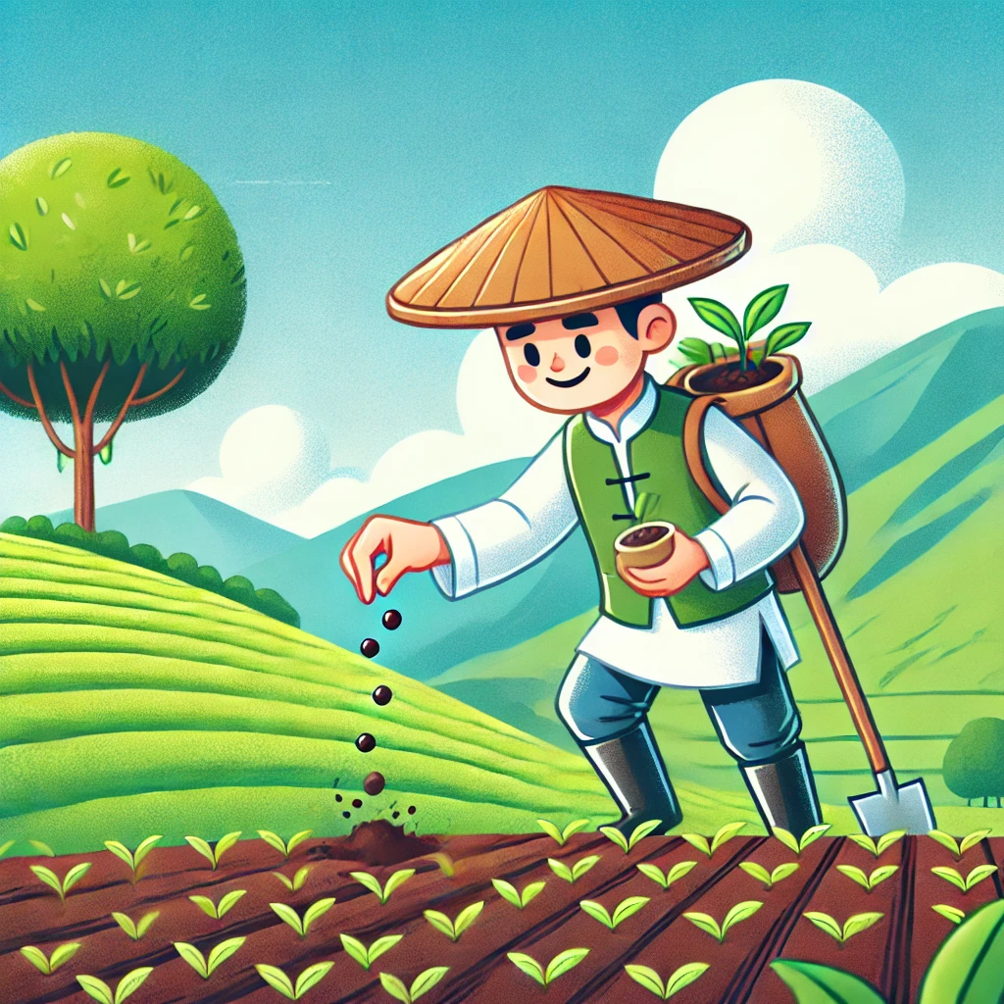2. _________________ |   3. ___________________
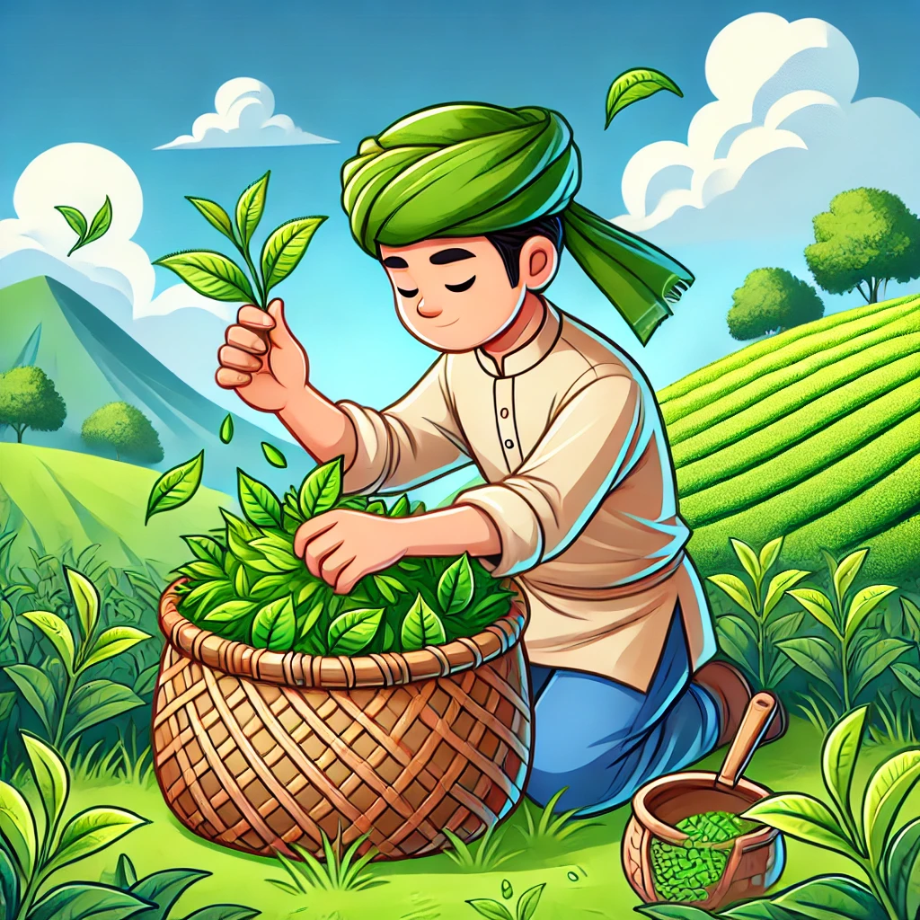  4. ___________________ | 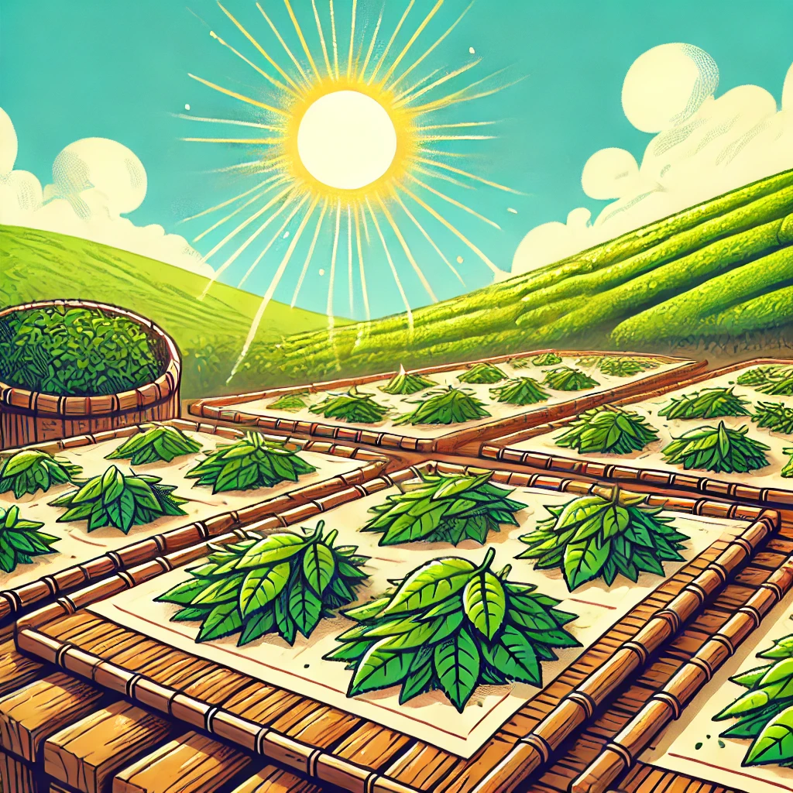  5. ___________________ | 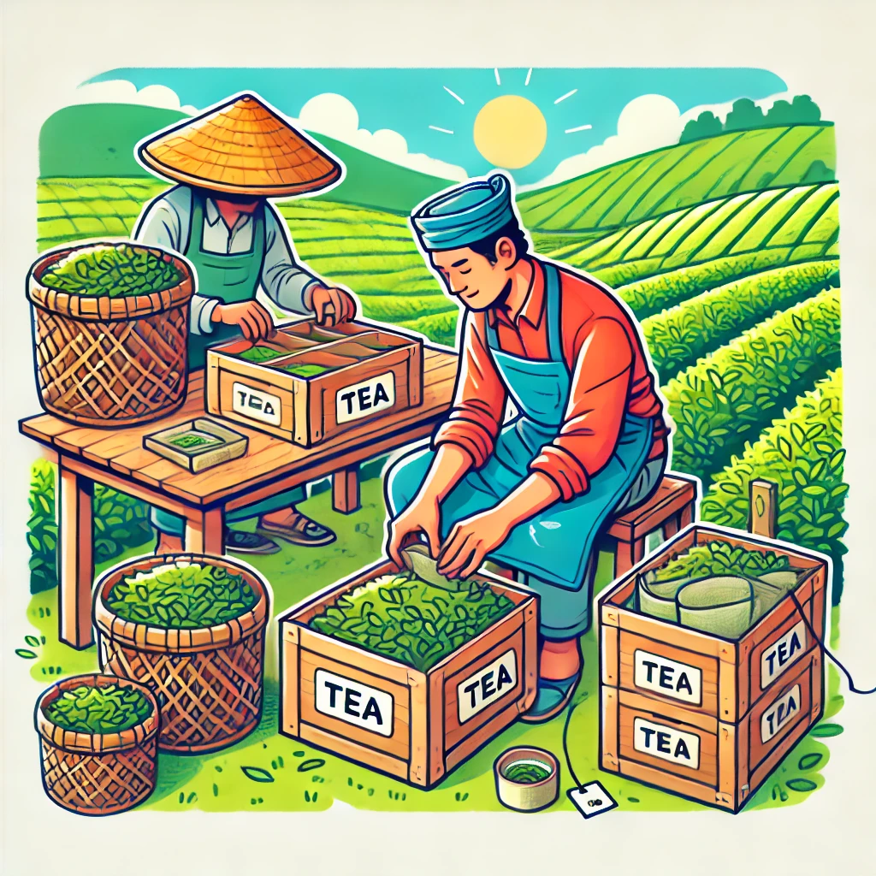  6. ___________________
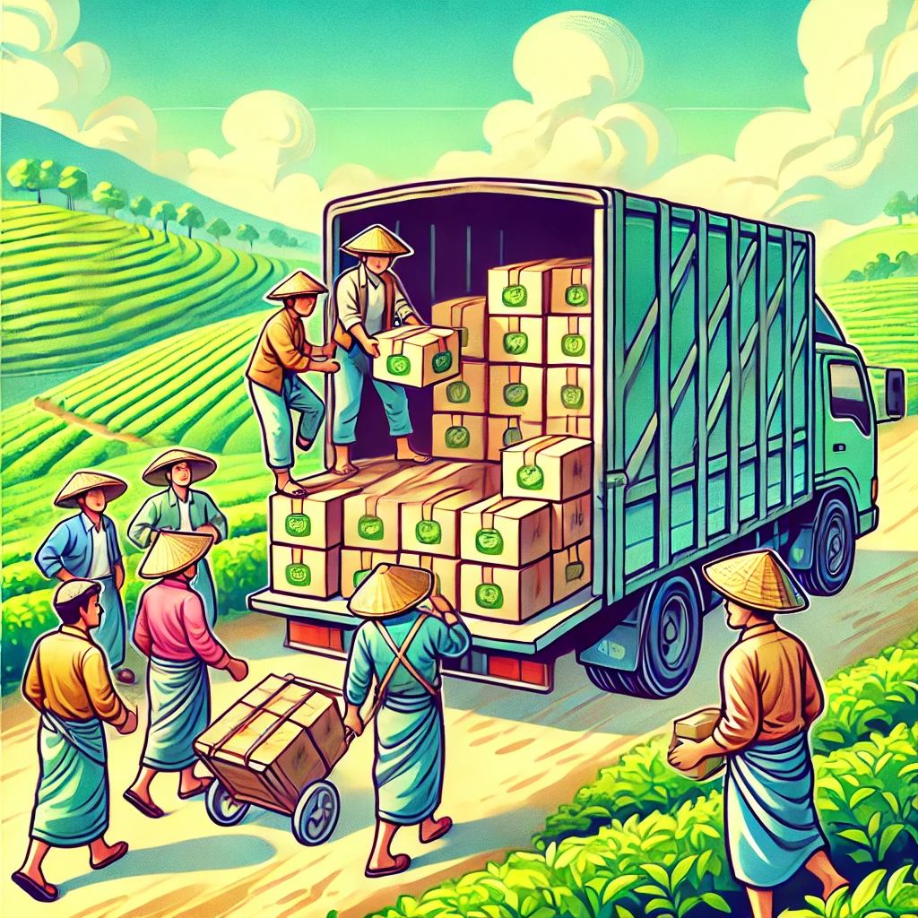  7. ___________________ | 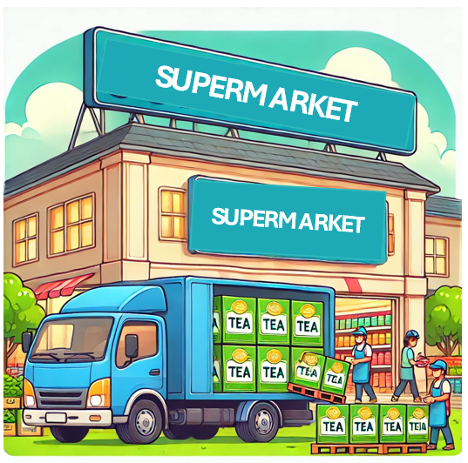  8. ___________________ | 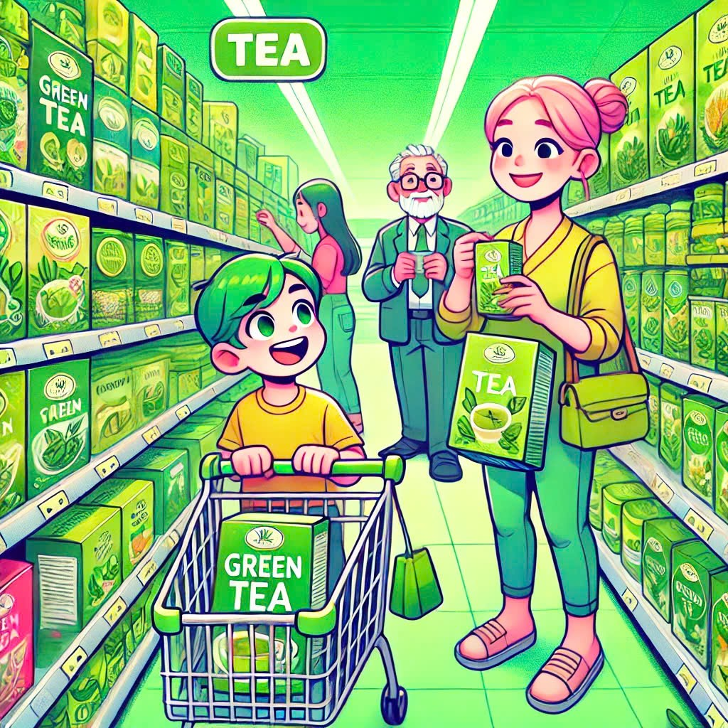9. ___________________
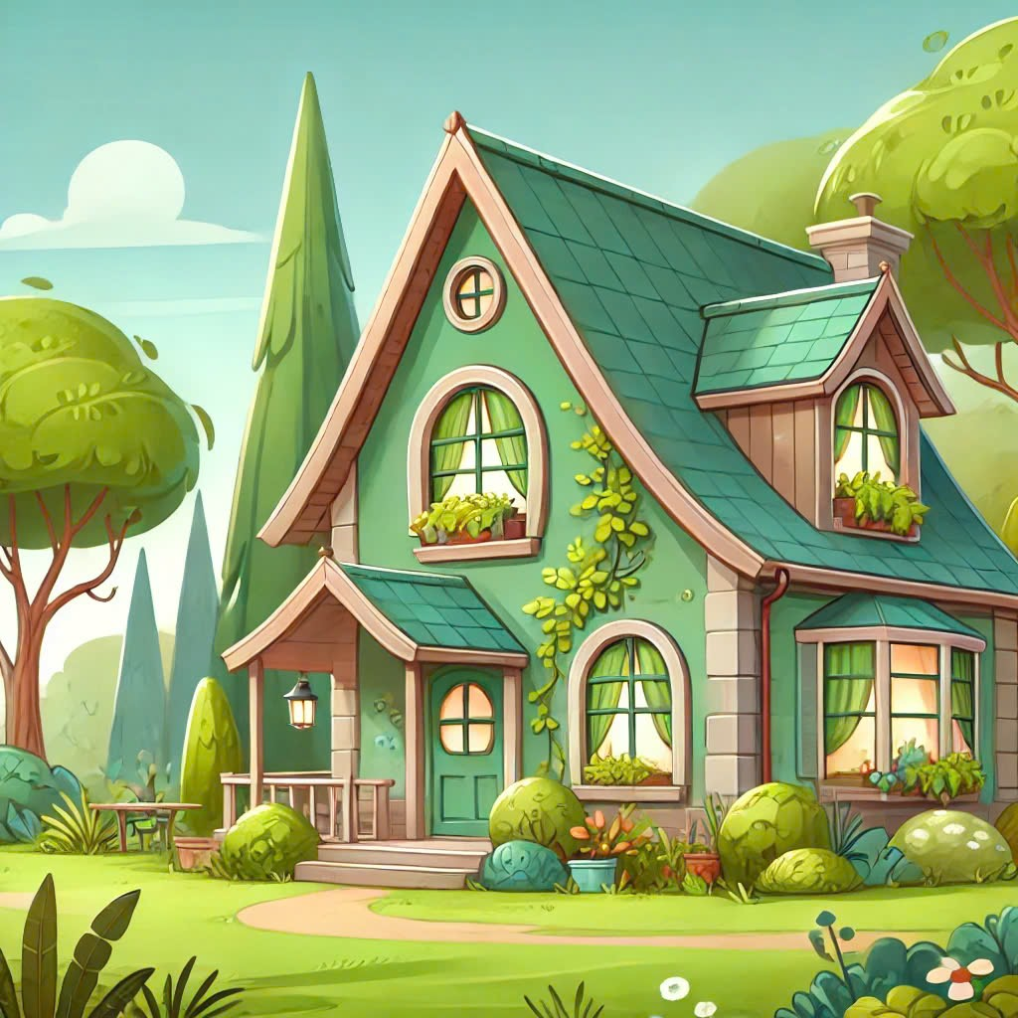
10. ___________________

Key:
- tea grows in India and China
- sow tea seeds
- sunshine - plants grows
- pick and put in basket
- dry tea leaves
- pack into boxes
- deliver tea in boxes
- load onto a lorry
- customers-buy
- take the tea home

Exercise 2. Use the correct form of the verbs in the box to complete the paragraph below

Dạng bài: quiz_type_7
deliver | grow (X2) | load | pack
pick | put (X2) | shine | sow

Tea (1) is grown in India and China. In the first stage, the tea seeds (2) ____________ by the farmer, and then the sun (3) ____________ and the seeds (4) ____________ into large tea plants. At this point, the tea leaves (5) ____________ and (6) ____________ in a basket, and then they (7) __________ on a tray in the sun to dry. The next step is that the dried tea leaves (8) ___________ boxes, and then the boxes (9) _________ onto a lorry, and then
(10) __________ to supermarkets, where customers buy them.
Key:
- are sown 3. shines 4. grow 5. are picked 6. are put/put
7. are put 8. are packed 9. are loaded
10. are delivered/delivered

B. Grammar

Exercise 3. The words and phrases in bold in each sentence are wrong. Write the correct word or phrase

Dạng bài: quiz_type_7
- Every year, several prizes are giving to the best students. | ___
- When the pizza was delivering, it was cold. | ___
- You will be telling when you can come in. | ___
- That song doesn't played on the radio very often, is it? | ___
- Your money was stealing out of your bag? | ___
- We haven't allowed to use a dictionary in the exam yesterday. | ___
- That film won't have shown in our local cinema for a long time. | ___
- I will be picked up from the station on Saturday? | ___

Key:
- given
- delivered
- told
- isn’t/is not
- Was your money stolen
- weren’t/ were not
- be
- Will I be

Exercise 4. Complete each second sentence using the word given, so that it has a similar meaning to the first sentence. Write between two and five words

Dạng bài: quiz_type_7
- Will they send the letters first class? sent
→ Will______________________________________________________ first class?
- I'm not sure if they eat pizza in China. is
→ I'm not sure if __________________________________________ in China.
- Someone told me that they don't make cars in the UK anymore. made
→ Someone told me that ___________________________________________ in the UK anymore.
- Do they usually feed the animals three times a day? fed
→ Are _________________________________________ three times a day?
- Mr Jones is ill, so he won't give us a geography test today! be
→ Mr Jones is ill, so ______________________________________ a geography test today!
- Did they take her to hospital in an ambulance? she
→ Was _______________________________________ to hospital in an ambulance?
Key:
- the letters be sent
- pizza is eaten
- car aren’t made/car are not made
- the animals usually fed
- we won’t be given/we will not be given
- she taken

Exercise 5. The following diagram shows how three different types of tea are made. Look at the process from the tea diagram. Which box do they belong in?

Dạng bài: quiz_type_7

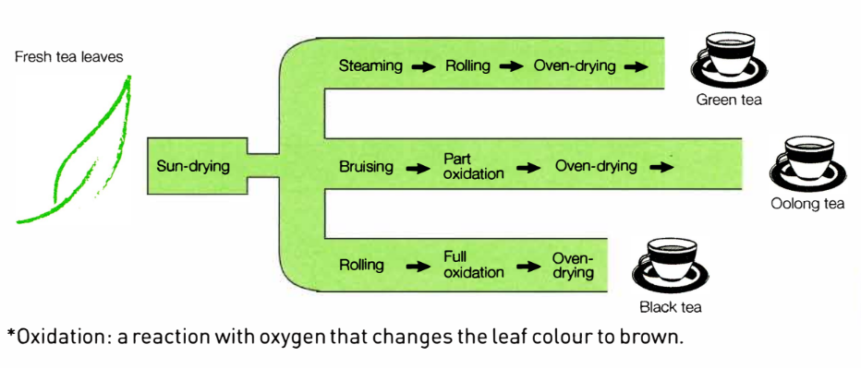

Fill in each blank with the correct term to complete the categories and answer the question.

Categorization Tasks:

1. Drying: (1) ___

2. Oxidation: (2) ___

3. Crushing: (3) ___

Question:

4. One process does not fit a category. Which one? (4) ___

ĐÁP ÁN

sun-drying / oven-drying

part oxidation / full oxidation

bruising / rolling

steaming

Exercise 6. Write YES or NO for each blank to indicate whether the processing step is used for each type of tea.

Dạng bài: quiz_type_7

- steaming:
  - Green tea: (1) ___
  - Oolong tea: (2) ___
  - Black tea: (3) ___
- crushing:
  - Green tea: (4) ___
  - Oolong tea: (5) ___
  - Black tea: (6) ___
- oxidation:
  - Green tea: (7) ___

Oolong tea: (8) ___

Black tea: (9) ___

ĐÁP ÁN

YES

NO

NO

YES

YES

YES

NO

YES

YES

Exercise 7. Which paragraph does each point belong in? Write the sentence number in the correct paragraph

Dạng bài: quiz_type_7
- One ingredient → three different products
- No oxidation, so not brown
- Basically same processes: drying / crushing (but different kinds of crushing) / drying
- Same process: oxidation, but different amounts
- Unique: steaming
- Basically the same: dry, crush, oxidation, dry
- Use same process: drying at start and finish
- Overview: (1) ___ , (2) ___
- Similar processes: (3) ___ , (4) ___ , (5) ___

Different processes: (6) ___ , (7) ___

ĐÁP ÁN

1

3

4

6

7

2

5

C. Writing

Exercise 8. You should spend about 20 minutes on this task

The following diagram shows how three different types of tea are made. Summarize the information by selecting and reporting the main features.

Write at least 150 words

Dạng bài: quiz_type_0

Easy IELTS - Task 1 - 20

Model answer

The diagram illustrates the step-by-step process of producing three types of tea: green tea, oolong tea, and black tea from fresh tea leaves. The process involves sun-drying, followed by different treatments that determine the final tea variety.

Initially, fresh tea leaves are sun-dried as the first step in all three processes. To produce green tea, the dried leaves undergo steaming, followed by rolling to shape them before being oven-dried, resulting in the final product.

For oolong tea, after sun-drying, the leaves are subjected to bruising, which helps release natural enzymes. This is followed by partial oxidation, a crucial step that differentiates oolong tea from the others. Finally, the leaves are oven-dried to complete the process.

In contrast, black tea undergoes a slightly different process. After sun-drying, the leaves are rolled, triggering full oxidation, which gives black tea its characteristic dark color and strong flavor. The final step involves oven-drying, similar to the other two types.

Overall, while all three tea types originate from the same raw material, their distinct flavors and appearances result from variations in processing, particularly in oxidation levels.

(181 words)

LESSON 2

A. Vocabulary

Exercise 1. Write these linking words and phrases in the correct column of the table below according to their meaning

Dạng bài: quiz_type_14

Then | First of all | Subsequently | The first step is that | Finally
At this point | The next step is that | To begin with | After that | The last step is
The following step is that | Following this | Finally | Initially | and then

- Next… | - The first stage is…. | 3. The last stage is
Then  Subsequently  After that  At this point  The next step is that  Following this  The following step is that  and then | First of all  The first step is that  To begin with  Initially | Finally  The last step is

Exercise 2. Number the steps in the correct order to make a cup of tea.

Dạng bài: quiz_type_7
__5_ Pour the water into the cup.
__1_ Fill the kettle with water.
__7_ Add milk and sugar.
__6_ Leave the tea for two minutes.
__2_ Boil the kettle.
__8_ Drink the tea.
__4_ Take the kettle off the stove.
__3_ Put a tea bag or tea leaves in the cup.

B. Grammar

Exercise 3. Complete this table of common irregular past participles

Dạng bài: quiz_type_7

Verb | Past participle | Verb | Past participle
grow | - _____________ | hold | 6. _____________
sow | - _____________ | grind | 7. _____________
tell | - _____________ | put | 8. _____________
take | - _____________ | cut | 9. _____________
wrap | - _____________ | weave | 10. _____________

Key:
- grown 2 sown 3 sold 4 taken 5 wrapped 6 held 7 ground 8 put 9 cut 10 woven

Exercise 4. Complete these sentences with the passive form of the verb in brackets.
Dạng bài: quiz_type_7

Oranges ______________ from Spain, to colder countries in Europe. (export)

Coffee beans ______________ in a machine, in order to make coffee powder. (grind)

Rice ______________ into bags and then delivered to supermarkets. (put)

Coconut ______________ from the trees, and then exported to other countries. (cut)

The bars of chocolate ______________ in silver paper and put into boxes. (wrap)
Key:
- are exported
- are ground
- is put
- are cut
- are wrapped

Exercise 5. Complete each second sentence so that it has a similar meaning to the first sentence. Write no more than four words.

Dạng bài: quiz_type_7
- I think John has taken my jacket.
→ I think my jacket _____________________________________ John.
- You should cook the chicken for at least an hour.
→ The chicken _____________________________________ for at least an hour.
- They're showing that film at the cinema in town.
→ That film _____________________________________ at the cinema in town.
- They hadn't invented digital cameras when we took that photo.
→ Digital cameras _____________________________________ when that photo was taken.
hot soapy water.
- When I got there, Carly was doing the ironing, so I didn't have to do it!
→ When I got there, the ironing ________________________ Carly, so I didn't have to do it!
- They were using hot soapy water to wash all the cars.
→ All the cars ________________________ hot soapy water.
Key:
- has been taken by
- should be cooked
- is being shown
- hadn’t been invented/had not been invented
- was being done by
- were being washed with

Exercise 6. Match the stages (1-4) to the corresponding extra details (a-d)

Dạng bài: quiz_type_7
The boxes of tea are delivered to supermarkets, ___ | a. which gives them extra flavour.
The sun shines, ___ | b. where they are put on the shelves to be sold.
Salt and sugar are added to the tomatoes, ___ | c. in order to be made into sugar for cooking.
The sugar cane is taken to a factory, ___ | d. which helps the plants to grow.

Key:
- b 2. d 3. a 4. c

Exercise 7. Join each pair of sentences using the words in brackets

Dạng bài: quiz_type_7

The fruit is sent to a factory. It is put into cans there. (where)
→ _________________________________________________.

The biscuits are put in the oven. They are cooked. (in order to be)
→ _________________________________________________.

The farmer waters the plants. This makes them grow more quickly. (which)
→ _________________________________________________.

The mushrooms are stored in a dark room. This helps them to stay fresh. (so that)
→ _________________________________________________.

Key:
- The fruit is sent to a factory, where it is put into cans
- The biscuits are put in the oven in order to be cooked
- The farmer waters the plants, which makes them grow more quickly
- The mushrooms are stored in a dark room, so that they stay fresh

C. Writing

Exercise 8. You should spend about 20 minutes on this task

The pictures below show how tomato ketchup is made.

Summarize the information by selecting and reporting the main features.

Write at least 150 words

Dạng bài: quiz_type_0

Easy IELTS - Task 1 - 20

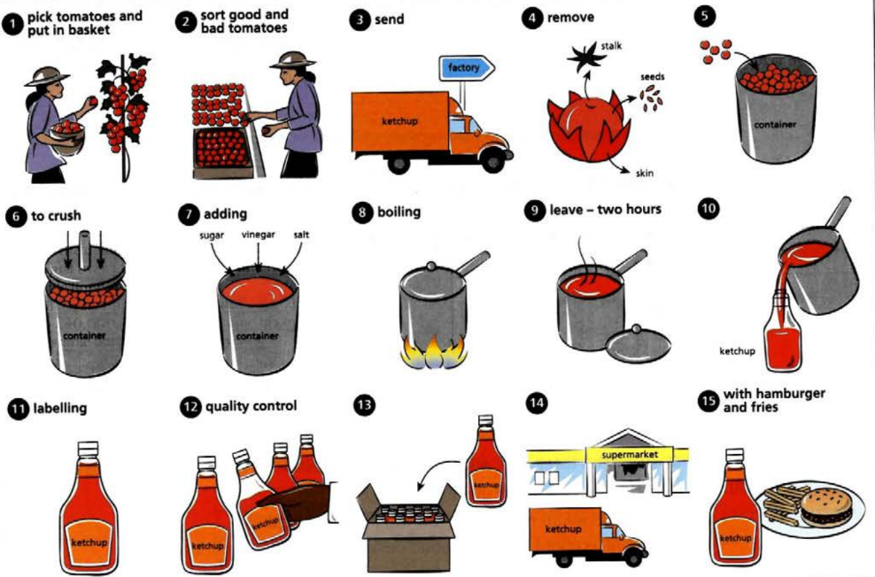

Model answer

The diagram illustrates the systematic process of producing tomato ketchup, which consists of 15 distinct stages, beginning with harvesting fresh tomatoes and ending with their consumption.

Initially, ripe tomatoes are carefully hand-picked by a farmer and sorted to separate high-quality ones from defective produce. The selected tomatoes are then transported to a factory, where their stalks, seeds, and skins are removed before being placed into large containers for further processing. Once collected, the tomatoes are crushed into a smooth pulp in preparation for the next stage.

Subsequently, sugar, vinegar, and salt are incorporated to enhance the flavor. The mixture is then boiled thoroughly and left to simmer for two hours, allowing the ingredients to blend effectively. Once the ketchup achieves the desired consistency, it is poured into sterilized bottles, which are then sealed, labeled, and subjected to rigorous quality control checks to ensure they meet industry standards. Only the approved bottles are packed and distributed to supermarkets.

In the final stage, customers purchase the ketchup and typically enjoy it as a complement to various meals, such as hamburgers and fries.

(180 words)

LESSON 3

A. Vocabulary

Exercise 1. Write these verbs in the correct column of the table below

Dạng bài: quiz_type_7
build construct convert cut down demolish enlarge erect expand extend industrialize introduce knock down make into modernize pull down redevelop remove
replace transform turn into urbanize

make bigger | take away | add something new
enlarge | cut down | build
change into something else | general statements about changes | build
convert | industrialize | build

Key:
make bigger | take away | add something new
enlarge  expand  extend | cut down  demolish  knock down  pull down  remove | build  construct  erect  introduce
change into something else | general statements about changes | build  construct  erect  introduce
convert  make into  redevelop  replace  turn into | industrialize  modernize  transform  urbanize | build  construct  erect  introduce

Exercise 2. Complete these sentences with a suitable present perfect form of the verb in brackets

Dạng bài: quiz_type_7

The city used to be very green, but it ____________ much more industrial. (become)

A new sports centre ____________ in the city centre. (construct)

The old stadium ____________ and replaced by a new one. (demolish)

Many significant changes ____________ the city in the last ten years. (take place)

The old town hall ____________ replaced by new flats. (knock down)

There used to be a park in the north of the city, but it ____________ by a supermarket. (replace)

The old houses ____________ to make way for new apartments. (pull down)

There didn't use to be many skyscrapers, but several ____________ in the last few years. (build)

In the last 15 years, the city ____________ considerably, from a quiet market town into a much busier small city. (change)

The disused factory in the south of the city ____________a shopping mall. (turn into)
Key:
- has become
- has been constructed
- has been demolished
- have taken place
- has been knocked down
- has been replaced
- have been pulled down
- have been built
- has changed
- has been turned into

B. Grammar

Exercise 3. Choose the correct word(s) to complete the sentences

Dạng bài: quiz_type_14
- Although/In spite of we left late, we still got there in time.
- She’s going on holiday with friends. Her parents, however/ whereas, are not very happy about it.
- We decided to work even though/despite the fact we were on holiday.
- They enjoyed the course, even though/as well it was very difficult.
- I told John the car was too expensive. However/Although, he still bought it.
- It was a fantastic evening, although/despite the terrible food.

Exercise 4. Match the cohesive devices in Column A with their correct functions in Column B.

Dạng bài: quiz_type_7
Column A | Column B
1. In addition | a) Contrast / Opposing ideas
2. For instance | b) Giving an example
3. On the contrary | c) Adding information
4. Consequently | d) Cause and effect
5. Nevertheless | e) Showing contrast
6. Thus | f) Showing result

Answer: 1. ___, 2. ___, 3. ____, 4. ___,5. ___, 6. ___
Key:
- c
- b
- a
- d
- e
- f

Exercise 5. Look at the Writing Task 1 question and the sample answer, then put paragraphs A to D in the correct order
Dạng bài: quiz_type_7
Question:
You should spend about 20 minutes on this task.
The plans below show a public park when it first opened in 1920 and the same park today.
Summarise the information by selecting and reporting the main features, and make comparisons where relevant.
Write at least 150 words.

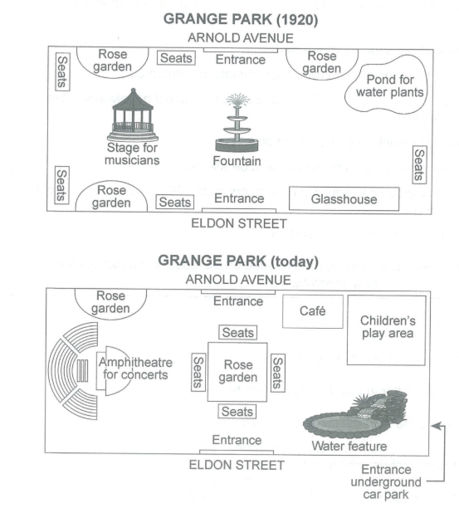
- In 1920, visitors could enter the park from the Northern or Southern entrance on Arnold avenue or Eldon street, but now they can get in by a new entrance from the underground car park. There was a fountain located at the center of the park and a large stage for musicians on the left-hand side of the fountain, but now both have been replaced by a huge rose garden surrounded by many seats and a large amphitheater for concerts.
- The two maps illustrate how Grange park has been changed from the opening in 1920 up until the present.
- Looking at the first picture, the stage was midway between two rose gardens, with many seats placed next to them. There was another rose garden to the east of the Northern entry, but it has been converted into a cafe. Also, a pond for water plants on the top right-hand corner and a glasshouse on the bottom one have been flattened to make room for a children’s play area and a water feature.
- As can be seen from the pictures, the park has been dramatically transformed after the constructions of several entertainment facilities over the given period.
- ______ 2. _________ 3. ___________ 4. __________

Key:
- B 2. D 3. A 4. C

C. Writing

Exercise 6. You should spend about 20 minutes on this task

The pictures illustrate the changes in Shipsmouth between 1995 and 2010. Summarize the information by selecting and reporting the main features, and make comparisons where relevant.

Write at least 150 words

Dạng bài: quiz_type_0

Easy IELTS - Task 1 - 20

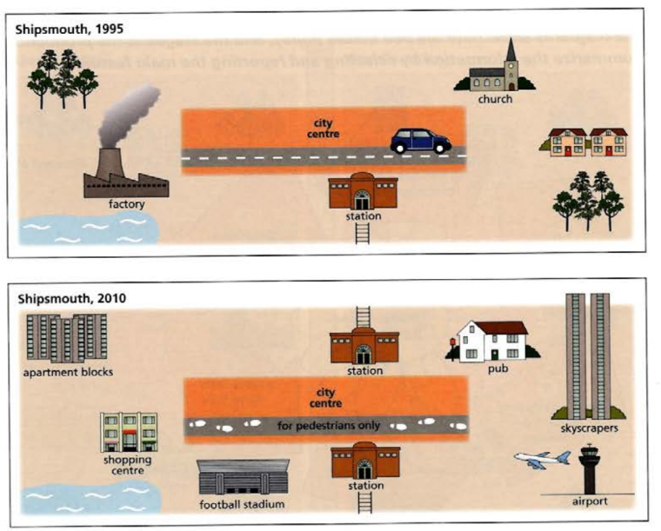

Model answer

The two maps compare the town of Shipsmouth in 1995 and 2010, showing various developments over this 15-year period.

In 1995, Shipsmouth had a factory near the waterfront, a church, a few houses, and a city center with a road running through it. The station was located in the middle of the town, with access to both sides. There were also some green areas with trees.

By 2010, the town had undergone significant modernization. The factory was removed and replaced with apartment blocks and a shopping center, suggesting a shift towards residential and commercial expansion. A football stadium was also introduced, providing new recreational opportunities. The city center was transformed into a pedestrian-only zone, reducing traffic congestion. Moreover, new skyscrapers, a pub, and an airport were added, reflecting increased urbanization and connectivity.

Overall, Shipsmouth experienced major changes, transitioning from an industrial town into a modernized urban center with improved residential, commercial, and transport infrastructure.

(154 words)

LESSON 4

A. Vocabulary

Exercise 1. Choose the correct word to complete the sentences.
Dạng bài: quiz_type_14

We made a profit (1) ___ (of / for) six million euros.

Sales rose (2) ___ (to / by) 10% last year.

The value of the shares fell (3) ___ (from / for) 240 pence to 225 pence.

There was a fall (4) ___ (of / from) 5% in the value of the shares.

There has been a gradual rise (5) ___ (with / in) profits.

The company made a loss two years (6) ___ (on / in) a row.

What's the current value (7) ___ (of / in) the euro?

ĐÁP ÁN

of

by

from

of

in

in

of

Exercise 2. Look at the graph and complete the text using the given words
Dạng bài: quiz_type_7
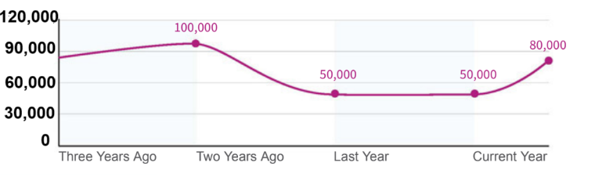

rose | decrease | stayed | increase | risen | loss
sharp | quarters | figures | sharply | graph | made

The (1) graph shows sales (2) _____________ for the last three and a half years. Three years ago sales (3) ___________ slightly and reached 100,000 units by the end of the year. The company (4) ________ a profit of almost £500,000 and decided to (5) _________ the price from £8.95 to £10.25. It had an immediate effect: there was a (6) ___________ (7) ____________ in sales over the year. It was bad news, and the company made a (8) __________. And in the next year sales (9) ______________ the same. However, in the first two (10) ____________ of this year, they have (11) _________________ (12) _______________ for the first time in many years.

Key:
2. figures 3. rose 4. made 5. increase 6. sharp
7. decrease 8. loss 9. stayed 10. quarters 11. risen 12. sharply

B. Grammar

Exercise 3. Combine parts from each column to form five short texts.

Dạng bài: quiz_type_7
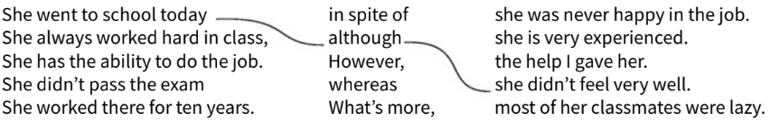
1. She went to school today although she didn’t feel very well.
2. __________________________________________________________________.
3. __________________________________________________________________.
4. __________________________________________________________________.
5. __________________________________________________________________.

Key:
2. She always worked hard in class, whereas most of her classmates were lazy
3. She has the ability to do the job. What’s more, she is very experienced
4. She didn’t pass the exam in spite of the help I gave her
5. She worked there for ten years. However, she was never happy in the job

Exercise 4. Complete the sentences

Dạng bài: quiz_type_7

People say the hotel is very good. It’s also quite cheap.

(1) ___ the fact that they were busy, they (2) ___ helped us.

It’s not the best dictionary you can buy. (3) ___, it’s better than nothing.

She managed to get there, (4) ___ she didn’t have a map like the others.

(5) ___ heavy rain, they’ve also had very strong winds.

She’s the youngest in the group, and she’s better than most of them (6) ___.

I think you can do it. It won’t be easy, (7) ___.

I was right at the back at the concert, (8) ___ I could (9) ___ hear everything.

ĐÁP ÁN

In spite of / Despite

still

However

although / even though

In addition to / As well as / Besides

as well / too

though

yet

still

Exercise 5. These overviews contain incorrect facts. Rewrite the sentences that need correction by filling in the blanks.

Dạng bài: quiz_type_7
- The following charts shows the population of a certain town from 1861 to 2002

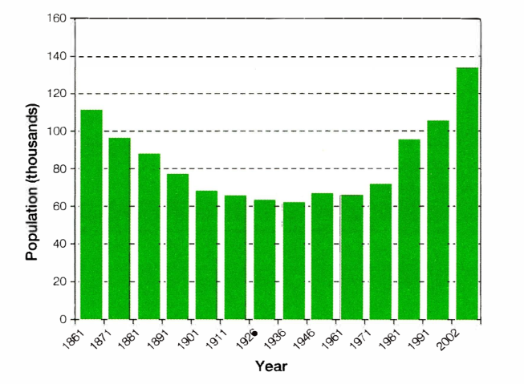

The population fell and then increased over the period. At the start of the period, in 1861, the population was 110 people, and after decreasing to nearly half, the population only exceeded the 1861 level in 2002, when there were around 130 residents in the town.

→ At the (1) ___ of the period, in 1861, the population was 110 (2) ___, and after (3) ___ to nearly half, the population only (4) ___ the 1861 level in 2002, when there were around 130 (5) ___ in the town.

The following graph shows the average monthly rainfall in two major cities.
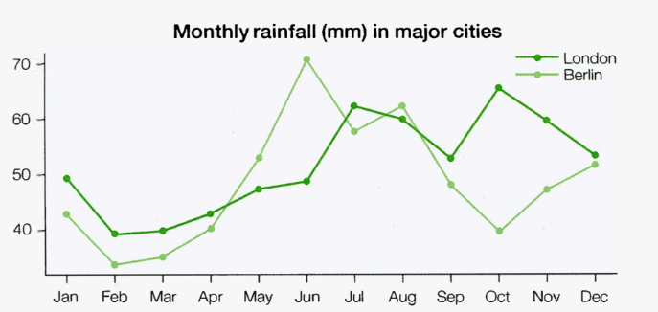

The monthly rainfall averages show similar patterns in the dry months (January to April, but different patterns in the rest of the year. Each city has two main peaks at different times and the highest monthly rainfall happens in London, in June.

→ Each city has two main (6) ___ at different times and the (7) ___ monthly rainfall happens in (8) ___, in June.

c. The following graph shows the percentage of people who recycle their rubbish, in five countries, over 12 years.

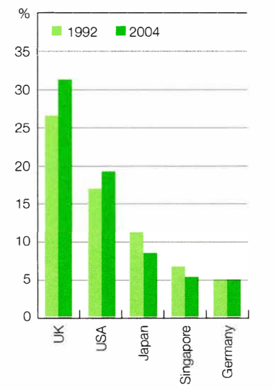

Between 1992 and 2004, there was a dramatic increase in the proportion of UK residents who recycle.

→ (9) ___ 1992 and 2004, there was (10) ___ increase in the (11) ___ of UK residents who (12) ___.

ĐÁP ÁN

start

thousand

decreasing

exceeded

thousand

peaks

highest

Berlin

Between

an

proportion

recycle

Exercise 6. Look at the answer and fill the gaps. The following diagrams show international student enrolments at a university from 1975 to 2009.

Dạng bài: quiz_type_7

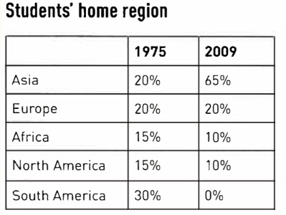

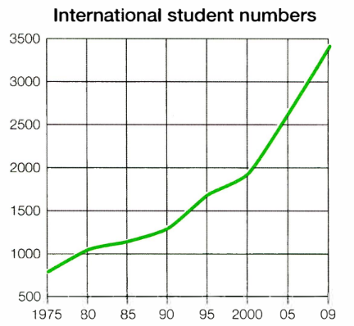

There were 1. _____ stages of growth: a period of slow growth between 2. _____ and 3. _____; a period of faster growth between 4. ______ and 5. _____; and a period of rapid increase between 6. _____ and 7. ________.

It seems the increase came mainly from higher numbers of 8. __________ students (up from 9. _____ percent in 1975 to 10. _____ percent in 2009). Proportions of students from other regions stayed roughly the same, or fell slightly, except for students from 11. _____. These students accounted for 12. _____ percent of all international students in 1975, but by 2009 there were no students from this region.
Key:

three/3
- 1975
- 1990
- 1990
- 2000
- 2000
- 2009
- Asian
- 20/twenty
- 65/sixty-five/sixty five
- South America
- 30/thirty

C. Writing

Exercise 7. You should spend about 20 minutes on this task

The graph below shows the number of visitors to three museums between 2000 and 2005.

Summarize the information by selecting and reporting the main features, and make comparisons where relevant.

Write at least 150 words

Dạng bài: quiz_type_0

Easy IELTS - Task 1 - 20

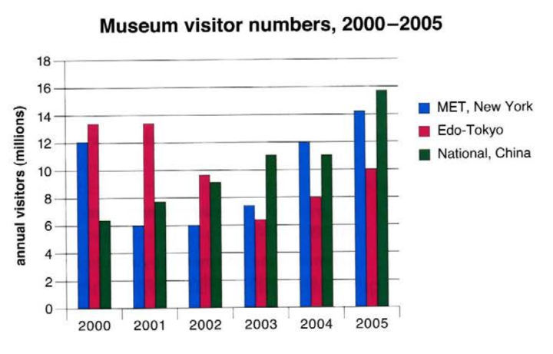

Model answer

The bar chart compares the annual number of visitors to three museums: the MET in New York, the Edo-Tokyo Museum, and the National Museum of China, over a six-year period from 2000 to 2005.

Overall, the MET, New York and the National Museum of China experienced upward trends in visitor numbers, whereas the Edo-Tokyo Museum witnessed a decline. By 2005, the National Museum of China recorded the highest number of visitors among the three museums.

In 2000, the Edo-Tokyo Museum had the largest attendance, attracting approximately 13 million visitors. This was followed by the MET, New York which received around 12 million visitors, while the National Museum of China had the lowest figure, just under 7 million. However, the number of visitors to the Edo-Tokyo Museum gradually decreased throughout the period, falling to about 10 million by 2005.

In contrast, the National Museum of China saw a steady increase, surpassing the other two museums in 2003 and reaching nearly 16 million visitors by 2005. The MET showed some fluctuation, with a decline in 2001 and 2002, but recovered significantly and peaked at around 14 million visitors in 2005.

(188 words)

