LESSON 1

A. Vocabulary

Exercise 1. What are these?

Dạng bài: quiz_type_7
  - _________________ |   - _________________ |   - _________________
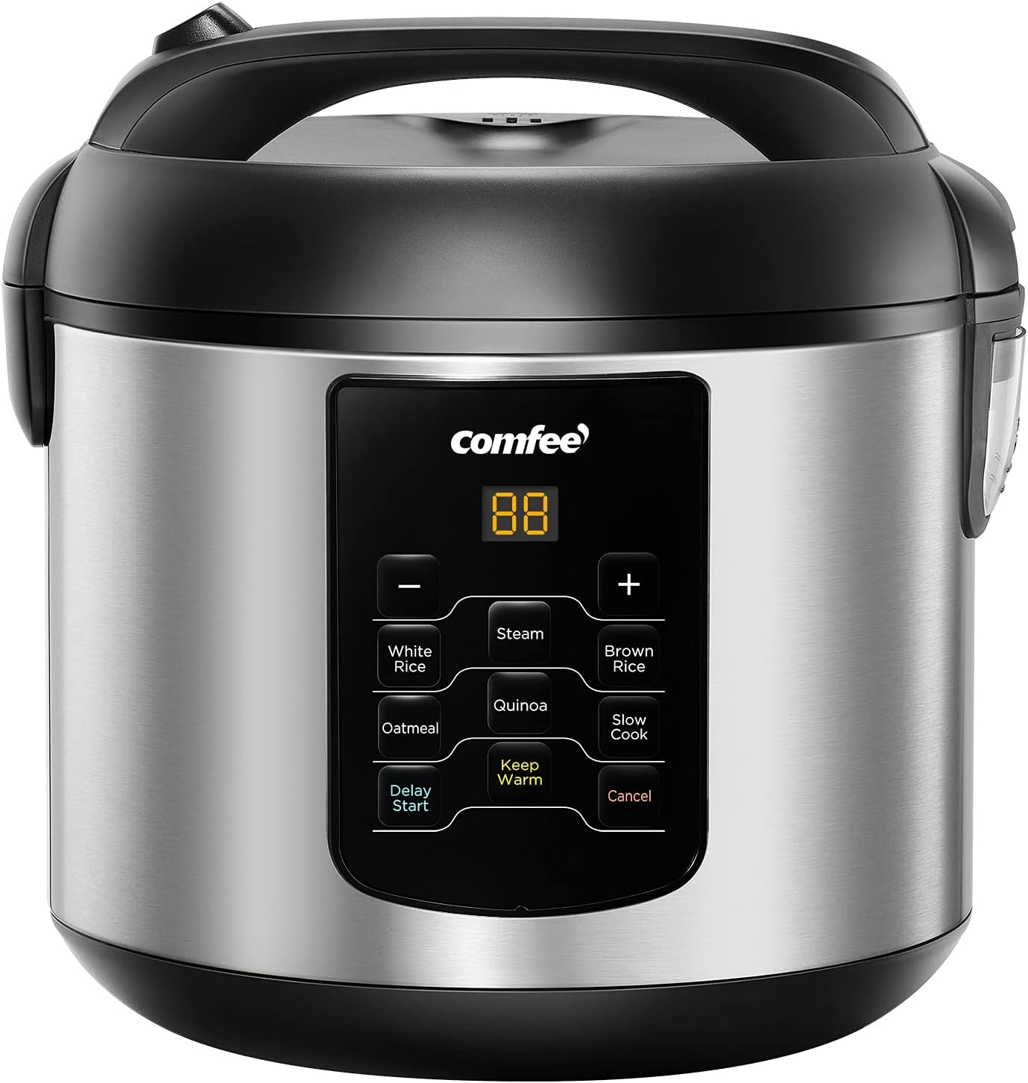  - ________________ | 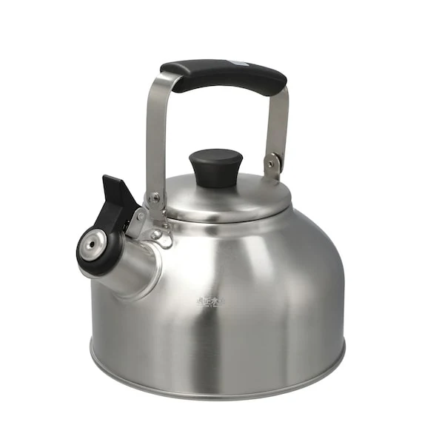  - ________________ |   - ________________
  - ________________ |   - ________________ |   - ________________

Key:
- sink
- microwave
- curtains
- cooker
- kettle
- washing machine
- blinds
- wardrobe
- tiles

Exercise 2. Complete the sentences.
wooden | spare | choice | study | en suite
share; own | blanket; duvet | tap(s) | blinds | utility

Dạng bài: quiz_type_7

I’m happy with curtains or blinds; I really don’t mind.

We used to have a (1) ___ floor, but it was a bit noisy so we put down a carpet.

When I got my new bedroom, my mum gave me a (2) ___ of curtains or blinds.

My mum works at home, so she spends all day in the (3) ___ on the computer.

As a child I had to (4) ___ a room with my sister, but now I’ve got my (5) ___ bedroom.

We often have guests to stay, but fortunately we’ve got a (6) ___ room.

‘Dad, there’s no water coming out of the (7) ___ in the kitchen sink.’

Some people like a sheet and (8) ___, but I prefer a (9) ___.

There’s a family bathroom, but I’ve got my own (10) ___ shower room next to the bedroom.

Our kitchen is small but we have a (11) ___ room for the washing machine.

ĐÁP ÁN

wooden

choice

study

share

own

spare

tap / taps

blanket

duvet

en suite

utility

Exercise 3. Complete the box using the given words

top floor | first floor | ground floor
front door | balcony | steps | second floor

Dạng bài: quiz_type_7

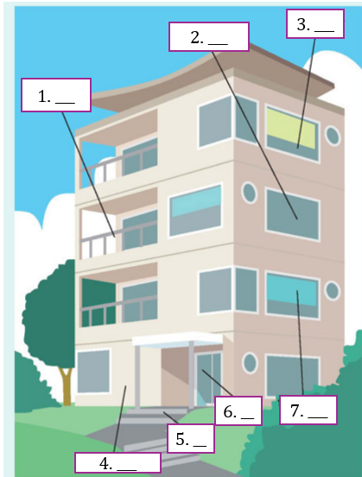

Answer: 1. ___, 2. ___, 3. ____, 4. ___,5. ___, 6. ___, 7.___
Key:
- balcony
- second floor
- top floor
- ground floor
- steps
- front door
- first floor

B. Grammar

Exercise 4. Put the verb into the correct form, present continuous or present simple.

Dạng bài: quiz_type_7

Why are all these people here? (What / happen) What’s happening?

Julia is good at languages. (She / speak) _____________ four languages very well.

Are you ready yet? (Everybody / wait) _____________ for you.

I’ve never heard this word. How (you / pronounce) _____________ it?

Kate (not / work) _____________ this week. She’s on holiday.

I think my English (improve) _____________ slowly. It’s better than it was.

Nicola (live) _____________ in Manchester. She has never lived anywhere else.

Can we stop walking soon? (I / start) _____________ to get tired.

Sam and Tina are in Madrid right now. (They / visit) _____________ a friend of theirs.

‘What (your father / do) _____________?’ ‘He’s an architect.’

It took me an hour to get to work this morning. Most days (it / not / take) _____________ so long.

I (I / learn) _____________ to drive. My driving test is next month. My father (teach) _____________ me.
Key:
2. She speaks
3. Everybody’s waiting / Everybody is waiting
4. do you pronounce
5. isn’t working / is not working / ’s not working
6. is improving
7. lives
8. I’m starting / I am starting
9. They’re visiting / They are visiting
10. does your father do
11. it doesn’t take
12. I’m learning / I am learning - is teaching / ’s teaching

Exercise 5. Are the underlined verbs OK? Correct them where necessary.

Dạng bài: quiz_type_7

- Water (boils) at 100 degrees Celsius.
- How often (are you going) to the cinema?
- Ben (tries) to find a job, but he hasn’t had any luck yet. (1) ___
- Martina (is phoning) her mother every day. (2) ___
- The moon (goes) round the earth in about 27 days. (3) ___
- Can you hear those people? What (do they talk) about? (4) ___
- What (do you do) in your spare time? (5) ___
- Sarah is a vegetarian. She (doesn’t eat) meat. (6) ___
- I must go now. It (gets) late. (7) ___
- ‘Come on! It’s time to leave.’ ‘OK, I (come).’ (8) ___
- Paul is never late. He’s always (starting) work on time. (9) ___
- They don’t get on well. They’re always (arguing). (10) ___

ĐÁP ÁN
- is trying
- phones
- OK
- are they talking
- OK
- OK
- It’s getting / It is getting
- I’m coming / I am coming
- He always starts
- OK

C. Writing

Exercise 6. You should spend about 20 minutes on this task
The diagram details the process of making smoked fish.
Summarise the information by selecting and reporting the main features, and make comparisons where relevant.
Write at least 150 words
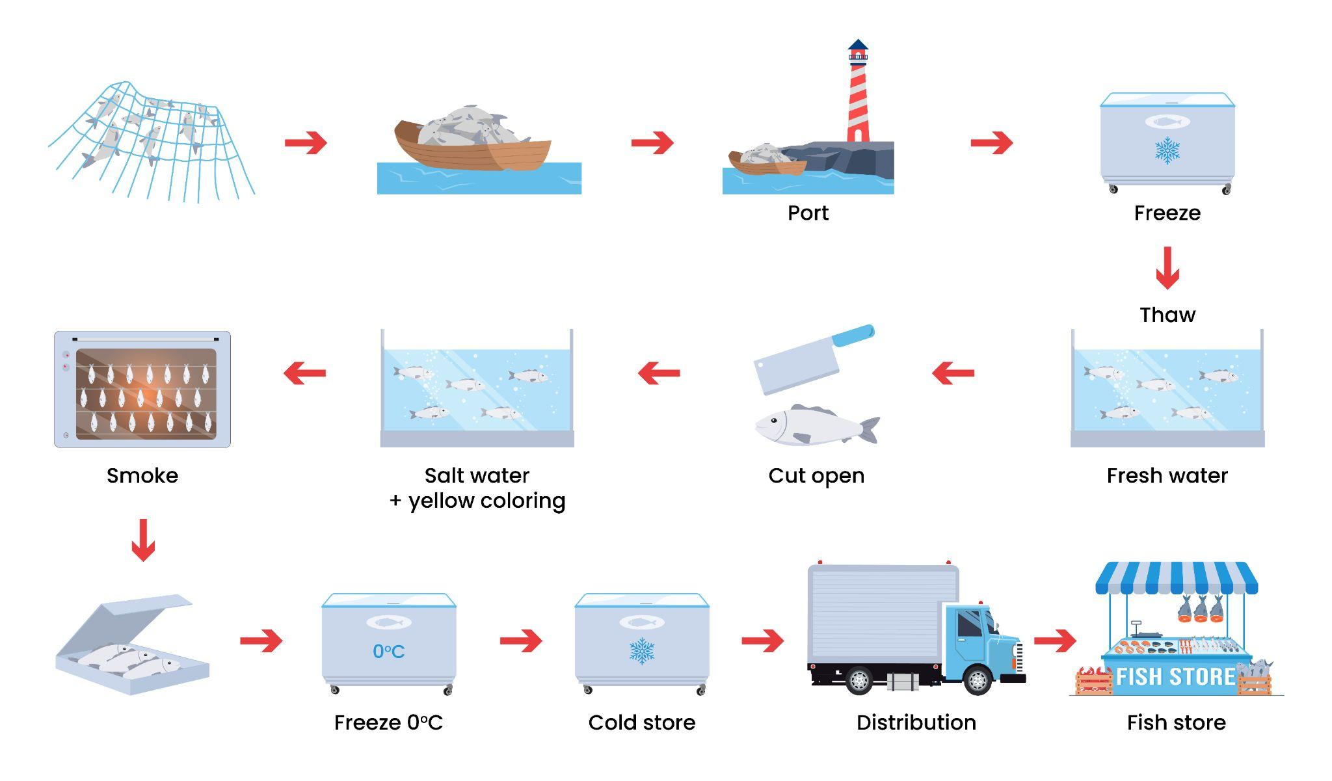

Dạng bài: quiz_type_0
Easy IELTS - Task 1 - 20

Model answer
The chart provides an overview of the step-by-step process involved in producing smoked fish. Overall, the smoking fish procedure can be categorised into three primary phases, commencing with the capture and transportation of the fish, and culminating with the distribution of the smoked fish to retail fish shops.
The first stage involves harvesting raw ingredients and preparing them. More specifically, in the initial step, fish are caught using large nets while out at sea. Once captured, they are transported back to the port via boats. Upon arrival at the port, the fish are stored and frozen to maintain their freshness and quality.
The processing of the prepared materials is shown in the second stage. First, they are thawed out in freshwater, followed by cutting them open for further preparation. The fish are then immersed in a solution of saltwater and yellow colouring, likely for flavour enhancement and visual appeal. After this, the fish are subjected to smoking, which adds the characteristic smoky flavour.
The third stage marks the completion of the production process. After the smoking process, the fish are carefully placed into boxes. To ensure proper preservation, the boxes of fish are frozen once again, this time at a temperature of zero degrees Celsius. These frozen boxes are then stored in a cold store, where the temperature is likely maintained at a suitably low level to prevent spoilage. Finally, the processed fish are distributed to local fish stores for sale. This distribution is carried out using trucks, which transport the frozen boxes from the cold store to the intended locations.
(261 words)

Exercise 7. You should spend about 40 minutes on this task
In the future, the main reason for going to the shopping mall will be for entertainment, not to shop. Do you agree or disagree?
Give reasons for your answer and include any relevant examples from your own knowledge or experience.
Write at least 250 words.

Dạng bài: quiz_type_0
Easy IELTS - Task 2 - 21

Model answer
In some countries a mall is known as a shopping centre. Although the main purpose of a mall was initially shopping, this trend is beginning to change. I believe that in the future, the main purpose of a mall will be for entertainment.
More and more of us enjoy shopping online. It is safer than ever and much more convenient. Many websites offer free next-day delivery. On sites like eBay and Amazon, there is far more choice and there are also many discounts and special offers. Obviously, this means that fewer shops will be needed. However, people still want to go out, meet their friends and have fun. A mall is a place which offers space to do that. If people have done their shopping online, the mall will have to offer other facilities to attract visitors.
Some malls already have cinemas and places to eat. However, as well as cheaper cafes and fast food chains, malls are beginning to offer better restaurants and places to eat. I believe this trend will continue. In addition, malls will offer all kinds of leisure facilities such as gyms, swimming pools, children's play areas, spas, and so on. There will be more live shows, including music, theatre and dance, and a range of exhibitions and special events.
I believe malls have an important role in future society but they will have a different purpose from today. There will still be a few shops but most people will go to the mall to relax and enjoy themselves with their family and friends.
(181 words)

LESSON 2

A. Vocabulary

Exercise 1. Put the words into the correct categories

Dạng bài: quiz_type_7

swimming | golfer | court | track | jump | pitch

net | motor racing | stick | basketball | athlete | box

skis | race | goalkeeper | racing driver | sail | rink

Sport: (1) ___ , (2) ___ , (3) ___ , (4) ___

Person: (5) ___ , (6) ___ , (7) ___ , (8) ___

Place: (9) ___ , (10) ___ , (11) ___ , (12) ___

Verb: (13) ___ , (14) ___ , (15) ___ , (16) ___

Equipment: (17) ___ , (18) ___ , (19) ___ , (20) ___

ĐÁP ÁN

swimming

motor racing

basketball

skiing

golfer

athlete

goalkeeper

racing driver

court

track

pitch

rink

jump

box

race

sail

net

stick

skis

swimming costume

Exercise 2. Complete the sentences using the given words
courses | costumes | fun | hockey | fit
jogging | tent | ring | racing | climbing

Dạng bài: quiz_type_7

Do you know the size of a boxing ring?

I used to play ice _____________.

We played golf in Scotland, where they have some fantastic golf _____________.

My dad plays golf. He’s not a serious golfer; he just plays for _____________.

If the girls go swimming, they must remember to take their swimming _____________.

We watch a lot of motor _____________.

I love swimming, and it helps to keep me _____________.

My sister enjoys rock _____________.

You can’t go camping unless you have a _____________.

Running is good exercise, so four or five times a week I go _____________.
Key:
2. hockey 3. courses 4. fun 5. costumes
6. racing 7. fit 8. climbing 9. tent 10. jogging

Exercise 3. Complete the sentences with the correct verb

Dạng bài: quiz_type_7

We play football in the winter at my school.

Do you _____________ much exercise?

I _____________ basketball in the summer and winter.

We always _____________ in the winter, as long as there is enough snow.

I _____________ a bit of yoga when I was younger.

We used to _____________ camping in the mountains.

I _____________ a lot of swimming in the summer.

If you want to _____________ fit, you need to run three or four miles every other day.

I used to _____________ in the gym, but I’m getting a bit old for that now.

Key: 2. do 3. play 4. ski 5. did

6. go 7. do 8. keep 9. work out

B. Grammar

Exercise 4. Choose the correct word or phrase

Dạng bài: quiz_type_14

When we were in Canada, we (1) ___ (went / were going) skiing almost every day.

About four years ago, I (2) ___ (decided / was deciding) to become a chef.

Georgia (3) ___ (had / was having) a shower when someone knocked at the door.

Holly and I ran from the house to the taxi because it (4) ___ (rained / was raining) heavily.

Two men (5) ___ (argued / were arguing) outside, so I went to see what was happening.

Daniel (6) ___ (called / was calling) you at one o'clock yesterday, but you were here with me.

We (7) ___ (ate / were eating) breakfast when a letter came through the letter box.

As I walked past the window, I saw that Paula (8) ___ (made / was making) a cake.

I (9) ___ (dreamt / was dreaming) about my favourite band when the alarm clock went off.

While I (10) ___ (practised / was practising) the trumpet late last night, a neighbour came to complain.

ĐÁP ÁN

went

decided

was having

was raining

were arguing

called

were eating

was making

was dreaming

was practising

Exercise 5. Complete using the correct past simple or past continuous form of the verbs in the box.

Dạng bài: quiz_type_7

get | put | have | be | shine | continue | practise
open | say | answer | sing | ring | go | wake

Amber's Big Match
One morning, Amber (1) __________ up early. The sun (2) __________ and the birds (3) __________. Amber (4) __________ very excited because it was the day of the big tennis match. Amber (5) __________ downstairs and into the kitchen, where her father (6) _________ breakfast.
'Morning, Amber. Today's the day!' he (7) ___________. Amber smiled nervously.
'Don't worry!' he (8) __________. 'You'll be fine.'
Amber (9) ___________ some toast into the toaster and (10) __________ the fridge. Just as she (11) ____________ the butter out, the phone (12) ____________.
Her father (13) __________ it. After a few minutes, he put the phone down.
'Bad news, I'm afraid. The other player (14) _____________ yesterday when she had an
accident. The match is off.'
Amber ate her toast slowly. She was surprised she didn't feel disappointed.

Key:
1. woke 2. was shining 3. were singing 4. was 5. went
6. was having 7. said 8. continued 9. put 10 .opened
11. was getting 12. rang 13.answered 14. was practising

C. Writing

Exercise 6. You should spend about 20 minutes on this task
The maps below show Colwick Arts Centre in 2005 and today.
Summarise the information by selecting and reporting the main features, and make comparisons where relevant.
Write at least 150 words

Dạng bài: quiz_type_0
Easy IELTS - Task 1 - 20
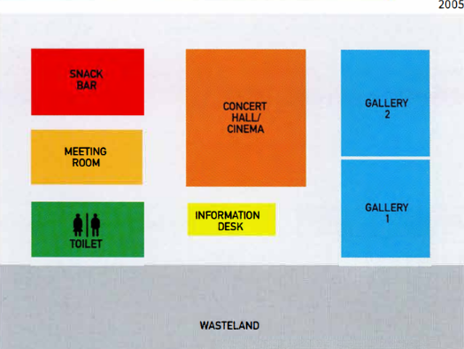
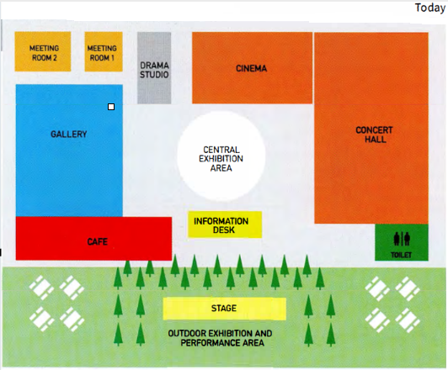

Model answer
The maps show the changes to Colwick Arts Centre between 2005 and the present day. We can see that the Centre expanded and new facilities were added during this period.
One of the major changes is that the outside area was developed. In 2005, there was an empty area of land outside the Centre. Trees were planted there and an outdoor exhibition area was made. The café was moved to the front of the Arts Centre and tables were added outside.
Inside, a central exhibition area was created. The information desk was moved to the front of the central area. In the past, there were two galleries but now there is only one; however, a drama studio was built. In 2005, the concert hall and cinema were in the same space, whereas now they are separate. In addition, an extra meeting room was constructed. The toilets moved to the opposite side of the Centre.
Overall, it is clear that Colwick Arts Centre is more attractive today and has better facilities than in 2005.
(173 words)

Exercise 7. You should spend about 40 minutes on this task
Global warming is one of the biggest threats to our environment. What causes global warming? What solutions are there to this problem?
Give reasons for your answer and include any relevant examples from your own knowledge or experience.
Write at least 250 words.

Dạng bài: quiz_type_0
Easy IELTS - Task 2 - 21

Model answer
Global warming has become a pressing issue that affects not only the environment but also human lives across the globe. It is a growing concern that demands immediate attention. This quiz_type_0 will discuss the main causes of global warming and suggest possible solutions to address the problem.
One major cause of global warming is the burning of fossil fuels such as coal, oil, and natural gas. These fuels are commonly used for producing electricity, running vehicles, and powering industries. However, they release a large amount of carbon dioxide into the atmosphere, which traps heat and raises the Earth’s temperature. Another significant reason is deforestation. Cutting down trees not only reduces the number of plants that absorb carbon dioxide but also increases the amount of greenhouse gases in the air. Additionally, the rise of industrial activities and the increasing use of personal vehicles have worsened the situation.
To solve this issue, governments and individuals must take action. Firstly, governments should invest more in renewable energy sources like wind, solar, and hydroelectric power to reduce dependence on fossil fuels. Laws should also be introduced to limit emissions from factories and cars. Secondly, reforestation programs should be promoted to restore forests and help absorb carbon dioxide. On a personal level, people can help by using public transport, reducing electricity consumption, and recycling waste.
In conclusion, global warming is mainly caused by human actions such as burning fossil fuels and cutting down forests. However, with combined efforts from governments and individuals, this problem can be controlled and the environment can be protected for future generations.
(263 words)

LESSON 3

A. Vocabulary

Exercise 1. Complete the crossword using the given words

Dạng bài: quiz_type_7

soap opera | documentary | report | national | chat show
series | article | daily | celebrity

- a famous person (1) ___
- a number of programmes with the same characters (2) ___
- a piece of writing about a news item (3) ___
- programmes several times a week about the same people (4) ___
- happening every day (5) ___
- a factual programme about real people and situations (6) ___
- relating to the whole country (7) ___
- a programme that interviews famous people (8) ___
- a piece of writing about an important subject (9) ___

ĐÁP ÁN
- celebrity
- series
- report
- soap opera
- daily
- documentary
- national
- chat show
- article

Exercise 2. Choose the appropriate word to complete the dialogues.

Dạng bài: quiz_type_14
- A: Have you heard of ‘Radio Five Live’?
B: Yes, it’s a very popular station/celebrity .
- A: Is the magazine published every day?
B: No, it came out/is published monthly.
- A: Is it a national paper?
B: No, it’s a regional/report paper for the south-west.
- A: Can we watch the news now?
B: Yes, it’s on channel/daily Four.
- A: Are they mostly famous people?
B: Yes, they’re all celebrities/series.

Exercise 3. Complete the sentences.

Dạng bài: quiz_type_7

reality | review | soap | is said | forecast
station | According | headline | advertisements | journalists

Did you read that article in the paper yesterday about space?

The manager was interviewed for the paper by one of their well-known (1) ___.

Do you understand this (2) ___?

Rock FM is the name of a radio (3) ___.

It (4) ___ in the paper that the interest rate is likely to go up soon.

I read a (5) ___ of his latest film. It doesn’t sound very good.

You often see (6) ___ in the paper which promise that you can learn a language in ten hours with this method. It isn’t true.

(7) ___ to the weather (8) ___ last night, it’s going to rain today.

I never watch (9) ___ operas.

I love The X Factor; in fact, I love all (10) ___ TV shows!

ĐÁP ÁN

journalists

headline

station

is said

review

advertisements

According

forecast

soap

reality

B. Grammar

Exercise 4. Complete the sentences using a comparative form

Dạng bài: quiz_type_7

This restaurant is very expensive. Let’s go somewhere cheaper.

This coffee is very weak. I like it _____________.

The town was surprisingly big. I expected it to be _____________.

The hotel was surprisingly cheap. I expected it to be _____________.

The weather is too cold here. I’d like to live somewhere _____________.

Sometimes my job is a bit boring. I’d like to do something _____________.

It’s a shame you live so far away. I wish you lived _____________.

It was quite easy to find a place to live. I thought it would be _____________.

Your work isn’t very good. I’m sure you can do _____________.

Don’t worry. The situation isn’t so bad. It could be _____________.
Key:
2. stronger
3. smaller
4. more expensive
5. warmer / hotter
6. more interesting / more exciting
7. nearer / closer
8. harder / more difficult / more complicated
9. better
10 .worse

Exercise 5. Complete the sentences. Use the comparative forms of the words in the box. Use ‘than’ where necessary.

Dạng bài: quiz_type_7

early | peaceful | high | slowly | important
interested | serious | big | reliable | thin

I was feeling tired last night, so I went to bed earlier than usual.

I’d like to have a more reliable car. The one I have keeps breaking down.

Unfortunately, the problem was ______________ we thought at first.

You look ______________. Have you lost weight?

We don’t have enough space here. We need a ______________ apartment.

James doesn’t study very hard. He’s ______________ in having a good time.

Health and happiness are ______________ money.

I like living in the country. It’s ______________ living in a town.

I’m sorry I don’t understand. Can you speak ______________, please?

In some parts of the country, prices are ______________ in others.
Key:

3. more serious than 4. thinner 5. bigger 6. more interested

7. more important than 8. more peaceful than 9. more slowly

10. higher than

C. Writing

Exercise 6. You should spend about 20 minutes on this task
The bar chart shows the literacy rate (% of people who can read and write) by region and gender in 2011.
Summarise the information by selecting and reporting the main features, and make comparisons where relevant.
Write at least 150 words
Dạng bài: quiz_type_0
Easy IELTS - Task 1 - 20
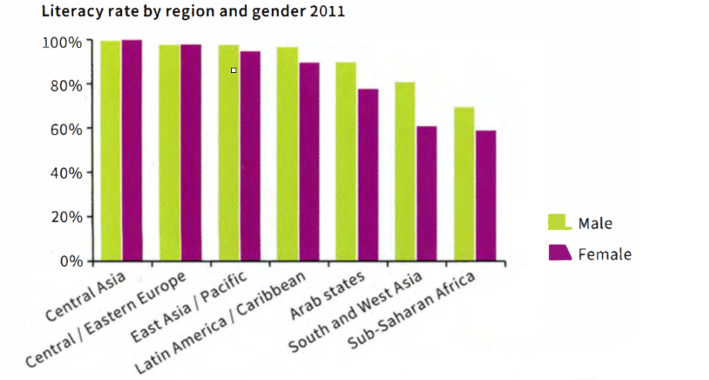

Model answer
The data shows the literacy rate for both males and females in seven different regions of the world. The horizontal axis lists the regions and the vertical axis shows percentage. In all regions except two, there is a difference in the literacy rates of men and women.
Central Asia and Central/Eastern Europe have the highest percentage of citizens who can read and write. Almost 100% of men and women are literate in those regions. The lowest literacy rates are in SubSaharan Africa.
In five out of the seven regions, there are different literacy rates for men and women. The greatest difference between men and women is found in South and West Asia. In this region, about 80% of men are able to read and write, but only about 60% of women. Overall, the difference between the most literate area and the least literate is about 30% for men and just over 40% for women.
In conclusion, literacy rates vary between regions, with males having higher levels than females in most regions.
(172 words)

Exercise 7. You should spend about 40 minutes on this task

In the past, most people used to travel to their place of work. With increased use of computers, the internet and smartphones, more and more people are starting to work from home.
What are the advantages and disadvantages of this development?
You should use your own ideas, knowledge and experience, and support your arguments with the examples and relevant evidence.
Write at least 250 words.

Dạng bài: quiz_type_0
Easy IELTS - Task 2 - 21
Model answer
In recent times, the rapid development of technology, especially the use of computers, smartphones, and the internet, has enabled more people to work remotely rather than commuting to a traditional workplace. While this trend offers significant advantages, it also brings several disadvantages that must be taken into account.
On the positive side, one of the most notable benefits of working from home is the flexibility it provides. Employees have the freedom to set their own schedules, which can help them balance their personal and professional lives more effectively. For example, parents can spend more time with their children while still fulfilling their work responsibilities. Additionally, remote work eliminates the need for daily commuting, saving both time and money. This not only reduces stress for employees but also has environmental benefits, such as decreased traffic congestion and lower carbon emissions.
However, despite these advantages, there are some potential drawbacks. One of the primary concerns is the lack of social interaction. Working from home can lead to feelings of isolation, as employees miss out on face-to-face communication with colleagues. This can have a negative impact on team collaboration, creativity, and overall workplace morale. Furthermore, working from home demands a high degree of self-motivation and discipline. Without direct supervision, some individuals may struggle to remain focused and productive. Technical issues, such as unreliable internet connections, can also pose challenges for remote workers.
In conclusion, the ability to work from home offers clear benefits in terms of flexibility and convenience. Nevertheless, it also presents challenges related to communication, social interaction, and productivity. It is essential for both employers and employees to weigh these pros and cons carefully before deciding if remote work is the most suitable option.
(283 words)

LESSON 4

A. Vocabulary

Exercise 1. Label the vehicles
helicopter | coach | motorbike
van | truck | bus

Dạng bài: quiz_type_7

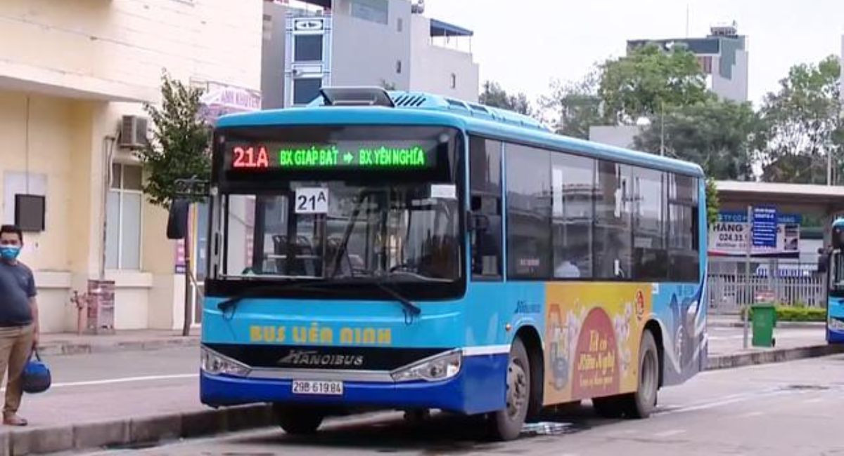  - _________________ | 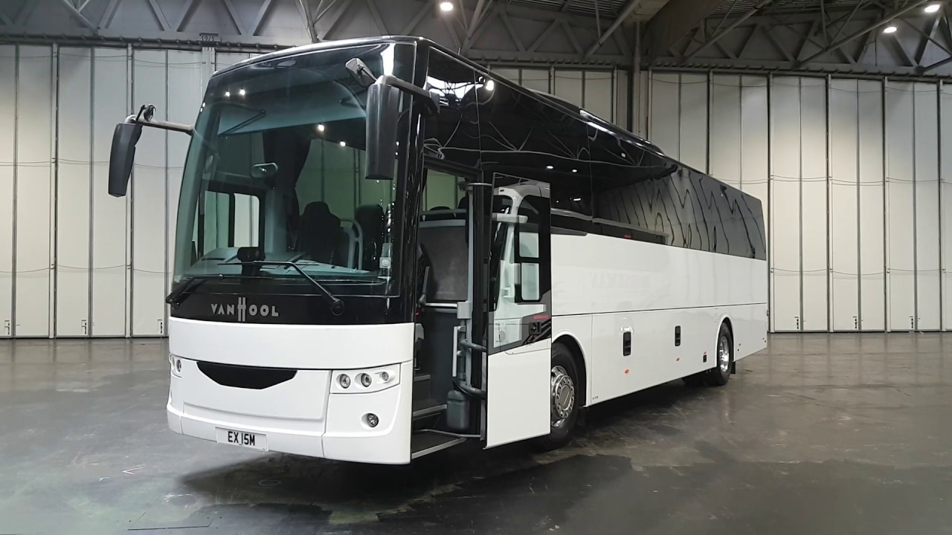  - _________________ | 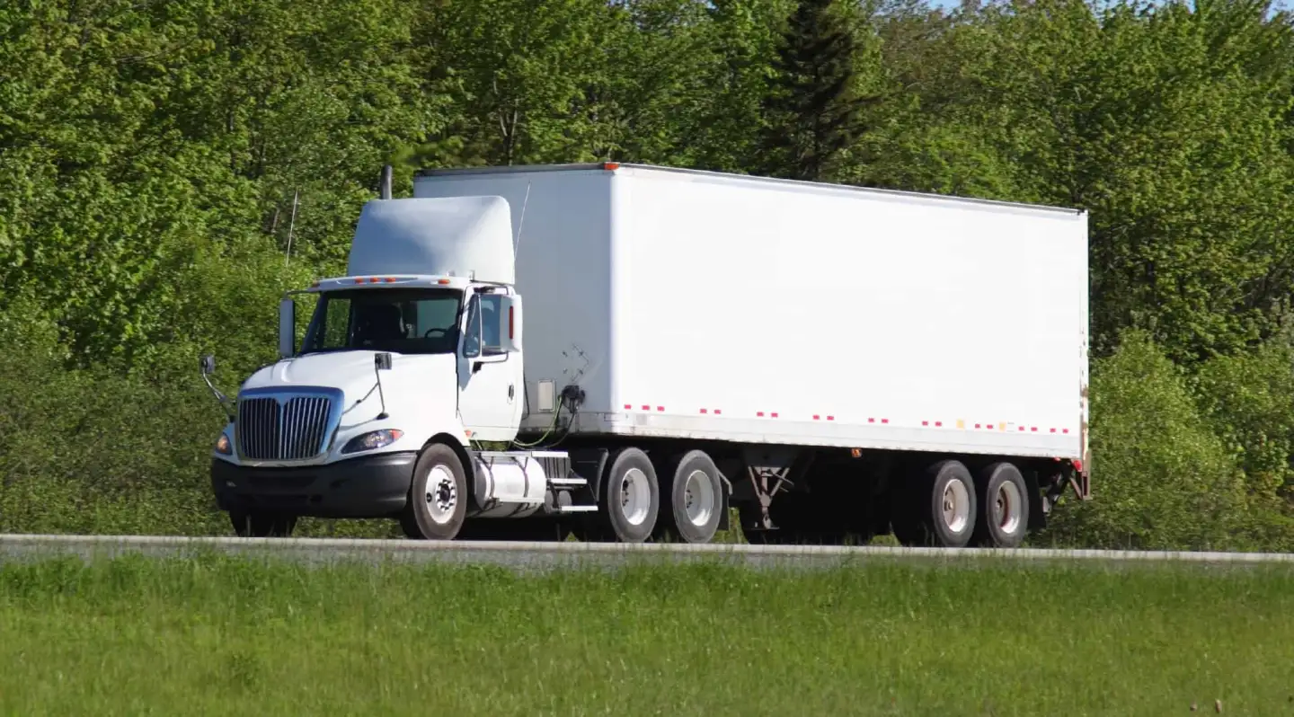  - _________________
  - _________________ | 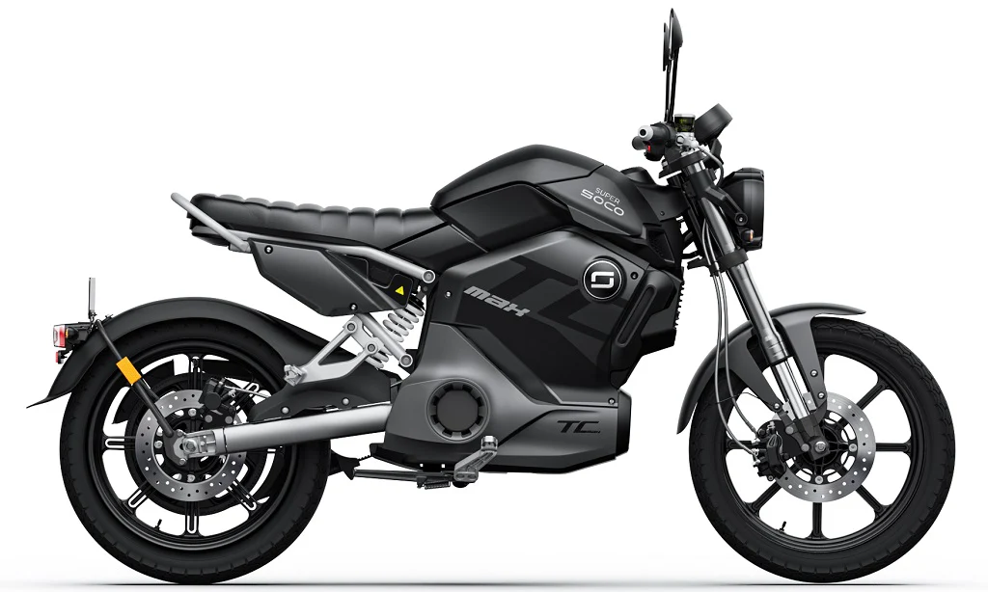  - _________________ | 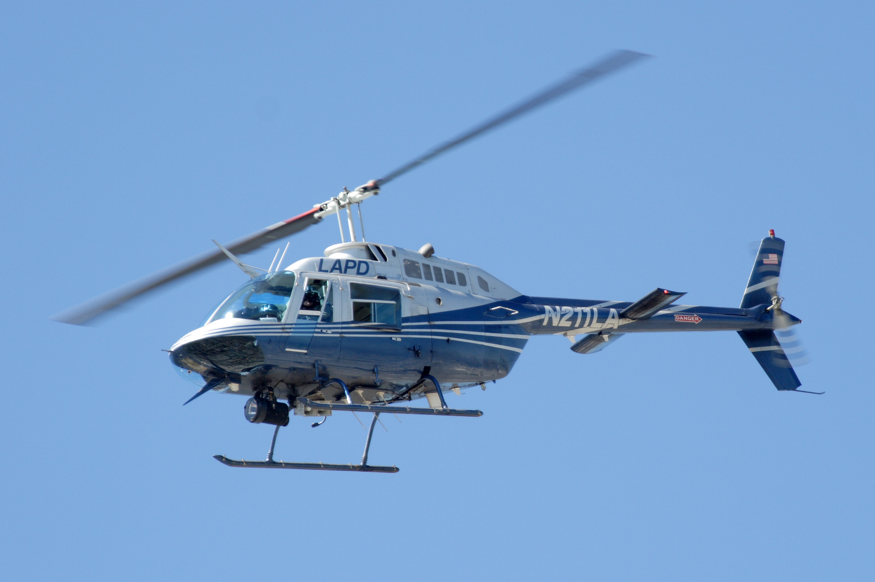  - _________________

Key:
- bus 2. coach 3. truck
4. van 5. motorbike 6. helicopter

Exercise 2. Choose the correct word(s) to complete the sentences
Dạng bài: quiz_type_14

We were late, so we had to get / go a taxi.

You mustn’t ride / drive a motorbike without a helmet in the UK.

She told him to get in / get on the car and fasten his seat belt.

The journey / travel to the airport takes half an hour.

Trains to the airport travel / run every half hour.

The pilot didn’t want to drive / fly the plane in such bad weather.

They left a bit late and lost / missed the bus.

I see that train fares / tickets are going up again.

You mustn’t speak to the bus pilot / driver when he is driving.

We must get off / out the bus at the next station / stop.

Exercise 3. Complete the sentences.

Dạng bài: quiz_type_7
journey | season | return | complaint | queue
reliable | complaining | convenient | platform | corner

- I wasn’t happy with the service, so I made a complaint.
- The flight was fine but we had a terrible _____________ from the airport to our hotel.
- Where I live, the public transport is not very _____________ because the nearest bus stop is two kilometres away, and there are no trains at all.
- The train station is just round the _____________ from where I live.
- Buses are not very _____________. Sometimes they come every five minutes, but other times you have to wait for forty minutes.
- When I got to the bus stop, there was a long _____________ of people.
- Train fares are crazy: a _____________ to Glasgow costs more than two singles.
- People are always _____________ about the buses, but I don’t think they’re that bad.
- I use the trains every day for work, so I’ve got a _____________ ticket.
- Your train is going to depart from _____________ six at 10:25.

Key:
2. journey 3. convenient 4. corner 5. reliable
6. queue 7. return 8. complaining 9. season
10. platform

B. Grammar

Exercise 4. Instead of using ‘somebody’, ‘they’ etc., write a passive sentence

Dạng bài: quiz_type_7

- Somebody has cleaned the room.
→ (1) ___
- They are building a new road around the city.
→ A (2) ___ around the city.
- They have built two new hotels near the airport.
→ Two (3) ___ near the airport.
- When I last visited, they were building some new houses here.
→ When I last visited, some (4) ___.
- The meeting is now on 15 April. They have changed the date.
→ The date of (5) ___.
- I didn’t know that somebody was recording our conversation.
→ I didn’t know that our (6) ___.
- Is anyone doing anything about the problem?
→ (7) ___ anything (8) ___ the problem?
- The windows were very dirty. Nobody had cleaned them for ages.
→ The windows were very dirty. They (9) ___.

ĐÁP ÁN
- The room has been cleaned.
- new road is being built
- new hotels have been built
- new houses were being built
- the meeting has been changed
- conversation was being recorded
- Is
- being done about
- hadn’t been cleaned / had not been cleaned for ages

Exercise 5. Write these sentences in another way, beginning as shown. Use the underlined word each time

Dạng bài: quiz_type_7

It is expected that the strike will end soon.

→ The strike is expected to end soon.

It is reported that many people are homeless after the floods.

→ Many people _______________.

It is thought that the thieves got in through a window in the roof.

→ The thieves _______________.

It is alleged that the driver of the car was driving at 110 miles an hour.

→ The driver _______________.

It is reported that the building has been badly damaged by the fire.

→ The building _______________.

It is said that the company is losing a lot of money.

→ The company _______________.

It is believed that the company lost a lot of money last year.

→ The company _______________.

It is expected that the company will make a loss this year.

→ The company _______________.
Key:
2. are reported to be homeless after the floods
3. are thought to have got in through a window in the roof
4. of the car is alleged to have been driving at 110 miles an hour/ is alleged to have been driving at 110 miles an hour/ of the car is alleged to have driven at 110 miles an hour/ is alleged to have driven at 110 miles an hour
5. is reported to have been badly damaged by the fire
6. is said to be losing a lot of money
7. is believed to have lost a lot of money last year
8. is expected to make a loss this year

C. Writing

Exercise 6. You should spend about 20 minutes on this task
The bar chart shows the percentage of adults who were overweight or obese (too fat or much too fat) in one country from 1965 to 2015. The pie chart shows the proportion of adults who were overweight, obese or severely obese in 2015.
Summarise the information by selecting and reporting the main features, and make comparisons where relevant.
Write at least 150 words

Dạng bài: quiz_type_0
Easy IELTS - Task 1 - 20

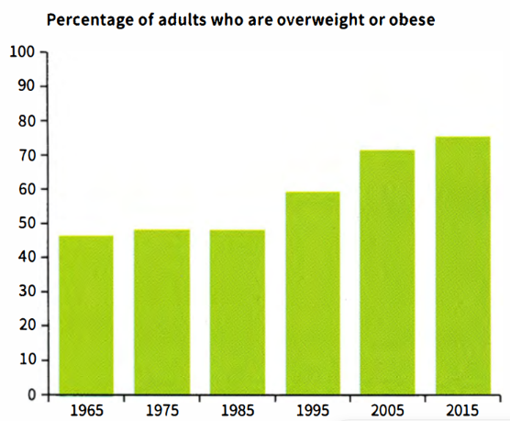
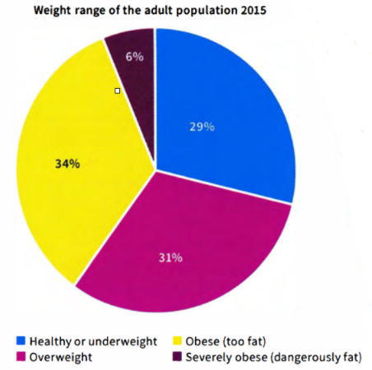

Model answer
The bar chart illustrates the proportion of adults who were classified as overweight or obese between 1965 and 2015, while the pie chart breaks down the weight categories of the adult population in 2015.
Overall, the bar chart shows a steady increase in the percentage of overweight and obese adults over the 50-year period. The pie chart further details the distribution of weight categories in 2015, highlighting that the majority of adults were above a healthy weight.
Between 1965 and 1985, there was a gradual rise in the proportion of adults who were overweight or obese, increasing modestly from around 45% to approximately 48%. However, a marked surge occurred between 1985 and 1995, with figures climbing sharply to nearly 60%. This upward trend continued over the next decade, reaching about 70% by 2005. In the following years, the growth persisted but at a slower pace.
Turning to the pie chart, it is evident that by 2015, over 70% of adults exceeded a healthy weight. Specifically, 6% of the population fell into the severely obese category, posing serious health risks. The rest of the overweight and obese groups accounted for the majority, while a smaller proportion of individuals maintained a healthy weight, though exact percentages are not provided. The distribution among the overweight and obese categories appears relatively balanced.
(218 words)

Exercise 7. You should spend about 40 minutes on this task
Many students choose to take a gap year before starting university, to travel or gain work experience. Do you think this is a good idea or a waste of time?
Give reasons for your answer and include any relevant examples from your own knowledge or experience.
Write at least 250 words.

Dạng bài: quiz_type_0
Easy IELTS - Task 2 - 21
Model answer
The majority of students start their degree in the same year as finishing school or college. Some students, however, choose to take a year out before starting university. In my opinion, this is a very good idea if the time is used wisely in order to gain new skills or knowledge. In the following quiz_type_0, I will discuss this idea further.
It is very important that, when a gap year is taken, the time is not wasted but used productively. It would not look very impressive to a future employer if the time was simply used to take a break. This does not mean to say that a gap year should not be enjoyed.
Many people choose to go travelling during their gap year. This can be very beneficial to the individual as it exposes them to new ideas and cultures. It can also mean that they are able to learn a new language. Other students decide to gain work experience during this year. This can be particularly useful, especially if connected to their chosen area of study. Often, students who have worked before attending university appreciate their course more, as they are able to understand the relevance of what is being taught.
Overall, therefore, as discussed in this quiz_type_0, there can be several benefits to taking a gap year. It is very important, however, that this time is used wisely and not wasted. This means that the year needs to be planned carefully in advance to get the most from the experience.
(283 words)

