Practice Test 1

Writing Task 1
You should spend about 20 minutes on this task.
Dạng bài: quiz_type_0
Easy IELTS - Task 1 - 20
The table below shows the changes in some household types in Canada from 1984 to 2020.
Summarise the information by selecting and reporting the main features, and make comparisons where relevant.
Write at least 150 words.
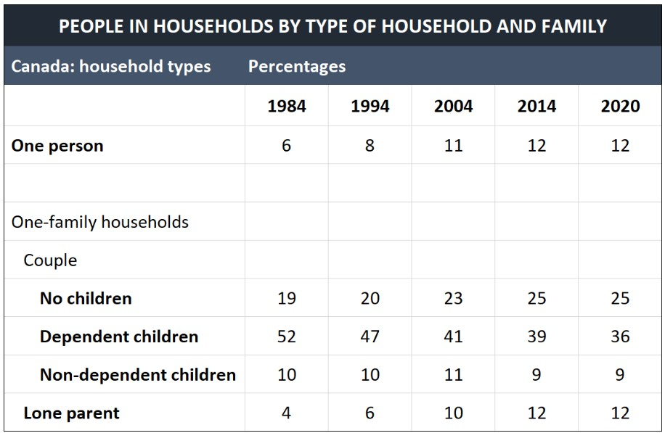
Model Answer
The table shows how household types in Canada changed over 40 years, with data recorded every 10 years from 1984 to 2014 and again in 2020. Overall, the percentage of one-person households and couples without children increased over time, while households with dependent children became less common. Lone-parent households remained relatively stable with a slight increase.
Throughout this time, households without children saw a consistent increase. One-person households, for example, doubled from 6% in 1984 to 12% in 2020, while the proportion of couples without children grew from 19% in 1984 to 23% in 2004, peaking at 25% in 2014 before stabilising in 2020.
Significant changes were observed in households with dependent children. The percentage of couples with dependent children dropped dramatically, from 52% in 1984 to 36% in 2020. Conversely, the number of lone-parent households tripled, rising from 4% in 1984 to 12% in 2020. Meanwhile, households with non-dependent children remained relatively stable, starting at 10% in 1984, increasing by just 1% over the next two decades, and then declining slightly to 9% by 2014.
Word count: 176

Writing Task 2
You should spend about 40 minutes on this task.
Dạng bài: quiz_type_0
Easy IELTS - Task 2 - 21
Write about the following topic:
Some people think that the government should ban dangerous sports, while others think that people should have freedom to do any sports or activity.
Discuss both views and give your opinion.
Give reasons for your answer and include any relevant examples from your own knowledge or experience.
Write at least 250 words.
Model Answer
Some people argue that the government should prohibit dangerous sports to ensure public safety, while others believe individuals should have the freedom to participate in any activity of their choice. In my opinion, although banning risky sports could prevent harm, it is better to let individuals decide for themselves.
On the one hand, banning dangerous sports can reduce accidents and protect lives. Many extreme sports, like skydiving or rock climbing, involve high risks, and accidents can cause serious injuries or even death. For example, a fall during mountain climbing can lead to permanent disabilities, placing a heavy emotional and financial burden on families. Additionally, these sports often require professional rescue services in emergencies, which can strain public resources. For instance, rescuing stranded climbers involves helicopters and skilled personnel, which could take a lot of time and money. Therefore, restricting such sports might benefit both individuals and society.
On the other hand, people should have the freedom to choose their own recreational activities, including risky ones. Many individuals find extreme sports thrilling and rewarding, as they help them overcome fears and gain a sense of achievement. For example, finishing a dangerous skydive can make someone feel more confident and leave them with great memories. Moreover, regulating these sports with proper safety measures, instead of banning them entirely, allows enthusiasts to enjoy their passions while minimising risks. For instance, requiring participants to take training and wear safety gear can greatly lower the chances of accidents. Thus, respecting individual choice and promoting safety together can be a balanced approach.
In conclusion, while banning dangerous sports might help reduce accidents and save resources, allowing people to pursue their interests with proper precautions is a better solution. Therefore, governments should focus on improving safety regulations rather than prohibiting these activities outright.
Word count: 296

Practice Test 2

Writing Task 1
You should spend about 20 minutes on this task.
Dạng bài: quiz_type_0
Easy IELTS - Task 1 - 20
The graph below shows the spending of UK residents on visits abroad between 1993 and 2013.
Summarise the information by selecting and reporting the main features and make comparisons where relevant.
Write at least 150 words.
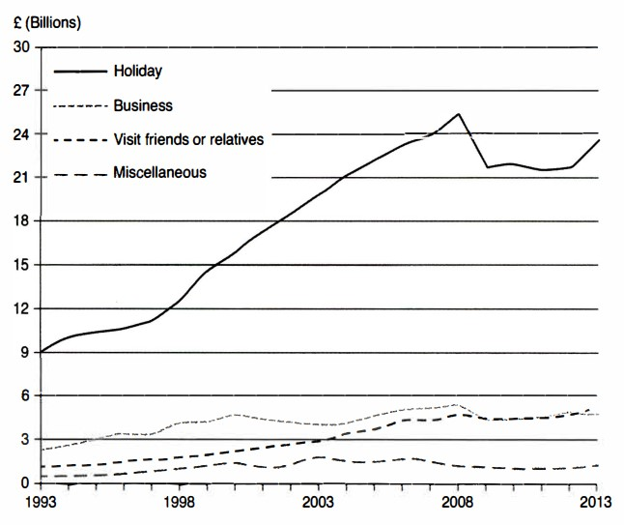
Model Answer
This line graph shows the amount of money in billions of pounds spent by people from the UK on visits abroad from 1993-2013. Overall, spending on holidays was consistently the highest, showing a significant increase over time, while other categories saw much lower spending levels and relatively smaller changes.
By far and away the largest sum of money was spent on travel, which has experienced a huge growth and reflects the growing popularity of overseas holidays. In fact, between 1993 and 2008, expenditure on travel almost tripled from nine billion to almost 27 billion pounds. There was a sharp fall in 2009 to just over 21 billion, with figures stabilising over the next few years. However, there were signs of growth again in 2013 to 24 billion pounds.
Expenditure in other areas has been far more stable during this twenty-year period. Money spent on visiting friends or relatives rose gradually from around one billion pounds in 1993 to approximately five billion in 2013. The amount spent on business since 2000 has had a gradual increase with minor fluctuations, but since 2008 has remained fairly steady at around five billion pounds.
Word count: 190

Writing Task 2
You should spend about 40 minutes on this task.
Write about the following topic:
Dạng bài: quiz_type_0
Easy IELTS - Task 2 - 21
Some people think that parents should read stories to their children while others argue that is no longer necessary as we have modern technology such as television and films. Discuss both views and give your own opinion.
Give reasons for your answer and include any relevant examples from your own knowledge or experience.
Write at least 250 words.
Model Answer
There is an ongoing debate about whether parents should read stories to their children or if modern technology, such as television and films, can replace this practice. While some people argue that technology is a sufficient alternative, I believe that reading stories to children is still very important.
Opponents of parental storytelling point to the wide range of stories available through books and television. Unlike parents, who tell a limited number of stories, these sources offer children access to countless stories every day, exposing them to different authors, cultures, and styles. This helps broaden their understanding of the world. Additionally, when children explore stories on their own, they develop independence by choosing stories that interest them and match their reading level. This fosters self-exploration and decision-making skills.
However, those who support parental storytelling highlight its unique benefits. Firstly, it helps build strong emotional bonds between parents and children. This shared experience creates closeness and allows parents to connect with their children on an emotional level, which helps their social and emotional growth. Secondly, parents can personalise the story based on their child's interests and needs. Unlike books or TV shows, parents can adjust the story and add their own explanations. For example, when reading a story about animals, a parent can pause to ask questions, helping the child think critically and understand better.
In conclusion, while external sources of stories can be beneficial, they cannot replace the emotional connection and personalised experience that parents provide. Parents should continue the practice of reading to their children to support their development and strengthen their relationships.
Word count: 263

