Practice Test 1

Writing Task 1
You should spend about 20 minutes on this task.
Dạng bài: quiz_type_0
Easy IELTS - Task 1 - 20
The chart below shows the number of magazines sold per person in five countries in 2000 and 2010, with projected sales for 2020. Summarise the information by selecting and reporting the main features, and make comparisons where relevant.
Write at least 150 words.
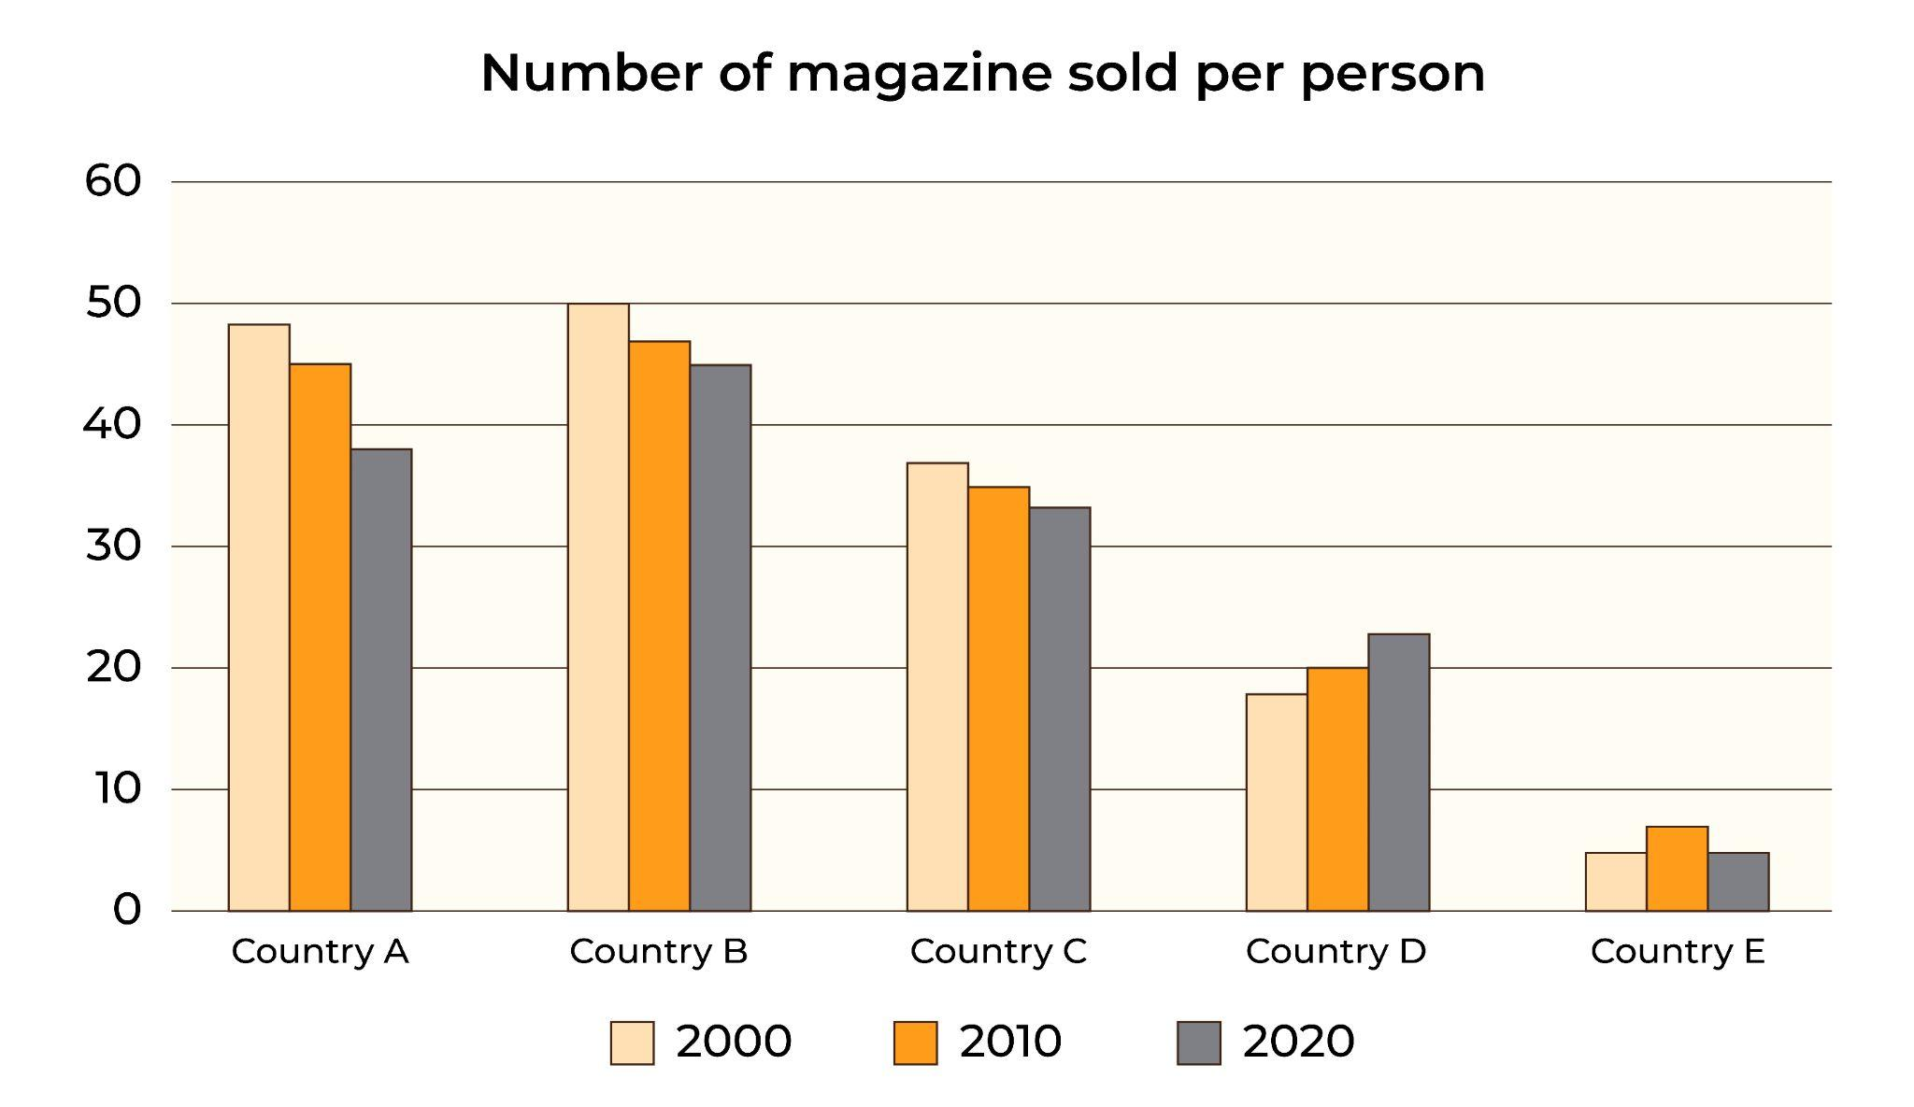
Model Answer
The provided chart presents a shift in reading habits of people in this digital era in five distinct countries from 2000 to 2020.
Overall, Countries A and B exhibit the most noteworthy average magazine purchases per person, while the converse is observed for Country E. Furthermore, there is a general downward trend in average magazine sales over the years in Countries A, B, and C, whereas Country D experiences an upward trend.
In Country A, B, and C, there is a steady drop in the percentage of newspaper consumption over the years. Among these, Country B has the highest magazine sales, with numbers decreasing from 50 in 2000 to 45 in 2020. Country A closely followed with an impressive 48 in 2000, but its sales fall by 10 per person by 2020. Meanwhile, Country C, though lower in sales, also sees a gradual drop of about 1-2 magazines per person each year.
In contrast, Countries D and E, which started with lower sales in 2000, show different patterns. Country D’s magazine sales were below 20 in 2000 but rose to 20 in 2010 and 22 in 2020. Lastly, Country E, representing only about 20% of Country B's sales over the span of 3 years, exhibited a marginal rise in 2010 but returned to the starting level by 2020.
Word count: 218

Writing Task 2
You should spend about 40 minutes on this task.
Dạng bài: quiz_type_0
Easy IELTS - Task 2 - 21
Write about the following topic:
Some people think children have the freedom to make mistakes, while other people believe that adults should prevent children from making mistakes.
Discuss both sides and give your opinion.
Give reasons for your answer and include any relevant examples from your own knowledge or experience.
Write at least 250 words.
Model Answer
In recent times, there has been a debate about whether children should be allowed to make their own mistakes or be protected by adults. Some people think children should have the freedom to learn from their mistakes, while others believe adults should step in to keep them safe. Finding a good balance between these views is important for helping children grow into well-rounded individuals.
Supporters of letting children make mistakes believe it helps them grow and develop important skills for adulthood. Learning through trial and error builds resilience and confidence, which are essential for handling life’s challenges. For instance, learning to ride a bike often involves falling and trying again, which builds perseverance and a sense of accomplishment. Moreover, making mistakes helps children become more responsible for their actions. When they see the results of their choices, they gain a better understanding of cause and effect, which helps them develop self-awareness and responsibility for the future.
On the other hand, those who believe children should be protected feel that adults have a duty to keep them safe from harm. They argue that mistakes can lead to emotional distress for children, causing feelings like guilt, shame, and lower self-esteem, which may harm their development. Additionally, some mistakes can put children in physical danger, such as risky behaviour or ignoring safety rules. For this reason, adults have a responsibility to step in and prevent children from engaging in dangerous activities.
In conclusion, while parental intervention has its benefits, allowing children to learn from their mistakes also plays an important role in their development. By balancing guidance and support with the freedom to make mistakes within safe limits, we can help children build resilience, responsibility, and self-awareness.
Word count: 284

Practice Test 2

Writing Task 1
You should spend about 20 minutes on this task.
Dạng bài: quiz_type_0
Easy IELTS - Task 1 - 20
The diagram shows how chocolate is produced.
Summarise the information by selecting and reporting the main features and make comparisons where relevant.
Write at least 150 words.
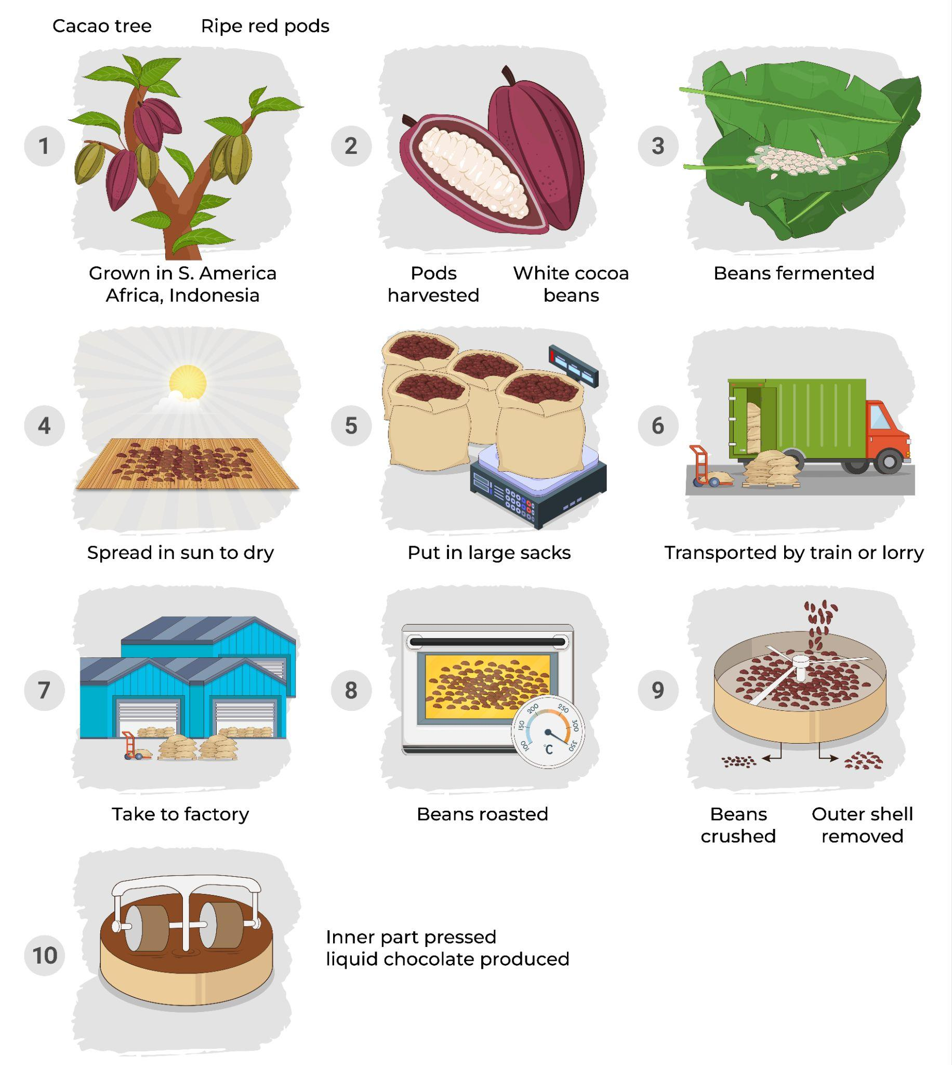
Model Answer
The diagram depicts the process of producing liquid chocolate. In total, there are ten stages involved in the creation of liquid chocolate, starting with picking ripe red cacao pods from cacao trees and ending with the production of liquid chocolate.
To begin with, ripe red cacao beans are carefully gathered directly from the trunks of cacao trees found in regions such as South America, Africa, and Indonesia. The cacao pods, which can number in the hundreds, are then opened to reveal the white cocoa beans inside. These beans are then fermented. After fermentation, the beans are dried in the sun, packed into large sacks, and sent by train or truck to the factory.
When the beans arrive at the factory, they are roasted at 350 degrees Celsius. After roasting, the beans are crushed to remove their outer shells. The inside of the beans is then pressed using rollers, which turns it into liquid chocolate.
Word count: 154

Writing Task 2
You should spend about 40 minutes on this task.
Dạng bài: quiz_type_0
Easy IELTS - Task 2 - 21
Write about the following topic:
Some people believe that children’s leisure activities must be educational, otherwise they are a waste of time.
Do you agree or disagree?
Give reasons for your answer and include any relevant examples from your own knowledge or experience.
Write at least 250 words.
Model Answer
The ongoing debate about the importance of leisure activities in children's lives has been around for years. Some people believe that only educational activities are worthwhile. While these activities can be valuable, it’s also important to see the benefits of other leisure activities.
Supporters of educational leisure activities believe these activities help children learn new skills and knowledge. For example, doing things like reading, writing, or playing educational games can help children gain knowledge and build skills like problem-solving, critical thinking, and creativity. Educational activities can also teach children discipline and perseverance. To illustrate this point, learning to play an instrument or studying a new language requires focus and dedication, which builds a strong work ethic and helps them keep going when things are tough. These skills not only improve their school performance but also prepare them for future goals, showing them the value of effort and resilience.
However, leisure activities do not have to be educational to help children develop important life skills. One reason is that a variety of fun activities allow children to explore their interests, express themselves, and grow their personalities. For instance, playing team sports helps kids learn teamwork, communication, and leadership skills, which are useful in many areas of life. Additionally, leisure activities give kids a break from the often stressful environment of schoolwork and homework. Taking time to relax helps their brains recharge, so they can focus better and do well academically when they return to their studies.
In conclusion, I believe that leisure activities play an important role in children's lives and should not be judged only by their educational value. While learning activities are helpful, it is also essential to recognize the importance of non-educational leisure activities in building life skills, reducing stress, and supporting overall well-being.
Word count: 296

Practice Test 3

Writing Task 1
You should spend about 20 minutes on this task.
Dạng bài: quiz_type_0
Easy IELTS - Task 1 - 20

The picture below shows the recycling process of wasted glass bottles. Summarise the information by selecting and reporting the main features, and make comparisons where relevant.

Write at least 150 words.

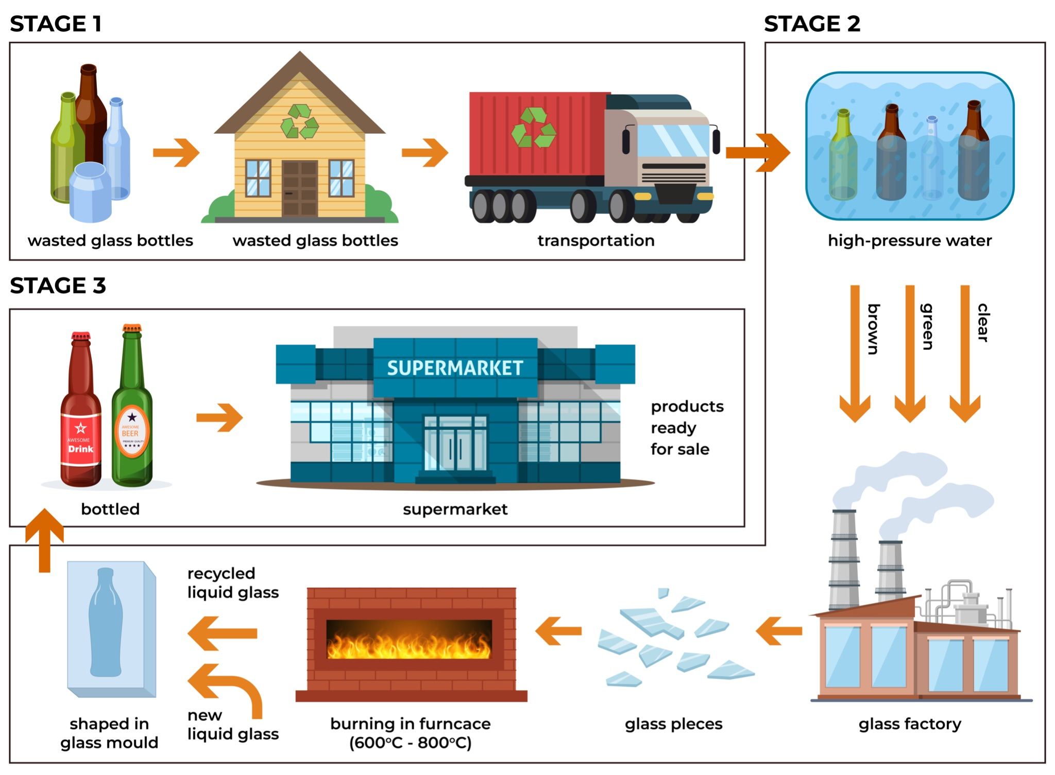
Model Answer
The diagram shows the process of recycling waste glass bottles. Overall, there are three main stages, starting with collecting used bottles and ending with distributing new bottles to stores, like supermarkets.
In the first stage, used bottles are collected and prepared. Following that, they are placed at collection sites, loaded onto trucks, and taken to a processing facility.
The second stage is the processing of these bottles. First, they are thoroughly cleaned with high-pressure water. Next, the bottles are sorted by colour into clear, green, and brown glass. Then, they are crushed into small pieces at a glass factory and heated in a furnace at temperatures between 600 and 800 degrees Celsius. The melted recycled glass is then mixed with new liquid glass and shaped into new bottles.
The third stage completes the process. The newly made bottles are filled with products and sent to supermarkets or other stores for sale.
Word count: 151

Writing Task 2
You should spend about 40 minutes on this task.
Dạng bài: quiz_type_0
Easy IELTS - Task 2 - 21
Write about the following topic:
The news media have too much influence on people’s lives today and this is a negative development.
To what extent do you agree or disagree?
Give reasons for your answer and include any relevant examples from your own knowledge or experience.
Write at least 250 words.
Model Answer
The impact of news media on people's lives has clearly grown in recent years. While I agree that the increased importance of news media has benefits, it also comes with risks of misinformation and manipulation.
On one hand, the news media provides many positive contributions to society today. With easy access to information, people can stay up-to-date on current events, politics, and important social issues. This awareness helps citizens participate in democracy, share their views, and make informed choices. News media also raises social awareness and encourages positive change. For example, stories about resilience, innovation, and positive actions not only inspire individuals but also motivate communities and organisations to work toward a better future.
On the other hand, news media can have negative effects. First, the fast spread of news in the digital age has led to the rapid spread of misinformation, with false or misleading content easily circulating on social media before facts are verified. This is especially harmful when false information relates to health or important policy decisions, as it can reduce trust in reliable news sources and make it harder for people to know what is true. Additionally, the large amount of negative news, often used to attract attention through sensational stories, can impact mental health. Constant exposure to distressing stories, designed to stir up emotions, can increase stress and anxiety, affecting people's mental well-being and quality of life.
In conclusion, while the growing influence of news media brings benefits like greater awareness and support for positive change, it also carries risks of misinformation and negative impacts on mental health. To address these risks, it would be beneficial for news platforms to promote responsible reporting and for individuals to develop skills to critically evaluate information sources.
Word count: 289

Practice Test 4

Writing Task 1
You should spend about 20 minutes on this task.
Dạng bài: quiz_type_0
Easy IELTS - Task 1 - 20

The diagram below shows the recycling process of aluminium cans. Summarise the information by selecting and reporting the main features, and make comparisons where relevant.

Write at least 150 words.

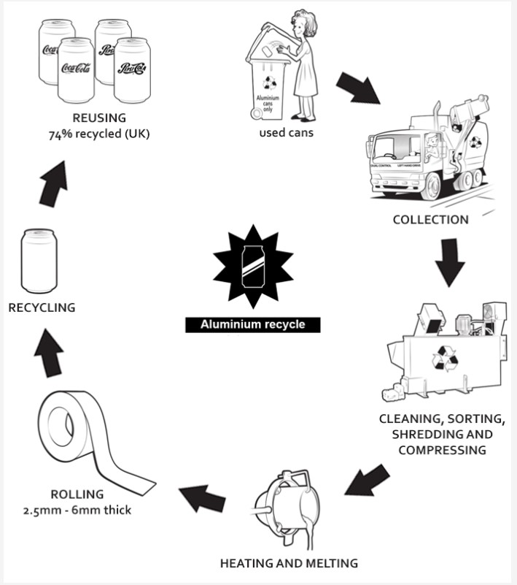
Model Answer
The diagram shows the process of recycling aluminium cans. Overall, the recycling of aluminium cans involves five main steps, starting with collecting the used cans and ending with the production of new recycled products.
First, used cans are gathered from different places to prepare them for recycling. Once collected, the cans are taken to a recycling plant where they are cleaned, sorted, shredded, and pressed into small pieces. Then, the shredded cans are heated to a very high temperature and melted into liquid aluminium, making them ready for the next steps.
After melting, the aluminium is cooled and flattened into thin sheets that are between 2.5 and 6 mm thick. In the final step, these sheets are used to make new cans, which are then sent out to be reused. It is interesting to note that 74% of the aluminium cans in the UK are made from recycled material.
Word count: 150

Writing Task 2
You should spend about 40 minutes on this task.
Dạng bài: quiz_type_0
Easy IELTS - Task 2 - 21
Write about the following topic:
Many young people choose to take a year out between finishing school and starting university in order to gain work experience or to travel. The experience of non-academic life offers benefits to the individual when they return to education.
To what extent do you agree or disagree?
Give reasons for your answer and include any relevant examples from your own knowledge or experience.
Write at least 250 words.
Model Answer
Many young people choose to take a gap year between completing school and starting university, often to gain work experience or travel. While I believe this time can provide valuable learning opportunities, it may have potential drawbacks if not properly planned.
One of the main advantages of a gap year is the opportunity to gain practical experience. For instance, working in a part-time job or internship allows young people to develop important skills like communication, teamwork, and responsibility. These experiences can give them a clearer idea of their future career path and help them decide what they want to study at university. Moreover, working during the gap year can make students more mature and financially independent, which can equip students with the confidence and life skills necessary to thrive in university and beyond.
On the other hand, taking a year off may also present some challenges. Without a structured environment, students might struggle to maintain motivation and could lose focus on their academic goals. Some young people may even find it difficult to adjust back to the routine of school after a long break. Moreover, if the gap year is spent travelling without acquiring relevant experiences or skills, it might not contribute significantly to personal growth or future academic success. In such cases, the break could feel like a missed opportunity to prepare for higher education.
In conclusion, while a gap year can offer useful life experiences and skills, it must be well-planned to avoid potential drawbacks. I believe it can be beneficial, but only if it is used purposefully to complement a young person's future academic and career goals.
Word count: 270

