Practice Test 1

Reading Passage 1: Listen and choose the correct answer. There is one example.

What was the matter with Tom yesterday?
Dạng bài: quiz_type_1

A.   | B.   | C.  

Which man is Lily’s dad?
Dạng bài: quiz_type_1
A.  | B.   | C. 

What did Peter see first at the zoo?
Dạng bài: quiz_type_1
A.   | B.   | C.  

Where is Lucy’s comic?
Dạng bài: quiz_type_1
A.   | B.   | C.  
- What is in the picnic box?
Dạng bài: quiz_type_1
A.  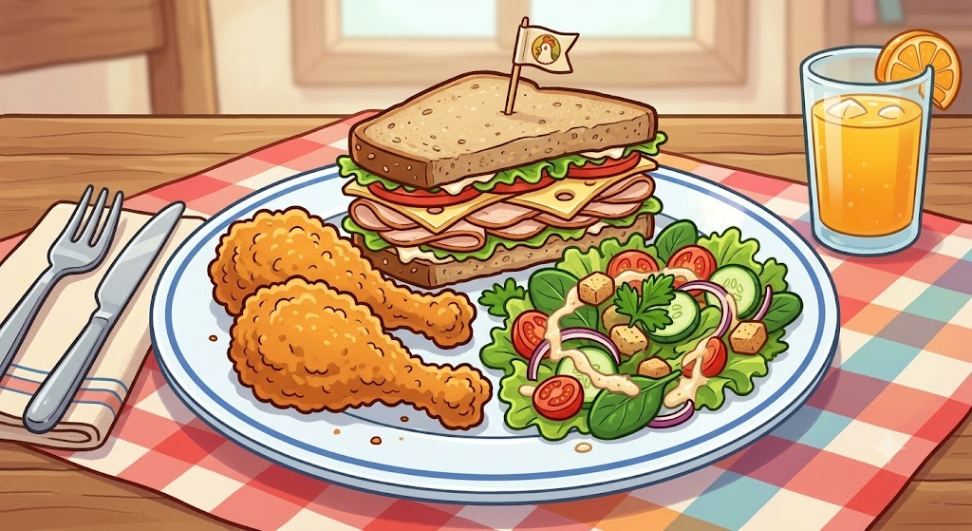 | B.  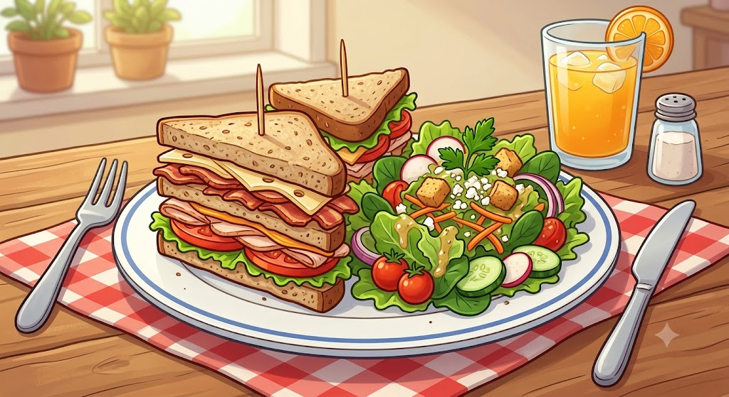 | C.  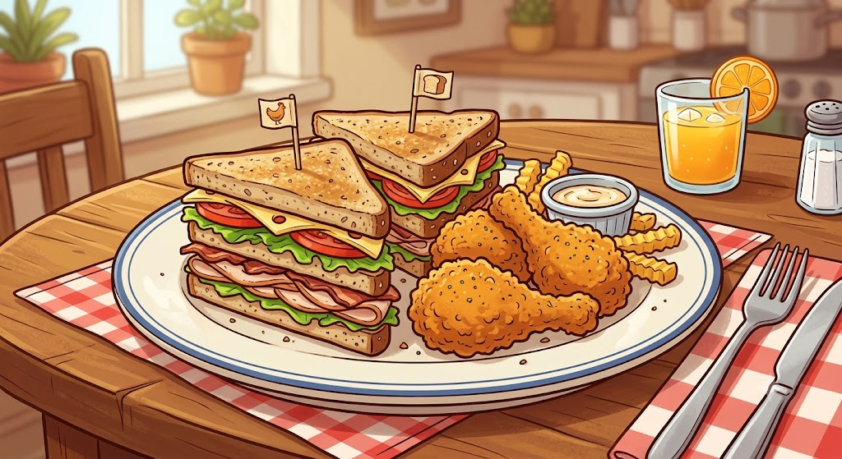

Why are the girls laughing?
Dạng bài: quiz_type_1
A.   | B.   | C.  

