LESSON 1

A. Vocabulary

Exercise 1. What are these?

Dạng bài: quiz_type_7
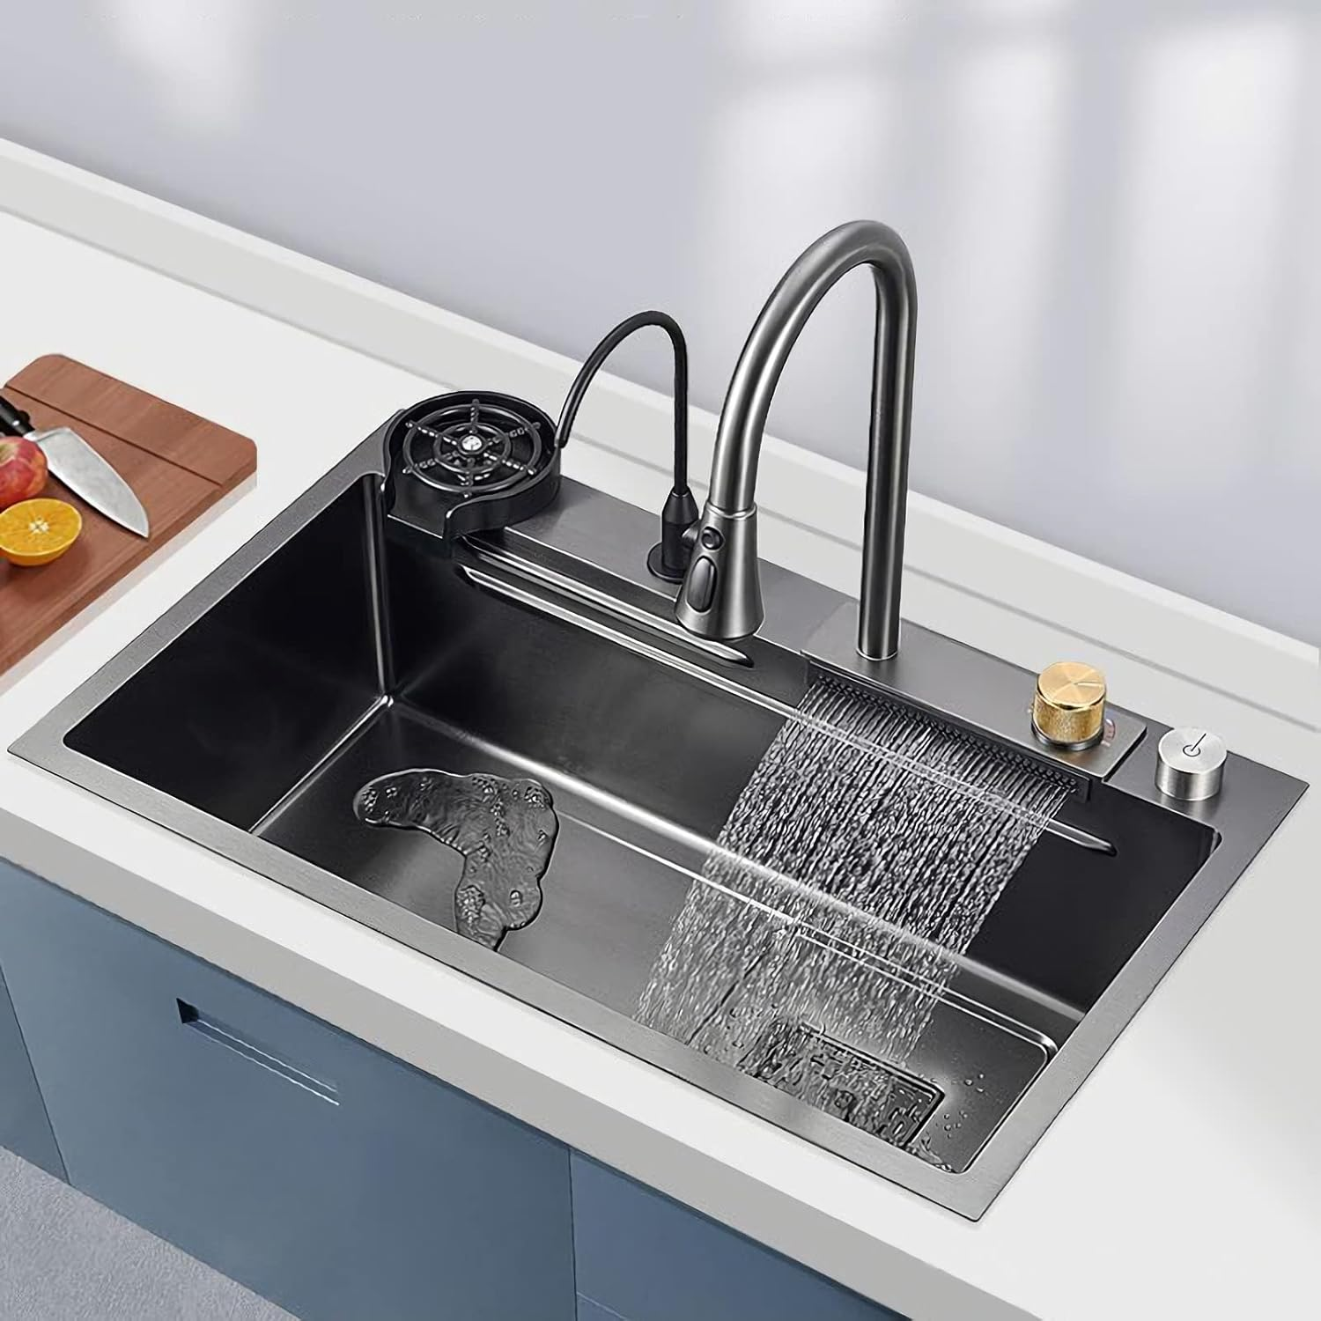  - _________________ |   - _________________ | 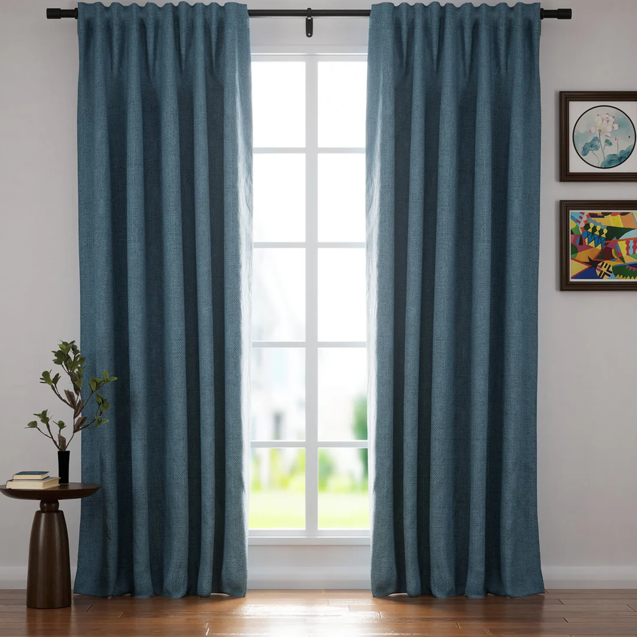  - _________________
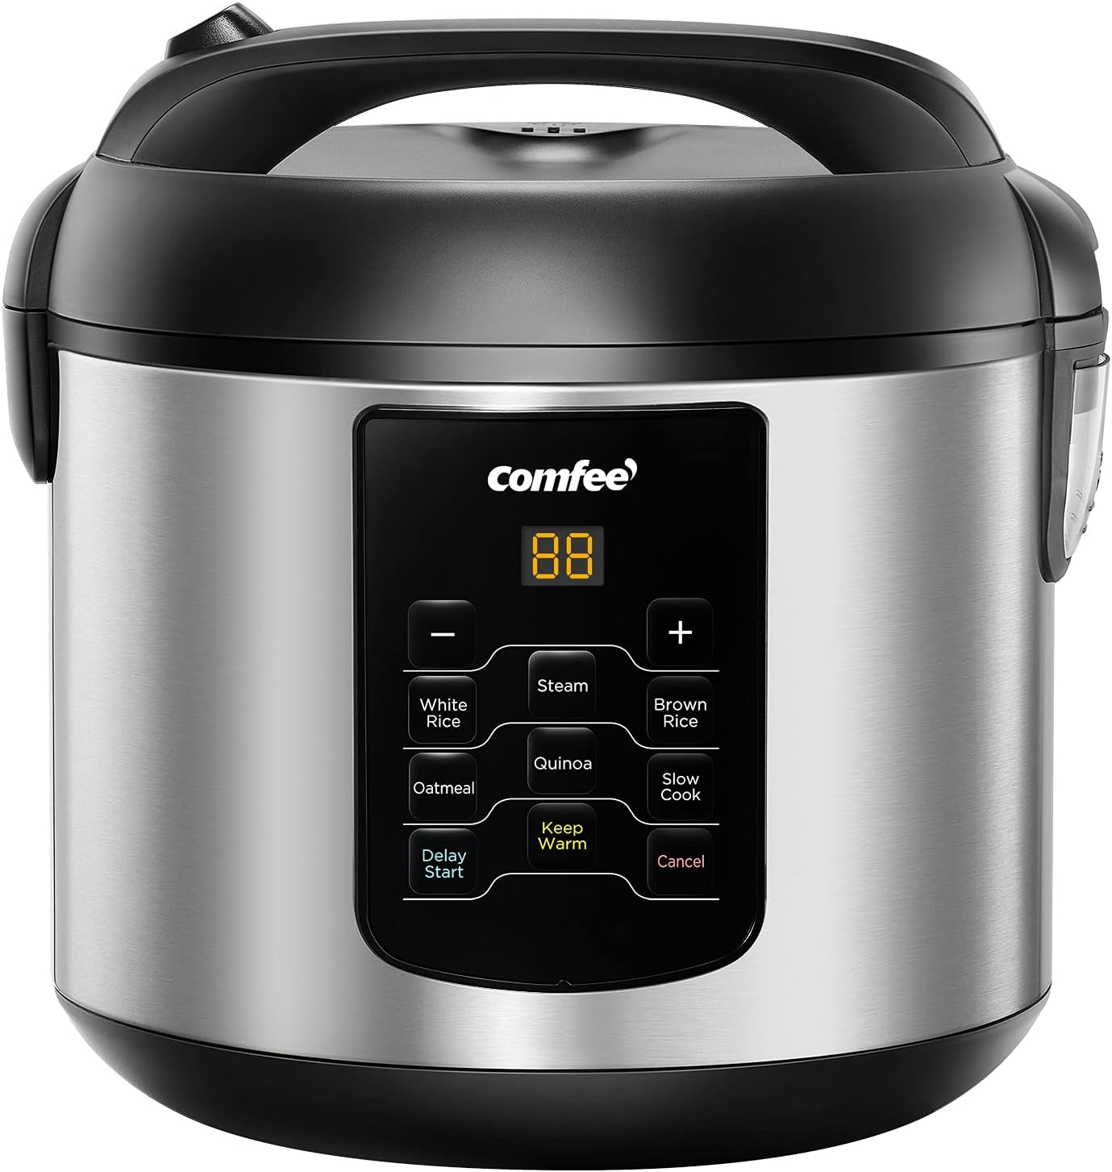  - ________________ | 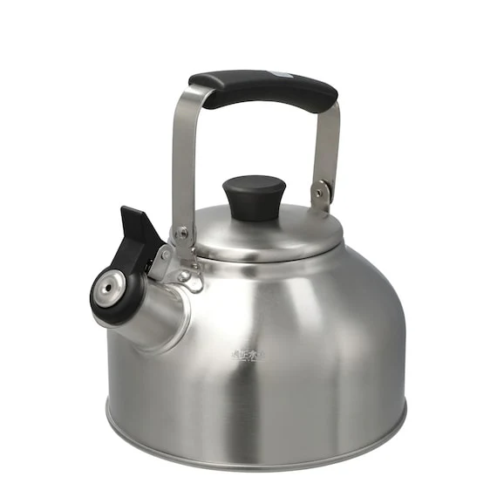  - ________________ | 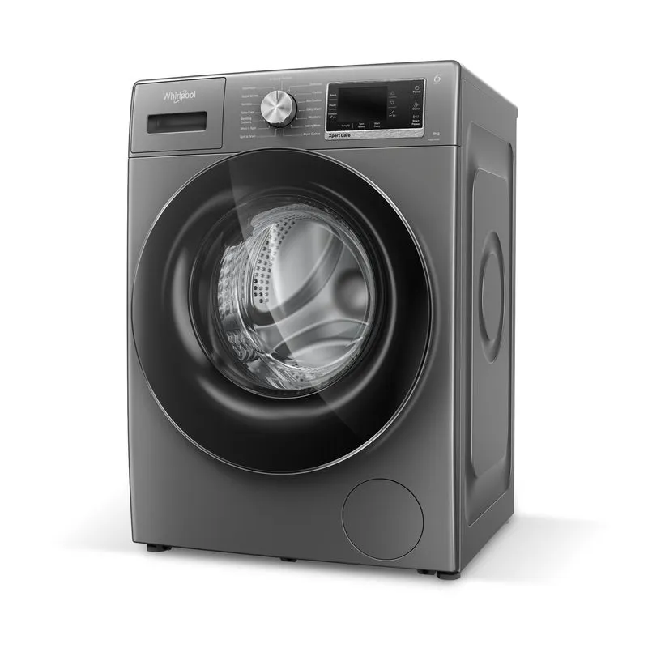  - ________________
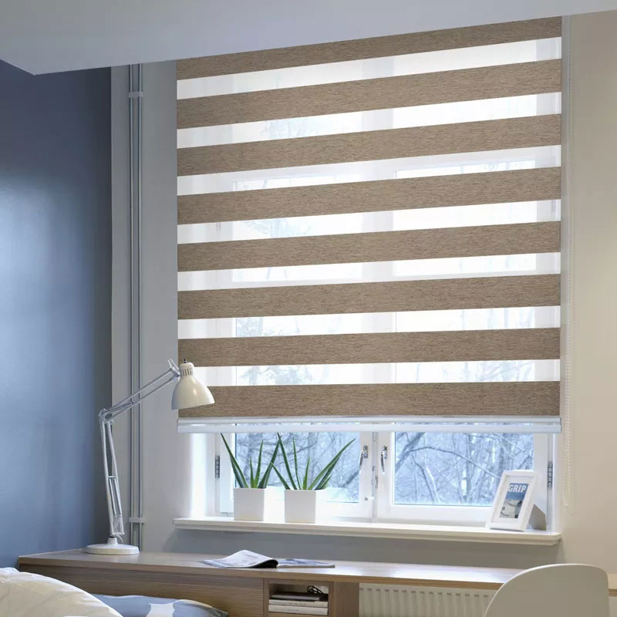  - ________________ | 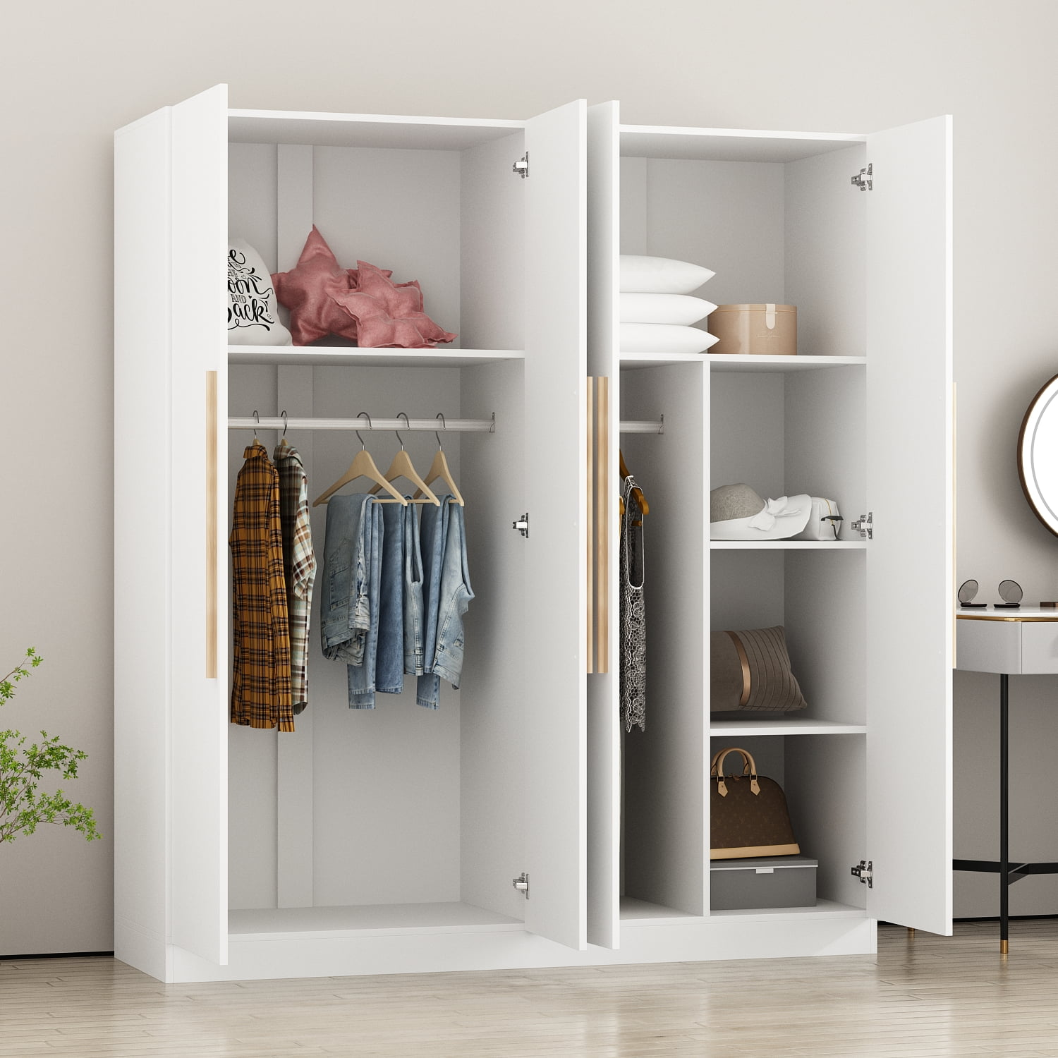  - ________________ | 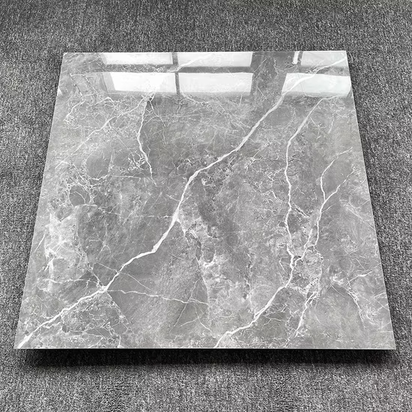  - ________________

Key:
- sink
- microwave
- curtains
- cooker
- kettle
- washing machine
- blinds
- wardrobe
- tiles

Exercise 2. Complete the sentences.
wooden | spare | choice | study | en suite
share; own | blanket; duvet | tap(s) | blinds | utility

Dạng bài: quiz_type_7

I’m happy with curtains or blinds; I really don’t mind.

We used to have a __________ floor, but it was a bit noisy so we put down a carpet.

When I got my new bedroom, my mum gave me a ________ of curtains or blinds.

My mum works at home, so she spends all day in the __________ on the computer.

As a child I had to __________ a room with my sister, but now I’ve got my __________ bedroom.

We often have guests to stay, but fortunately we’ve got a __________ room.

‘Dad, there’s no water coming out of the __________ in the kitchen sink.’

Some people like a sheet and __________, but I prefer a __________.

There’s a family bathroom, but I’ve got my own __________ shower room next to the bedroom.

Our kitchen is small but we have a __________ room for the washing machine.
Key:

2. wooden 3. choice 4. study 5. share; own 6. spare

7. tap/taps 8. blanket; duvet 9. en suite 10. utility

Exercise 3. Complete the box using the given words

top floor | first floor | ground floor
front door | balcony | steps | second floor

Dạng bài: quiz_type_7

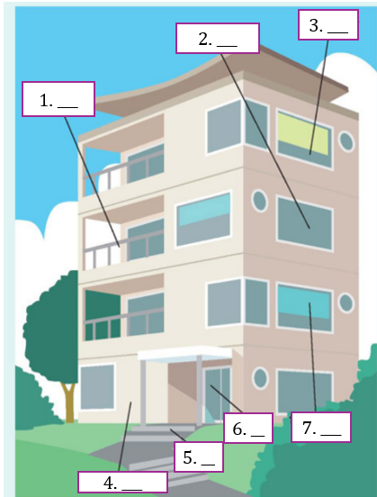

Answer: 1. ___, 2. ___, 3. ____, 4. ___,5. ___, 6. ___, 7.___
Key:
- balcony
- second floor
- top floor
- ground floor
- steps
- front door
- first floor

B. Grammar

Exercise 4. Put the verb into the correct form, present continuous or present simple.

Dạng bài: quiz_type_7

Why are all these people here? (What / happen) What’s happening?

Julia is good at languages. (She / speak) _____________ four languages very well.

Are you ready yet? (Everybody / wait) _____________ for you.

I’ve never heard this word. How (you / pronounce) _____________ it?

Kate (not / work) _____________ this week. She’s on holiday.

I think my English (improve) _____________ slowly. It’s better than it was.

Nicola (live) _____________ in Manchester. She has never lived anywhere else.

Can we stop walking soon? (I / start) _____________ to get tired.

Sam and Tina are in Madrid right now. (They / visit) _____________ a friend of theirs.

‘What (your father / do) _____________?’ ‘He’s an architect.’

It took me an hour to get to work this morning. Most days (it / not / take) _____________ so long.

I (I / learn) _____________ to drive. My driving test is next month. My father (teach) _____________ me.
Key:
2. She speaks
3. Everybody’s waiting / Everybody is waiting
4. do you pronounce
5. isn’t working / is not working / ’s not working
6. is improving
7. lives
8. I’m starting / I am starting
9. They’re visiting / They are visiting
10. does your father do
11. it doesn’t take
12. I’m learning / I am learning - is teaching / ’s teaching

Exercise 5. Are the underlined verbs OK? Correct them where necessary.

Dạng bài: quiz_type_7

Water boils at 100 degrees Celsius. OK

How often are you going to the cinema? do you go

Ben tries to find a job, but he hasn’t had any luck yet.

Martina is phoning her mother every day.

The moon goes round the earth in about 27 days.

Can you hear those people? What do they talk about?

What do you do in your spare time?

Sarah is a vegetarian. She doesn’t eat meat.

I must go now. It gets late.

‘Come on! It’s time to leave.’ ‘OK, I come.’

Paul is never late. He’s always starting work on time.

They don’t get on well. They’re always arguing.
Answer: 3. ____, 4. ___,5. ___, 6. ___, 7.___, 8.___, 9.___, 10.___11. ___, 12. ___,
Key:
3. is trying
4. phones
5. OK
6. are they talking
7. OK
8. OK
9. It’s getting / It is getting
10. I’m coming / I am coming
11. He always starts
12.OK

C. Writing

Exercise 6. You should spend about 20 minutes on this task
The diagram details the process of making smoked fish.
Summarise the information by selecting and reporting the main features, and make comparisons where relevant.
Write at least 150 words
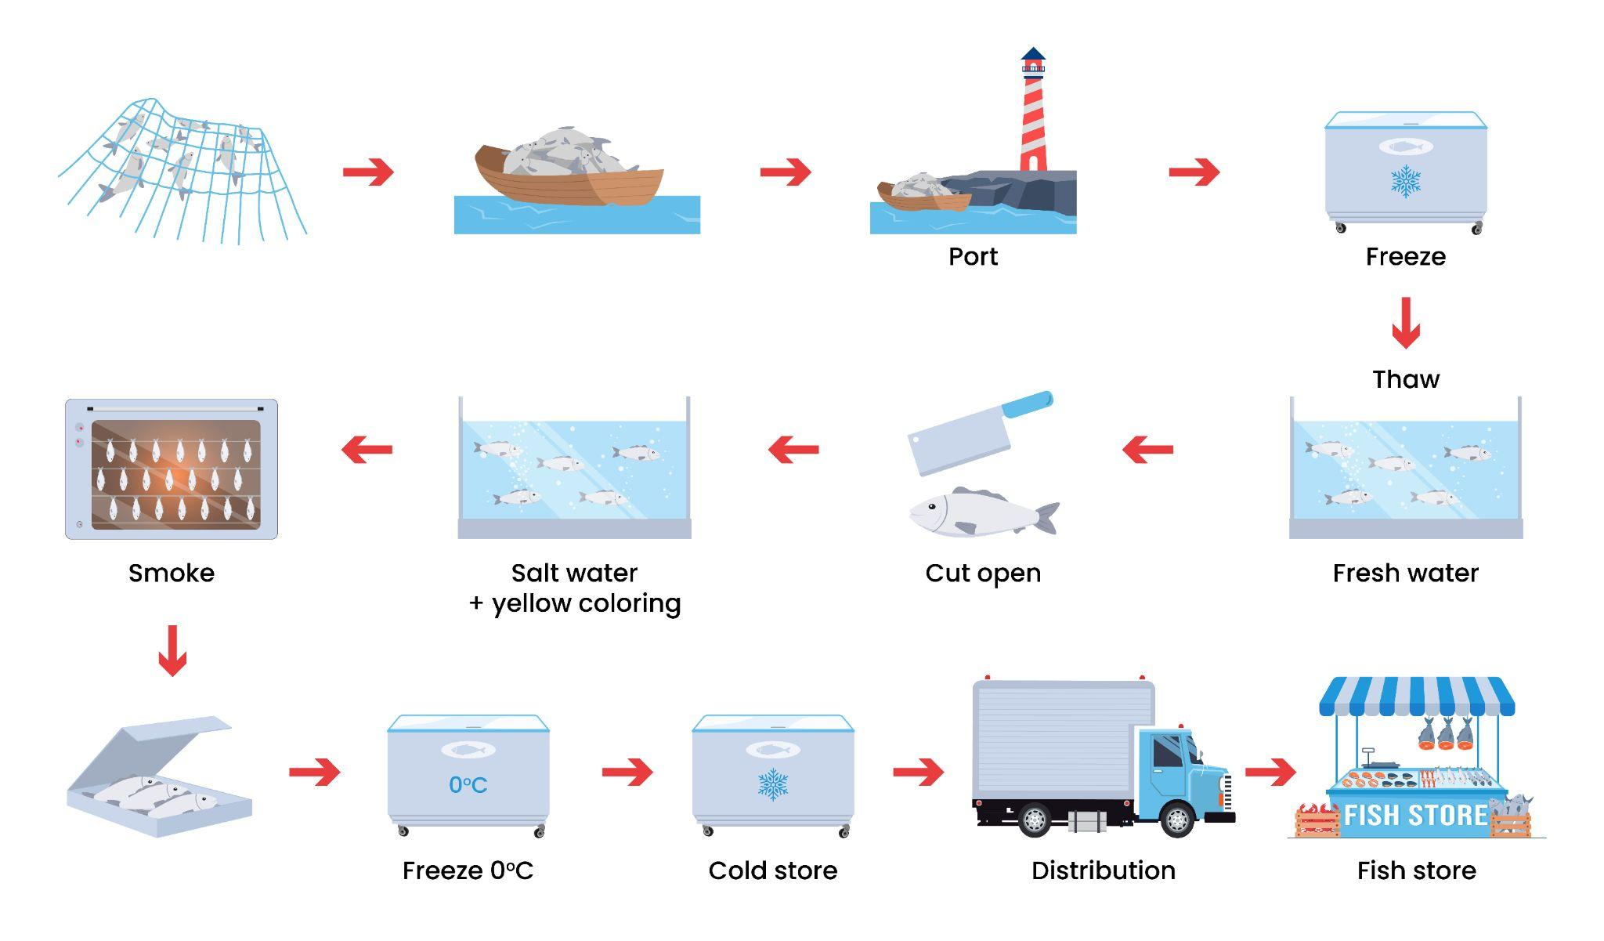

Dạng bài: quiz_type_0
Easy IELTS - Task 1 - 20

Model answer
The chart provides an overview of the step-by-step process involved in producing smoked fish. Overall, the smoking fish procedure can be categorised into three primary phases, commencing with the capture and transportation of the fish, and culminating with the distribution of the smoked fish to retail fish shops.
The first stage involves harvesting raw ingredients and preparing them. More specifically, in the initial step, fish are caught using large nets while out at sea. Once captured, they are transported back to the port via boats. Upon arrival at the port, the fish are stored and frozen to maintain their freshness and quality.
The processing of the prepared materials is shown in the second stage. First, they are thawed out in freshwater, followed by cutting them open for further preparation. The fish are then immersed in a solution of saltwater and yellow colouring, likely for flavour enhancement and visual appeal. After this, the fish are subjected to smoking, which adds the characteristic smoky flavour.
The third stage marks the completion of the production process. After the smoking process, the fish are carefully placed into boxes. To ensure proper preservation, the boxes of fish are frozen once again, this time at a temperature of zero degrees Celsius. These frozen boxes are then stored in a cold store, where the temperature is likely maintained at a suitably low level to prevent spoilage. Finally, the processed fish are distributed to local fish stores for sale. This distribution is carried out using trucks, which transport the frozen boxes from the cold store to the intended locations.
(261 words)

Exercise 7. You should spend about 40 minutes on this task
In the future, the main reason for going to the shopping mall will be for entertainment, not to shop. Do you agree or disagree?
Give reasons for your answer and include any relevant examples from your own knowledge or experience.
Write at least 250 words.

Dạng bài: quiz_type_0
Easy IELTS - Task 2 - 21

Model answer
In some countries a mall is known as a shopping centre. Although the main purpose of a mall was initially shopping, this trend is beginning to change. I believe that in the future, the main purpose of a mall will be for entertainment.
More and more of us enjoy shopping online. It is safer than ever and much more convenient. Many websites offer free next-day delivery. On sites like eBay and Amazon, there is far more choice and there are also many discounts and special offers. Obviously, this means that fewer shops will be needed. However, people still want to go out, meet their friends and have fun. A mall is a place which offers space to do that. If people have done their shopping online, the mall will have to offer other facilities to attract visitors.
Some malls already have cinemas and places to eat. However, as well as cheaper cafes and fast food chains, malls are beginning to offer better restaurants and places to eat. I believe this trend will continue. In addition, malls will offer all kinds of leisure facilities such as gyms, swimming pools, children's play areas, spas, and so on. There will be more live shows, including music, theatre and dance, and a range of exhibitions and special events.
I believe malls have an important role in future society but they will have a different purpose from today. There will still be a few shops but most people will go to the mall to relax and enjoy themselves with their family and friends.
(181 words)

LESSON 2

A. Vocabulary

Exercise 1. Put the words into the correct columns

Dạng bài: quiz_type_7

swimming golfer court track jump pitch

net motor racing stick basketball athlete

box skis race goalkeeper racing driver

sail rink skiing swimming costume

sport | person | place | verb | equipment
swimming  ___  ___  ___ | ___  —-  ___  ___ | ___  —-  ___  ___ | ___  —-  ___  ___ | ___  —-  ___  ___  —-
Key:

sport | person | place | verb | equipment
swimming  motor racing  basketball  skiing | golfer  athlete  goalkeeper  racing driver | court  track  pitch  rink | jump  box  race  sail | net  stick  skis  swimming costume

Exercise 2. Complete the sentences using the given words
courses | costumes | fun | hockey | fit
jogging | tent | ring | racing | climbing

Dạng bài: quiz_type_7

Do you know the size of a boxing ring?

I used to play ice _____________.

We played golf in Scotland, where they have some fantastic golf _____________.

My dad plays golf. He’s not a serious golfer; he just plays for _____________.

If the girls go swimming, they must remember to take their swimming _____________.

We watch a lot of motor _____________.

I love swimming, and it helps to keep me _____________.

My sister enjoys rock _____________.

You can’t go camping unless you have a _____________.

Running is good exercise, so four or five times a week I go _____________.
Key:
2. hockey 3. courses 4. fun 5. costumes
6. racing 7. fit 8. climbing 9. tent 10. jogging

Exercise 3. Complete the sentences with the correct verb

Dạng bài: quiz_type_7

We play football in the winter at my school.

Do you _____________ much exercise?

I _____________ basketball in the summer and winter.

We always _____________ in the winter, as long as there is enough snow.

I _____________ a bit of yoga when I was younger.

We used to _____________ camping in the mountains.

I _____________ a lot of swimming in the summer.

If you want to _____________ fit, you need to run three or four miles every other day.

I used to _____________ in the gym, but I’m getting a bit old for that now.

Key: 2. do 3. play 4. ski 5. did

6. go 7. do 8. keep 9. work out

B. Grammar

Exercise 4. Choose the correct word or phrase

Dạng bài: quiz_type_14

When we were in Canada, we went / were going skiing almost every day.

About four years ago, I decided / was deciding to become a chef.

Georgia had / was having a shower when someone knocked at the door.

Holly and I ran from the house to the taxi because it rained / was raining heavily.

Two men argued / were arguing outside, so I went to see what was happening.

Daniel called / was calling you at one o'clock yesterday, but you were here with me.

We ate / were eating breakfast when a letter came through the letter box.

As I walked past the window, I saw that Paula made / was making a cake.

I dreamt / was dreaming about my favourite band when the alarm clock went off.

While I practised / was practising the trumpet late last night, a neighbour came to complain.

Exercise 5. Complete using the correct past simple or past continuous form of the verbs in the box.

Dạng bài: quiz_type_7

get | put | have | be | shine | continue | practise
open | say | answer | sing | ring | go | wake

Amber's Big Match
One morning, Amber (1) __________ up early. The sun (2) __________ and the birds (3) __________. Amber (4) __________ very excited because it was the day of the big tennis match. Amber (5) __________ downstairs and into the kitchen, where her father (6) _________ breakfast.
'Morning, Amber. Today's the day!' he (7) ___________. Amber smiled nervously.
'Don't worry!' he (8) __________. 'You'll be fine.'
Amber (9) ___________ some toast into the toaster and (10) __________ the fridge. Just as she (11) ____________ the butter out, the phone (12) ____________.
Her father (13) __________ it. After a few minutes, he put the phone down.
'Bad news, I'm afraid. The other player (14) _____________ yesterday when she had an
accident. The match is off.'
Amber ate her toast slowly. She was surprised she didn't feel disappointed.

Key:
1. woke 2. was shining 3. were singing 4. was 5. went
6. was having 7. said 8. continued 9. put 10 .opened
11. was getting 12. rang 13.answered 14. was practising

C. Writing

Exercise 6. You should spend about 20 minutes on this task
The maps below show Colwick Arts Centre in 2005 and today.
Summarise the information by selecting and reporting the main features, and make comparisons where relevant.
Write at least 150 words

Dạng bài: quiz_type_0
Easy IELTS - Task 1 - 20
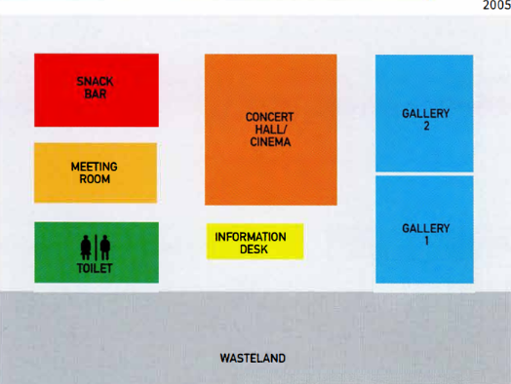
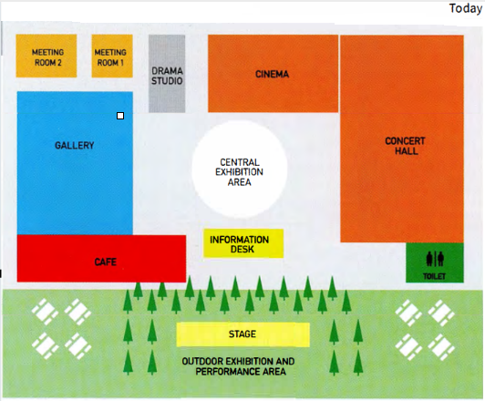

Model answer
The maps show the changes to Colwick Arts Centre between 2005 and the present day. We can see that the Centre expanded and new facilities were added during this period.
One of the major changes is that the outside area was developed. In 2005, there was an empty area of land outside the Centre. Trees were planted there and an outdoor exhibition area was made. The café was moved to the front of the Arts Centre and tables were added outside.
Inside, a central exhibition area was created. The information desk was moved to the front of the central area. In the past, there were two galleries but now there is only one; however, a drama studio was built. In 2005, the concert hall and cinema were in the same space, whereas now they are separate. In addition, an extra meeting room was constructed. The toilets moved to the opposite side of the Centre.
Overall, it is clear that Colwick Arts Centre is more attractive today and has better facilities than in 2005.
(173 words)

Exercise 7. You should spend about 40 minutes on this task
Global warming is one of the biggest threats to our environment. What causes global warming? What solutions are there to this problem?
Give reasons for your answer and include any relevant examples from your own knowledge or experience.
Write at least 250 words.

Dạng bài: quiz_type_0
Easy IELTS - Task 2 - 21

Model answer
Global warming has become a pressing issue that affects not only the environment but also human lives across the globe. It is a growing concern that demands immediate attention. This quiz_type_0 will discuss the main causes of global warming and suggest possible solutions to address the problem.
One major cause of global warming is the burning of fossil fuels such as coal, oil, and natural gas. These fuels are commonly used for producing electricity, running vehicles, and powering industries. However, they release a large amount of carbon dioxide into the atmosphere, which traps heat and raises the Earth’s temperature. Another significant reason is deforestation. Cutting down trees not only reduces the number of plants that absorb carbon dioxide but also increases the amount of greenhouse gases in the air. Additionally, the rise of industrial activities and the increasing use of personal vehicles have worsened the situation.
To solve this issue, governments and individuals must take action. Firstly, governments should invest more in renewable energy sources like wind, solar, and hydroelectric power to reduce dependence on fossil fuels. Laws should also be introduced to limit emissions from factories and cars. Secondly, reforestation programs should be promoted to restore forests and help absorb carbon dioxide. On a personal level, people can help by using public transport, reducing electricity consumption, and recycling waste.
In conclusion, global warming is mainly caused by human actions such as burning fossil fuels and cutting down forests. However, with combined efforts from governments and individuals, this problem can be controlled and the environment can be protected for future generations.
(263 words)

